Easy Read

Improving mental health Services for adults in Gwent

Use this form to tell us what you think about our plans
Response form
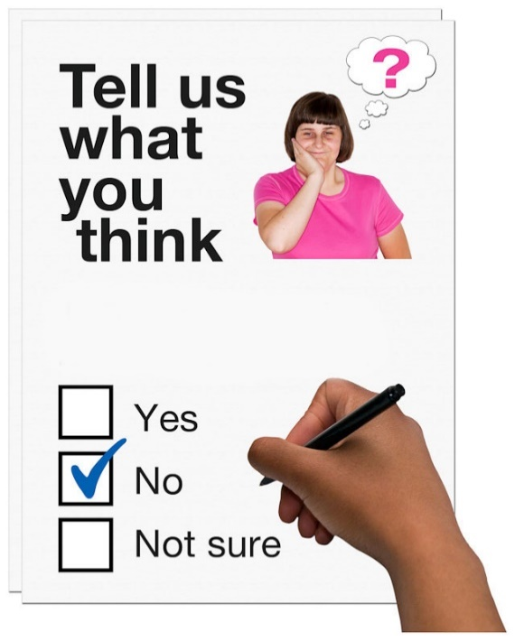

This is an easy read version of Aneurin Bevan University Health Board’s ‘Transforming Adult Mental Health Services in Gwent’.

January 2021

How to use this form
 | Please read the Improving mental health Services for adults in Gwent document before you fill out this form.
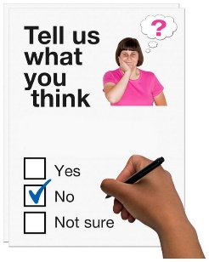 | Answer each question by ticking the answer you agree with.
 | Please return this form by 21 February 2021
 | By Post: Freepost, Gwent MHLD Division
 | E-mail: ABB.MHLDEngagement@Wales.nhs.uk
 | This form was made into easy read by Easy Read Wales using Photosymbols.

– Your personal details

What you think about our plans

Level 1 – staying healthy

Please read pages 6 to 9.

- Do you agree or disagree with what we want to do here?
Agree | ☐ | Disagree | ☐ | I do not know | ☐

- Is there anything else we can do to support your mental health?

- Do you think it is good or bad to have a choice about how you are supported, face to face or on telephone or video technology?
It’s good | ☐ | It’s bad | ☐ | I do not know | ☐

- Would you be happy to travel further for support if it meant you could be helped quicker?
Happy | ☐ | Not happy | ☐ | I do not know | ☐

- Would you be happy to travel further for support if it meant you could be helped by someone who could support you better?
Happy | ☐ | Not happy | ☐ | I do not know | ☐

Level 2 – help in the community

Please read pages 10 to 12.

- Do you think we should employ more people to help GPs support people with their mental health?
Yes | ☐ | No | ☐ | I do not know | ☐

- Do you think we should employ Psychological Well-being Practitioners?
Yes | ☐ | No | ☐ | I do not know | ☐

- Do you think it is a good or bad idea to support people in Neighbourhood Care Centres?
Good idea | ☐ | Bad idea | ☐ | I do not know | ☐

Level 3 – help in a crisis

Please read pages 12 to 13.

- Do you agree or disagree that it is good to set up the Crisis Assessment Unit?
Agree | ☐ | Disagree | ☐ | I do not know | ☐

- Do you agree or disagree with the Crisis Assessment Unit being at St Cadocs Hospital in Caerleon?
Agree | ☐ | Disagree | ☐ | I do not know | ☐

- Do you think it is a good or bad idea to have 1 way for all organisations to contact the Crisis Assessment Unit?
Good idea | ☐ | Bad idea | ☐ | I do not know | ☐

Level 4 – help in hospital

Please read pages 14 to 15.

- Do you agree or disagree with having separate wards for people who have just had a crisis and people who are getting better?
Agree | ☐ | Disagree | ☐ | I do not know | ☐

- Do you agree or disagree with having 1 ward for anyone in Gwent who has had a crisis to be assessed?
Agree | ☐ | Disagree | ☐ | I do not know | ☐

Level 5 – Special help

Please read pages 16 to 17.

- Do you agree or disagree that we should have a new Specialist In-patient Unit in Gwent?
Agree | ☐ | Disagree | ☐ | I do not know | ☐

- Do you think it is a good idea or bad idea to move some services from other hospitals to the new Specialist In-patient unit?
Good idea | ☐ | Bad idea | ☐ | I do not know | ☐

16. We want to know what is most important to you. Please tick which box applies the most to you.

16 a: Supported by the best staff for your needs. Tick 1 box.
 | Extremely Important | ☐
 | Very Important | ☐
 | Quite Important | ☐
 | Slightly Important | ☐
 | Not Important | ☐
16 b. The quality of the place you get support. For example, the hospital Tick 1 box.
 | Extremely Important | ☐
 | Very Important | ☐
 | Quite Important | ☐
 | Slightly Important | ☐
 | Not Important | ☐
16 c. Standard of care you received. Tick 1 box.
 | Extremely Important | ☐
 | Very Important | ☐
 | Quite Important | ☐
 | Slightly Important | ☐
 | Not Important | ☐
16 d. Knowing where to go to get support. Tick 1 box.
 | Extremely Important | ☐
 | Very Important | ☐
 | Quite Important | ☐
 | Slightly Important | ☐
 | Not Important | ☐
16 e. Being seen quickly. Tick 1 box.
 | Extremely Important | ☐
 | Very Important | ☐
 | Quite Important | ☐
 | Slightly Important | ☐
 | Not Important | ☐
16 f. Being seen close to home. Tick 1 box.
 | Extremely Important | ☐
 | Very Important | ☐
 | Quite Important | ☐
 | Slightly Important | ☐
 | Not Important | ☐
16 g. Being involved in your care. Tick 1 box.
 | Extremely Important | ☐
 | Very Important | ☐
 | Quite Important | ☐
 | Slightly Important | ☐
 | Not Important | ☐

Is there anything else?

Please use this space to tell us about anything else you want to say about our plans.

Your personal details

 | Title:
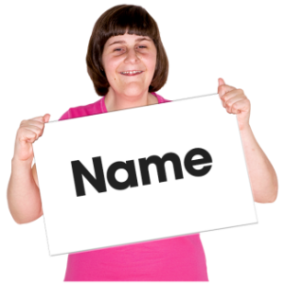 | Your full name:
 | Your address:
 | Your email address:
 | Your telephone number:

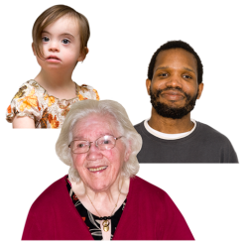 |  | How old are you?
 | 16 - 24 years old |  | ☐ | 25 - 49 years old | ☐
 | 50 - 64 years old |  | ☐ | Over 65 years old | ☐
 | I do not want to say |  | ☐

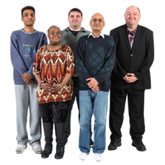 | Are you:
 | Male | ☐
 | Female | ☐
 | Non-binary - I do not identify as male or female | ☐
 | I do not want to say | ☐

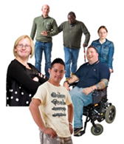 | Are you disabled?
 | Yes | ☐ | No | ☐ | I do not want to say | ☐

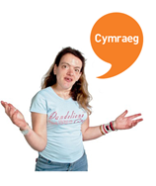 | Can you speak Welsh?
 | Yes | ☐
 | No | ☐
 | I do not want to say | ☐

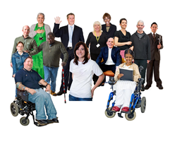 | Do you consider to be Black and Minority ethnicity (BME)?
 | Yes | ☐
 | No | ☐
 | I do not want to say | ☐

Thank you

