COVID-19

Gwent Community Well-Being Information Group

Resource Pack No 4 (24th April 2020)

Hello and welcome to our fourth resource pack. We have four broad themes this week:

- Compassionate communication,
- Supporting people with learning disabilities,
- Supporting older adults and people living with dementia, and
- Promoting wellbeing and resilience.

There are resources for each, with a brief explanation below.

The Community Well-Being Information Group, convened by the Mental Health and Learning Disability Division, has pulled these resources together. Our growing Directory of resources can accessed on Aneurin Bevan University Health Board intranet and internet.

Compassionate Communication

We have included a number of attachments that feel clear and helpful around talking to people and breaking bad news.

The infographic from the Chelsea and Westminster hospital has some useful ideas about things you might say when talking to relatives.

A team from Oxford University have produced some step-by-step guidance about breaking bad news over the phone here:

https://www.psych.ox.ac.uk/files/research/contacting-relatives-by-phone-to-communicate-death-of-a-patient.pdf

We have also attached a guide on how to talk to children about someone dying.

There is a longer document from Samaritans Cymru called “Working with Compassion” in both English and Welsh produced well before the Covid-19 pandemic. We think this may be helpful for those of you having conversations with people in distress. Their practical ideas are presented in the following format:

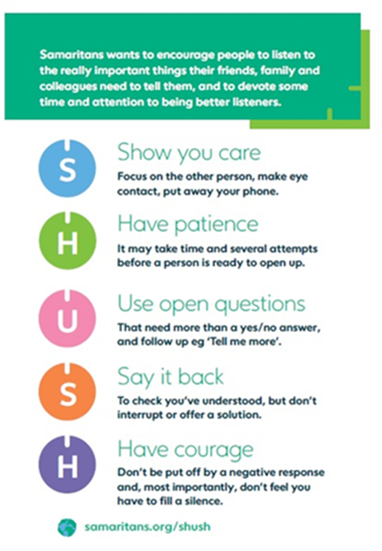
.
People with Learning Disabilities

We have included three attachments that are for people with Learning Disabilities and their carers that are part of the Books Beyond Words series. They cover important issues, including how to look after mental health and well-being, how to support Covid-19 decision making (eg going into hospital), and how to talk with someone about a death from Covid-19.

Older Adults and People living with Dementia

We have some resources this week about supporting older people and people living with dementia during self-isolation. They include practical suggestions for how to meet universal psychological needs such as occupation, identity, and attachment. The first one contains slides and is in an easier read format. The second is written as a guidance paper and is relevant for anyone working with older people and/ or people with dementia, or for those of us with family members in these groups. Both resources also contain helpline numbers for the Alzheimer’s Society, Age UK, and The Silver Line.

Promoting well-being and resilience

Finally, and of equal importance, we have included some resources about looking after ourselves and promoting our own wellbeing. This is an area we want to address every week. Caring for ourselves and each other is always important, and during these challenging times it can be hard to find the time and space to do that every day. The WHO and FACE COVID posters could be printed and laminated and displayed in work or social areas.

