COVID-19

Gwent Community Well-Being Information Group

Resource Pack No 5 (1st May 2020)

From: Community Well-Being Information Group (CWIG)

Hello and welcome to our 5th resource pack.

It’s always a challenge to know how much information to include in these packs, and as the weeks progress, we become more aware of themes we could address. In addition to this week’s themes of domestic abuse, Covid-19 mythbusting, and promoting well-being and resilience, we want to draw attention to Mental Health Awareness week.

Mental Health Awareness week

Mental Health Awareness Week is hosted by the Mental Health Foundation and will take place from Monday 18th May 2020 to Sunday 24th May 2020. This year’s theme is ‘Kindness’ and we thought that this would be a great opportunity to celebrate and showcase the many acts of kindness happening around Gwent.
Please contact Lucy Goodwin (Professional Head OT for Adult Mental Health) either by emailing: lucy.goodwin2@wales.nhs.uk or telephoning: 07772134292 by 14th May so that we can collate these stories to go out with our CWIG briefing that week which will focus on kindness.
You can find more information in this attachment

Returning to our themes domestic abuse, Covid-19 mythbusting, and promoting wellbeing and resilience. There are resources for each, with a brief explanation below.

DOMESTIC ABUSE

While we are all being asked to stay safe and stay at home, for some people home is not a place of safety. Recognising that we can all play a vital role in helping to keep individual’s, their children and extended families safe from harm, one of the themes this week focuses on Domestic Abuse and includes resources that provide guidance on.
- What are the indications of possible abuse,
- How to talk with people if you have concerns, they are at risk,
- What advice to share
- Where to find support and help.
Domestic abuse is any type of controlling, bullying, threatening or violent behaviour between people in a relationship. As well as the impact on the person being abused it can seriously harm children and young people and experiencing domestic abuse is child abuse.
For help, see following helplines

National Guidance on Domestic Abuse

These links are to the UK and Welsh governments advice and guidance on Domestic abuse

https://www.gov.uk/government/publications/coronavirus-covid-19-and-domestic-abuse/coronavirus-covid-19-support-for-victims-of-domestic-abuse

https://gov.wales/live-fear-free/domestic-abuse-wales

https://gov.wales/five-ways-help-children-and-young-people-stay-safe-during-coronavirus-lockdown

COVID-19: guidance on isolation for domestic abuse safe-accommodation settings. Guidance to support domestic abuse survivors including their children in domestic abuse safe accommodation settings, including refuges and other types of safe accommodation

https://www.gov.uk/government/publications/covid-19-guidance-for-domestic-abuse-safe-accommodation-provision

Gwent Safeguarding Referral Pathway

https://www.gwentsafeguarding.org.uk/en/Adults/Professionals/What-is-abuse/Domestic-Abuse/Referral-Pathway/Domestic-Abuse-Referral-Pathway.aspx

Gwent Police Domestic Abuse Awareness Raising Campaign

Gwent Police have launched a new awareness raising campaign today on their social media feeds and website. The campaign will help people recognise the signs of coercive control and report any concerning behaviour.

Links to the campaign follow below.

Web story: https://www.gwent.police.uk/en/newsroom/story/news/read-between-the-lines/

Facebook: https://www.facebook.com/gwentpolice/videos/156267739159839/

Twitter: https://twitter.com/gwentpolice/status/1253679581841817600

Further posts on Facebook, Twitter and Instagram will go up over the course of the week.

Myth busters

With ongoing concerns about some of the “information” people are seeing about coronavirus, below is a link to a helpful article addressing some of the myths and conspiracy theories

https://www.medicalnewstoday.com/articles/coronavirus-myths-explored

Free on-line course - Stress Control
Stress Control is an online course aiming to help people cope with everyday stress and anxiety. The course is made up of 6 two-hour sessions, over a period of 3 weeks. These sessions are being live-streamed twice a week via You Tube. As a resident of, or employee within, Gwent you are able to access this course at no cost.

Although not designed specifically for COVID-19, this evidence-based course can help support your mental health and well-being during this particularly stressful time. This very popular course is now being delivered online, as participants cannot attend face-to-face sessions during the COVID-19 outbreak. This animation tells you more:

https://www.youtube.com/watch?v=TjUJQqRfZgE
Find out more information by watching the introductory video:
https://www.youtube.com/watch?v=8UUmZKoy-tk
If you are not able to access You Tube or are available at the time of live streaming, you can download, free of charge, booklets and relaxation/mindfulness tracks with or without music, which complement the class. Visit the website www.stresscontrol.org for more information. Registration is not required.

Timetable:
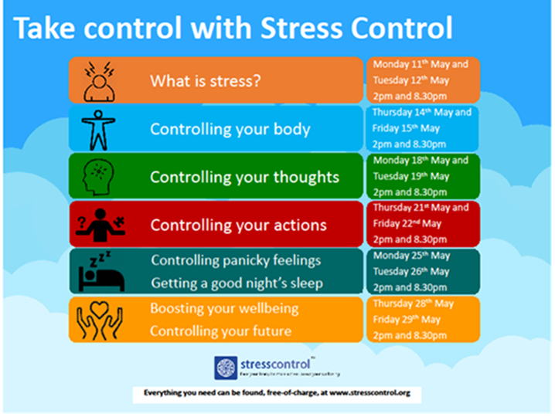

These resources have been pulled together by the Community Well-Being Information Group (CWIG), convened by the Mental Health and Learning Disability Division. Our growing Directory of resources can be found on the intranet

http://howis.wales.nhs.uk/sitesplus/866/page/78091

and internet pages

https://abuhb.nhs.wales/coronavirus/mental-health-and-well-being/


This is the fourth COVID-19 resources of the week from the
Gwent Community Psychology Service and the Gwent Attachment Service.

We have been busy developing an interactive directory of all the COVID-19 resources we have collected and reviewed. Please use this link to search and view the directory:
(please note this link may not work on Ipads and some networks)
Interactive Google Drive Resource Directory

We know for some of you this is your sixth week of physical distancing, shielding & home schooling.
This week we wanted to acknowledge lockdown fatigue.
This may look like exhaustion & irritability as well as being drained of motivation.
The resources this week are aimed at different ways of continuing to cope with
lockdown for young people, parents & professionals.



 |  | Resources for young people
 |  | 
Aneurin Bevan University Health Board
Paediatric Psychology Pack

 |  | Psychological Support for Children Booklet
Resources for parents |  |  | 

Parental Self Care
South East Wales Adoption Service - Psychology
The Three R’s – Regulate, Relate, Reason

 |  | Resources for professionals
 |  | Self-Care During COVID-19
 |  | Compassionate Wellbeing: Paul Gilbert Videos
 |  | Coping with COVID: ACT Matrix

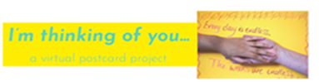
Here is a link to the I’m thinking of you….. ABUHB Arts Project
Please note this is a twitter link therefore may not work on some networks

 | Best Wishes & Keep Safe  We hope these resources are useful. We will be aiming to send out more once a week, subject to service changes. In the meantime if you would like any specific resources please email either: |  |  | Gwent Attachment Service Email
 |  |  |  | Gwent Community Psychology Service Email
 |  |  |  |  | 

http://howis.wales.nhs.uk/sitesplus/866/page/78091

and internet pages

https://abuhb.nhs.wales/coronavirus/mental-health-and-well-being/

