
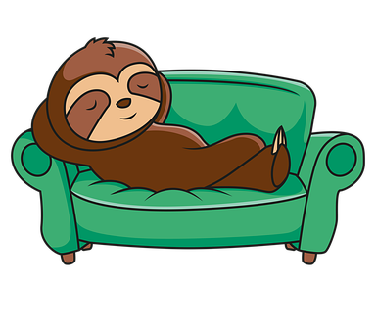
This toolkit was created by the Paediatric Psychology team at ABUHB to support self-care strategies for young people with physical health conditions
Self-Care Toolkit
Advice for young people on the importance of self-care and being kind to yourself
What is Self-Care?
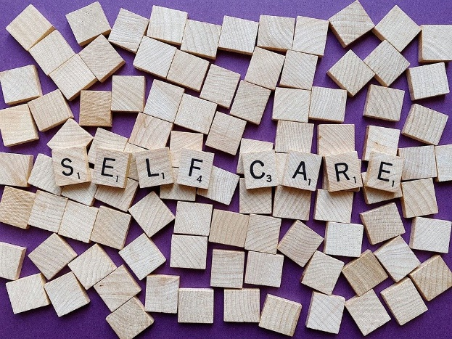
Self-care is about things you can do to be kind to yourself and look after yourself, especially when you’re finding things difficult and stressful. It is important to do this at times of stress but also a little bit each day can be really helpful.

Self-care can be doing something each day, or it can be making an extra effort to look after ourselves when we are particularly struggling with something.

Self-care is unique for everyone. It does not need to be about indulgence or pampering. It’s just about doing something we enjoy and showing ourselves some kindness. Having a health condition can be very tricky sometimes. This can take a toll on our wellbeing and make it harder for us to look after ourselves.

Why should I self-care?

If we forget to self-care, we may feel more tired, stressed, upset, and frustrated. In the long term, not being kind to ourselves can make life difficult at both home and school, especially when you are managing a health condition. It can feel much harder to manage our lives if we don’t make time to look after ourselves.

Good self-care can lead to us feeling relaxed, positive and in a better mood. This can leave us feeling more able to do the things that are important. 5 minutes or 5 hours, it doesn’t matter about the length of time we take to self-care, just that we are doing something.
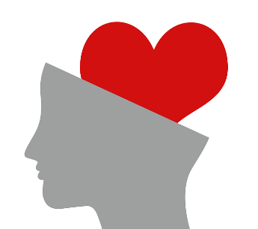
Read this document on wellbeing and self-care suggestions:

10 ways to self-care

- Set small goals

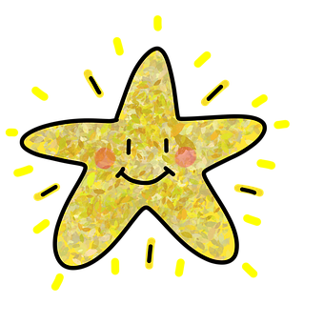
When there is something you need to do that feels difficult, break this task up into smaller ‘chunks’. Taking a break and resting in-between these ‘chunks’ can make the task seem easier. Ask for support from a parent/carer, teacher, or professional if you are finding the task hard. Trying to ‘put off’ or avoid doing tasks can make them seem worse when it comes around to doing them. Once you have finished, give yourself a big pat on the back and choose something as a reward for yourself.

- Set some structure and routine

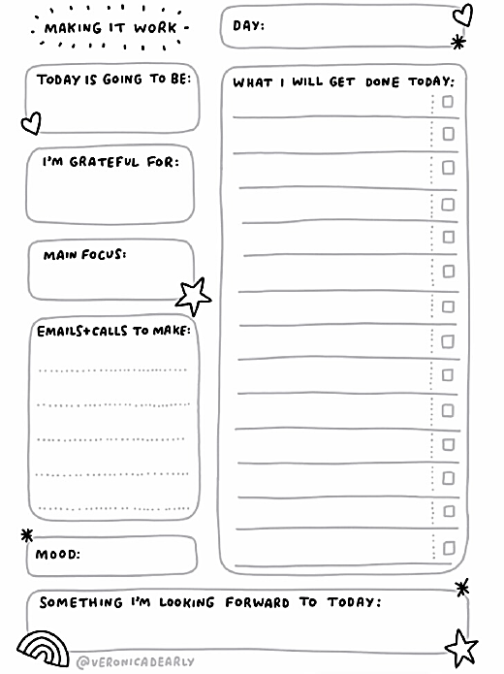
Having a structure and a routine can help us feel organised and contained. It can help us feel more motivated and like we have more energy to get things done. Try to come up with your own structures and routines for things – you could use this template!


- Eat a regular and balanced diet

It’s important to eat regularly and to eat the correct amount from each food group. Eating well can make us feel good in our bodies and in our mind! It can help us feel less tired, and makes us feel like we have more energy to keep going throughout the day. You can find a poster on what makes a balanced diet here:
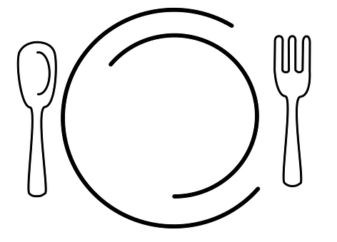

Eat Well Guide

- Look after your physical wellbeing

Get some exercise where you can to stay fit and healthy. There are lot of different types of exercise you can do. You can find one that you enjoy the most, or try lots of different types of exercise. Exercise has also been proven to release ‘endorphins’ in our brains – these make us feel good! You could try..

Martial Arts
Riding a bike
Running
Swimming
Skipping
Dancing

Playing a team sport
Walking
Yoga

- Try to get enough sleep

Getting enough sleep means we feel awake and alert throughout the day, and ready to face the tasks we need to do. A lack of sleep can leave us feeling exhausted and we may find it difficult to concentrate. Sometimes our racing thoughts and worries can keep us awake at night and stop us getting enough sleep. But, it’s also ok to use sleep as a form of self-care and rest when needed (for example, having a short nap). This booklet gives more information on helping problems with sleeping. Perhaps you could go through it with an adult! -
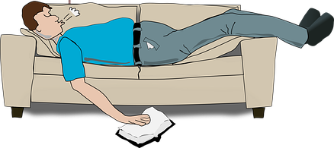

- Have some ‘me time’ and chill out!

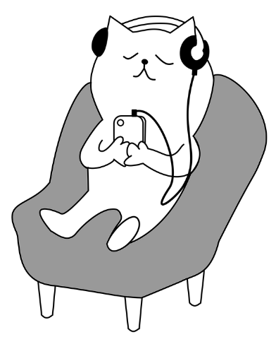
It’s really important to set time aside to do things that you enjoy and are good for your wellbeing. This can be doing things like exercise, baking/cooking, and creative activities, but can also be just chilling out and watching some TV or listening to music. Setting time aside to do this each day allows our minds to have a ‘break’. Even watching TV takes up energy, but it’s important to have a good balance between tasks and hard work versus fun and rest. It’s also good to take short breaks when you are in the middle of a task that’s taking up a lot of mental or physical energy.

- Connect with other people

Take some time to connect with friends, family and loved ones. When things feel hard it can be good to have these people around for support and help. This is often called a ‘support network’. It’s like a web of people that we can talk to and share tricky feelings with to make them feel easier to manage.
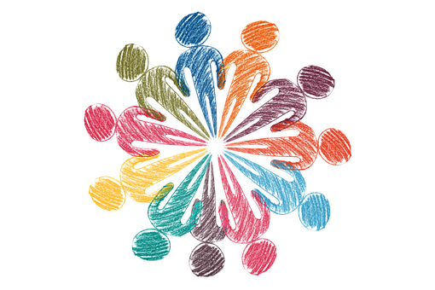

- Be kind to yourself

When we are dealing with difficult thoughts and feelings, it can be easy to blame ourselves for feeling that way. We sometimes feel like we must always be happy and positive even when we have something really tricky going on in our lives. But, it’s OK to allow ourselves to feel upset, unhappy or frustrated sometimes. This is called being kind to ourselves and accepting the emotions we are feeling.
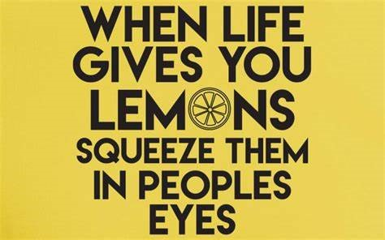
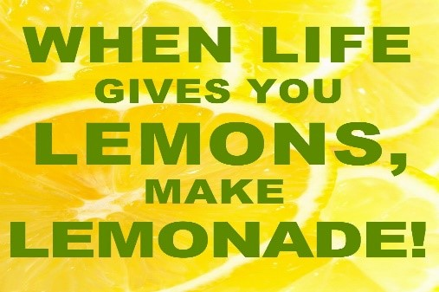

…But it’s also OK to feel like this!
You may feel like this sometimes…

- Reward yourself for achievements


This one is short and simple! When you have done something you feel really proud of, or have achieved something you found to be really tricky, give yourself a big pat on the back and a nice reward. This could be some chocolate, hanging out with friends, time on your Xbox or PlayStation, or just a nice rest. It’s really important to notice our achievements and things we are really proud of.
- Accepting things you can’t change, but remember the things you can

When we are facing something difficult, it can be really hard to focus on anything other than the problem in front of us. Some things about physical health conditions can’t be changed, but the way we cope and manage with the tricky parts can. It can be helpful to know what is in our ‘control’ and what isn’t, so we know to focus on the things we can do something about, and ‘let go’ of the rest.
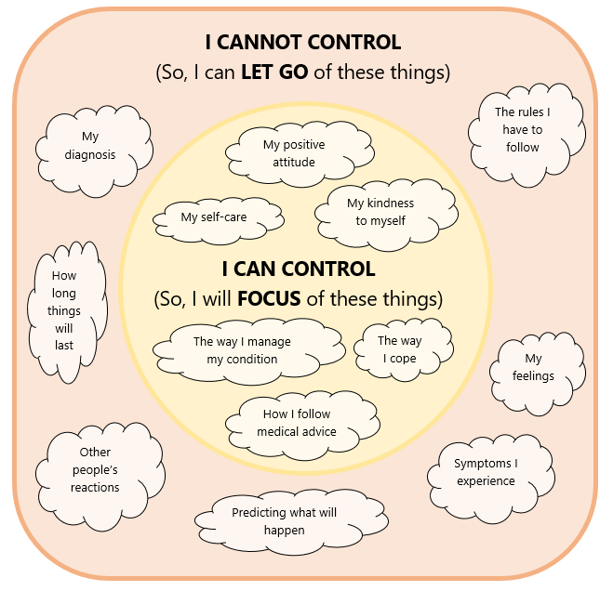

My Self Care Plan
Sometimes making a plan to help plan your self-care a good idea. You could use this table below.

What could I do today to look after myself or be kinder to myself?
If I want to, who could I talk to?
E.g. When I’m feeling sad I can talk to my parent or carer

What are 3 things I am thankful for?

Self-care is so important for our wellbeing and helps us to manage things that are tricky or take up a lot of mental and physical energy. It can also be helpful to focus on positive things. Use this journal to help you:
Useful Information

This toolkit was created by the Paediatric Psychology team at Aneurin Bevan University Health Board (ABUHB).

If you would like more information about this toolkit or our other resources, you can ask an adult or a professional, who can contact the team using these details:
Paediatric.Psychology.ABB@wales.nhs.uk
01633 436996

Please also visit our website for links to other resources on these topics:
Coping with my condition
Relationships with others

Managing difficult thoughts and feelings

