
Understanding your Epilepsy
12 – 18 years
Created by the Paediatric Psychology Team
Created by Dr Anne Johnson, Alex Marsh, Gemma Johns, Rhiannon Peters, Phoebe Borrie



How to use this booklet

This is a long booklet, but no need to worry!

You can work through this booklet however suits you, whether that’s bit by bit over a period of time, or by skipping to pages that interest you.

We have separated the content into 3 sections:
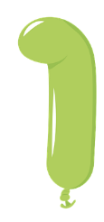
What is epilepsy and the impact on my life, for example; medication, trigger management Pages 3-20

What does epilepsy mean for my life, for example; friends, family, school
Pages 21-25

What impact can epilepsy have on my thoughts and feelings, and how to manage this
Pages 26-36

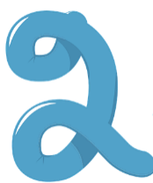

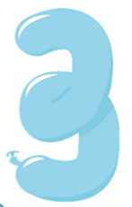

You might also find it helpful to share some of the things in this booklet with people who are close to you like your family, or your teachers in school.


Throughout this booklet, there will be QR code links to resources that you can find by hovering a smartphone camera or a QR code reader app over them. If this is tricky, all of the URL links are provided towards the end of the booklet.

Most of all, we hope you find this information helpful. There are extra resources towards the end of the booklet. If you have any further questions or worries, we would recommend talking to your parents/carers, your epilepsy team or your GP.
What is epilepsy?
What is epilepsy and the impact on my life?

There are over 60,000 children in the UK with epilepsy. Epilepsy just means you have a condition where you are more likely to have seizures than other people.
However, seizures are more common than you think! 1 in 10 people will have a seizure in their lifetime! So, when you feel that no one understands you, people do! You aren’t alone.

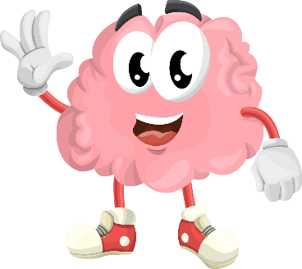
A seizure happens when the electrical activity in your brain (which is how bits of our brain talk to each other), gets out of hand and becomes over-excited. It can happen in just one bit of our brain (this is called a localised seizure), or all over our brain (a generalised seizure).
If it happens in one bit of our brain, the type of seizure is determined by what that bit of the brain does. For example, if it happens in the bit of the brain that controls our arm movements, our arms might twitch.

Some people have the same seizures each time, where a specific bit of their brain gets over excited. Other people have different bits that get over excited at different times and so they have different types of seizures.

What is epilepsy?

Check out Jack’s story: (https://youtu.be/tA-Bikjbka4)
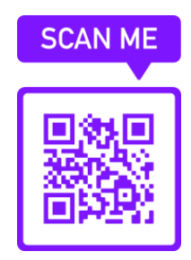 | 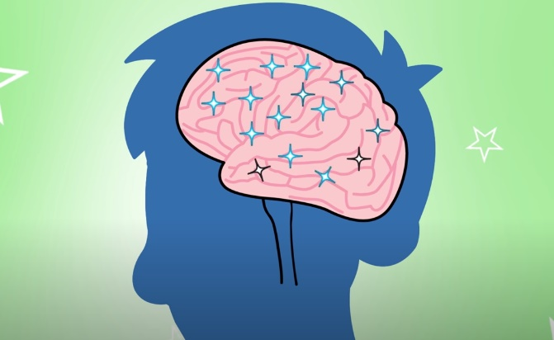

How does epilepsy affect people?

Because different bits of our brain do different things, our epilepsy affects us differently. Some people have epilepsy in bits of their brain that:

- Affects how they think (e.g., their memory skills, ability to concentrate and focus)
- Help us manage our emotions and behaviours (e.g., some people might struggle to stop themselves from acting on a thought as soon as it pops into our heads)
- Some young people have a type of epilepsy that only affects them during sleep, while others can have a seizure any time.
- Different people have different treatments for their epilepsy, depending on their type of epilepsy. These can include:
- Medications
- Surgery
- Vagal nerve stimulation
- Special diets
Treatments might work better for some people than others. They can also cause side-effects, particularly when they are first used (e.g., when you start a new medication, you might have more side-effects, but these often settle after a few weeks).
It is important to talk with your parents and your doctor about any side-effects including changes in your mood, behaviours, thinking skills, health, and physical abilities (like your energy levels) so that they can work with you to manage them.

Living with epilepsy can also have an impact on different aspects of our lives. It can impact:
- Our feelings and behaviour
- Family and friendships
- School and our ability to learn new things
- Sleep
And just like how everyone is affected by epilepsy differently, everyone experiences different impacts on different aspects of their lives. Even though it can be frustrating, it is normal for aspects of your life to change. While it may be tricky, it is important that we try not to let them get in the way of doing the things we love and living a full and happy life. We will touch upon this more later!

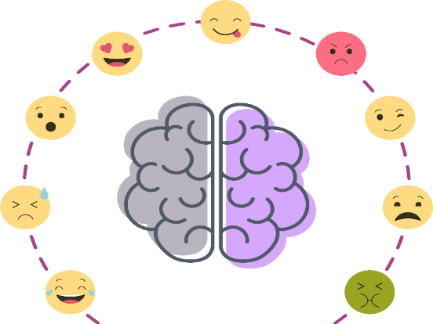

Understanding your triggers
If you feel like things are getting too tricky for you, it is important to try and talk about your thoughts and feelings with the people around you who are important to you.

For some people, a seizure can change the way they experience the world while it is happening. It can affect what they see, hear, feel and their ability to control their body. For some people, it might affect all of these things, some people may lose awareness of the world and their body entirely, while some might only have a few of these things affected. Other people might also notice changes in the person’s behaviour. Some people are completely unaware during seizure, whereas others are aware of what is happening but are unable to respond.

Below are some common symptoms. Have a go at ticking the ones you experience, and think about any others that you have noticed:

Collapsing | ❑ | Tiredness | ❑ | Stomach pain | ❑
Blacking out | ❑ | Racing heart | ❑ | Blurred vision | ❑
Shaking | ❑ | Weakness | ❑ | Dizziness | ❑
Feeling distant | ❑ | Difficulty speaking | ❑ | Headache | ❑
Going blank | ❑ | Confusion | ❑ | Unable to respond | ❑
Memory problems | ❑ | Jerking limbs | ❑ | Feeling distant | ❑
Anything else you have noticed:
…………………………………………………………………………………………………………………………………………………………………………………………………………………………………………………………………………………………………………………………………………………………………………………………………………………………………………………………………………………………………………………………………………………………………………

Some people have warning signs, such as sudden feelings of panic, sensations in the body, or feeling distant from themselves. Make a note of any warning signs you’ve noticed below:

My warning signs are: ……………………………………………………………………………………………………………………………………………………………………………………………………………………………………………………………………………………………………………………………………………………………………………………………………………………………………………………………………………………………………………………………………………………………………………………

After a seizure, you might feel tired, forgetful, or notice changes in how you feel emotionally or in your body:

After a seizure, I feel: ……………………………………………………………………………………………………………………………………………………………………………………………………………………………………………………………………………………………………………………………………………………………………………………………………………………………………………………………………………………………………………………………………………………………………………………

Triggers can differ from person to person, so it is important to work out what your personal patterns are. Knowing your personal triggers can help you to develop more effective coping strategies to manage your seizures.

Even if you already know some of your triggers, it can be really helpful to keep a diary for a few weeks. This can help you to see patterns and identify other triggers. Sometimes, seizures seem to happen out of nowhere, like when you are sat quietly watching a film or reading a book. If you keep a diary you might see patterns that you would otherwise miss.

Use the worksheet on the next page to keep a log. You only need to write a little bit in each box, but make sure you write enough to jog your memory. For example, write ‘argued with Sam at dinner time’ rather than ‘dinner’, or ‘read a good book in bed’ rather than just ‘bed’. You should record what you did, your mood ratings (on a scale of 1-10), and when you had a seizure. There is also space to record information about your sleep.

Once you have recorded the information for a week or two, take some time to review your notes and make a note of any triggers or patterns you notice below. Make a note of any things that make your seizures worse (i.e. trigger a seizure, or make one more likely).

My personal triggers and patterns: ……………………………………………………………………………………………………………………………………………………………………………………………………………………………………………………………………………………………………………………………………………………………………………………………………………………………………………………………………………………………………………………………………………………………………………………………………………………………………………………………………………………………………………………

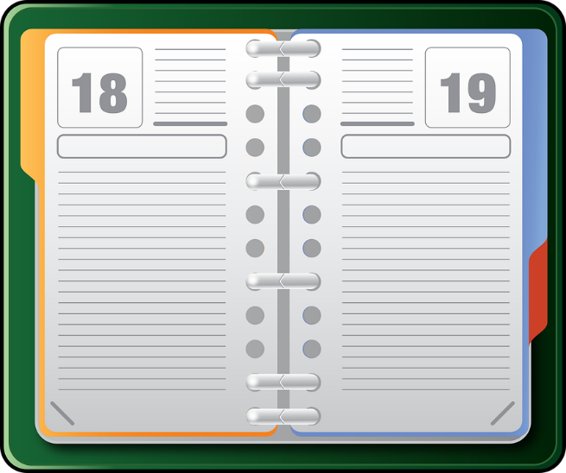
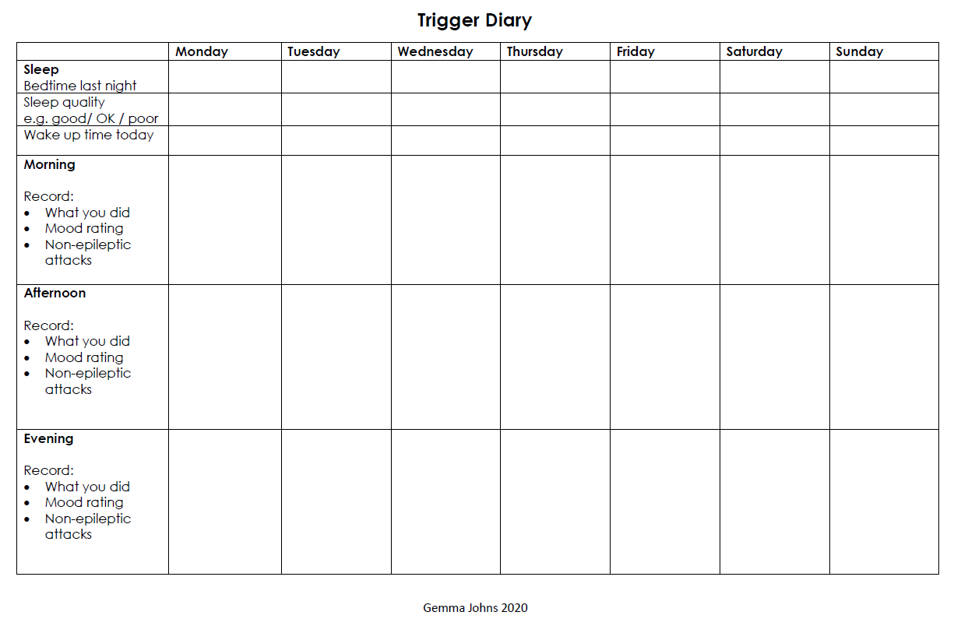

Life with epilepsy

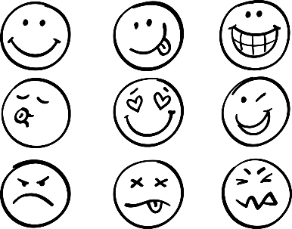
Receiving a diagnosis of epilepsy may leave you feeling a wide range of emotions. You might find that you feel:
- Shocked
- Relieved because you finally know what is happening
- Angry
- Worried
- Worried or anxious about having epilepsy or that you may have a seizure.

Many young people with epilepsy experience thoughts and feelings of:
- Concern about their seizures and of ‘losing control’ during a seizure
- Being more reliant on parents or other adults when your friends are becoming more independent or getting to do more things
- Worrying about going into hospital or having doctors’ appointments
- Worrying about managing medication and any possible side-effects
- Friends not understanding and maybe teasing or bullying
- Feeling different from everyone else

These are all really normal thoughts for young people with epilepsy. While it may be tricky, it is important that we try not to let them get in the way of doing the things we love and living a full and happy life.
It is important to try and talk about your thoughts and feelings with the people around you who are important to you. We understand that this isn’t always easy, so we are going to provide you with some handy tips and skills to help you navigate and manage these thoughts, so you can lead a life doing the things you love!

It is important to remember, you are not alone. Many young people live with epilepsy and lead happy and meaningful lives.
Check out some their stories here: | Listen to some of the positive aspects from people with epilepsy here: | You might be surprised who else has epilepsy:
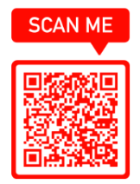 | 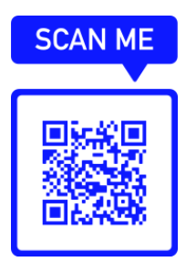 | 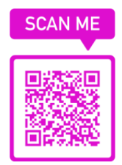

You and the people you live with

Talking to the people you live with can help both you and them realise what information you all still need in terms of your epilepsy management. The better informed you all are, the clearer you can all be about what might or might not be possible for you.

If you’re worried about having epilepsy, that’s ok. Hopefully this information can help you to feel more confident about your epilepsy. It should also give you some ideas about what you can do to help yourself feel more confident to do the things that matter to you. It may be that you are fairly relaxed but that your parents or carers are worried about you having epilepsy. This can feel difficult, and so helping each other to feel less worried can be helpful. Feeling confident to manage your epilepsy with the support of your family and other important adults in your life can make it easier for you to be more independent.

Here are some thing you could do that might help you and your parents or carers manage some of these worries in a helpful way:

- You can carry an epilepsy awareness card around with you
- Put an alarm on your phone to remind you to take any medication
- Download our seizure diary or an app and record useful information in it
- Work together to talk though parts of your epilepsy that might seem confusing, or that you might not understand. You can talk with your medical team about this.
- Talk to others around you to make sure that they would know what to do if you have a seizure. This could be other family members, friends, or teachers in school.
- Agree to check in with your parents or carers every so often by phone, when you go out



Famous People with Epilepsy
You might feel like you are alone with your epilepsy, because often we might not meet other people who have the same health condition as us. Remember, there are over 60,000 children in the UK with epilepsy, and 1 in 10 people will have a seizure in their lifetime.

Sometimes, you might feel like your epilepsy is holding you back in life, but with the right information and support, you can still do things that matter and feel important to you. Here are some examples of famous people with epilepsy!





Lil Wayne
Rapper, singer songwriter, record, actor
Won awards in the American Music Awards, the BET Awards, the BET Hip Hop Awards, the Billboard Music Awards, the BMI Awards, the Grammy Awards and many more!
Lewis Carroll
Author, illustrator, poet, mathematician, photographer, teacher, inventor
Author of Alice’s Adventures in Wonderland
Elton John
Singer, songwriter, pianist, composer
More than fifty Top 40 UK hits in and US Billboard Hot 100, including 7 number ones in the UK and 9 in the USA
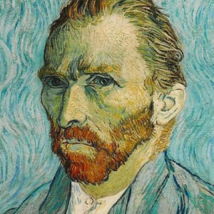

Vincent van Gogh
Post-impressionist painter
One of the most famous and influential figures in Western art



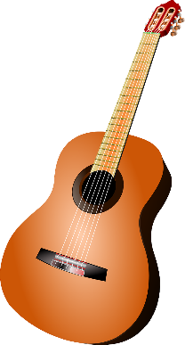
Imogen Clarke
50-meter champion swimmer
Has won a silver medal in the European Championships
Diagnosed with photosensitive epilepsy at the age of 14
Zac Shaw
Para-Athlete
Sprinter for Great Britain
Diagnosed with epilepsy at 11
Martin Kemp
Actor, musician, director
Arguably, best known for his role in EastEnders, and his membership in the band Spandau Ballet
Epilepsy in the media

While it can be inspiring to see famous people who are also living with epilepsy, we know that it might be difficult to relate to them.
Sometimes it is helpful to hear from people who are more like you.
Here are some YouTube videos that you can have a look at and hear
from people going about their everyday lives!



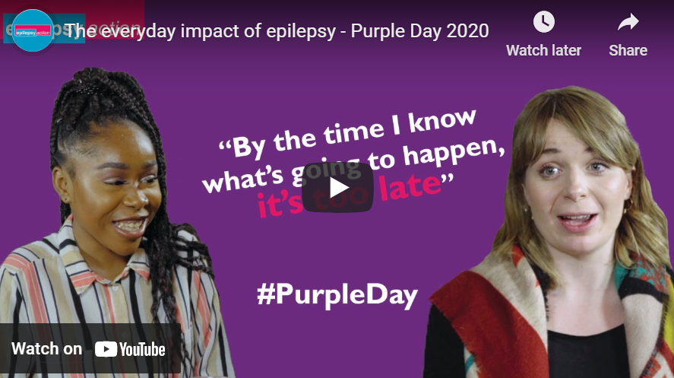

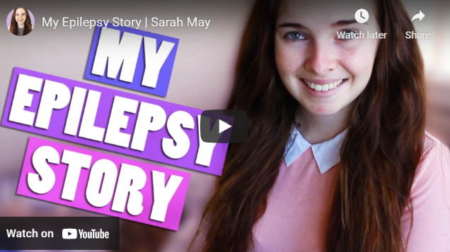
Epilepsy Action’s YouTube page is full of really helpful videos, including this one, “the everyday impact of epilepsy”
Sarah May is a 19-year-old university student from Australia studying Veterinary Science. In this video, she talks about her own experiences of epilepsy to help try to break the stigma
Scan the QR codes with your smartphone camera to find the videos!


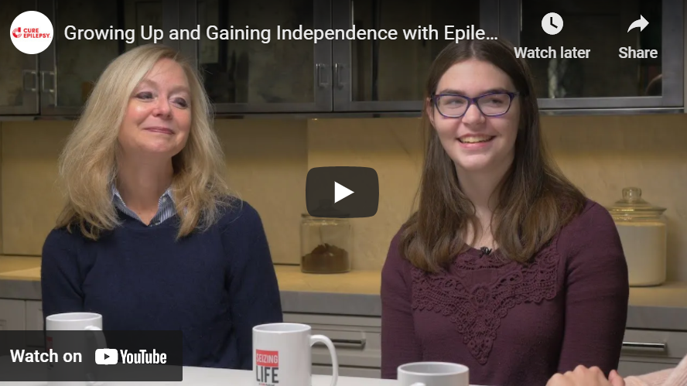
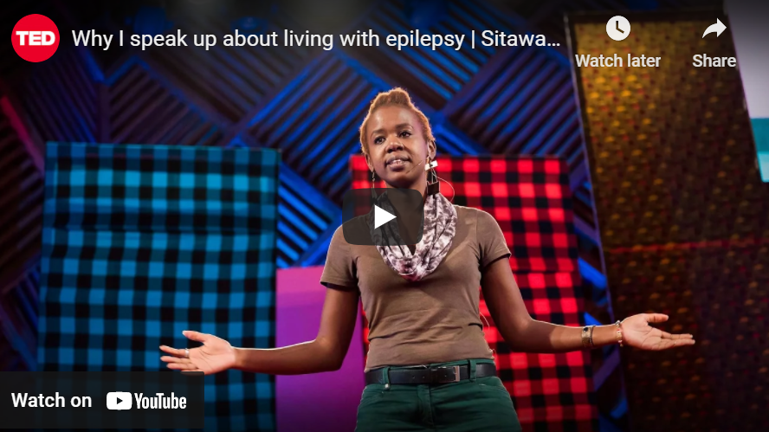

In this video, we learn about some of the challenges that may come up as you grow older and want to become more independent. Caroline and her mum Ashleigh talk about what it’s like now Caroline is living away from home and attending college.

There are loads of TedTalks out there of people talking about their lived experiences. In this video, mental health advocate Sitawa Wafula cuts through the stigma and exclusion of epilepsy to talk about what it's like to live with the condition.


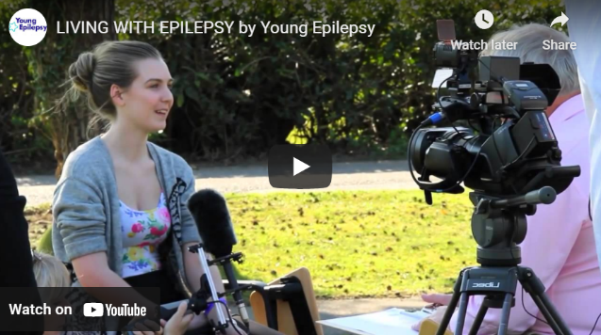
Activity: How has epilepsy impacted you?
Tip!
If you are finding it tricky to answer questions from your friends or loved ones about your epilepsy, you might find it useful to show them some of these videos too!
This video from the Young Epilepsy YouTube page can help you to understand more about living with epilepsy, what to do if you see someone having a seizure, and real life stories from young people just like you who are living with epilepsy.

Think about the reasons that were mentioned above. How has your epilepsy impacted your life?

It might have impacted your thoughts, relationships, your daily routine, the sports you like to play etc. Write these around the body. You might like to do this in other ways, for example, by writing in a diary.



How can I look after myself?

There are many different ways you can look after yourself when you have epilepsy. Here are some ideas for you:

- Get plenty of sleep – sleep is really important for our brains and helps keep them healthy
- Get support from your friends, family and loved ones when you are having a difficult time
- Learn different ways to manage your feelings and emotions (you can get some tips from this booklet!)
- Focus of what you value and what is important to you in life
- If you take medication, take it regularly and as prescribed, this will make sure your epilepsy stays as controlled as possible
- Eat a healthy, balanced diet, and try to eat regularly – this will help make sure your brain gets the fuel it really needs to function at its best and keep you healthy!
- Exercise – this will help to improve your blood circulation, and pump blood to your brain more efficiently so it can do its job effectively!

There is plenty of research to suggest that by doing some of the things listed above, you might:

- Improve control of your seizures
- Improve the side effects of some forms of anti-seizure medications
- Help with your feelings of worry or low mood
- Improve your thinking skills (such as learning, memory, attention)
- Have a better overall quality of life
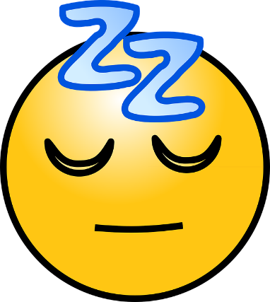
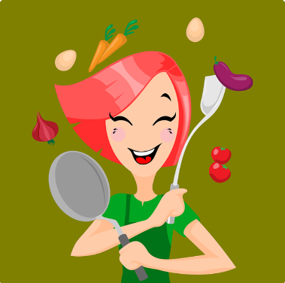
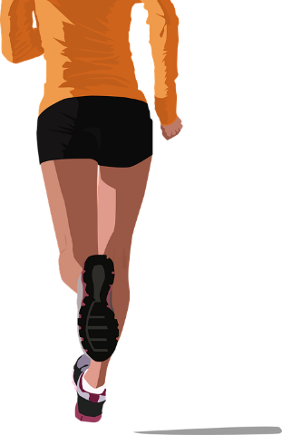
Which areas do you think you could work on?
Your diet, exercise and sleep
Diet
Food is fuel for our brain and body. When we are lacking in fuel, we can have difficulties concentrating and controlling our mood and emotions. This can increase our stress. Keeping your body and brain well fuelled means sticking to a regular eating pattern and choosing the right ‘fuel’. It can be helpful to remember ‘rubbish in, rubbish out’ when thinking about what you choose to eat. Remember – there are no ‘good’ or ‘bad’ foods. Nothing is off limits - it’s more about how much of something you eat!

Here ae some tips for maintaining a healthy diet:
- Eat at regular times throughout the day
- Keep the same pattern of meals from day to day (e.g. breakfast, lunch and evening meals, plus two snacks)
- Avoid long gaps between meals (i.e. more than 3-4 hours between meals or snacks)
- Avoid ‘fad’ diets, fasting or comfort eating
- If you have trouble remembering to eat regularly, try settling an alarm to signal meal/snack times
- Eat a wide variety of foods to ensure you are getting a variety of nutrients
- Aim for at least 5 portions of fruit and vegetables per day

Exercise

We all know exercise is good for us, but sometimes it’s worth reminding ourselves why…
Regular exercise can:
- Boost your mood, relax your muscles, reduce stress and improve sleep
- Improve heart and lung function
- Strengthens our muscles and bones
- Helps us to maintain a healthy weight
- Improves our self-confidence and social skills
Young people should aim for, on average, at least 60 minutes of moderate intensity physical activity a day. This should be a combination of aerobic exercise and exercise to strengthen muscles and bone
.
Moderate intensity activities will raise your heart rate, and make you breathe faster and feel warmer. One way to tell if you’re working at a moderate intensity level is if you can still talk, but not sing.
To get started on becoming more active, try to find an activity you can do regularly. It’s important to do something you enjoy, or it will be hard to keep it up. Some examples to get you started…
- Walking (e.g. walking to school, college or work; walking the dog)
- Jogging or running
- Team sports (e.g. football, , basketball, netball, hockey)
- Classes, in person or online (e.g. dance, aerobics, gymnastics, yoga, )
- Gym, home-based or paid membership (e.g. resistance exercises with exercise bands, weight machines or free weights, sit-ups, press ups, skipping with a rope)
- Other active hobbies (e.g. rock climbing, horse riding, roller blading, ice skating, surfing, skateboarding, tennis, badminton)

Sleep

Sleep problems are common. The ‘right’ amount of sleep varies from person to person and our sleep needs can change throughout our lives. Lots of things can affect sleep, including: age, health conditions, mood, the bedroom environment and our routine. Poor sleep can increase feelings of stress, and may lead to poorer epilepsy management. We can get ‘stuck’ in a cycle of poor sleep increased stress poorer management more stress worse sleep.
There are lots of ways to break the cycle and get better sleep. This can reduce stress and make it easier to cope with your management. Here are some top dos and don’ts:
Sleep ‘Don’ts’ | Sleep ‘Dos’
Staying in bed when you are not able to sleep. This creates a negative connection with being in bed and being awake | If you’re not asleep after 20-30 mins (without watching the clock), get up and do something relaxing and not too exciting, such a reading a book. Get back into bed as soon as you feel sleepy again. If you can, avoid studying, chatting to friend, watching TV and other waking activities while in bed. Try using a desk or beanbag area instead.
Going to sleep and waking up at different times each day  Avoid regular lie-ins as they disrupt your body clock Research has shown a weekend lie-in can often make you feel worse on a Monday morning | Try to stick to a regular bedtime and waking up time, this works best if you stick to it at weekends as well. Having a consistent waking up time even if you have struggled to sleep is the most effective way to get into a good sleep schedule.
Lack of bedtime routine to let our brain know that it is time for sleep. E.g. studying, video calling friends, or playing computer games until late, then expecting to fall asleep straight after. | Create a regular night-time routine to signal to your brain and body that it is time to wind down. Try to include routine (e.g. pyjamas on, teeth brushed) and relaxing activities (e.g. bath, reading, drawing, listening to relaxing music etc.) in the hour before bed.
Bedroom environment e.g., uncomfortable bed, messy room, too hot, too light etc. | Try to make sure you have a comfortable mattress, keep the room clean and uncluttered, cool and dark (black out curtains or blinds can help), keep pets out of the bed with you. Your bedroom should be a relaxing, cosy and inviting place to sleep!
Too much blue light (from computers, phones, TV) interferes with melatonin production, which is a hormone we need to make us feel sleepy. | Avoid blue light from electronic devices for at least one hour before bed (i.e. no laptops, tablets, phones or TV). Use ‘night mode’ or ‘blue light filter’ from early evening.
Day time napping | Avoid napping. If you really have to, make sure you don’t nap for longer than 45 minutes.
Stress and worries | Talk through worries with friends and family, write them down and/or go through them in ‘worry time’ earlier in the day. At night time, you can use apps like WorryTime: https://play.google.com/store/apps/details?id=com.worrytime&hl=en_GB&gl=US
Watching the clock | Turn your alarm clock to face the other way. Move your phone out of arms reach so you’re not tempted to check the time.
Being inactive | Get enough regular exercise (see below). This helps you to feel naturally tired. But don’t exercise before bed as this will wake your body up.
Not getting enough daylight | Try to get out in daylight every day, to set your body clock. Then keep your room relaxed, cool and dim before bed.
Eating too late at night | Don’t go to bed hungry, but don’t eat too late. Leave 2 hours between food and bed. If you do eat, choose something light and easily digested.
Too much caffeine. Caffeine is a stimulant which will keep you awake | Keep caffeinated drinks to morning only
Smoking, alcohol, drugs | All of these affect the quality and quantity of sleep. Avoid or reduce.
Pain, hormonal changes (e.g., menstrual cycle), snoring. | See your GP if pain, hormonal issues or snoring affects your sleep.
One thing I’d like to do to try and improve my diet is: ……………………………………………………………………………………………………………………………………………………………………………………………………………………………………………………………………………………..
One thing I’d like to do to try and improve my exercise is:
……………………………………………………………………………………………………………………………………………………………………………………………………………………………………………………………………………………..
One thing I’d like to do to try and improve my sleep is…
……………………………………………………………………………………………………………………………………………………………………………………………………………………………………………………………………………………..

Barriers to having a healthier lifestyle
Sometimes things come up that make it harder to make healthier lifestyle choices. When we are feeling big emotions or feel overwhelmed, comfort eating, avoiding exercise and having a long lie in can feel good! It’s ok to give yourself a break and do these things sometimes. Everything in moderation is ‘healthy’! However, if you find yourself doing some of these things all of the time, this can be a good first step to noticing when we might need to intervene.
At first, changing our behaviours completely can feel like a daunting task. You could set small, achievable goals to take small steps towards this. Over time, this might help make it easier to feel motivated to continue this long term, or set bigger goals!
Today I will… eat one more fruit and one more vegetable

Next week I will… Add an extra 10 minutes onto my walk

Add your own here! _________________________________________________________

School, college, university and work
What does epilepsy mean for my life?

Whether you’re at school, college, university or work, it’s a good idea to let someone know about your epilepsy, unless you have seizure control. Most people would see seizure control as not having had a seizure for about 12 months.

This way, your teacher, tutor or manager can be prepared, in case you do have a seizure. They can think about putting a plan in place to help you feel safe, and that adults know how to look out for you and keep you safe.

If your epilepsy is well controlled and you haven’t had a seizure for 12 months or more, you might feel you no longer need to tell people about your epilepsy. But seizures can still happen, for example, if you’re ill or you’ve forgotten to take your epilepsy medicine. So, some people choose to tell people they spend time with about their epilepsy, and what to do to help if they have a seizure.

Having epilepsy can make school a bit more difficult, but you can still continue to learn and enjoy your time in education.

Some things that might affect your learning are:

- The epilepsy itself
- The cause of the epilepsy
- The effects of the seizures
- Side-effects of medication
- Absences from school (e.g., illness, doctors’ appointments, psychology clinics etc.)

If this is happening for you, it is important to share this information with your school, your medical team and your parents/carers, so that they can help to find the best way to support you. You may be able to access a neuropsychology assessment or support from an Educational Psychologist via your school to help identify how your epilepsy may be impacting you and how this can be best supported.



Telling people about your epilepsy

You might feel that a diagnosis of epilepsy somehow makes you different from other people. Young people have said to us that they are worried that people will treat them differently. Often, people can be unsure about things that they don’t understand. This can feel very tricky, but the more confident and positive that you are able feel about your own epilepsy, the less likely others will see you as ‘different’. Information can be found about what epilepsy is at the following links. You might find it helpful to show others these links so that they can find out a little bit more about epilepsy!

ABUHB Epilepsy Service | Epilepsy Action
 | 

Other people’s attitudes

Sometimes other people might seem to treat you differently. And it may feel like this is because of your epilepsy. It might be, but it might not be. It’s important to remember that there could be other reasons for someone’s behaviour. If you feel confident to, you could try checking with the person you think is treating you differently. They might be able to explain what they’re feeling.

Sometimes someone can treat you differently because they are finding it hard to understand. It’s normal to feel unsure, or even scared, of something you don’t understand. If you feel able to, you could try and answer other people’s questions about your epilepsy. If it doesn’t feel okay to do this, you could point them to the Aneurin Bevan Health Board webpage, or Epilepsy Action website.

If this is happening at school or college, you could ask whether an adult you trust, like your parent/carer, or even someone from your epilepsy team, could contact your school to have a conversation about how to help.

There are over 600,000 people in the UK with epilepsy, so, the more that people are aware of epilepsy, the better. Some young people enjoy giving information to their friends or class about what it means to have epilepsy. If you like, you could ask your teacher about opportunities to share your story! Remember, you don’t have to do this if you don’t want to. It is other people’s responsibility to learn about things that they may not understand in order to be kind to others. It is not your job to teach them if it makes you feel uncomfortable.

Answering comments and questions about your epilepsy

People who have a medical or physical health condition like epilepsy can sometimes be asked questions about it, and it can be hard to know how to answer to these questions. It can be easier if you think of some ways you could answer before someone asks.

Here are some ideas for answers to questions and comments that you could try. Some of these might suit you better than others. It might be helpful to try them out with someone you trust, when you’re in a good mood, to see which are best for you. You may also want to add your own as you practice.

As well as being prepared for questions, it is also good to remember that people sometimes ask questions because they are just curious, or because they don’t know what else to say. Usually, they are not trying to upset you.

One way to do this is to answer questions with a brief and clear explanation. It’s important to think of answers that suit you and your epilepsy. The more you practice hearing and answering these questions, the more confident you will feel.

You could try saying…

“Hi, I’m __________. I have a health condition called epilepsy. This means that ____________. I manage this by doing __________. That’s all.”

Try to fill in the blanks, change the sentence, or come up with whatever suits you! Practice saying this at home with someone you know well and trust. You could write it out, or make it into a colourful poster.
Another way to respond is to give a short explanation and then to change the subject. For example:
- “It’s just _____________. Did you see that film last night?”
- “________________ sometimes affects_____________. I have ways to manage this, though.”
- “Have you done that maths homework yet?”
- “I don’t want to talk about it at the moment. Isn’t Mr John a nice teacher?”
- “I have/I am ______________. Have you ever met anyone with this condition before?”
Responding to Unkind Comments and Questions
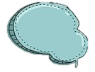
Sometimes people ask questions that seem a little rude and don’t consider your feelings. When this happens, a firm response can show that these questions are not welcome. Here are some examples:
- “Nothing’s wrong with me.”
- “I don’t really want to talk about that because people always ask me.”
- “That’s a bit of a personal question”
- “I don’t need to explain that if I don’t feel like it”

Positive Self Talk
It can be upsetting when people ask questions about your medical or physical health condition. In these situations, saying positive things to yourself can help you to cope. This is called ‘positive self-talk’. Here are some examples:

- People asking unkind questions is their problem, not mine.
- People ask questions because they want to know about me.
- That boy was just curious. He was not trying to be nasty or to upset me.
- My condition or problem does not define me. I am good at lots of things like drawing and football.
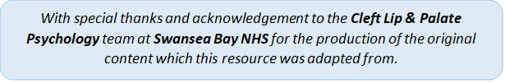

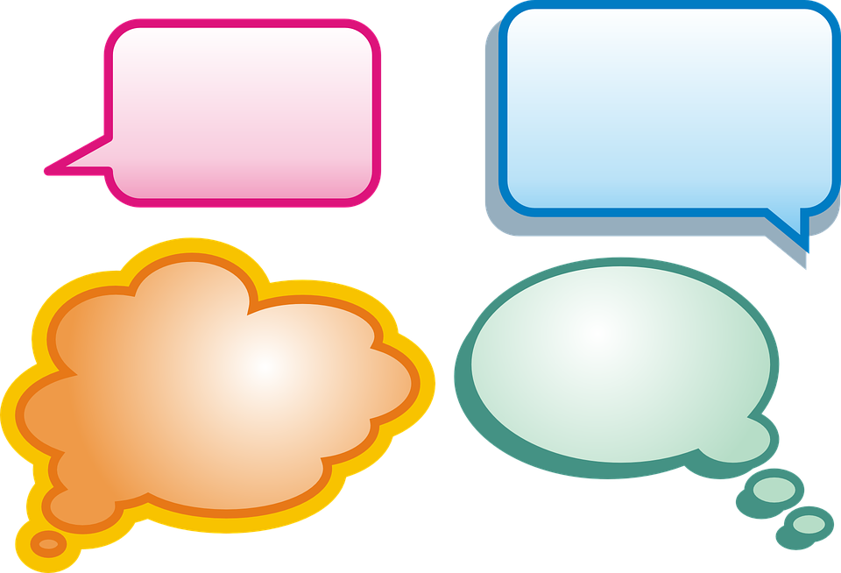
Bullying and Teasing
Most people experience a little bit of teasing or jokes made about them — often we can laugh too. But sometimes it gets to a point where it stops being funny and it starts to hurt. This is when it has to be stopped. It is normal to feel scared, sad and embarrassed. But it is important to remember that you are not alone!

Bullying can happen in different ways. Here are some examples:
- Hurting someone else physically
- Calling them names
- Leaving someone out on purpose and lots of times
- Giving them bad looks
- Spreading mean rumours about them.

Bullies pick on people for lots of different reasons. They might have low self-esteem and/or feel powerless. They might take out their angry feelings on others. It might be because they want attention from others. But the one thing bullies want is to get a reaction!

Some General Advice

Talk to someone – This is often the easiest way to make it stop. Bullies often warn that if you ‘tell’ they will make things worse. But teachers and parents need to know about the bullying to make sure things are sorted out, and they can do this without letting on they know what’s been happening.
Keeping a diary – Keeping a diary can sometimes help teachers understand what you are facing. The law says that your school has to have a special policy about bullying, so with your parents’ help you can ask to see it and ask what the school are going to do to stop the problem.
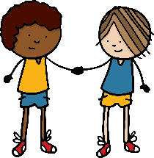
Making friends – Being with a group of friends can sometimes be enough to stop a bully being nasty, but friends are also important at reminding us about the good things about ourselves and keeping the fun in life.
Clubs and activities are good ways to get to know new people. You can use the Kidscape website for ideas about how to start up a conversation and make friends. www.kidscape.org.uk
Keep yourself safe – It is important to involve an adult, especially if you are at risk of harm. Make sure you seek help as soon as you can. Here are some tips to keep safe:

- Try to stay in safe areas of school where there are lots of other people
- On the school bus sit near the driver or by other adults.
- If you walk home then try to walk with other people.
- No one has a right to hurt you. If someone tries to hurt you, seek help. If the person you talk to doesn’t listen or take you seriously, don’t blame yourself. Find someone who can help!
Experiencing difficult thoughts and feelings
How can epilepsy impact my thoughts and feelings?
As human beings, we all experience difficult thoughts and feelings. For you, some of these difficult thoughts and feelings might come up about your epilepsy. Here are some strategies that can help us to feel calm and grounded when big emotions get quite overwhelming.

Progressive muscle relaxation
Muscle tension is common when we are feeling stressed. It is part of the fight or flight response, our body is getting ready to ‘spring’ into action. Fidgeting, fiddling, tapping, clenching, grinding your teeth, and hunching your shoulders can all be signs of tension related to stress. Feeling on edge, wound up or easily startled can also be signs.
We often don’t notice quite how tense we are, so becoming more aware of our body can be helpful. With practice, you will become more aware of when you are feeling tense and you will have the skills to help you relax. Regular muscle relaxation can help to reduce stress and can improve sleep.
To give it a try, follow the progressive muscle relaxation script at the end of this workbook. You might find it easier to ask someone to read it to you, or record yourself and play it back. Alternatively, there are lots of progressive muscle relaxation audio guides that you can search for online. During this exercise, each muscle should be tensed, but not to the point of strain. If you have any injuries or pain, you can skip those areas. Pay special attention to the feeling of releasing tension in each muscle and the resulting feeling of relaxation.

Mindfulness
When we feel low in mood, our mind can become focussed on the past, going over and over past events, or things that we’ve said and done. When we are anxious, we tend to be living in the future, we can get caught up with “what ifs...?”, worrying about what could or might happen. When we feel stressed, our minds are often racing with thoughts, and our brains are working over-time.
Mindfulness is a state of non-judgemental awareness of what’s happening in the here and now. It’s awareness of our thoughts, feelings, and senses.
The goal of mindfulness is not to stop thinking or get rid of unwanted thoughts or feelings. Instead, the aim is to practice noticing and accepting whatever comes up, in the present moment, without getting drawn into further judgment or analysis. It can also help to calm us neurologically (in our brains!).
There are lots of proven benefits to mindfulness, but it’s hard to be mindful without practice. There is even evidence to suggest it can help with epilepsy and seizures. Try the exercises below. There is a full list of mindfulness exercises in the back of this workbook. There are also lots of apps and audio guides that you can use to help you practice.

Mindfulness Jars
Our minds are full of thoughts, swirling around like the glitter in the jar.
Shake the jar up until the glitter is swirling around.
Then set it down on a table or the floor and calmly watch it settle.
Let your thoughts settle in time with the glitter in the jar.
When our minds are calm it’s easier to think clearly about whatever is bothering us and make choices in line with what’s really important to us. We can use the strategies below to help us settle our thoughts and bring us back to the present moment when our minds are swirling like the glitter!



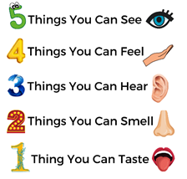
Five senses
One way to bring yourself back to the present moment when your mind is racing is the 5 senses exercise. Work your way through the steps in the picture and try to cover all 5 senses! Try to do this slowly and calmly to help feel more grounded.

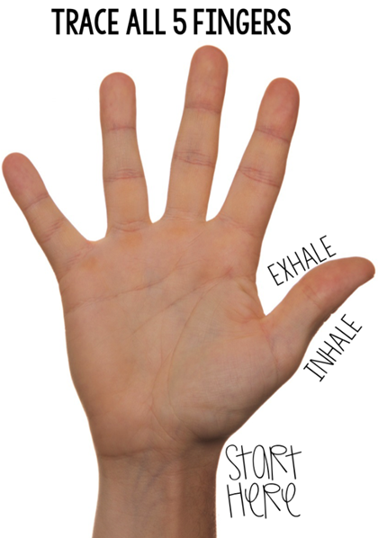
Hand breathing
When we are stressed, afraid, or angry our breathing becomes fast and shallow!
Learning to slow your breathing can help your body to trigger calming hormones. Spread your hand and stretch your fingers out like a star, and follow these instructions.

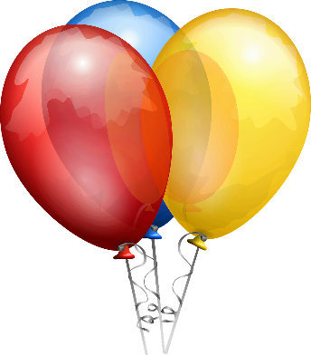
Belly breathing
Put your hands on your tummy.
Pretend that your tummy is a balloon, and you want to fill it as full as you can.
Breathe in slowly and see how big you can make your tummy.
Hold for a moment then slowly let the air out of the balloon. Try not to let the air out too quickly. As you do, try counting slowly.
Try to gradually increase the number you count to on the in breath and on the out breath.

Other top tips
- Plan to take time out. It may feel like there isn't time to take a break because there is so much to do. However, if you are feeling that things are getting out of control, making a plan with breaks can make you feel back in control and allow you to clear your mind and return to the task feeling refreshed.
- Learn to say no. It is ok to say no to things, particularly if you are feeling overwhelmed.
- Keep connected. Lots of people start to avoid situations because they fear having a seizure. But the more isolated and avoidant we become, the worse we feel. So it’s really important to keep seeing people and doing things that you enjoy.
- Talk about your feelings, rather than keeping them bottled up inside. Reach out to friends and family.
- Ask for help. You might find it helpful to show this guide to your family, friends and teachers. You can also speak to your doctor or staff at school about getting help.


How I Show My Feelings

 | 
When I am in a bad mood | When I am in a good mood
These are the things I usually do (activities, people I spend time with, etc.): | These are the things I usually do (activities, people I spend time with, etc.):
This is how I look and sound to other people (eye contact or not, slumping or standing up, sad or happy voice): | This is how I look and sound to other people (eye contact or not, slumping or standing up, sad or happy voice):
This is what I think about myself and my world: | This is what I think about myself and my world:
This is how my body feels (antsy, sleepy, relaxed, etc.): | This is how my body feels (antsy, sleepy, relaxed, etc.):
This is how I act around others: | This is how I act around others:

Scheduling time for fun
Write down one fun activity you can do each day that might help when you feel sad, angry or worried. Write your “feelings thermometer” before and after each activity.
Day and Plan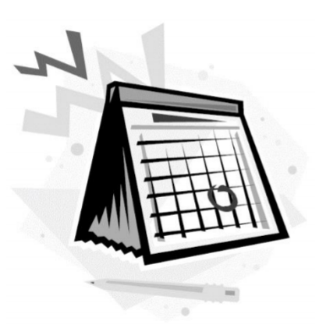 | How I Felt Before (0-10)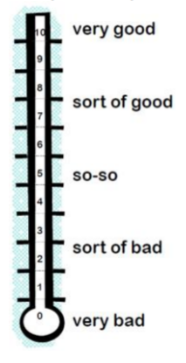 | Activity I Did  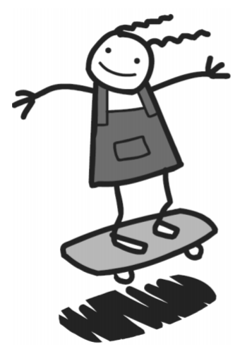 | How I Felt After (0-10)
Example
SATURDAY: Play football with my friend after lunch | 5 | Played football with my friend after lunch | 8
SUNDAY:

MONDAY:

TUESDAY:

WEDNESDAY:

THURSDAY:

FRIDAY:


Useful Resources
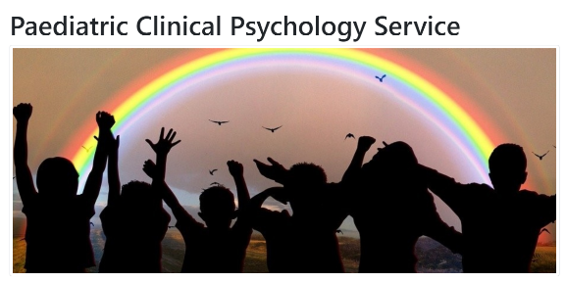 |  | 
ABUHB Epilepsy page |  | 


 | 
Managing your epilepsy | 
Rachel’s story |   Scan the QR codes with your smartphone camera to find the links!
I am Still Me | 
For Girls | 
For Boys | 
  Epilepsy in Young People | 
 | 
 | 
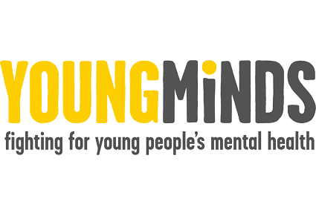 | 

Mindfulness Exercises

Take Ten Breaths
1. Take ten slow, deep breaths. Focus on breathing out as slowly as possible until the lungs are completely empty—and then allow them to refill by themselves.
2. Notice the sensations of your lungs emptying. Notice them refilling. Notice your rib cage rising and falling. Notice the gentle rise and fall of your shoulders.
3. See if you can let your thoughts come and go as if they’re just passing cars, driving past outside your house.
4. Expand your awareness: simultaneously notice your breathing and your body. Then look around the room and notice what you can see, hear, smell, touch, and feel.

Mindfulness in Your Morning Routine
Pick an activity from your morning routine, like brushing your teeth or taking a shower. When you do it, totally focus your attention on what you’re doing: the body movements, the taste, the touch, the smell, the sight, the sound, and so on. Notice what’s happening with an attitude of openness and curiosity.
For example, when you’re in the shower, notice the sounds of the water as it sprays out of the nozzle, as it hits your body, and as it gurgles down the drain. Notice the temperature of the water, and the feel of it in your hair, and on your shoulders, and running down your legs. Notice the smell of the soap and shampoo, and the feel of them against your skin. Notice the sight of the water droplets on the walls or shower curtain, the water dripping down your body and the steam rising upward. Notice the movements of your arms as you wash or scrub or shampoo. When thoughts come up, acknowledge them, and let them come and go like passing cars. Again and again, you’ll get caught up in your thoughts. As soon as you realize this has happened, gently acknowledge it, note what the thought was that distracted you, and bring your attention back to the shower.

Mindfulness of Chores
Pick an activity such as washing dishes or vacuuming the floors—something mundane that you have to do to make your life work—and do it mindfully. For example, when ironing clothes, notice the colour and shape of the clothing, and the pattern made by the creases, and the new pattern as the creases disappear. Notice the hiss of the steam, the creak of the ironing board, the faint sound of the iron moving over the material. Notice the grip of your hand on the iron, and the movement of your arm and your shoulder.
If boredom or frustration arises, simply acknowledge it, and bring your attention back to the task at hand. When thoughts arise, acknowledge them, let them be, and bring your attention back to what you’re doing. Again and again, your attention will wander. As soon as you realize this has happened, gently acknowledge it, note what distracted you, and bring your attention back to your current activity.

Mindfulness of Pleasant Activities
Pick an activity you enjoy such as cuddling with a loved one, eating lunch, stroking the cat, playing with the dog, walking in the park, listening to music, having a soothing hot bath, and so on. Do this activity mindfully: engage in it fully, using all five of your senses, and savour every moment. If and when your attention wanders, as soon as you realize it, note what distracted you, and re-engage in whatever you’re doing.


Check out this website for some more ideas:

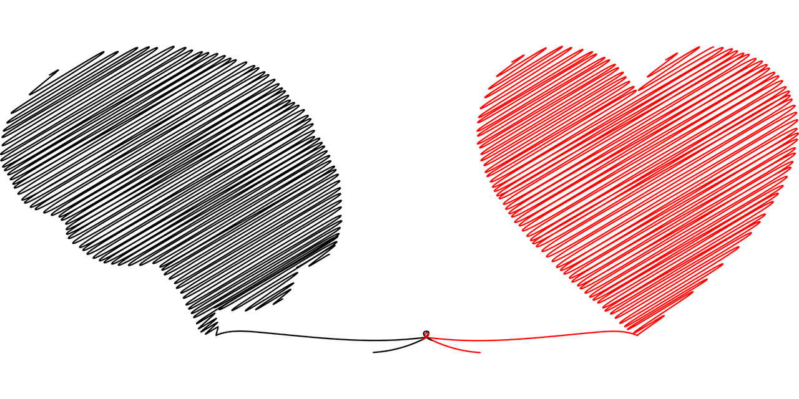

Progressive Muscle Relaxation Script

Sit back or lie down in a comfortable position. Shut your eyes if you’re comfortable doing so. Begin by taking a deep breath and noticing the feeling of air filling your lungs. Hold your breath for a few seconds.

(brief pause)

Release the breath slowly and let the tension leave your body. Take in another deep breath and hold it.

(brief pause)

Again, slowly release the air. Even slower now, take another breath. Fill your lungs and hold the air.

(brief pause)

Slowly release the breath and imagine the feeling of tension leaving your body. Now, move your attention to your feet. Begin to tense your feet by curling your toes and the arch of your foot. Hold onto the tension and notice what it feels like.

(5 second pause)

Release the tension in your foot. Notice the new feeling of relaxation. Next, begin to focus on your lower leg. Tense the muscles in your calves. Hold them tightly and pay attention to the feeling of tension.

(5 second pause)

Release the tension from your lower legs. Again, notice the feeling of relaxation. Remember to continue taking deep breaths. Next, tense the muscles of your upper leg and pelvis. You can do this by tightly squeezing your thighs together. Make sure you feel tenseness without going to the point of strain. And release. Feel the tension leave your muscles. Begin to tense your stomach and chest. You can do this by sucking your stomach in. Squeeze harder and hold the tension. A little bit longer.

(5 second pause)

Release the tension. Allow your body to go limp. Let yourself notice the feeling of relaxation. Continue taking deep breaths. Breathe in slowly, noticing the air fill your lungs, and hold it.

(brief pause)

Release the air slowly. Feel it leaving your lungs. Next, tense the muscles in your back by bringing your shoulders together behind you. Hold them tightly. Tense them as hard as you can without straining and keep holding.

(5 second pause)

Release the tension from your back. Feel the tension slowly leaving your body, and the new feeling of relaxation. Notice how different your body feels when you allow it to relax. Tense your arms all the way from your hands to your shoulders. Make a fist and squeeze all the way up your arm. Hold it.

(5 second pause)

Release the tension from your arms and shoulders. Notice the feeling of relaxation in your fingers, hands, arms, and shoulders. Notice how your arms feel limp and at ease. Move up to your neck and your head. Tense your face and your neck by distorting the muscles around your eyes and mouth.

(5 second pause)

Release the tension. Again, notice the new feeling of relaxation. Finally, tense your entire body. Tense your feet, legs, stomach, chest, arms, head, and neck. Tense harder, without straining. Hold the tension.

(5 second pause)

Now release. Allow your whole body to go limp. Pay attention to the feeling of relaxation, and how different it is from the feeling of tension. Begin to wake your body up by slowly moving your muscles. Adjust your arms and legs. Stretch your muscles and open your eyes when you’re ready.

From: https://www.therapistaid.com/worksheets/progressive-muscle-relaxation-script.pdf

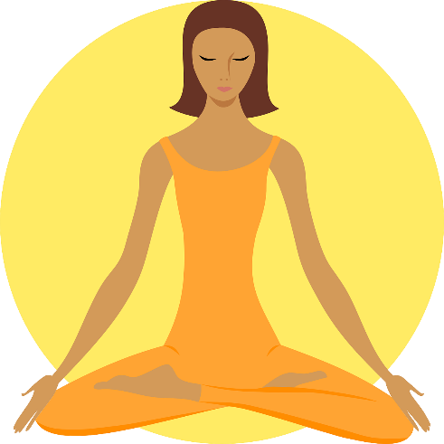

Links

Throughout this booklet, we have put lots of QR codes to access useful links and videos. If you don’t have a smart phone to scan these codes, we have put all of the links here for you instead.

Useful Links
ABUHB Paediatric Clinical Psychology Service | https://abuhb.nhs.wales/hospitals/a-z-of-services/paediatric-clinical-psychology-service/
Aneurin Bevan University Health Board Epilepsy Service | https://abuhb.nhs.wales/hospitals/a-z-of-services/epilepsy-service/
Young Minds | https://youngminds.org.uk/
Epilepsy Society | https://epilepsysociety.org.uk/
Epilepsy Society – Young people and epilepsy | https://epilepsysociety.org.uk/living-epilepsy/young-people-and-epilepsy
Young Epilepsy | https://www.youngepilepsy.org.uk/
Healthtalk.org – Epilepsy in Young People | https://healthtalk.org/epilepsy-in-young-people/overview
Epilepsy Action | https://www.epilepsy.org.uk/
Epilepsy Action – For girls | https://www.epilepsy.org.uk/info/children-young-adults/young-people/girls
Epilepsy Action – For Boys | https://www.epilepsy.org.uk/info/children-young-adults/young-people/boys
Epilepsy Action – The Epilepsy Space | https://epilepsyspace.org.uk/
Epilepsy Action – The Epilepsy Space – Managing your epilepsy | https://epilepsyspace.org.uk/medical-issues/managing-your-epilepsy/

Epilepsy Action – The Epilepsy Space – Rachel’s story | https://epilepsyspace.org.uk/stories/my-epilepsy-and-work/
Epilepsy Action – The Epilepsy Space – I am Still Me | https://epilepsyspace.org.uk/stories/i-am-still-me/
Famous people with epilepsy | https://epilepsycentre.org.au/famous-people-epilepsy/
Stories from young people with epilepsy | www.youngepilepsy.org.uk/for-young-people/share-your-story/your-stories/
Video links
What is epilepsy? | https://youtu.be/tA-Bikjbka4
Epilepsy and the art of being positive | https://youtu.be/EIvACF-LXos
The everyday impact of epilepsy | https://youtu.be/uLguzVhITv8
My Epilepsy Story – Sarah May | https://youtu.be/HXKxncKDtLA
Why I speak up about living with epilepsy – Sitawa Wafula | https://youtu.be/_B1JmOerYmY
Growing up and gaining independence with epilepsy | https://youtu.be/zUw9aPhLTgA
Living with epilepsy by Young Epilepsy | https://youtu.be/4nlAVhDbo_g

