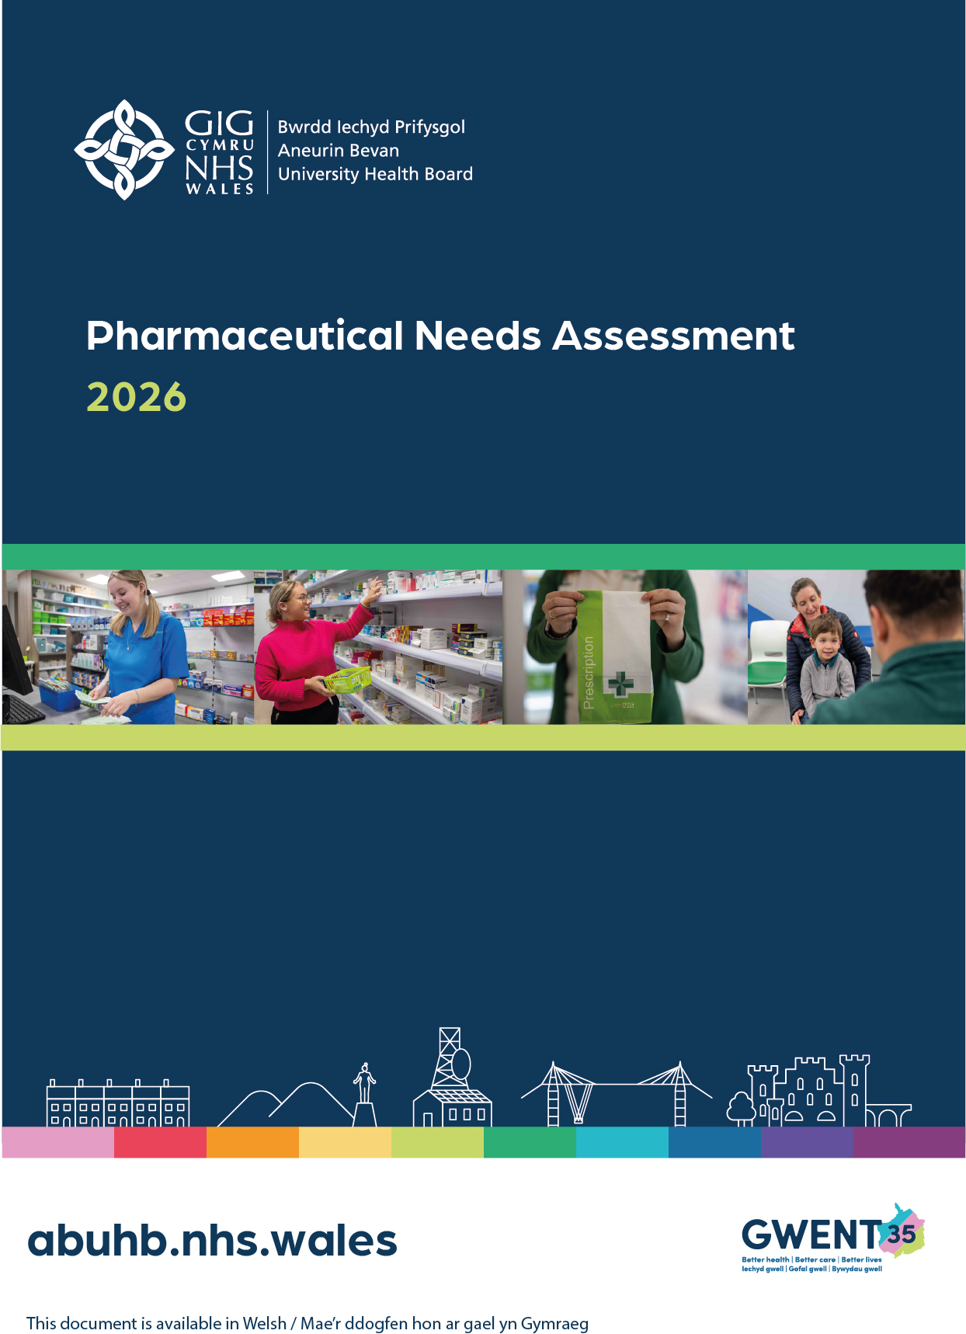
Table of Contents
Executive Summary 1
Chapter One – Introduction 6
Chapter Two - Population Profile, Health Inequalities and Pharmaceutical Need 21
Chapter Three – Current Provision of Pharmaceutical Services 58
Chapter Four - Other NHS Services 81
Chapter Five - Health Needs That Can Be Met by Pharmaceutical Services 86
Chapter Six – Assessment of Pharmaceutical Service Adequacy 90
Chapter Seven - Conclusions for the Purpose of Schedule 1 of the NHS (Pharmaceutical Services) (Wales) Regulations 2020 149
Appendix A - Legislative Framework and Health Board Duties in Relation to the Pharmaceutical Needs Assessment 154
Appendix B – Essential Services 157
Appendix C – Additional Pharmaceutical Services (that must be offered to all pharmacies in ABUHB 158
Appendix D – Additional Pharmaceutical Services (that may be offered to all pharmacies in ABUHB) 160
Appendix E - Terms of Service for Dispensing Appliance Contractors 164
Appendix F – PNA Steering Group Membership 167
Appendix G- Patient and Public Engagement Questionnaire 168
Appendix H – Full Results - Patient and public engagement Questionnaire 178
Appendix I- Community Pharmacy Engagement Questionnaire 225
Appendix J – Dispensing Practice Questionnaire 230
Appendix K – Consultation Changes 233
Appendix L - Protected Characteristics and Vulnerable and inclusion groups Data 260
Appendix M - Dispensing Practice Opening Hours 262
Appendix N - Community Pharmacy Opening Hours 263
Appendix O – Maps for the purposes of Schedule 1 of the NHS Pharmaceutical Services Regulations 264

Executive Summary

Purpose of the Pharmaceutical Needs Assessment
This Pharmaceutical Needs Assessment (PNA) is a statutory document produced in accordance with the NHS (Pharmaceutical Services) (Wales) Regulations 2020. It sets out how pharmaceutical services meet the current and anticipated health needs of the population of Aneurin Bevan University Health Board.
The PNA informs strategic planning and commissioning of pharmaceutical services and underpins decisions on market entry, relocation and changes to core opening hours. It provides the evidence base against which the adequacy of pharmaceutical provision is assessed. It ensures that people across Gwent can access safe, timely and equitable pharmaceutical care now and in the future.
The PNA is both a strategic assessment of pharmaceutical need and an important source of evidence for decisions taken under the pharmaceutical market-entry framework. It does not itself approve a new pharmacy or determine an application. Its findings must therefore be read together with the applicable regulatory criteria and the circumstances prevailing when any application is determined.

Strategic and Public Health Context
Pharmaceutical services operate within a national and local policy framework that prioritises prevention, early intervention, reducing health inequalities and delivering care closer to home, consistent with Marmot principles and the Well-Being of Future Generations (Wales) Act. The Health Board’s strategic direction, including Gwent 2035 and the Integrated Medium-Term Plan, emphasises place-based care, strengthening community services and improving equitable access to health support.
Community pharmacies, dispensing appliance contractors and dispensing doctors play a key role in supporting these ambitions through accessible medicines supply, clinical services, vaccination delivery and preventative interventions. The PNA ensures that pharmaceutical service provision aligns with wider public health priorities and supports the Health Board’s ambition to improve population health and reduce inequality across Gwent.
Public and stakeholder engagement has informed this assessment, with findings indicating high levels of accessibility and satisfaction with existing provision.

Population and Health Needs
Pharmaceutical demand across the Health Board area is shaped by demographic change, socioeconomic inequality, and geography.
The population of approximately 600,000 people is distributed across five local authorities, with significant variation in population density, deprivation and rurality.
The population is ageing, with increasing prevalence of long-term conditions, multimorbidity and polypharmacy, driving sustained demand for medicines supply and optimisation, accessible pharmaceutical care, and additional clinical services delivered within community pharmacy.
Marked health inequalities persist across the Health Board area, with variation in life expectancy and earlier onset of chronic disease in more deprived communities. Geographic factors, including rurality and transport access, also influence how services are accessed. In many areas, community pharmacy represents the most accessible point of contact with the healthcare system.
Together, these factors shape both the volume and complexity of demand for pharmaceutical services across the Health Board area.

Current Pharmaceutical Service Provision
Pharmaceutical services across the Health Board area are delivered through a network of community pharmacies, dispensing appliance contractors and dispensing doctors. Provision is distributed across urban centres, valley communities and rural areas, broadly reflecting population density and established patterns of demand.
The Health Board has identified a range of pharmaceutical services as necessary to meet population need. Contractors provide essential services alongside a range of nationally and locally commissioned clinical services including; the Clinical Community Pharmacy Service, Discharge Medicines Review and seasonal vaccination programmes. The availability of these services varies by service type and locality; while the Clinical Community Pharmacy Service is delivered by all contractors, other additional clinical services are provided by a majority of pharmacies rather than being universally available across all providers.
In addition, a number of additional clinical services, such as the palliative care service, urgent medicines supply and needle exchange are commissioned on a Health Board-wide or needs-led basis. These services are designed to meet population need across Gwent and are accessed across locality boundaries.
Provision of pharmaceutical services from contractors outside the Health Board area also contributes to meeting need, reflecting patient choice and patterns of service utilisation.
Taken together, this model provides a flexible and integrated network of pharmaceutical services delivered at both local and Health Board level.

Assessment of Adequacy
Provision has been assessed against the population characteristics and pharmaceutical-service relevant needs using a locality-based approach at both Local Authority and Neighbourhood Care Network level.
The assessment demonstrates that:
- Pharmaceutical services are well distributed and accessible, with the majority of the population living within reasonable travel times of a pharmacy.
- Contractor capacity is generally sufficient, with most providers able to accommodate increases in demand where required.
- Service provision aligns with identified population need across both essential and additional clinical services.
- Additional clinical services commissioned on a Health Board-wide or targeted basis are sufficient to meet need, even where they are not provided in every pharmacy.
- There is sufficient choice for people to access pharmaceutical services across the Health Board area.
Across all localities, there is no evidence of unmet need or requirement for additional pharmaceutical services at the present time. This supports the overall conclusion that current pharmaceutical service provision is appropriate, resilient and proportionate to need across the Health Board area.

Identified Gaps and Future Needs

Current Provision
For the purposes of Schedule 1 of the NHS (Pharmaceutical Services) (Wales) Regulations 2020, the Health Board concludes that no current systemic or geographical gaps exist in the provision of pharmaceutical services across the Health Board area. Residents have sufficient choice and access to services, and this position is consistent with the previous PNA.

Previously Identified Gaps
The previously identified gap in Level 3 smoking cessation services has been resolved through expanded provision and alternative delivery models.
The gap in influenza vaccination has been addressed within existing provision.

Overall Conclusion
The Health Board concludes that current pharmaceutical service provision is adequate and sufficient to meet identified population need, with no current systemic or geographical gaps identified across the Health Board area.
Changes in population, housing development, primary care configuration, service availability or provider capacity may affect pharmaceutical need during the lifetime of the PNA. These matters will be kept under review and, where the evidence identifies a significant change in pharmaceutical need or service availability, the Health Board will consider appropriate action under regulation 6 of the NHS (Pharmaceutical Services) (Wales) Regulations 2020.

How to read this Pharmaceutical Needs Assessment
This PNA is structured to provide a clear and transparent assessment of pharmaceutical needs across the Health Board area.

Chapter 1
Purpose, statutory basis and strategic context.

Chapter 2
Population, health needs and inequalities.

Chapter 3
Current pharmaceutical service provision and stakeholder feedback.

Chapter 4
Other NHS services influencing pharmaceutical need.

Chapter 5
How population need can be met through pharmaceutical services.

Chapter 6
Locality-based assessment of adequacy.

Chapter 7
Formal conclusions on adequacy, gaps and future need.

Chapter One – Introduction

Purpose of a Pharmaceutical Needs Assessment
Pharmaceutical Needs Assessments (PNAs) are a statutory requirement in Wales and provide the framework for assessing how pharmaceutical services meet the current and future health needs of the local population. In doing so, PNAs draw on wider population health intelligence, including the Gwent Joint Strategic Assessment (JSA) 2024/25 Edition, the Gwent Wellbeing Assessment and the Gwent Wellbeing Plan.
PNAs support Health Boards in planning, commissioning, and reviewing pharmaceutical services. They provide the evidence base for decisions on applications to open new pharmacies or appliance contractor premises, relocating existing premises, or amending core opening hours. PNAs also inform decisions on where dispensing doctors may provide services, ensuring provision aligns with identified local population needs.
One of the goals of the PNA is to ensure pharmaceutical services are responsive to the local population. Public feedback helps identify gaps in service, such as accessibility issues, opening hours, or desired services and can support to testing assumptions about local health needs.
A robust PNA will ensure those who commission services from pharmacies and dispensing appliance contractors (DACs) are able to ensure services are targeted to areas of greatest health need and can reduce the risk of overprovision in areas where there is less need.

Strategic and Public Health Context

National Policy Direction
The publication of “A Healthier Wales” in 2018 saw the beginning of a new phase of planning for future health and social care service provision focussed on the health and wellbeing of citizens and on preventing illness. The ambition to create a seamless, integrated system of care designed around communities where people who live in these places are involved in developing long term solutions that help citizens prevent avoidable illness and provide sustainable services for future generations.
Delivering a Healthier Wales was released in April 2019 and sets out long term goals for service transformation to enable the citizens of Wales to get the most health gain from their medicines. This was received by the Minister for Health and Social services and is being progressed via the establishment of a delivery board. This vision is aligned to 14 principles to transform pharmacy in Wales by 2030 with a focus on the following four themes:
- Enhancing patient experience,
- Developing the workforce,
- Seamless pharmaceutical care, and
- Harnessing innovation and technology.

Health Board Priorities
‘Gwent 35’ has been designed to transform health and care by 2035, building upon the foundations of the previous Clinical Futures programme to ensure better health, care, and lives. It aligns with the clinical strategy by accelerating the shift toward preventative, community-based care and enhancing local services, ensuring equitable health opportunities across Gwent.
As part of the Health Board Integrated Medium-Term Plan (IMTP) 2025-2028, some key aims are detailed below:
- Embed prevention and Population Health in all that we do;
- Progress place-based models of care and sustainability in primary and community services;
- Improve our urgent and emergency care system focusing on experience, access and discharge pathways.
For out-of-hospital services to be delivered most effectively, ABUHB is committed to implementing a model of ‘place-based care’. The overarching strategic aim of Place Based Care is to make Gwent a region of connected, resilient communities where people are supported to live healthy, independent, and fulfilled lives as close to home as possible. This approach prioritises prevention, early intervention, and coordinated support within neighbourhoods, integrating services around what matters most to people in their everyday lives. Central to this model are accessible community assets, such as community pharmacy and dispensing doctors working alongside wider primary care services, local authorities, and the voluntary sector to provide timely, preventative, and personalised support. This ambition aligns with the ABUHB 10-year strategy Gwent 2035, by improving population health and equity, strengthening integrated local care, and addressing wider determinants of health in partnership with communities.
Pharmacy services across primary and secondary care play a key role in optimising the safe and effective use of medicines. Community pharmacists and their teams are increasingly expected to work at the top of their professional competence, supporting access to the right care in the right setting and contributing to prevention and early intervention.
National and local policy direction supports the continued development of clinical and preventative services delivered through pharmaceutical services. Over the lifetime of this PNA, pharmacy is expected to play an increasing role in supporting, vaccination, and wider public health priorities, subject to commissioning decisions and available resources.
Pharmacies will also underpin the provision of services provided at other levels, for example the dispensing of prescriptions issued by the urgent primary care out of hours service (Health Board level) and maintaining a stock of palliative care drugs to support end of life care at home.

Public Health and Prevention Agenda
Pharmaceutical services are a key enabler of ABUHB ambitions to improve population health, reduce inequalities, and strengthen prevention across Gwent. From a public health perspective, the PNA provides a critical mechanism for aligning pharmaceutical provision with ABUHB’s strategic priorities and the health needs identified through the Gwent Joint Strategic Assessment and local wellbeing assessments.
ABUHB’s public health priorities include a stronger focus on prevention and early intervention across the life course, reducing health inequalities through proportionate universalism, addressing the wider social determinants of health, and delivering services through place-based approaches such as Integrated Wellbeing Networks and community hubs. Embedding Making Every Contact Count (MECC) which is an approach to behaviour change that utilises the millions of day-to-day interactions that organisations and individuals have with other people to support them in making positive changes to their physical and mental health and wellbeing. Consistent public health messaging across all points of care is also a core ambition.
Community pharmacies play a unique and accessible role in supporting these priorities. As trusted healthcare settings embedded within local communities, they are well placed to deliver preventative interventions, improve access to care closer to home, and support targeted action in areas of higher need.
The PNA therefore acts as a strategic tool, ensuring that pharmaceutical services are aligned with ABUHB’s wider public health ambitions, including strengthening community-based care, expanding preventative services, improving early years outcomes, and ensuring resources are distributed in an equitable and needs-based way.
Gwent is a Marmot Region which means there is a network of local stakeholders committed to tackling inequity through action on the social determinants of health, the social and economic conditions which shape our health. Becoming a Marmot Region signifies a collective intent to work together to improve equity across Gwent and improve the lives of all our communities as a result, in line with Marmot principles.
By identifying current provision, access, capacity, and future requirements, the PNA helps ensure the pharmaceutical system is responsive, sustainable, and adaptable to the evolving needs of the population.

Health Board Duties in Respect of the Pharmaceutical Needs Assessment
Following the publication of the Health Board’s original PNA in 2021 this revised assessment has been produced in accordance with the National Health Service (Pharmaceutical Services) (Wales) Regulations 2020.
The Health Board will keep changes in the availability of pharmaceutical services under review throughout the lifetime of this PNA. Where a change is of a significant extent and is relevant to the granting of applications under section 83 of the National Health Service (Wales) Act 2006, the Health Board will consider whether a revised assessment is required under regulation 6(2).
Pending publication of a revised assessment, the Health Board may publish a supplementary statement explaining relevant changes to the availability of pharmaceutical services where the conditions in regulation 6(3) are met. Any supplementary statement will become part of the PNA, and the bodies listed in regulation 7(1) will be notified of its publication as soon as reasonably practicable.
Further information on the Health Board’s specific duties in relation to PNA and the policy and regulatory framework to the PNA can be found in appendix A.

Scope of the Pharmaceutical Needs Assessment
The services that are to be included in a PNA are defined in section 81 and 82 of the National Health Service (Wales) Act 2006. Pharmaceutical services may be provided by:
- A pharmacy contractor who is included in the pharmaceutical list for the area of the Health Board;
- A dispensing appliance contractor who is included in the pharmaceutical list held for the area of the Health Board; and
- A doctor or GP practice that is included in a dispensing doctor list held for the area of the Health Board.
Each Health Board is responsible for preparing, maintaining and publishing its lists. In ABUHB there are 125 community pharmacies, 13 GP practice dispensaries and no dispensing appliance contractors.
Contractors may operate as a sole trader, partnership, or body corporate. The Medicines Act 1968 governs who may act as a pharmacy contractor, whereas there are no equivalent restrictions on who may operate as a dispensing appliance contractor, which is a provider authorised to supply and support patients with prescribed medical appliances such as stoma products, catheters, and incontinence appliances.
Only GPs may provide dispensing doctor services. Dispensing doctors are GP practices permitted to dispense medicines directly to patients in designated rural areas where access to a community pharmacy is limited. These services are governed primarily by the National Health Service (Wales) Act 2006, supported by secondary legislation, including the National Health Service (General Medical Services Contracts) (Wales) Regulations 2023.
While the PNA considers whether pharmaceutical services are adequate to meet population need, there are certain factors that are outside the scope of the PNA or beyond the direct control of the Health Board. Minimum core opening hours for pharmacies are agreed nationally through regulation, and operational matters such as staffing arrangements and breaks (including the presence of a responsible pharmacist) are the responsibility of individual contractors. In addition, medicines supply and stock availability are influenced by UK-wide supply chains and regulatory arrangements, which are not devolved and cannot be addressed through a local PNA. Some services frequently requested by the public, such as the provision of compliance aids and home delivery, are not NHS pharmaceutical services unless specifically commissioned, and their availability therefore falls outside the statutory scope of this assessment.

Pharmaceutical Services
This section explains the services that different pharmaceutical providers are required to offer. It also outlines any additional services the Health Board may choose to commission for them to deliver to meet the health needs of the local population.

Pharmaceutical Services Provided by Community Pharmacy Contractors
Unlike GPs and dentists, but similar to optometrists, ABUHB does not hold contracts with the pharmacy contractors in its area. Instead, they provide services under a contractual framework.
- The National Health Service (Pharmaceutical Services) (Wales) Regulations 2020;
- The Pharmaceutical Services (Clinical Services) (Wales) Directions 2022;
- The Pharmaceutical Services (Advanced Services) (Appliances) (Wales) Directions 2010; and
- The Primary Care (Contracted Services: Immunisations) (Influenza) Directions 2025.
Pharmacy contractors provide two types of service that fall within the definition of pharmaceutical services and the community pharmacy contractual framework. They are:
Essential Services
These are part of the terms of service set out in schedule 5 of The NHS (Pharmaceutical Services) (Wales) Regulations 2020 and must be provided by all pharmacies. They include:
- Dispensing services
- Disposal of unwanted drugs
- Promotion of healthy lifestyles
- Signposting
- Support for self-care
Additional Pharmaceutical Services
These services are defined by Directions issued to Health Boards by the Welsh Ministers. Under these Directions, Health Boards are required to commission certain specified additional services and may, at their discretion, commission others. Pharmacy Contractors may choose whether to provide any of these services. However, if they opt to provide one or more of them, services they must comply with the requirements set out in the relevant Directions and associated regulations listed below:
- The Pharmaceutical Services (Clinical Services) (Wales) Direction 2022;
- The Pharmaceutical Services (Advanced Services) (Appliances) (Wales) Directions 2010; and
- The Primary Care (Contracted Services: Immunisations) (Influenza) Directions 2025.
Additional Pharmaceutical Services that must be offered by Health Boards:
- The Discharge Medicines Review Service
- The Clinical Community Pharmacy Service
- The Pharmacy Independent Prescribing Service
- The Primary Care Contracted Services: Immunisation Scheme for Influenza
- The Stoma Appliance Customisation Service
- The Appliance Use Review Service
Additional Pharmaceutical Services that may be offered by Health Boards:
- Anticoagulation monitoring*
- Care home service
- Disease specific medicines management service
- Emergency pandemic treatment and prophylaxis supply service*
- Emergency pandemic vaccination service*
- Gluten free food supply service*
- Home delivery service*
- Language access service*
- Medicines assessment and compliance support service
- Medication review service*
- Needle and syringe exchange service
- On demand availability of specialist drugs service
- Out of hours service
- Patient group direction service*
- Prescriber support service*
- Schools service*
- Screening service
- Stop smoking service
- Supervised administration service
- Prescribing service*
- An anti-viral collection service*
- Waste minimisation service
Services marked with an asterisk are not currently commissioned from pharmacies within the Health Board area.
Further information on the essential and additional pharmaceutical services requirements can be found in appendices B, C and D respectively.
Underpinning the provision of all of these services is the requirement on each pharmacy contractor to participate in a system of clinical governance. This system is set out within the NHS (Pharmaceutical Services) (Wales) Regulations 2020 and includes:
- A patient and public involvement programme
- Collaboration in clusters with other Health Care Professionals
- A risk management programme
- A clinical effectiveness programme
- A staffing and staff management programme
- An information governance programme
- A premises standards programme
Pharmacies are required to open for not less than 40 hours per week, and these are referred to as core opening hours, but many choose to open for longer and these additional hours are referred to as supplementary opening hours. Under the NHS (Pharmaceutical Services) (Wales) Regulations 2020 it is possible for pharmacy contractors to successfully apply to open a pharmacy with a greater number of core opening hours in order to meet a need identified in a PNA.
The proposed opening hours for each pharmacy are set out in the initial application, and if the application is granted and the pharmacy subsequently opens, these form the pharmacy’s contracted opening hours. The contractor can subsequently apply to change their core opening hours and the Health Board will assess the application against the needs of the population of its area as set out in the PNA, to determine whether to agree to the change in core opening hours or not. If a pharmacy contractor wishes to change their supplementary opening hours, they simply notify the Health Board of the change providing at least three months’ notice of any reduction in supplementary hours.

Pharmaceutical Services Provided by Dispensing Appliance Contractors
Whilst the Health Board does not currently have any dispensing appliance contractors, the following section sets out their role and the functions they would ordinarily be expected to provide within pharmaceutical services.
As with pharmacy contractors, Health Boards do not hold contracts with dispensing appliance contractors. Their terms of service are set out in schedule 6 of the NHS (Pharmaceutical Services) (Wales) Regulations 2020.
Dispensing appliance contractors provide the following services for appliances (not drugs), for example catheters and colostomy bags, which fall within the definition of pharmaceutical services:
- Dispensing of prescriptions
- Home delivery service for certain specified items
- Supply of appropriate supplementary items (e.g., disposable wipes and disposal bags)
- Provision of expert clinical advice regarding the appliances, and
- Signposting
They may also choose to provide additional pharmaceutical services. If they do choose to provide them then they must meet certain requirements and must also be fully compliant with their terms of service and the clinical governance requirements. Under The Pharmaceutical Services (Advanced Services) (Appliances) (Wales) Directions 2010, appliance contractors may also provide:
- The Stoma Appliance Customisation Service
- The Appliance Use Review Service
As with pharmacies, dispensing appliance contractors are required to participate in a system of clinical governance. This system is set out within the NHS (Pharmaceutical Services) (Wales) Regulations 2020 and includes:
- A patient and public involvement programme
- A clinical audit programme
- A risk management programme
- A clinical effectiveness programme
- A staffing and staff programme,
- An information governance programme, and
- A premises standards programme.
Further information on the requirements for these services can be found in appendix E.
Dispensing appliance contractors are required to open not less than 30 hours per week, and these are referred to as core opening hours. They may choose to open for longer and these additional hours are referred to as supplementary opening hours. Under the NHS (Pharmaceutical Services) (Wales) Regulations 2020 it is possible for dispensing appliance contractors to successfully apply to open premises with a greater number of core opening hours to meet a need identified in a PNA.
The proposed opening hours for each dispensing appliance contractor are set out in the initial application, and if the application is granted and the dispensing appliance contractor subsequently opens then these form the dispensing appliance contractor’s contracted opening hours. The contractor can subsequently apply to change their core opening hours. The Health Board will assess the application against the needs of the population of its area as set out in the pharmaceutical needs assessment, to determine whether to agree to the change in core opening hours or not.

Pharmaceutical Services Provided by Doctors
Regulation 26 of The NHS (Pharmaceutical Services) (Wales) Regulations 2020 allows Health Boards to make arrangements with doctors to dispense to eligible patients in certain circumstances. The applicable terms of service are set out in Schedule 7. The regulations are complex, but in summary:
- Patients must live in a ‘controlled locality’ (an area which has been determined by the Health Board or a preceding organisation as rural in character, or on appeal by the Welsh Ministers), more than 1.6km (measured in a straight line) from a pharmacy; and
- Their practice must have, historic rights or premises approval and outline consent to dispense to that area.
There are some exceptions to this, for example patients who have satisfied the Health Board that they would have serious difficulty in accessing a pharmacy by reason of distance or inadequacy of means of communication. Additionally, only the provision of the services set out in Schedule 7 of the 2020 Regulations fall within the legal definition of pharmaceutical services.
Publication of this PNA does not itself determine, amend or resolve controlled-locality boundaries, outline-consent areas or individual eligibility for doctor dispensing. Before determining any application to which the controlled-locality provisions may be relevant, the Health Board will establish and consider the applicable controlled-locality determination, distance, outline-consent, premises-approval and other regulatory evidence prevailing at that time. Any separate review of controlled-locality information will be undertaken through the appropriate statutory and Health Board governance process.
Eligibility for doctor-dispensing services is determined under the statutory controlled-locality framework and cannot be extended through the PNA. Current controlled-locality determinations and maps are maintained separately by the Health Board and should be consulted when considering doctor dispensing, reserved locations or proposals close to a controlled-locality boundary. The Schedule 1 PNA map identifies pharmaceutical and dispensing premises; it does not determine or reproduce controlled-locality boundaries.
The opening of a new pharmacy may affect eligibility for doctor dispensing where a patient living in a controlled locality is within 1.6 kilometres, measured in a straight line, of that pharmacy. This can apply even where the pharmacy premises are outside the controlled locality. Any effect on existing dispensing arrangements will be determined in accordance with relevant regulations and the applicable transitional, postponement and appeal provisions.

Other NHS Services
Other services which are commissioned or provided by ABUHB which affect the need for pharmaceutical services are also included within the PNA.

Pharmaceutical Needs Assessment methodology

Pharmaceutical Needs Assessment Steering Group
ABUHB is responsible for publishing the PNA, with the Executive Director of Public Health and Strategic Partnerships overseeing its development. To support this, the Health Board re-established a PNA steering group to ensure the new assessment complies with the NHS (Pharmaceutical Services) (Wales) Regulations 2020 and reflects the needs of the local population. The group includes representatives from all key stakeholders, with full membership listed in Appendix F.

Pharmaceutical Needs Assessment Localities
Gwent has 125 community pharmacies operated by 55 pharmacy contractors, alongside 13 dispensing doctor dispensaries, forming the core network of pharmaceutical service provision across the Health Board area. The region comprises five Local Authorities and is organised into eleven Neighbourhood Care Networks (NCNs).
NCNs bring together partners from public health, local government, housing, and the third sector to plan services around clearly defined local populations. Because NCN boundaries provide an accurate reflection of community health needs, they are used as the basis for the PNA localities and as a key reference point throughout the assessment.
Table one presents the number of pharmacies and dispensing doctors within each Local Authority and NCN area. For the purposes of this PNA, the local areas correspond directly to the NCN boundaries.
Table 1: Community Pharmacies and Dispensing Doctors by Local Authority and Neighbourhood Care Network.
Local Authority | Number of pharmaceutical service providers in Local Authority | Neighbourhood Care Networks | Number of providers in Neighbourhood Care Networks
Blaenau Gwent | 16 Pharmacies | Blaenau Gwent East | 7 Pharmacies
Blaenau Gwent | 16 Pharmacies | Blaenau Gwent West | 9 Pharmacies
Caerphilly | 41 Pharmacies | Caerphilly East | 13 Pharmacies
Caerphilly | 41 Pharmacies | Caerphilly North | 14 Pharmacies
Caerphilly | 41 Pharmacies | Caerphilly South | 14 Pharmacies
Monmouthshire | 18 Pharmacies  12 Dispensing Doctors | Monmouthshire North | 11 pharmacies  7 Dispensing Doctors
Monmouthshire | 18 Pharmacies  12 Dispensing Doctors | Monmouthshire South | 7 pharmacies  5 Dispensing Doctors
Newport | 30 Pharmacies | Newport East | 13 pharmacies
Newport | 30 Pharmacies | Newport West | 17 pharmacies
Torfaen | 20 Pharmacies  1 Dispensing Doctor | Torfaen North | 10 pharmacies  1 dispensing Doctor
Torfaen | 20 Pharmacies  1 Dispensing Doctor | Torfaen South | 10 Pharmacies

Other Sources of Information
The interactive Gwent Joint Strategic Assessment 2024/25 Edition collates indicators together to provide an overview of the health and well-being of the people of Gwent. This provided background information on the health needs of the population and can be found on the Health Board website.
The following documents and websites were used as sources of information on the health needs of the population:
- Gwent Wellbeing Assessment May 2022
- Gwent Wellbeing Plan May 2023
- Nomis website
- StatsWales website
- Public Health Wales Observatory website
- Welsh Index of Multiple Deprivation (WIMD) 2025 results report
- Maps Wales website
- The local authorities’ Local Development Plans and Annual Monitoring Reports

Patient and Public Engagement
The PNA aims to ensure pharmaceutical services meet local needs, and public feedback is essential for identifying gaps such as access, opening hours and service availability. To gather views from patients and the public, an online questionnaire (available in Welsh and English from 10 November to 22 December 2025) asked how people currently use community pharmacies and dispensing doctors, how they would like to use them in future, and what works well or could be improved.
The results of the questionnaire are reflected later in this document setting out current pharmaceutical provision. In addition, appendix G contains the questionnaire and appendix H contains the full results.

Contractor Engagement
A Community Pharmacy questionnaire was made available online from 10 November to 22 December 2025. Sixty six of the 125 pharmacies in the Health Board area responded, giving a response rate of 53%. The questionnaire gathered information on available facilities, current demand and capacity, and the range of services provided. A copy of the Community Pharmacy questionnaire is included in appendix I, and further detail is provided in the section on current pharmaceutical provision.
During the same period, an online questionnaire was issued to all 12 dispensing practices. Three practices responded, representing a 25% response rate. Contractors were asked about their services, capacity, and opening hours. The questionnaire is included in appendix J, with further explanation provided in Chapter Five.

Consultation
The draft PNA was published on the Health Board's website for statutory consultation from 2 July to 31 August 2026, a period of not less than 60 days. In accordance with regulation 7 of the National Health Service (Pharmaceutical Services) (Wales) Regulations 2020, the Health Board notified and consulted the prescribed organisations and persons.
The consultation sought views on the accuracy of the assessment, current provision, identified gaps, future pharmaceutical needs and the conclusions of the draft PNA. The Health Board considered all responses received before finalising the assessment. A report of the principal issues raised, the Health Board's response and amendments made is provided in Appendix K.

Structure of the Pharmaceutical Needs Assessment
This PNA is structured to provide a clear and transparent assessment of pharmaceutical need and service provision. It first describes the population, health needs and groups with particular pharmaceutical needs, before setting out current pharmaceutical provision and the wider NHS services that influence demand. It then assesses whether existing provision is adequate to meet identified need at locality level and concludes by identifying any gaps and future pharmaceutical needs to inform planning and decision-making.

Chapter Two - Population Profile, Health Inequalities and Pharmaceutical Need
This chapter describes the population profile, health needs and wider determinants that influence demand for pharmaceutical services across the Health Board area, including groups who may experience particular barriers to access. It provides the contextual evidence base against which current provision and, in later chapters, the adequacy of that provision is assessed.

Local Authorities Overview
The footprint of ABUHB is coterminous with Greater ‘Gwent’, a term used to reflect the five local authority areas. The map below illustrates the five local authority areas.
Map 1 Gwent local authorities
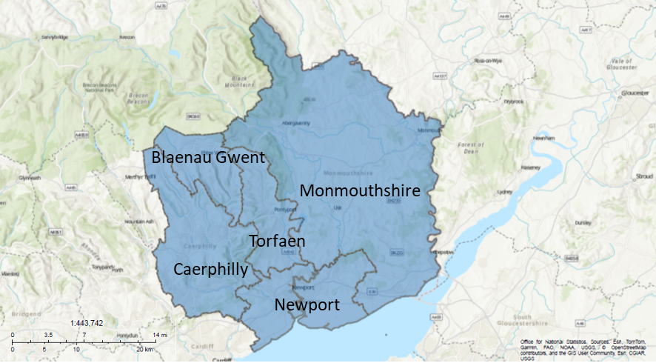
Gwent covers an area of 1,533 square kilometres (km²), which is 7.2% of Wales (21,225 km²) and has a population of 601,686, which equates to 18.8% of the whole of the Welsh population (3,186,581).
The ABUHB area is varied with both urban centres and rural countryside, along with the most easterly of the South Wales valleys. The map below shows the rural urban classification for the Lower Super Output Areas (LSOAs) in the Health Board and shows the general split of rurality in the East against the urban areas in the West.

Map 2 – Rural Urban Classification (2011) Aneurin Bevan University Health Board
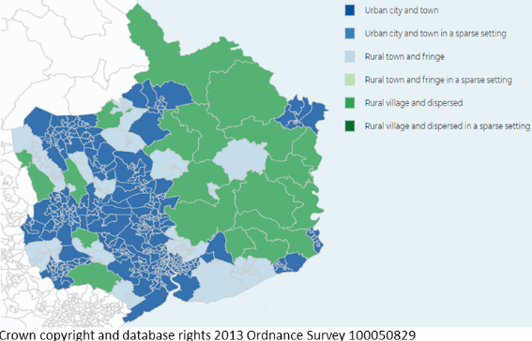

Blaenau Gwent County Borough
Blaenau Gwent is geographically the smallest borough in Wales with an area of approximately 109 km² and a population of 67,873. Blaenau Gwent is defined physically by high hillsides dividing the three main valleys.
Blaenau Gwent comprises a number of urban centres within a largely rural geography. Socio-economic indicators show higher levels of unemployment and income deprivation relative to national averages.
Map 3 – Blaenau Gwent County Borough
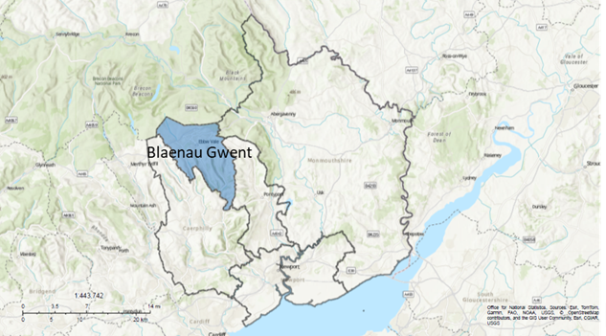

Caerphilly County Borough
Caerphilly County Borough covers some 280 km² of the Valleys area of South-East Wales and has a population of 176,865. The county borough is a mixture of urban and rural communities. Three quarters of the county borough is used for agriculture and forestry.
Caerphilly town has an expanding economy and benefits through good transport links to Cardiff but there are significant levels of unemployment and poor health.
Map 4 – Caerphilly County Borough
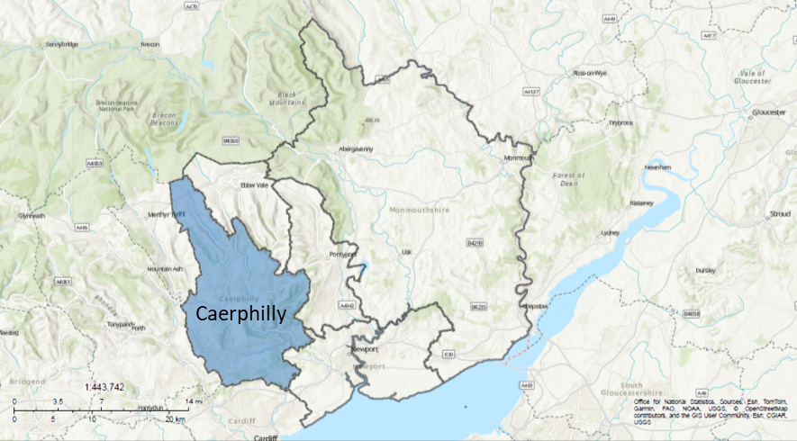

Monmouthshire County
Located in South-East Wales, Monmouthshire County has a strategic position between the major centres in South Wales, the South-West of England and the Midlands. The county covers an area of approximately 880 km² with an estimated population of 94,930.
Monmouthshire is generally a prosperous area offering a high quality of life for its residents, but this does mask some areas of deprivation.

Map 5 – Monmouthshire County
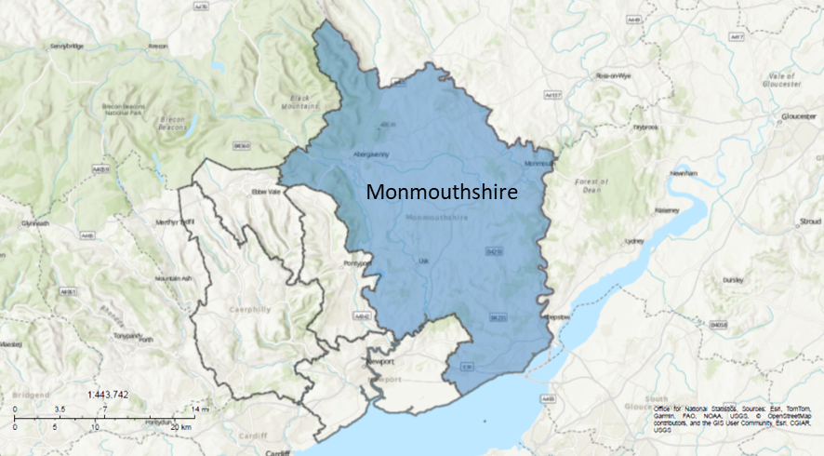

Newport City County Borough
Newport City is a multicultural city and the third-largest urban centre in Wales, with a population of 167,899 and an area of 217.7 km².
Newport City County Borough area, which encompasses both the city and surrounding communities within the borough, has experienced sustained demographic change, with the proportion of residents from minority ethnic communities increasing from 10.1% in 2011 to 14.4% in 2021.
Map 6 – Newport City County Borough
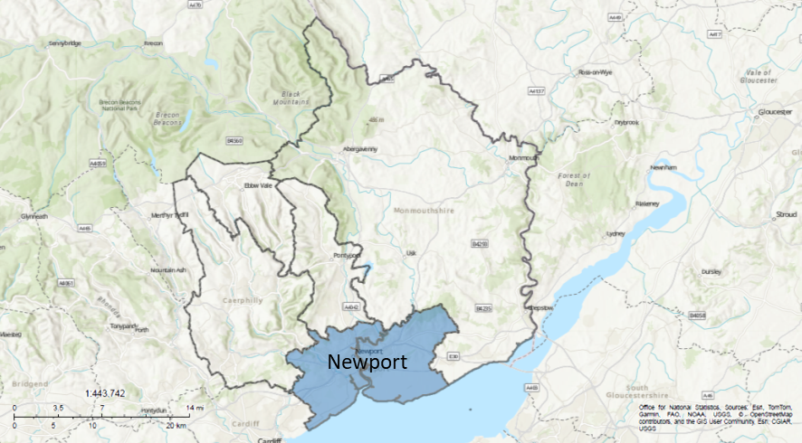

Torfaen County Borough
The county borough of Torfaen has an area of 126 km² and is the third-smallest borough in Wales, with a population of around 94,119.
Torfaen is the most easterly of the South Wales Valleys and comprises a mix of urban settlements and rural communities. Torfaen has a legacy of industrial development and experiences variation in socio-economic conditions across the borough, with some areas facing higher levels of deprivation alongside more affluent communities.
Map 7 – Torfaen County Borough
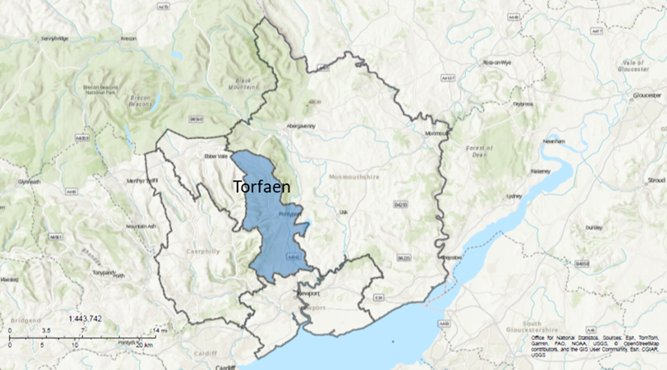

Population
This section describes the size, distribution and age profile of the population across the Health Board area, including trends in population growth and ageing. These factors influence overall demand for pharmaceutical services and the type of services required, particularly in relation to long-term conditions and medicines use.

Population Size
Based on StatsWales population estimates for mid-year 2024, the total population of the Health Board’s area was 601,686, of which 49.02% were male and 50.97% were female. Population size and distribution vary across the five local authority areas, with Caerphilly and Newport together accounting for over half of the total population (57.30%), while Blaenau Gwent, Monmouthshire and Torfaen each represent smaller but significant population bases. Table 2 shows the distribution of the Gwent population by local authority area, highlighting the percentage contribution each makes to the overall Health Board population.
Table 2: Population by Local Authority
 | Population | % of Gwent
Blaenau Gwent | 67,873 | 11.28
Caerphilly | 176,865 | 29.39
Monmouthshire | 94,930 | 15.78
Newport | 167,899 | 27.91
Torfaen | 94,119 | 15.64
Gwent | 601,686

Population Projection
Figure 1 shows projected overall growth across most local authorities between 2018 and 2043, with the largest absolute increase in Newport, reflecting its role as the main growth area. These patterns of growth and distribution provide important context for understanding current and future demand for pharmaceutical services, particularly in relation to service capacity and geographic access. The implications of this growth, including changes in age structure, are considered further in section 2.2.4.
Figure 1 – Projected Population by Local Authority 2022-2047
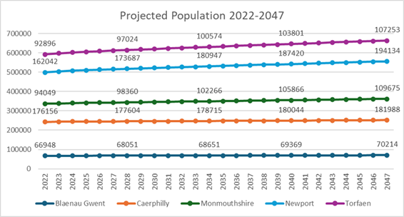

Life Expectancy and Healthy Life Expectancy
Significant inequalities in life expectancy and healthy life expectancy are evident across the Health Board area, and these differences underline the need for targeted pharmaceutical interventions that support prevention, self‑care, early diagnosis, medicines optimisation and long‑term condition management in the communities experiencing the poorest outcomes. The average life expectancy at birth for the Health Board is 77.6 years for males and 81.3 years for females, but there are clear differences in life expectancy between the Health Board local authority areas.
Monmouthshire has the highest life expectancy for both males, at 80.4 years, and females, at 83.9 years. In contrast, Blaenau Gwent records the lowest life expectancy, with males living on average 76.0 years and females 78.9 years. Caerphilly, Newport and Torfaen fall between these two ends of the spectrum, and across all areas females consistently live longer than males.
These patterns highlight persistent geographic inequalities in health outcomes across Gwent, which are relevant to understanding variation in long-term condition prevalence and demand for pharmaceutical services.

Figure 2 – Life Expectancy at Birth- Years of Life 2021-23
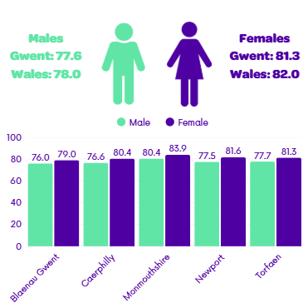
Healthy life expectancy is the number of years that people live in good health. The difference in healthy life expectancy between most and least deprived areas in ABUHB is 12.8 years for men and 20.5 years for women.
Monmouthshire has the highest healthy life expectancy for both males and females and Torfaen has the lowest.
Figure 3 - Healthy Life Expectancy at Birth -Healthy Years of Life, 2021-23
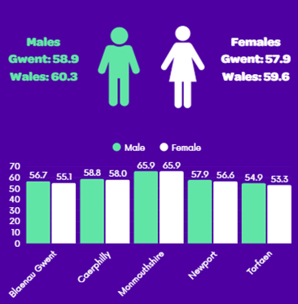

These differences in life expectancy and healthy life expectancy reinforce the importance of ensuring that pharmaceutical services are accessible, proportionate and responsive to meet the needs of the populations within the areas experiencing the greatest health inequalities across Gwent.

Age Structure and Population Ageing
The age profile (figure 4) shows a broad working-age population across the Health Board area, with the largest numbers in the 30–59 age group for both males and females. In 2023, approximately 61% of the population were of working age (16–64), 21% were aged 65 and over, and 18% were under 16.
Figure 4 - Gwent Population by Age (2023 midyear estimates)
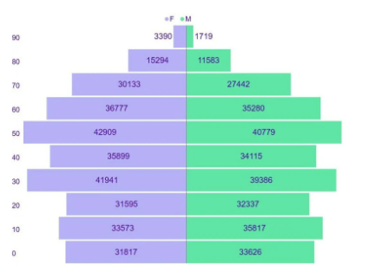
Figure 5 highlights variation in age structure across local authorities, with Monmouthshire having a relatively older population profile and Caerphilly and Newport larger working-age populations. Areas with higher proportions of older residents are likely to experience greater demand for pharmaceutical services, particularly in relation to long-term conditions, polypharmacy and medicines optimisation, while larger working-age populations influence demand for prevention and public health services.
Figure 5 – Population Structure by Age Band and Local Authority, 2023
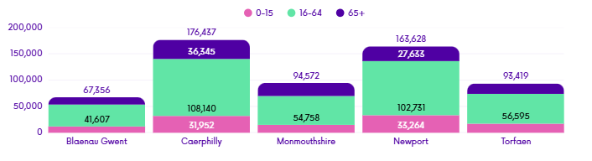
As outlined in figure 1 (section 2.2.2), overall population growth is projected across Gwent to 2047.
Alongside this growth, the age profile of the population is changing, with an increasing proportion of older residents in several local authority areas. Population ageing is projected to accelerate further, with around one in four residents in Gwent (23.5%) aged 65 or over by 2034, and the number of people aged 85 and over expected to increase by 44.6% from 2025 to 2034, exceeding national projections .
These trends indicate increasing demand for pharmaceutical services associated with long-term conditions and multimorbidity, alongside continued need for preventative and early-intervention support across the life course. They also highlight the importance of addressing polypharmacy, medicines adherence and the accessibility needs of an ageing population across Gwent.

Household Composition
Household composition provides additional context for understanding population needs across the Health Board area. Census 2021 data show that 30.6% of households were single-person households, almost half of which were occupied by people aged 66 and over. Single-family households accounted for 65% of households, with a small proportion classified as other household types. There is variation between local authorities, with Blaenau Gwent having the highest proportion of single-person households, while Monmouthshire has the highest proportion of single-person and single-family households occupied entirely by people aged 65 and over. These patterns provide contextual insight into living arrangements across the area and are relevant to understanding how pharmaceutical services may be accessed and used, particularly by older people living alone.

Mortality and Premature Death
Mortality patterns reflect the underlying burden of long-term conditions that drive ongoing prescribing and preventative pharmacy interventions.
Age-standardised mortality rates by local authority demonstrates decline since 2015 for Caerphilly (-7.8%), Monmouthshire (-8.4%), Newport (-8.6%) and Torfaen (-2.1%). However, in Blaenau Gwent the age-standardised mortality rate has increased from 1,214 per 100,000 of population in 2015 to 1,247.5 per 100,000 of population in 2024, an increase of 2.8%.
Premature mortality (defined as someone who died from any cause before their 75th birthday) from key non-communicable diseases shows substantial variation across local authorities and provides further evidence of health inequality. Blaenau Gwent has the highest rate of premature mortality within Gwent and is ranked second worst in Wales, while Monmouthshire has the lowest rate and is ranked best. Caerphilly, Newport and Torfaen fall between these extremes.
Table 3 details the number of premature deaths from key non communicable diseases, 2021-2023 by local authority. These rates are European age-standardised rates of premature deaths from key communicable diseases per 100,000 population.
Table 3 - Premature Deaths from Key Non Communicable Diseases, 2021-2023
Local Authority | Age Standardised Rates of Premature Deaths per 100,000 population | Rank
Blaenau Gwent | 385.0 | 2
Caerphilly | 357.4 | 3
Monmouthshire | 239.4 | 22
Newport | 338.2 | 6
Torfaen | 331.3 | 9

These patterns are consistent with the observed differences in healthy life expectancy, with areas experiencing higher premature mortality also tending to have fewer years lived in good health. Together, this evidence highlights the unequal burden of preventable ill health across Gwent and its implications for pharmaceutical service demand.

General Fertility Rate
Fertility rates provide an indication of future population growth and the potential demand for maternity, child health and family-related pharmaceutical services.
The Total Fertility Rate (TFR) in England and Wales is the average number of children a woman would be expected to have over her lifetime if current age-specific birth rates remained the same throughout her child-bearing years. The TFR has been in decline since 2010 and continues to fall despite a small increase in the number of births in 2024. In Wales, the number of live births decreased by 2.0% between 2023 and 2024, and recent estimates indicate that births have fallen below deaths, reflecting longer-term demographic change. There is variation across local authorities within the Health Board area. In 2024, Newport had the highest TFR in Wales at 1.64 and has recorded the highest rate since 2022. This means that, on average, each woman in Newport is having 1.64 children over their lifetime. Blaenau Gwent and Torfaen also had higher fertility rates than the Wales average, with TFRs of 1.50, meaning that, on average, each woman is having about one and a half children, while Caerphilly aligned with the national average at 1.35.
Overall, the general fertility rate and TFR are higher in three out of five local authorities in Gwent than the Wales average, indicating relatively greater demand for maternity, reproductive health, childhood medicines and vaccination-related pharmaceutical services in some areas.
Together, these population trends provide important context for understanding patterns of medicines use and demand for pharmaceutical services across Gwent.

Social Determinants of Health
This section outlines patterns of deprivation and wider social determinants of health, including income, employment and housing. Socio-economic inequalities are closely associated with poorer health outcomes and higher medicines use and are therefore an important consideration in assessing pharmaceutical need.

Welsh Index of Multiple Deprivation
The Welsh Index of Multiple Deprivation (WIMD) 2025 is the official measure of relative deprivation for small areas in Wales. It identifies areas with the highest concentrations of several different types of deprivation. Lower Layer Super Output Areas (LSOAs) are small, consistent geographic units used for census data and statistics in England and Wales, typically containing 1,000–3,000 residents or 400–1,200 households. The WIMD ranks LSOAs in Wales from 1 (most deprived) to 1,917 (least deprived).
There are eight domains which make up the index, each of which have different indicators within them. These are weighted and then combined to give the overall index of multiple deprivation. Figure 6 shows each domain and their weighting.
Figure 6 – Domains of the Welsh Index of Multiple Deprivation 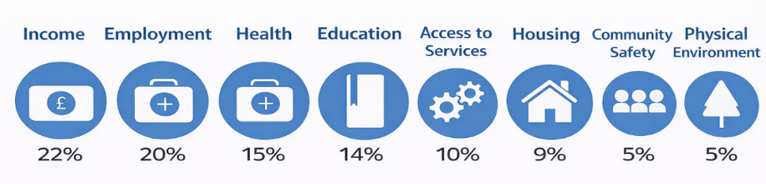
Being deprived does not just mean being in financial hardship, it can also mean having fewer resources and opportunities than we might expect in our society, for example in terms of health or education. The distribution of deprivation across Gwent is important when developing area-based policies, programmes and funding. WIMD can be used to inform these decisions and give a greater understanding of deprivation trends across Gwent including identifying the most deprived small areas. LSOA’s are used to break down large areas, like local authorities, into smaller, manageable chunks to compare data between different local neighbourhoods.
The map below shows each LSOA within the Health Board area and where it sits in the index. The local authority with the highest proportion of these small areas in the most deprived 10% in Wales is Blaenau Gwent (20% or 9 areas) followed by Newport (18% or 18 areas). Monmouthshire is the only local authority with no areas in the most deprived 10%.
Map 8 – Map of LSOAs Shaded by Deprivation Group, WIMD 2025
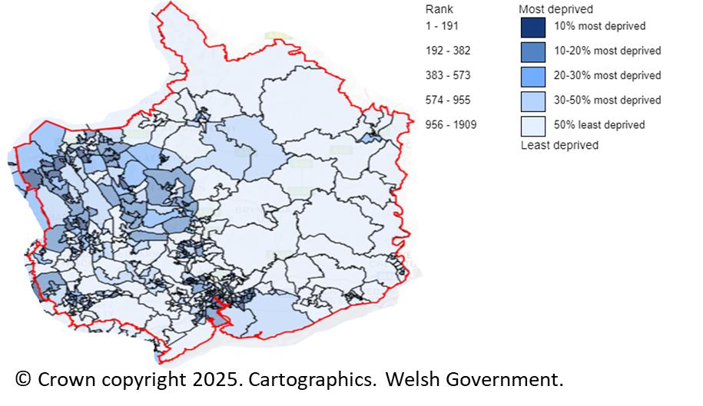
Table 4 shows the distribution of LSOA across national deprivation bands for each local authority within the Health Board area, based on the WIMD 2025 overall index. The variation between local authorities highlights differences in the concentration of deprivation within the area and provides contextual background for understanding how demand for pharmaceutical services may vary geographically.
Table 4 – most deprived lower super output areas by local authority (2025)
Local Authority | Total LSOAs | Most deprived 10% LSOAs in Wales (ranks 1 - 191) | Most deprived 20% LSOAs in Wales (ranks 1 - 382) | Most deprived 30% LSOAs in Wales (ranks 1 - 574) | Most deprived 50% LSOAs in Wales (ranks 1 - 958)
Blaenau Gwent | 46 | 9 | 17 | 27 | 35
Caerphilly | 110 | 12 | 28 | 41 | 65
Monmouthshire | 58 | 0 | 3 | 4 | 11
Newport | 100 | 18 | 32 | 41 | 51
Torfaen | 60 | 5 | 18 | 26 | 35
As set out in section 2.2.3, higher levels of deprivation are associated with poorer health outcomes and reduced life expectancy. Figure 7 illustrates the deprivation gap, in years, of healthy life expectancy across the Health Board area, showing variation between localities and a consistent gap between males and females. This relationship provides important context for understanding patterns of demand for pharmaceutical services, particularly in more deprived communities where reliance on accessible services such as community pharmacies is likely to be greater.
Figure 7 – Gwent Deprivation Gap, in Years, of Healthy Life Expectancy 2018-20
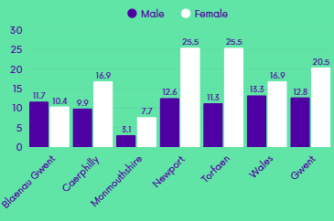
Healthy life expectancy data (2018–20) demonstrate a clear deprivation gap across Gwent. The 2025 WIMD confirms that patterns of deprivation remain embedded across parts of the Health Board area, providing continued context for these inequalities.

Economic Activity
Economic activity is a key component of deprivation within the WIMD and is closely linked to health outcomes and healthy life expectancy. Areas with lower levels of economic activity are more likely to experience higher deprivation, earlier onset of ill health and reduced healthy life years, as illustrated by the deprivation and life expectancy patterns described in section 2.2.
Figure 8 shows employment rates for males and females across the Health Board area in 2023/24. Areas with higher concentrations of deprivation, as shown in the WIMD 2025 distribution in table 4, tend to have lower overall employment rates. Across all areas, employment rates are consistently higher for males than females.

Figure 8 – Employment Rate (% 16–64 year olds)
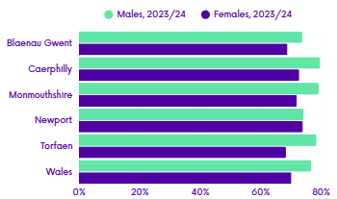
Deprivation and life expectancy patterns are relevant to pharmaceutical service provision, as populations in more deprived areas typically have higher prevalence of long-term conditions and greater reliance on accessible services such as community pharmacies for medicines supply, advice, preventative services and support with medicines adherence.

Geographic Distribution
Geographic variation influences how services are accessed and highlights the importance of locally appropriate provision. Differences in population density and rurality affect physical access to pharmaceutical services across the Health Board area. Rural areas may rely more heavily on dispensing practices, medicines delivery services and flexible access arrangements, while more densely populated urban areas may experience higher volumes of activity and associated capacity pressures.

Population Density
With the exception of Monmouthshire, population density across the Health Board area is higher than the Wales average. Newport is the most densely populated local authority, while Monmouthshire has a substantially lower population density, reflecting its more rural character. Table 5 shows population density by local authority.
Table 5 - Population Density (persons per square kilometre), 2023

Wales | 152.60
Blaenau Gwent | 619.49
Caerphilly | 636.07
Monmouthshire | 111.37
Newport | 859.25
Torfaen | 743.20

Transport
Transport availability is an important factor in how people access services, particularly in areas with lower population density. Census 2021 data show that 19.9% of the households in the Health Board’s area did not have a car or a van. Lower levels of car ownership in some areas may create barriers to accessing pharmaceutical services, increasing the importance of locally accessible pharmacies, delivery services and appropriate opening hours. Car ownership is higher in Monmouthshire, where a greater proportion of households have access to two or more vehicles, while Blaenau Gwent has a higher proportion of households with no access to a car or van or access to only one vehicle.
Figure 9 – car ownership at local authority level
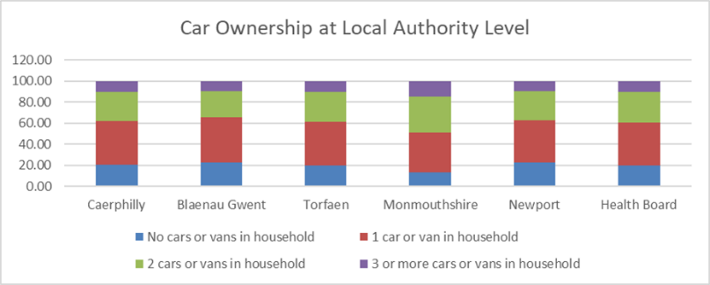

Protected Characteristics
Protected characteristics, as defined under the Equality Act 2010, include age, disability, gender reassignment, marriage and civil partnership, pregnancy and maternity, race, religion or belief, sex and sexual orientation. Consideration of these characteristics is important as they may influence access to and engagement with pharmaceutical services.
In this assessment, all protected characteristics have been considered. Where relevant and supported by available evidence, greater emphasis is placed on characteristics most closely linked to pharmaceutical service access and use, such as age, disability, ethnicity and sex. Other protected characteristics are acknowledged to demonstrate due regard and equality of access but are not discussed in detail where there is limited local evidence of consequence to pharmaceutical service provision.

Age
Age is a protected characteristic under the Equality Act 2010 and is a key factor influencing pharmaceutical service use. As set out in section 2.2.4, the Health Board area has an ageing population, with increasing numbers of older people and adults of advanced ages. This is relevant to pharmaceutical services due to the higher prevalence of long-term conditions, multimorbidity and polypharmacy in older age groups, alongside the need for accessible services, medicines adherence support and preventative interventions across the life course. Detailed population analysis by age is provided earlier in this chapter and is not repeated here.

Disability
Disability is a protected characteristic under the Equality Act 2010 and is closely linked to age, long-term conditions and patterns of pharmaceutical service use. This includes people with learning disabilities, who may experience additional barriers related to communication, medicines understanding and service navigation. These factors may affect access to services, reliance on medicines, and the need for additional support from pharmacy teams. As the population ages, the number of people living with a limiting long-term illness is expected to increase across all local authority areas within the Health Board.
Projections indicate that between 2013 and 2035, all local authorities in the Health Board area are expected to see an increase in the number of people aged 18 and over with a limiting long-term illness, with predicted increases ranging from 14.1% in Blaenau Gwent to 25.1% in Newport.
Figure 10 – Predicted Number of People aged 18+ with a Limiting Long-Term Illness
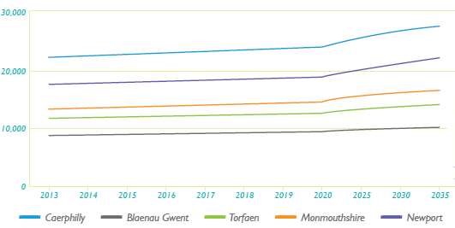
Figure 11 below shows the proportion of adults aged 16 and over whose day-to-day activities are limited by a longstanding illness across the Health Board area. The proportion varies between local authorities and is higher than the Wales average in Blaenau Gwent and Torfaen, while lower proportions are observed in Newport and Caerphilly. This variation provides contextual insight into differences in functional limitation across the population, which is relevant to understanding accessibility considerations for pharmaceutical services.
Figure 11 – Adults Aged 16+ whose Activities are Limited by Longstanding Illness 2022-23
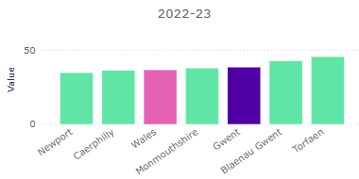
Together, these patterns provide contextual information on levels of functional limitation across the population and highlight considerations relevant to accessibility and service experience. Increasing numbers of people with disabilities and limiting long-term illness are likely to result in increased demand for accessible premises, home delivery, compliance aids, medicines reviews and ongoing medicines support.

Ethnicity and Language
Ethnicity is a protected characteristic under the Equality Act 2010 and is relevant to pharmaceutical service access, communication and engagement. Census 2021 data, show that the Health Board area has a predominantly White population, with smaller proportions of residents from Asian, Black, Mixed and other ethnic groups. Figure 12 demonstrates that Newport has a more ethnically diverse population than the other local authority areas, while the remaining authorities have a higher proportion of residents identifying as White compared to the Wales average. Appendix L provides a full breakdown of these data and also includes information relating to other protected characteristics, as well as vulnerable and inclusion groups.

Figure 12 Percentage Ethnicity of Gwent
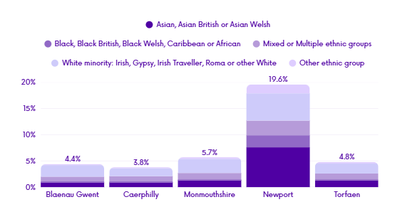
Areas with greater ethnic diversity, may require enhanced access to culturally appropriate services, language support and targeted public health interventions to ensure equitable access to pharmaceutical care.
While language is not a protected characteristic under the Equality Act 2010, household language is closely linked to race and ethnicity and is an important factor in ensuring equitable access to services.
The 2021 Census shows that most residents identify English or Welsh as their main language. However, a small minority report that they have limited ability to speak English confidently or fluently. This varies by local authority, with Newport having a lower proportion of households where English is the main language compared to the rest of the Health Board area (Figure 13).
Figure 13 – Proficiency in English by Age
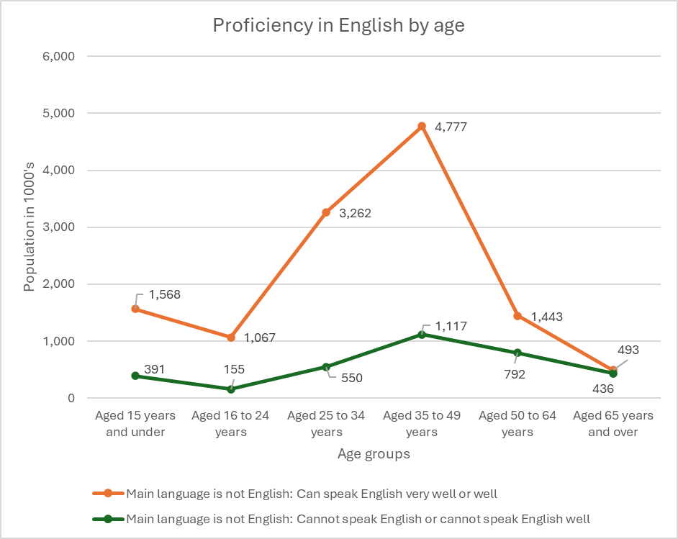

Language barriers can affect communication, understanding of medicines and engagement with healthcare, and may disproportionately impact some protected groups.
The Welsh language, while not included as a protected characteristic under the Equality Act 2010, is subject to statutory duties under the Welsh Language Act 1993 and the Welsh Language (Wales) Measure 2011. Census data show variation in Welsh language skills across local authorities, with most residents reporting no Welsh language ability. Caerphilly records comparatively higher levels of Welsh language proficiency than many other areas. (Appendix L)
Together, ethnicity and language patterns provide contextual information relevant to understanding communication needs and accessibility considerations for pharmaceutical services across the Health Board area.

Sex
Sex is a protected characteristic under the Equality Act 2010 and is relevant to understanding differences in health needs, patterns of service use and access to care. Sex-related differences influence engagement with preventative services, reproductive and sexual health, and the management of long-term conditions across the life course. Consideration of sex provides important context for understanding how pharmaceutical services are accessed and experienced by different population groups.
As set out in sections 2.2.3 and 2.3.1, there are consistent sex differences in both life expectancy and healthy life expectancy across Gwent. Females have higher life expectancy than males in every local authority, with the highest life expectancy in Monmouthshire and the lowest in Blaenau Gwent (Figure 2). However, healthy life expectancy is lower for females than males (Figure 3), indicating that women typically live longer but spend more years in poorer health. Inequalities are also strongly gendered, the deprivation gap in healthy life expectancy is substantially larger for females than males across Gwent (20.5 years vs 12.8 years), with particularly large gaps shown in Newport and Torfaen (Figure 7).
In Wales, national policy, including the Welsh Government’s Women’s Health Plan, highlights the importance of improving access, early intervention and preventative support for women’s health needs.
Men experience different patterns of health need and engagement with healthcare services compared to women, including lower uptake of some preventative services and later presentation for certain conditions. These differences are relevant when considering access to pharmaceutical services, particularly in relation to early intervention, self-care and engagement with advice and support.
Together, consideration of protected characteristics provides important context for understanding differences in access, experience and engagement with pharmaceutical services across the Health Board area. This assessment adopts a proportionate approach, focusing on characteristics most closely linked to pharmaceutical service access and use, while ensuring due regard is given to all protected characteristics in line with equality duties.

Vulnerable and Inclusion Groups
In addition to protected characteristics, some population groups may experience increased vulnerability or face additional barriers in accessing healthcare services. These groups are not defined by a single protected characteristic but may experience compounded disadvantage related to health, social circumstances or patterns of service use. Consideration of vulnerable and inclusion groups provides further context for understanding how pharmaceutical services are accessed in practice across the Health Board area and informs later assessment of service provision. This section describes population groups who may experience barriers to accessing healthcare or poorer health outcomes, including homeless people, Gypsy and Traveller communities, carers and offenders. Other vulnerable groups, such as asylum seekers, refugees and migrants, sex workers, military veterans, and children and young people in contact with the youth justice system, are also recognised, with their pharmaceutical needs considered through the wider assessment of access, continuity of care and medicines support rather than as standalone subsections.
Public Health Wales has published evidence summaries outlining the health status of Inclusion Health groups across Wales. Although these data are not specific to Gwent, they provide important context regarding the scale and complexity of health need experienced by these populations and inform consideration of how pharmaceutical services can respond proportionately.
Mental health conditions are considered within long-term conditions due to their chronic nature and associated medicines use.

Carers
Carers are people of any age who provide unpaid care and support to a family member, friend or neighbour who has a disability, long-term physical or mental health condition, or substance misuse issue, and who could not manage without this support. Caring roles can involve a wide range of practical and supportive activities, including assistance with daily living, coordination of care and support with medicines.
Census 2021 data show that there were approximately 310,700 unpaid carers in Wales, representing around 10.5% of the population. This proportion is higher than in England. Of those identifying as unpaid carers, a greater proportion were female than male, reflecting wider national patterns of caring responsibility.
Within the Health Board area, 60,415 residents identified themselves as unpaid carers, equating to 10.9% of the population. There is variation in both the prevalence and intensity of caring across local authorities. Over one-fifth of carers reported providing 50 hours or more of unpaid care per week, while others provided lower levels of care alongside employment or education. The highest proportions of unpaid carers were recorded in Caerphilly and Torfaen, with variation in hours of care provided across the area.
These patterns provide important context for understanding pharmaceutical service access and use. Carers may have additional support needs related to medicines management, time constraints, stress and coordination of care, both for the person they care for and for their own health. Consideration of carers is therefore relevant to understanding how pharmaceutical services are accessed and experienced across the Health Board area.

Gypsy, Roma and Traveller Communities
Gypsy, Roma and Traveller communities are recognised as groups that may experience poorer health outcomes and face barriers in accessing healthcare services. In the Census 2021, “Gypsy or Irish Traveller” and “Roma” were recorded as separate categories within the White ethnic group, reflecting recognition of Roma as a distinct population.
In the 2021 Census, 0.12% (71,440) of the usual resident population of England and Wales identified as Gypsy or Irish Traveller. Of these, 94.9% (67,815) lived in England and 5.1% (3,630) lived in Wales. In terms of Roma population, 0.2% (103,020) of the usual resident population of England and Wales identified their ethnic group as Roma, of these 98.2% (101,135) lived in England and 1.8% (1885) lived in Wales.. As of January 2025, there were 1,320 Gypsy, Roma or Irish Traveller caravans in Wales, of which 87% were authorised and 13% unauthorised.
The Inclusion Health Dashboard shows within ABUHB, there were 188 Gypsy, Roma or Irish Traveller caravans, with Torfaen containing the highest count (eighty-six) and Newport the highest proportion of unauthorised sites. Data show small proportions of the population in each local authority identifying as Gypsy or Irish Traveller, with variation across the Health Board area (see appendix L). While these proportions are comparable to the Wales average, they may not fully reflect the size or distribution of the community due to under-counting. This data provides important context for understanding the geographic distribution of Gypsy, Roma and Traveller communities within the Health Board area.
Public Health Wales evidence , which includes Roma, Gypsy and Irish Traveller communities indicates these communities experience significantly poorer health outcomes compared to the general population, including life expectancy 10-12 years shorter, higher prevalence of long-term conditions, increased risk of anxiety and suicide, and substantially higher smoking rates (57% compared to 21.5% in comparator groups). The evidence also highlights markedly increased risk of vaccine-preventable disease, including measles at 100 times higher than the general population. These findings are relevant to pharmaceutical services in relation to smoking cessation, vaccination uptake, long-term condition management and accessible medicines advice delivered in community settings.
This information provides contextual insight into the characteristics and lived circumstances of Roma, Gypsy and Traveller communities across Gwent. Mobility, site location, cultural and communication factors may influence how individuals from these communities’ access and engage with pharmaceutical services.

People in Contact with the Criminal Justice System
The presence of prison populations and individuals transitioning into the community has implications for continuity of medicines, access to community pharmacies and support with adherence and ongoing treatment. There are two prisons within the Health Board area; HMP Usk and its satellite establishment, HMP Prescoed. HMP Usk is a Category C men’s prison located in Usk, Monmouthshire, housing up to 275 men.
The second establishment, HMP Prescoed, is a Category D men’s open prison located in Coed-y-Paen, approximately three miles from Usk, and accommodates up to 260 men. Prisoners can spend time outside of prison and can access NHS services, including pharmaceutical services on the High Street.
The Inclusion Health Dashboard show as of July 2025, there were 5,353 prisoners in Wales, including those on authorised absence, with the Usk/Prescoed prison population increasing from 483 to 520 between February and July 2025. The Health Board area also contains 2,986 individuals on probation. These figures demonstrate the scale of justice-involved populations within the Health Board footprint and underline the importance of pharmaceutical services in supporting medicines continuity, smoking cessation, substance use support and care transitions on release into the community.
Public Health Wales evidence shows high levels of complex health need within the justice system, including dual mental health and substance use diagnoses (75–85%), elevated suicide risk, and significant medicines use, with 44% of the prison population taking prescribed medication. Mortality is 20% higher in the first year following release from prison. These findings are relevant to pharmaceutical services in supporting medicines continuity at transition points, smoking cessation (54% express desire to quit), substance use support and access to primary care–linked services following release.
This provides important context for understanding patterns of pharmaceutical service access and use among the offender population within the Health Board area, particularly where individuals may access services both within custodial settings and in the community.

Homeless and Rough Sleepers
Rough sleepers are defined as persons who are sleeping overnight in the open air (such as shop doorways, bus shelters or parks) or in buildings, vehicles or other places not designed for habitation (such as stairwells, barns, sheds, car parks, tents, cars/vans).
The Inclusion Health Dashboard shows in 2023–24, 2,895 homeless households were recorded in ABUHB area. In Wales, a household is considered legally homeless if they have no accommodation in the UK or elsewhere that they have a legal right to occupy, or if they cannot secure entry to their home. This includes situations such as sleeping rough, sofa surfing, living in temporary accommodation (e.g., hostels or B&Bs), or facing imminent risk of eviction or domestic abuse.
Newport accounts for the highest count of homeless households (1,284). Around 30 rough sleepers were counted in ABUHB in May 2025. These figures highlight the scale of housing insecurity within the Health Board area.
Public Health Wales evidence shows individuals experiencing homelessness face extreme health inequalities, including mean ages of death in the early-to-mid 40s, high levels of chronic disease, and elevated risk of substance-related mortality. Between 57–82% are reported to smoke and 80% report poor mental health. The prevalence of blood-borne viruses, respiratory disease and cardiovascular disease is significantly higher than in the general population.
These patterns provide important context for understanding how pharmaceutical services are accessed by people experiencing homelessness or rough sleeping, where engagement may be intermittent and medicines support requires flexibility. More broadly, national evidence relating to Inclusion Health groups demonstrates complex, overlapping health needs that are highly relevant to the accessibility, responsiveness and preventative role of community pharmacy services across Gwent.

Transient and Temporary Populations
Transient and temporary populations, such as higher education students and visitors, can influence patterns of demand and access for pharmaceutical services in parts of the Health Board area.

Students
The University of South Wales, which has a significant campus in Newport, is one of the largest universities in Wales, with over 23,000 enrolled students across its campuses in the Health Board area. Student populations may be highly mobile and rely on local pharmaceutical services, particularly for sexual health services such as contraception and emergency hormonal contraception, smoking cessation support, vaccination and treatment for minor illness. Increasing levels of anxiety, depression and other mental health concerns among students also highlight the importance of accessible pharmacy-based advice, medicines support and signposting to wider services, particularly where students may face barriers accessing other parts of the health system.

Tourists
Visitor activity also contributes to temporary population variation across the Health Board area, with both domestic and international visitors accessing local services. Key attractions include; Chepstow Racecourse, the Celtic Manor Resort, the Wye Valley Area of Outstanding Natural Beauty, the Brecon and Monmouthshire Canal, Tredegar Park and a range of heritage sites such as Abergavenny Castle, Blaenavon World Heritage Site, Tintern Abbey, Caerphilly Castle and Raglan Castle. While comprehensive Health Board–level tourism data are not routinely available, national tourism surveys indicate that visitor activity generates additional demand for local services, including pharmaceutical services providing advice, emergency supply and treatment for minor illness.
The presence of both student and visitor populations provides contextual insight into fluctuations in service use and underlines the importance of ensuring accessible and responsive pharmaceutical services throughout the year.

Long-Term Conditions
Long-term conditions are a major driver of morbidity, mortality and medicines use across the Health Board area and place sustained demand on pharmaceutical services. Conditions such as cancer, cardiovascular disease, diabetes, mental health conditions and respiratory disease are more prevalent in older populations and in areas of greater deprivation, contributing to health inequalities and complex patterns of medicines use. These conditions are associated with a range of health markers shaped by social, economic and environmental factors, and require ongoing treatment, medicines optimisation and adherence support.
Community pharmacy has a key role in supporting people living with long-term conditions through safe and effective medicines use, management of polypharmacy, early identification of problems, support for self-management and signposting to wider services. Understanding the prevalence and distribution of long-term conditions therefore provides important context for assessing whether current pharmaceutical service provision meets population need.

Cancer
Cancer data show that cancer remains a significant contributor to ill health and premature mortality across the Health Board area, with higher incidence and poorer outcomes associated with increasing deprivation. Lung, bowel, prostate, and female breast cancers account for over 43% of all cancer deaths in Wales. In 2022, age-standardised mortality rates from all cancers (excluding non-melanoma skin cancers) for persons in Gwent were higher than the Wales average. Figure 14 below demonstrates variation across local authority areas. Rates were highest in Blaenau Gwent and Caerphilly and lowest in Monmouthshire.
Figure 14 - Deaths Caused by all Cancers (excluding non-melanoma skin cancers: Persons) 2022
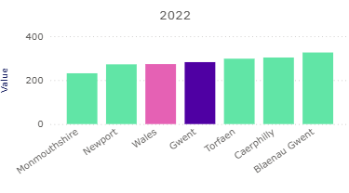
This highlights ongoing inequalities and opportunities for pharmaceutical services to support people affected by cancer including; management of treatment-related side effects, smoking cessation and ongoing support during and after treatment.

Diabetes
Type 2 Diabetes causes preventable early death and disability in Wales, including stroke, kidney disease, amputations, and vision loss, often in working-age adults. The Gwent Joint Strategic Assessment (JSA) 2024/25 identifies diabetes as a growing long-term condition. Figure 15 below demonstrates a steady increase of 0.2 percentage points per year in the prevalence of diabetes among 17+ year olds, since 2020. This represents an increase of 4,902 patients across the Health Board area.
Figure 15 - Diabetes percentage 17+ years 2020-2024
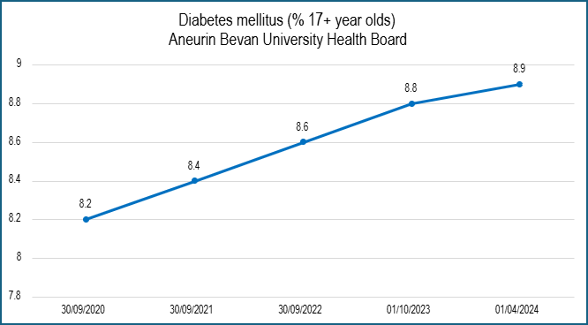
Rising prevalence contributes to increasing demand for medicines and management of associated complications. Pharmaceutical services can support diabetes care through medicines optimisation, adherence support, blood glucose monitoring advice and prevention activity.

Mental Health
Mental health conditions are prevalent across all age groups in Gwent, with the Gwent JSA highlighting ongoing pressures related to anxiety, depression, severe mental illness and dementia, particularly in deprived areas and among older people. Mental health conditions are a major driver of long-term medicines use. Mental health conditions can sometimes coexist with alcohol or substance use, increasing the complexity of care and highlighting the need for coordinated, community-based support.
Trends over recent years show fluctuations in the proportion of adults reporting mental health conditions across Gwent local authority areas, with an overall upward pattern in several areas. Blaenau Gwent and Caerphilly show consistently higher levels over time, while Monmouthshire remains lower but variable. These patterns indicate ongoing demand for medicines support and accessible, community-based mental health interventions.
Figure 16 below demonstrates that in 2022–23, the proportion of adults aged 16 and over reporting a mental health condition was higher in Gwent than the Wales average at 12.1%. Within the Health Board area, prevalence was highest in Blaenau Gwent at 16.8% and Caerphilly 14.8% and lowest in Monmouthshire at 8.4%, highlighting variation between local authority areas.
Figure 16 – Percentage of Adults Aged 16+ Reporting Having Mental Health Conditions
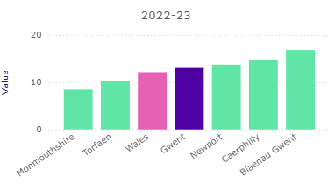
Community pharmacies support mental health through adherence support, early identification of issues, signposting to specialist services and delivery of person-centred, accessible care.

Respiratory Conditions
Respiratory conditions such as asthma and chronic obstructive pulmonary disease continue to place a significant burden on health services across Gwent, with higher prevalence and poorer outcomes in more deprived areas. Smoking remains a key risk factor.
Figure 17 below demonstrates in 2022–23, the proportion of adults aged 16+ reporting respiratory system complaints in Gwent was broadly in line with the Wales average at 8.2% with variation across local authority areas. Rates were highest in Newport at 9% and Blaenau Gwent at 8.6% and lowest in Monmouthshire at 6.2%.
Figure 17 – Percentage of Adults Aged 16+ Reporting Respiratory System Complaints
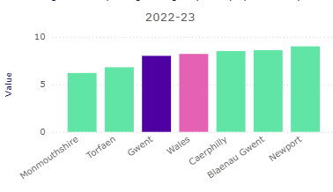
Pharmaceutical services support respiratory health through inhaler technique checks, smoking cessation services, vaccination and support for self-management.
Taken together, the evidence in this section shows that long-term conditions continue to drive demand for medicines and pharmaceutical support across the Health Board area, with patterns closely linked to age, deprivation and place. These conditions are associated with a range of wider health markers shaped by social, economic and environmental factors, which can limit individuals’ ability to make or sustain changes to behaviour. The following section therefore considers prevention, health improvement and public health, focusing on how pharmaceutical services contribute to addressing these health markers through accessible, place-based support and early intervention.

Health Markers, Prevention and Public Health
Building on the assessment of long-term conditions, this section considers the wider health markers that influence population health across the Health Board area. These markers are shaped by social, economic, environmental and commercial determinants of health, which can significantly influence health behaviours and contribute to persistent health inequalities, particularly in areas of deprivation. As a Marmot region, there is a strong focus on addressing the conditions in which people are born, grow, live, work and age.
This section focusses on five priority health markers where pharmaceutical services can play an important role in prevention and public health: smoking and vaping; weight; sexual health; alcohol consumption; and vaccination, highlighting how pharmaceutical services can contribute by providing preventative services, advice and support within local communities, particularly for populations experiencing greater disadvantage.

Smoking (including e-cigarettes)
Smoking remains a significant health marker across the Health Board area and continues to contribute to inequalities in health outcomes. As set out in earlier sections, smoking is strongly associated with increased incidence and poorer outcomes for cancer, respiratory disease and cardiovascular disease, and contributes to the development and progression of long-term conditions such as diabetes. Smoking prevalence is also higher among people living with mental health conditions, compounding existing inequalities and increasing the complexity of medicines use and long-term care. Community pharmacies, alongside ‘Help me Quit’ services, play an important role in addressing smoking-related harm through accessible smoking cessation services, advice and support, including for populations experiencing greater disadvantage, thereby contributing to prevention, early intervention and reduced future demand on health services.
Figure 18 below demonstrates that in 2023, the proportion of adults aged 18 and over who were current smokers varied across the Health Board area, with rates highest in Torfaen at 16.3% and Blaenau Gwent at 15.8% and lowest in Monmouthshire at 7.1%. Smoking prevalence in several local authority areas was higher than the Wales average at 12.6%. Smoking contributes to cancer, respiratory disease, cardiovascular disease and diabetes, highlighting the importance of accessible smoking cessation support delivered through community pharmacy, particularly in areas experiencing greater health inequality.
Figure 18 Percentage of the 18+ Population who are Current Smokers (Annual Population Survey)
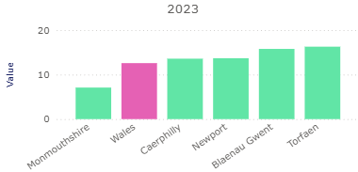
While smoking prevalence among children and young people remains relatively low early exposure to nicotine continues to be an important health marker with implications for future health outcomes. Patterns of nicotine use are changing, with increased use of e-cigarettes among adults though lower levels of tobacco smoking. Early initiation of smoking or nicotine use is associated with increased risk of long-term tobacco dependence and future development of some cancers, respiratory and cardiovascular disease. These trends highlight the importance of prevention and early intervention, including the role of community pharmacy in providing advice, smoking cessation support and signposting for young people and families.

Weight
Maintaining a healthy weight is a key health marker influencing population health and long-term demand for health services. The Healthy Weight: Healthy Wales delivery plan 2025 - 2027 recognises that excess weight is associated with increased risk of cardiovascular disease, type 2 diabetes, musculoskeletal conditions and some cancers, and highlights the influence of the wider food environment including availability, affordability and marketing of food and drink, in shaping dietary patterns. Local measures within the Gwent Indicator Framework, including fruit and vegetable consumption and intake of sugar-sweetened drinks, provide additional context on dietary trends across the Health Board area.
Figure 19 below demonstrates the proportion of adults aged 16 and over who were overweight or obese in Gwent, in 2021-2023, was higher than the Wales average, with marked variation across local authority areas. Rates were highest in Blaenau Gwent and Caerphilly and lowest in Monmouthshire.
Figure 19 - Percentage of Adults with a BMI of 25+ (overweight or obese)
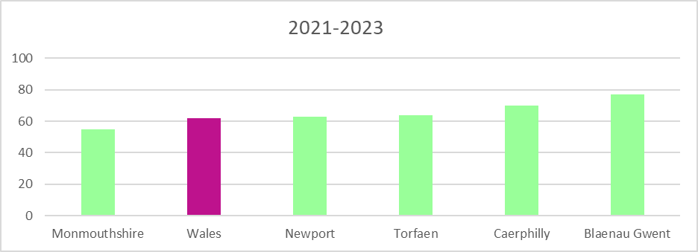
Community pharmacies contribute through accessible advice, brief interventions and signposting to local weight management and lifestyle support services, particularly in areas experiencing greater deprivation.
Consultation respondents identified pharmacy-based weight management support as a potential future community pharmacy service. Any inclusion would be subject to national policy, assessed need, workforce capacity, clinical governance and sustainable commissioning. These services are not identified as current gaps in pharmaceutical provision

Sexual Health
Sexual health is an important health marker that contributes to overall wellbeing and population health outcomes. It includes prevention, testing and treatment of sexually transmitted infections (STIs), access to contraception, and support to avoid unintended pregnancy. National standards for sexual and reproductive health emphasise timely access to the full range of contraceptive methods, including emergency contraception and long-acting reversible contraception (LARC), with particular focus on equitable access for populations experiencing deprivation or vulnerability. These standards provide important context for assessing pharmaceutical service provision.
The Sexual Health Trends in Wales: Annual Report 2025 highlights ongoing variation of STIs across Wales, with younger adults disproportionately affected and inequalities associated with deprivation. While specialist sexual health services are responsible for diagnosis and treatment of infections such as gonorrhoea and syphilis, community pharmacies make a considerable contribution to prevention and early intervention.
Community pharmacies can provide sexual health advice and some methods of contraception that include emergency contraception, bridging contraception (an initial 3-month supply of the progestogen-only pill), or a mixture of both. The Community Pharmacy Services: April 2023 to March 2024 Report states that contraception consultations in community pharmacies in 2023-24 across Wales, had increased and a large majority of consultations (97.0%) were for emergency contraception only, a long-established community pharmacy service.
Although teenage pregnancy rates have declined over time nationally, variation persists between local areas and is closely linked to socioeconomic disadvantage. Ensuring equitable access to contraception and sexual health advice therefore remains important in addressing health inequalities and supporting young people’s health and life chances.
Community pharmacies can contribute to sexual health through provision of emergency hormonal contraception, participation in public health campaigns, signposting to STI testing and treatment services, and delivery of advice during routine consultations. Pharmacy access, including extended opening hours and walk-in availability, can improve timely access to contraception and advice, particularly when other primary care services are closed. This accessible, community-based role supports prevention, early intervention and reduction of future demand on wider health services.

Alcohol Consumption
Alcohol consumption is an important health marker influencing population health outcomes and long-term demand for services. Excess alcohol use is associated with increased risk of several cancers, cardiovascular disease, liver disease and poor mental health, and can contribute to complex medicines use and multimorbidity. Patterns of alcohol consumption are also shaped by wider social and environmental factors, including deprivation, availability and affordability, and are associated with health inequalities.
Figure 20 demonstrates that in 2021–2023, the proportion of adults aged 16 and over reporting consumption of more than 14 units of alcohol per week varied across the Health Board area. Rates were highest in Monmouthshire and Torfaen and lowest in Newport and Blaenau Gwent. In some local authority areas, reported consumption above 14 units per week exceeded the Wales average. These differences highlight variation in alcohol-related health markers across Gwent and reinforce the importance of prevention and early intervention.
Figure 20 - Percentage of Adults (16+) who Reported Drinking Over 14 Units of Alcohol Per Week (age standardised percentage).
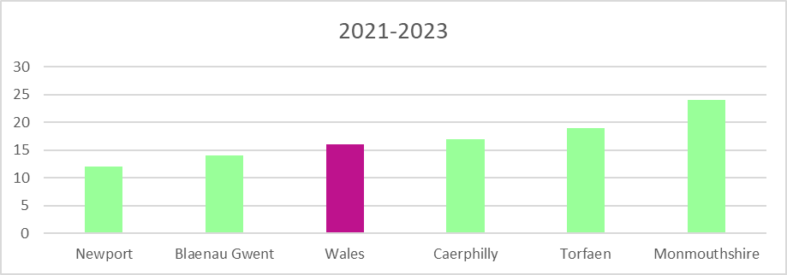
Community pharmacies contribute through brief interventions, opportunistic advice, medicines reviews and signposting to specialist substance misuse services. Their accessibility within local communities enables early engagement and supports reduction of alcohol-related harm, particularly for populations experiencing disadvantage.

Vaccination
Vaccination remains one of the most effective public health interventions, protecting individuals and communities from serious infectious disease and preventing avoidable hospitalisation and mortality. However, as highlighted in the Director of Public Health Annual Report 2025/26 – The Big Gwent Vaccination Conversation, uptake across Gwent varies by vaccine and population group, and recent years have seen a decline in coverage for some programmes. Uptake data presented in the report show that while some programmes meet or approach national targets (e.g., influenza vaccination in older adults), others fall below recommended coverage levels, including childhood immunisations, HPV and COVID-19 booster uptake in eligible groups.
Practical barriers to vaccination were a recurring theme within the Director of Public Health’s engagement, including limited awareness of pharmacy vaccination services and transport challenges affecting access to centralised clinics. The local presence of community pharmacies within neighbourhoods provides an opportunity to mitigate these barriers, as pharmacies are often accessible on foot, via local transport routes and without the need for formal appointments. Increasing awareness of pharmacy-delivered vaccination services therefore has the potential to improve convenience, reduce travel-related obstacles and support more equitable uptake across communities.
Pharmacies provide accessible, community-based vaccination services, particularly for seasonal influenza vaccination, reducing demand on general practice and improving convenience for working-age adults and underserved groups. Their extended opening hours, local presence within neighbourhoods, and established relationships with patients position them to increase uptake, provide evidence-based reassurance, counter misinformation, and support equitable access. Pharmacy-delivered vaccination services therefore form a key component of the Health Board’s prevention offer and its commitment to reducing inequalities in immunisation coverage across Gwent.
Consultation respondents identified COVID-19 booster, pneumococcal and respiratory syncytial virus vaccination as potential future community pharmacy services. Any expansion would be subject to national policy, assessed need, workforce capacity, clinical governance and sustainable commissioning. These services are not identified as current gaps in pharmaceutical provision.

Summary
This chapter demonstrates that population characteristics, deprivation, geography and wider health markers shape both the distribution of long-term conditions and the way pharmaceutical services are accessed across the Health Board area. Clear variation exists between local authority areas, with inequalities reflected in healthy life expectancy, long-term condition prevalence and prevention-related indicators. Pharmaceutical services therefore operate within a complex, place-based context where accessibility, continuity and targeted prevention are critical.
The following chapter sets out the current provision of pharmaceutical services across the Health Board area, establishing the baseline from which assessment of adequacy and future need is made.

Chapter Three – Current Provision of Pharmaceutical Services
This chapter describes the current provision of pharmaceutical services across the Health Board area and beyond its boundaries. It builds on the definitions, legislative framework and service scope set out in Chapter One and focuses on the availability, accessibility and distribution of pharmaceutical services. In addition to describing service provision, the chapter incorporates evidence from patient, public and contractor engagement to provide contextual insight into how pharmaceutical services are accessed and delivered in practice. The chapter establishes a factual baseline of provision and experience and does not assess adequacy or identify gaps, which are considered in later chapters.

Pharmaceutical Service Provision within the Health Board Area
This section describes the current availability of pharmaceutical services provided by community pharmacies, dispensing appliance contractors and dispensing doctors within the Health Board area, as defined in Chapter One.

Dispensing Appliance Contractors
As mentioned in Chapter One, there are no dispensing appliance contractors located within the Health Board Area. Appliance prescriptions are dispensed by community pharmacies or dispensing doctors within the Health Board area or dispensed outside its area.

Dispensing Doctors
In terms of the services offered by dispensing doctors, only the provision of drugs or listed appliances is classified by legislation as a pharmaceutical service covered by this PNA.
There are 13 dispensing doctor dispensaries within the Health Board area. These include branch sites and are operated by 11 GP practices who are able to dispense to eligible patients, as described in Chapter One. One of the dispensaries is operated by a GP practice outside of the Health Board area in Gloucester and is included in this section as it provides a pharmaceutical service to patients within our area. One GP practice within the Health Board area which has a dispensary outside of the area is not included in this chapter.

Service Availability
Dispensing GP practices provide dispensing service during their standard opening hours from Monday to Friday excluding public and bank holidays. Services provided from a branch surgery will reflect the opening hours of the branch. Please see appendix M
As described in Chapter One, the regulations around the provision of a dispensing service by doctors are complex and means they can only be accessed by people who:
- Live in a controlled area (usually of rural character) at a distance of more than 1.6km in a straight line from a pharmacy; and
- Are registered with a practice that has historic rights or consent to dispense and premises approval for each dispensary; and
- Would have serious difficulty obtaining necessary drugs or appliances due to distance or inadequacy of communication
These people will be living in the area covered by the practice registration list and for the purposes of the PNA distances to dispensing doctor dispensaries are outside the scope of this PNA. It should be noted patients remain free to use a community pharmacy of their choice.

Dispensing Activity
As of November 2025, the dispensing doctor practices within the Health Board area dispensed to 26,209 of their registered patients (4.15% of the total list size for all 67 Practices). The percentage of dispensing patients at the practices varies between 5% and 94% their registered patients.
In 2024/25 these dispensing doctors dispensed 708,660 prescriptions (4.13% of all prescriptions dispensed and 4.09% of all prescriptions written in ABUHB).

Community Pharmacies
As of February 2026, there are one hundred and twenty-five pharmacies included in the Health Board’s pharmaceutical list, operated by fifty-five different contractors.

Service Availability
Appendix N provides information on community pharmacy opening hours as of February 2026 and at that point in time there were:
- 8 pharmacies open seven days a week.
- 22 pharmacies open Monday to Saturday.
- 39 pharmacies open Monday to Friday, and for a half day on a Saturday.
The Health Board has used distance data to reflect accessibility to pharmacy services. Pharmacy locations were analysed by NHS Wales Digital Health and Care Wales. As can be seen from Map 9, most of the Health Board’s population lives within a 10-minute drive of a pharmacy.
Map 9 – Drive Time to Access a Pharmacy
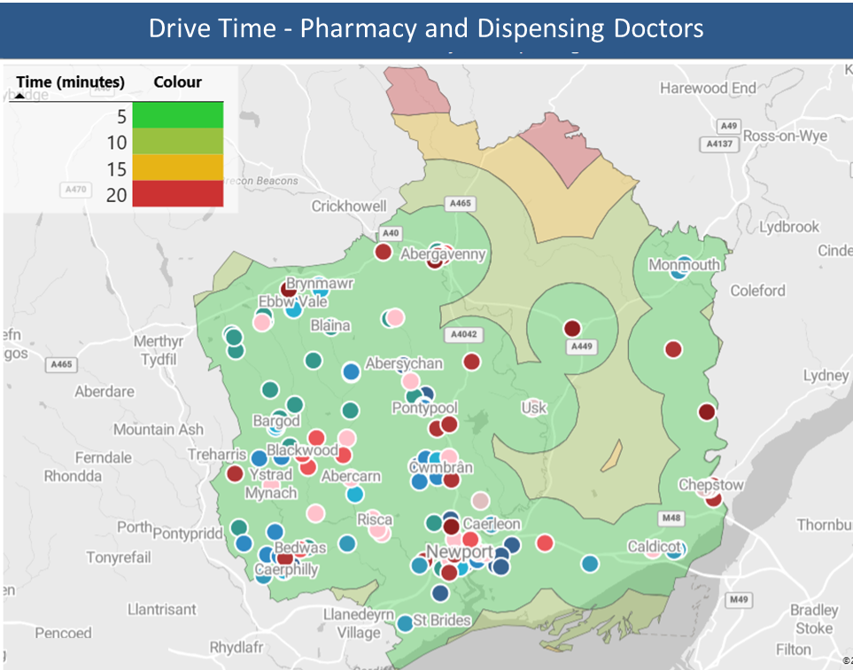

Dispensing Activity
During 2024/25, 97.17% of the 17,308,966 NHS items prescribed within the Health Board area were dispensed within the Health Board area. Of these, 95.79% were dispensed by community pharmacies.
Of the 2.83% of prescriptions that were not dispensed within the Health Board area, 24.77% were dispensed in other areas of Wales, 40.11% were dispensed in England and 35.12% were personally administered by the prescriber.

Availability and Activity of Additional Clinical Services

Clinical Community Pharmacy Service
The Clinical Community Pharmacy Service brings together three modules of service identified below to provide a consistency of access.
- Common Ailments Service
The Common Ailment Service provides NHS funded advice and treatment for a range of specified conditions such as acne, chickenpox, conjunctivitis, head lice, sore throat/tonsillitis and verrucae. Patients register with a pharmacy and receive a consultation with a pharmacist and advice on management and treatment where required, or referral if necessary. The service utilises the clinical skills of pharmacists and offers patients an alternative to making a GP appointment.
All 125 pharmacies on the Health Board’s pharmaceutical list are commissioned to provide the service and undertook 70,637 consultations during 2024/25.
- Contraception Service
This service enables an NHS funded supply of emergency, bridging or quick start contraception by pharmacists and pharmacy technicians. The service aims to reduce unplanned pregnancy by improving access to emergency contraception and sexual health advice.
All 125 pharmacies provide the service and during 2024/25 4,602 consultations were provided.
- Emergency Medicines Supply
The Emergency Medicines Supply Service provides access to previously prescribed medication to patients in situations where there is an immediate need for the prescription only medicine, and that it is impracticable in the circumstances to obtain a prescription without undue delay. The cost of medicine supplied is funded by the NHS and the service aims to reduce the burden on out of hours and emergency care by removing the cost barrier associated with private emergency supplies of medicine.
Regulation 225 of the Human Medicines Regulations 2012 remains the primary legislation governing the emergency supply of medication at the request of a patient, and all supplies must comply with that regulation.
All 125 pharmacies in the Health Board area provide the service and during 2024/25, 23,257 consultations and 40,458 medicines supplied.

Pharmacist Independent Prescriber Service
The Pharmacist Independent Prescriber service provides patients presenting in the community pharmacy with access to effective advice and treatment, for a range of acute conditions and contraception, relevant to their clinical needs, provided by a community pharmacist independent prescriber. The service enables patients to access NHS funded clinical care without the need to see a GP.
During 2024/25, 57 pharmacies were commissioned to provide the service and undertook 24,692 consultations.

Influenza Immunisation Service
This service allows pharmacies to provide influenza immunisation for those patients in nationally and locally agreed at risk groups. It supports the wider provision of influenza immunisation and by increasing access, aims to increase the proportion of at-risk individuals who receive immunisation thus helping to reduce morbidity and mortality.
During the 2024/25 season, 124 pharmacies were commissioned to provide the service vaccinated 14,563 individuals.

Smoking Cessation Level 2 Service
The Smoking Cessation Level 2 service formally links community pharmacies with the Help Me Quit (HMQ) intensive behavioural support programme and improves access to nicotine replacement therapy (NRT) to strengthen quit attempts. Under this service, pharmacy contractors supply NRT to individuals upon presentation of a HMQ referral letter confirming nicotine dependence.
One hundred and twenty-two pharmacies are commissioned for the service and during 2024/25, 5,040 consultations were provided.

Smoking Cessation Level 3 Service
The Smoking Cessation Level 3 service is designed to provide patients with a comprehensive behavioural support and NRT treatment service to help them stop smoking over a 12-week programme.
Ninety-four pharmacies are commissioned to provide the service and provided 3,513 patient consultations during 2024/25.

Needle and Syringe Programme
The primary aim of this service is to help reduce the spread of HIV, Hepatitis C and other blood-borne viruses amongst injecting drug users by providing clients with convenient access to a pack of sterile injecting equipment and a facility for the safe disposal of used equipment, therefore reducing the risk in the community.
Twenty-one pharmacies are commissioned across the Health Board area and provide components of a tiered service:
- Level one is a supply only service with 15 contractors commissioned to supply pre-packed supplies and 6 supplying via a pick and mix choice arrangement.
- Level two comprises the same supply function as level 1 but adds a condition of the provision of proactive advice, signposting and identification of individuals for blood borne virus testing. Two contractors are commissioned to provide this alongside the supply of pre-packed equipment.
- Level 3 includes either level 1 or level 2 plus the provision of take-home naloxone and advice/training on its safe use. Three contractors are commissioned for this in ABUHB.
During 2024/25 pharmacies conducted 7,095 individual contacts for the service.

Urgent Medicines Supply Service
The Urgent Medicines Supply service is commissioned in 25 pharmacies across the Health Board area. There are two levels of service provision; level 1 provides a broad range of medicines including those commonly needed for end-of-life care, urgent treatment of over anticoagulation and antiviral prophylaxis. Level 2 includes a more specialised range of palliative care medicines and antimicrobials and is linked to the community pharmacy on call palliative care service.
Sixteen pharmacies are commissioned for the level 1 service with a further 9 providing the level 2 service.

Supervised Administration Service
The Supervised Administration service supports the various addiction services within ABUHB by providing access to supervised consumption of prescribed therapy. The service aims to support adherence to agreed treatment plans and minimise the risk of inappropriate use and diversion of medicines.
One hundred and fourteen pharmacies are commissioned to provide the service and during 2024/25 70,435 doses of medicine were supervised.

Lateral Flow Test Supply Service
The Lateral Flow Test (LFT) Supply Service is commissioned to enable patients eligible for COVID-19 antiviral treatment to access a supply of LFTs to keep at home.
Ninety-two pharmacies are commissioned to provide the service and during 2024/25 2,346 LFT kits were provided to eligible individuals.

Access to the Blood Borne Virus Testing Service
The Blood Borne Virus Testing Service is intended to increase access to and awareness of blood borne virus screening and associated treatment and health advice. It aims to increase the number of people tested for blood borne viruses and reduce the personal and public health risks associated with Hepatitis-B, Hepatitis-C and HIV.
The service is commissioned in 11 pharmacies across Gwent and completed 296 tests in 2024/25.

Access to Out of Hours Pharmaceutical Services - Rota Provision
Rotas operate to ensure access to pharmaceutical services on weekday evenings, Sundays and public and bank holidays. Their details are published on the Health Board’s website. Posters confirming which pharmacies will be open, and when, are also displayed in the pharmacies.
Regulations 80 and 81 of the National Health Service (Wales) Act 2006 set out a duty for the Health Board to make arrangements within its area for the provision of pharmaceutical services to persons within that area. However, the regulations do not set out the days and times during which these must be available: only that “proper and sufficient drugs, medicines and listed appliances” and directed additional services be provided.
Community Pharmacies and DACs are not required to open on Christmas Day, Good Friday, Easter Sunday or any bank holiday. Additionally, they need only provide a minimum of 40 hours (Pharmacies) and 30 hours (DACs) of pharmaceutical services each week unless otherwise directed by the Health Board. This is reflected in the fact that only eight pharmacies open commercially on Sundays.
To support access to pharmaceutical services on Sundays, Christmas Day, Good Friday, Easter Sunday and bank holidays, the Health Board commissions further pharmaceutical services on a rota basis. Additionally, in areas where pharmacies do not operate with extended hours, a weekday rota provides the additional cover.
Twenty-five pharmacies provide a regular Sunday service between 18:00h and 20:00h on a rota basis to provide access to dispensing services in each of the five Health Board Localities.
A further 64 pharmacies provide cover across the Health Board area on Sundays, Christmas Day, Good Friday, Easter Sunday and bank holidays. In the Blaenau Gwent, Caerphilly and Torfaen localities, weekday rotas are provided between 17:30h and 18:00h or 18:30h depending on the area.

Medicines Administration Record (MAR) Service
The MAR Service supports safe medicines administration for domiciliary care patients by supplying clear, accurate MAR charts in response to presented prescriptions and ensuring effective communication between pharmacies, care providers, and prescribers. It aims to improve the safe and effective use of medicines and provide accessible pharmacy support for resolving medicines‑related issues.
Eighty-five pharmacies are commissioned to provide the service and in 2024/25, 2,376 MAR charts were provided.

Inhaler Review Service
The Inhaler Review Service supports patients using inhaled medicines by assessing and improving inhaler technique, optimising treatment adherence, and identifying poorly controlled asthma or COPD. It also aims to reduce medicines waste and promote environmentally sustainable prescribing by reviewing inhaler types and suitability for lower‑carbon alternatives. Level 1 focuses on inhaler technique and environmental considerations, while Level 2 provides an in‑depth clinical review of asthma or COPD symptom control.
Forty-seven pharmacies provide the service in ABUHB and during 2024/25, 1,164 level one reviews were conducted. During the same period two level two reviews were provided.

Discharge Medication Review (DMR)
The DMR Service supports patients after discharge from a care setting by reconciling medicines to reduce errors, improve safety, and maintain continuity of care. It improves communication between hospitals, community pharmacies and GP practices, enhances patient understanding of their medicines, reduces waste and duplicated prescribing, and helps prevent avoidable re-admissions. The service makes effective use of pharmacist and pharmacy technician skills to ensure continuity of accurate medicines information at transfer of care.
All pharmacies in ABUHB are commissioned and able to provide the service. During 2024/25, 2,494 DMRs were completed.

Waste Reduction Service
The Community Pharmacy Waste Reduction service aims to reduce prescribing waste and unnecessary repeat medication by asking patients whether each item on a repeat prescription is required at the point of collection. Pharmacy teams identify “when required” and variable‑use medicines and discuss reasons for items not needed. Items that aren’t needed are appropriately endorsed and the majority of the cost of issue is saved. Clinically significant decisions are communicated to prescribers with patient consent. The service improves medicines optimisation, reduces avoidable waste, and supports safer prescribing and dispensing practices. In ABUHB, 106 pharmacies are commissioned to provide the service and in 2024/25 16,518 interventions were made which prevented £278,363 of unwanted medicines being issued.

Directly Observed Therapy
The Directly Observed Therapy service enables community pharmacies to help patients adhere to their agreed treatment plan by dispensing prescribed medication in specified instalments and witnessing the doses taken. It has commonly been used for tuberculosis medications and is intended to support individuals with complex medication needs. Whilst no pharmacies are currently commissioned, it remains available for commissioning at prescriber request to meet patient need.

Tuberculosis DOTS Team Supply Service
Two pharmacies are commissioned to provide a support service to the Health Board Directly Observed Therapy (DOT) Team for Tuberculosis. The DOTs team are based in St Woolos Hospital, Newport and the service is commissioned with two pharmacies local to the service. During 2024/25 the pharmacies provided 250 instances of support to the DOTs team.

Out of Hours Palliative Care Service
The Out of Hours Palliative Care service provides on call access to an agreed range of specialist medicines in line with the specification laid out in the Level 2 Urgent Medicines Service. The service operates in conjunction with the Gwent Out of Hours Service and the Emergency Transport Service to provide urgent access to end-of-life medicines across the Health Board area.
Nine pharmacists provide this service on a rota basis ensuring continuous 24-hour availability. In 2024/25 the pharmacists responded to 193 call outs for urgent access to palliative care medicines during the out of hours period.

Pharmacy Delivery Service to HMP Usk and HMP Prescoed
There are two prisons within the Health Board’s area:
- HMP Usk is a Category C men's prison, located in Maryport Street in Usk; and
- HMP Prescoed is an open prison, holding category D convicted adult males, located in the village of Coed-y-Paen.
Both prisons are operated by His Majesty's Prison Service, and jointly managed.
In 2024/25, 26,673 items were prescribed in and dispensed for the prison population as part of pharmaceutical services. To ensure the items are delivered to the pharmacy in a safe, efficient and effective manner that complies with prison rules and standing orders, a delivery service is commissioned from a single pharmacy within Monmouthshire. The pharmacy delivers dispensed and ordered medication to both prisons on an as needed basis.

Care Home Service Level 1
The Care Home Review service provides community pharmacy led reviews of medicines management to improve safety, reduce waste, and support compliant systems for ordering, storage, administration, and disposal of medicines. It includes two annual visits to assess practice, set and monitor action plans, and offer guidance aligned with NICE and CIW standards, with DMRs completed for newly transferred residents.
Six pharmacies are commissioned to provide the service. In 2024/25 the service was provided by two pharmacies, who made 76 care home visits between them.

Appliance Use Reviews (AUR)
The Appliance Use Review service provides patients with advice and support on the safe and effective use of specified prescribed appliances. It is designed to help identify any problems the patient may experience in using their appliance and to improve adherence and outcomes.
No pharmacies provided this service in 2024/25.

Stoma Appliance Customisations
The Stoma Customisation service ensures that supplied stoma appliances are modified according to an individual patient’s clinical needs to ensure they can be properly fitted and adjusted for comfort, safety and effective use.
No pharmacies provided this service in 2024/25.

Choice in Obtaining Pharmaceutical Services
Choice is an important aspect of access to pharmaceutical services and reflects how individuals engage with provision in practice. Patients have a choice of where they access pharmaceutical services. This may be close to their GP practice, their home, their place of work, or where they go for shopping, recreational or other reasons.
Feedback indicates that most people have a preferred community pharmacy and demonstrate consistent patterns of use, often influenced by factors such as convenience, trust in pharmacy staff, service experience, and proximity to other healthcare services.
The availability of multiple providers within some areas enables choice, while in other locations choice may be shaped by geography, transport, or service configuration.
This context supports understanding of how pharmaceutical services are accessed and selected by the population and provides background for the assessment of provision in later chapters.

Pharmaceutical Services Provided Outside the Health Board Area
As patients are free to choose where they access pharmaceutical services, some individuals living within the Health Board area may receive services from providers located outside the area.
During 2024/25 0.68% of all the prescriptions written by prescribers within the Health Board area were dispensed by contractors in other areas of Wales. A further 1.11% were dispensed by contractors in England.

Dispensing Appliance Contractors (DACs)
Patients within the Health Board area are prescribed appliances broadly in line with other patients in Wales. Whilst community pharmacies and dispensing doctors are able to dispense appliances, a proportion of the prescriptions dispensed outside of the Health Board area are likely to be for appliances.

Dispensing Activity
Welsh data suggests 0.16% of prescriptions written in the Health Board were dispensed by DACs domiciled in other areas of Wales. Given there are also DACs located in England and delivery is often part of the service, it’s likely that patients also utilise these to obtain appliances prescribed within ABUHB.

Appliance Use Reviews
Information on the type of services provided by pharmacies and dispensing appliance contractors outside the Health Board’s area to its residents is not available. When claiming for services contractors claim for the total number provided for each service.

Stoma Customisation
Whilst payment for this service is made based on the information contained on the prescription, activity provided by dispensing appliance contractors outside the Health Board’s area to its residents is not available.

Dispensing Doctors
Some residents of the Health Board’s area will choose to register with a GP practice outside of the area and may access the dispensing service offered by their practice. Vauxhall Practice in Chepstow also has a dispensary over the border in Tutshill, England and some residents of ABUHB may be eligible for the dispensing service there.

Community Pharmacies

Dispensing Services
Data for Health Board residents accessing dispensing services is not available from contractors outside the area. However, it’s likely that of the 1.79% of prescriptions written within the area that are dispensed elsewhere, a proportion will be dispensed by pharmacy contractors.

Additional Clinical Services
Clinical service provision data does not identify the patients provided with the service. However, given the reasons mentioned previously around patient choice, it's likely that patients may access services elsewhere.

Stakeholder and Public Feedback on Existing Provision of Pharmaceutical Services
This section summarises feedback received from patients, the public and pharmaceutical contractors on their experience of accessing and providing pharmaceutical services across the Health Board area. It highlights key themes and patterns and is intended to provide contextual insight into how services are experienced in practice, rather than an assessment of adequacy. Detailed results, including full tables and verbatim comments, are provided in Appendix H: Patient, public and contractor engagement results.

Public Feedback

Overview of Engagement Activity
Engagement activity, through the use of questionnaires, captured views from a broad range of residents and pharmaceutical contractors across the Health Board area, providing insight into access, awareness and experience of pharmaceutical services. The questionnaire sought to understand more about how local people access and use community pharmacies and dispensing doctors, how they would like to use them in the future, and their views on what works well and what could be better. The questionnaire was made available online in both Welsh and English from 10 November to 22 December 2025. A total of 1,102 people (0.17% of the registered population) completed the questionnaire. A copy, which shows the questions asked, can be found in appendix G. The full results can be found in appendix H. Table 6 below presents the postcodes of respondents to the patient questionnaire, with feedback received from across the Health Board, demonstrating a broad and representative spread of participants.
Table 6 - Postcode Districts of those Responding to the Patient and Public Questionnaire
Postcode | Number of responses | Percentage
NP26 | 322 | 29.2%
NP16 | 130 | 11.8%
NP11 | 85 | 7.7%
NP4 | 70 | 6.4%
NP44 | 56 | 5.1%
NP19 | 54 | 4.9%
NP20 | 48 | 4.4%
NP23 | 46 | 4.2%
CF83 | 39 | 3.5%
NP10 | 39 | 3.5%
NP22 | 36 | 3.3%
NP7 | 35 | 3.2%
NP12 | 32 | 2.9%
NP13 | 19 | 1.7%
NP18 | 17 | 1.5%
CF82 | 14 | 1.3%
NP25 | 13 | 1.2%
NP15 | 11 | 1.0%
CF81 | 4 | 0.4%
CF8 | 3 | 0.3%
NP24 | 3 | 0.3%
CF46 | 2 | 0.2%
CF3 | 1 | 0.1%
GL14 | 1 | 0.1%
GL15 | 1 | 0.1%
NP48 | 1 | 0.1%
NP6 | 1 | 0.1%
NP8 | 1 | 0.1%
Invalid format | 18 | 1.6%
The age profile of respondents is shown in Figure 21. Older age groups were more strongly represented, which should be considered when interpreting patterns of service use reported in later sections.
Figure 21– Age Profile
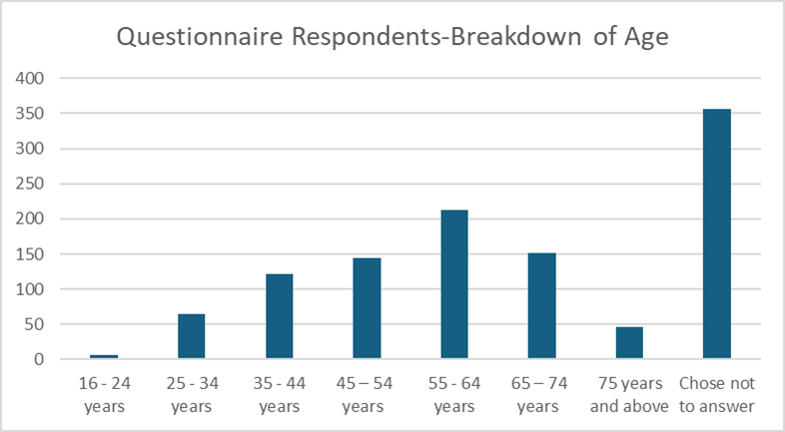

Use of Community Pharmaceutical Services
Feedback indicates that community pharmacy services are widely used, with 64.2% of respondents reporting regular use of their local pharmacy. 32.21% of respondents reported that their prescriptions are dispensed by their GP practice and 3.54% didn’t know, however their subsequent responses would suggest they are dispensed at a pharmacy. It should be noted that this response overstates dispensing by GP practices, as analysis suggests some respondents may have interpreted the question as asking where they receive their prescription rather than where it is dispensed; notably, a significant proportion (66%) of affirmative responses were from areas without dispensing doctor provision. This suggests around 11-15% of respondents are likely to use dispensing doctor services.
Pharmacies are commonly accessed for the supply of medicines and for advice and are frequently used as a first point of contact for medicines-related queries, reflecting their accessibility within communities.
Respondents reported using community pharmacies for a range of reasons, most commonly for the supply of prescribed medicines. Many also reported visiting pharmacies for advice about medicines, minor illnesses and general health concerns, reflecting the role of pharmacies as an accessible source of professional support.

Access
This section summarises feedback from patients and the public on how they access and use pharmaceutical services, including patterns of use, convenience, access and reasons for visiting a pharmacy. The findings provide contextual insight into service use and are not intended to assess adequacy or identify gaps.
Figure 22 below shows how frequently responders visit a pharmacy. As may be expected most people visit monthly which will reflect prescription length.
Figure 22 – How often do you visit a pharmacy?

Whilst 34.12% of respondents didn’t have a preference as to the most convenient time, for those that did the most convenient time was 3pm to 6pm (20% of responses), followed by 8am to 12 noon (18%). Figure 23 demonstrates the responses.
Figure 23 - What time is the most convenient for you to use a pharmacy?
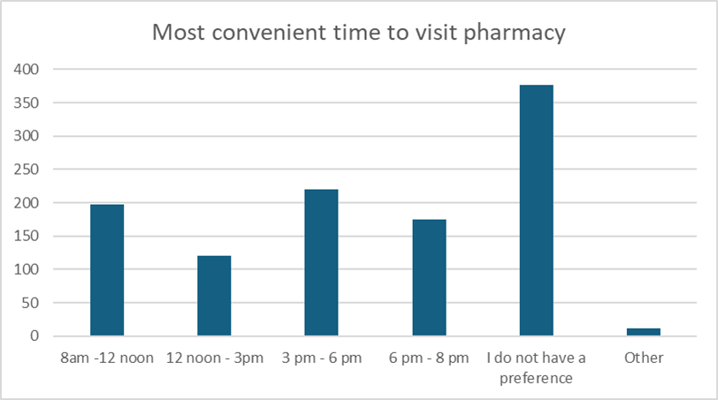
The most convenient time to access a pharmacy was then analysed by age group of the respondents to identify any differences this may have on the times pharmacies are used. Figure 24 below illustrates the age and most popular time to visit a pharmacy.
Figure 24 – Age and most popular time to visit a pharmacy
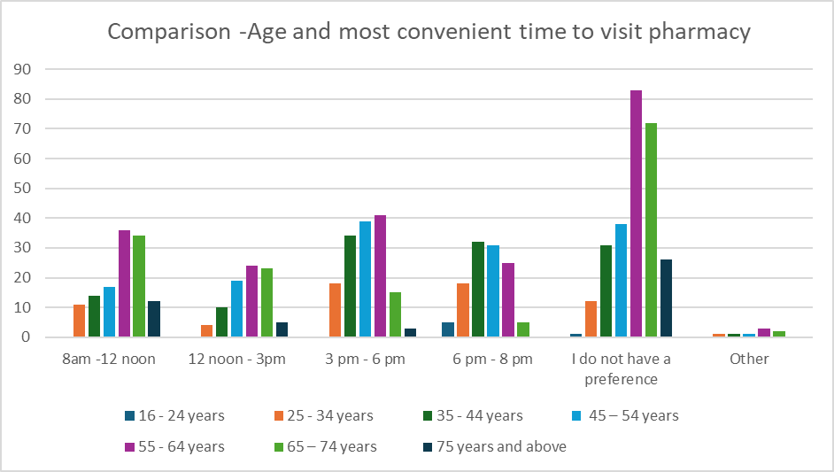
Out of 1,102 responses, 746 people answered both questions. The most popular time to visit a pharmacy for those aged 25 to 54 was 3pm to 6pm and 6pm to 8pm. Respondents aged 55 and over, generally did not have a preference in terms of what time was better for them to access the pharmacy.
When asked which the most convenient day to access a pharmacy 43% said they didn’t have a preference, 22% of responders said weekdays in general, and 18.14% said weekends in general.
When respondents’ normal pharmacy was closed, most respondents reported adapting by either attending another pharmacy or waiting until their usual pharmacy reopened. A smaller number indicated that they would seek support from other parts of the health system, such as contacting their GP, NHS 111 Wales or attending hospital. Multiple responses were permitted for this question.
Feedback also showed that most respondents demonstrate consistent pharmacy use, with over two-thirds reporting that they always use the same pharmacy and a further proportion using different pharmacies but preferring one most often. Only a small minority reported rarely using a pharmacy or consistently using different pharmacies.

Travel and Convenience
The questionnaire then looked at how people travel to pharmacies. Figure 25 below illustrates how people travel to a pharmacy. The pattern of travel has remained the same as 2021.
Figure 25 - if you go to the pharmacy how do you usually get there?
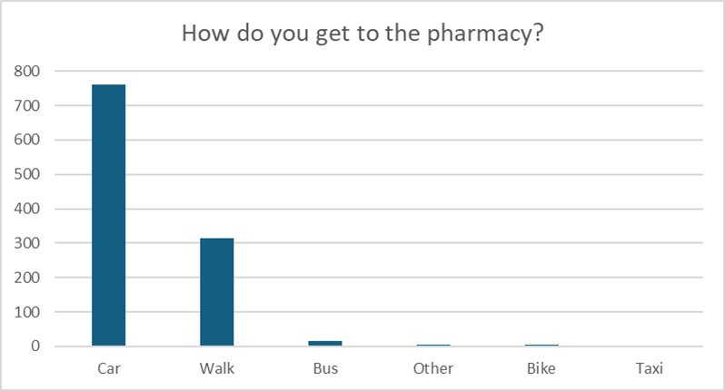
For the majority of the responders their journey time takes less than 15 minutes (90%), with 97.3% being within 20 minutes of a pharmacy. 2.6% of people who responded, state that it takes them more than 20 minutes to get to the pharmacy. Figure 26 below shows the journey times.
Figure 26 - how long does it usually take to get to the pharmacy?
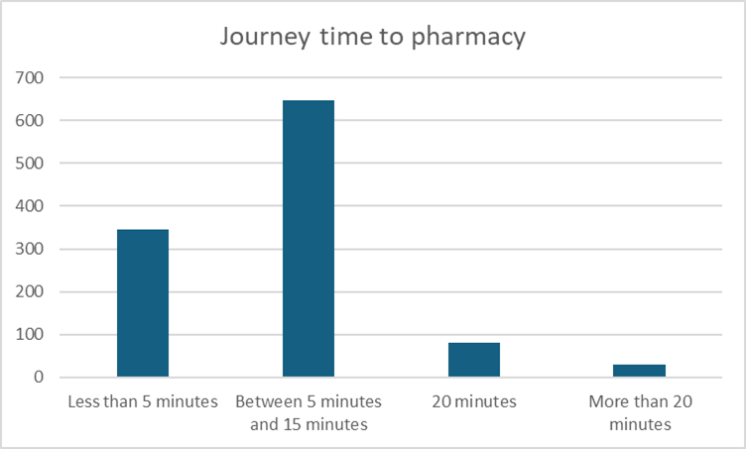

Influences for Choice of Pharmacy
When asked about choice of pharmacy most respondents reported consistent use of a community pharmacy, with 67.9% always using the same pharmacy and a further 29% using different pharmacies but preferring one most often. Only a small minority reported rarely using a pharmacy or consistently using different pharmacies.
When asked what influences their choice of pharmacy, respondents most commonly cited proximity and convenience, particularly pharmacies being close to home or GP practices and easy to access. Quality of service and trust were also important factors, including positive customer service, trust in pharmacy staff, continuity of use and confidence that medicines would be in stock. Practical considerations such as parking, speed of service and opening hours were also influential. Multiple responses were permitted for this question, and full results are provided in the appendix H.
When respondents indicated that they were aware of a closer or more convenient pharmacy that they did not use, the most commonly cited reasons related to service experience and practical barriers. These included perceptions of slower service, medicines not being available in stock, difficulty with parking, limited opening hours, and previous negative experiences. Issues relating to privacy, continuity of staff and familiarity with pharmacy teams were also reported. Additional reasons provided reflected loyalty to an existing pharmacy, prescriptions being sent to a particular location, co-location with GP practices, and wider operational factors. Full response details are provided in the appendix H.
When asked if there is a more convenient and/or closer pharmacy that they don’t use, 316 people responded yes and 306 went on to give a reason why (please note that multiple answers could be given to this question).
A proportion of respondents reported that they were aware of a more convenient or closer pharmacy that they did not use and provided reasons for this choice. These reasons most commonly related to loyalty to an existing pharmacy, prescriptions being sent to a particular location, service experience and staff behaviour, operational issues such as waiting times, and the convenience of co-location with GP practices. Additional detail on responses categorised as ‘other’ is provided in the appendix H.

Awareness of Pharmaceutical Services
Searching via the internet was the most popular way of finding information on a pharmacy for example, opening hours and services offered, this was followed looking in pharmacy windows or poster displayed in the pharmacy. Other popular choices for finding information, was the pharmacy webpage and calling the pharmacy directly.
When asked if they feel able to discuss something private with a pharmacist the majority either answered yes (53%) or maybe (21.3%). 12.4% of respondents however said no, which is of concern particularly as all pharmacies have an area for confidential consultations.
Whilst most respondents use a pharmacy to have a prescription dispensed, pharmacies do provide a range of clinical services. The questionnaire listed several services that are provided by all or the majority of pharmacies in the Health Board’s area and asked if respondents were aware of them.
Public awareness of NHS services available through community pharmacies in 2025 is largely unchanged from 2021. In both years, awareness is highest for established services such as flu vaccination, the common ailments scheme and smoking cessation support, while awareness of services such as discharge medicines reviews and emergency medicines supply remain lower. Although response numbers are higher in 2025, the overall pattern and relative awareness of services are consistent with 2021, indicating no significant change over time and highlighting an ongoing need to improve public awareness of the full range of pharmacy services. Appendix G lists the services covered by the questionnaire.

Experience of Accessing Services
There were 99 positive comments about pharmacies and 1 about dispensing doctors, 176 negative comments about pharmacies, and 125 observations, the detail is in appendix H.
Feedback highlighted delivery of medicines as a valued service, alongside the broader contribution of pharmacy teams to local healthcare. Positive comments most related to the standard and quality of service provided, improvements associated with the introduction of electronic prescribing and dispensing technologies, and the friendliness, helpfulness and approachability of pharmacy staff. This feedback closely mirrors that from 2021. In both years, positive comments emphasise the professionalism, approachability and community value of pharmacy staff. Negative comments are also consistent, focusing on waiting times, staffing pressures, stock availability, privacy and limited opening hours.
Alongside this positive feedback, respondents also identified areas where their experience could be improved. These included communication between GP practices and pharmacies, variation in service availability depending on location and pharmacist availability, and practical access issues such as opening hours, waiting times and stock availability. Additional concerns were raised about staff attitude and behaviour in some cases, experiences when accessing the common ailments service, and charges associated with compliance aids such as dosette boxes. Although more comments were received this time, the themes remain unchanged, indicating ongoing operational challenges alongside sustained public appreciation of community pharmacy services.

Summary of Key Engagement Themes
Overall, the findings highlight the central role of community pharmacies in providing accessible medicines supply and advice and provide important context for understanding how pharmaceutical services are accessed in practice across the Health Board area.

Pharmacy Contractor Feedback on Pharmaceutical Service Provision
This section summarises feedback received from community pharmacy contractors on their experience of delivering pharmaceutical services across the Health Board area. It provides contextual insight into how services operate in practice, including comments on current capacity and the ability to manage planned increases in service provision. The section outlines operational factors only and does not assess adequacy or identify gaps. A copy of the questionnaire is provided in Appendix I.

Overview of Community Pharmacy Engagement
An online questionnaire was issued to community pharmacies between 10 November and 22 December 2025. Responses were received from sixty-six of the one hundred and twenty-five community pharmacies in the Health Board area, representing a response rate of 53%.

Premises, Accessibility and Consultation Facilities
All responding community pharmacies confirmed that their premises are accessible to disabled people. The majority reported having a consultation room that meets the contractual requirements for the provision of advanced and clinical services, including being a closed and designated space suitable for confidential discussions. Almost all (97%) consultation areas were reported to be accessible by wheelchair. It should be noted that Health Board conducted monitoring visit data reflects that all pharmacies have consultation rooms meeting contractual requirements so there may be a degree of underreporting in the responses.
Pharmacies also reported the availability of staff who speak languages other than English. Welsh language capability was reported by a number of pharmacies, alongside a range of other languages, reflecting variation in linguistic support across the Health Board area.

Dispensing Activity and Appliance Provision
Pharmacies are required to dispense all valid NHS prescriptions for drugs and for appliances they supply “in the normal course of business”. Fifty-six pharmacies (85%) confirmed that they dispense all appliances, seven (11%) confirm they only dispense dressings, two do not dispense any appliances and one dispenses appliances other than those for incontinence.

Non-NHS Services Offered by Pharmacies
Some pharmacy services are not part of the core contractual framework and are outside the direct control of the Health Board. Contractors reported providing a range of services that sit outside the core NHS contractual framework.
All 66 of the pharmacies collect prescriptions from GP practices. Forty pharmacies deliver dispensed items to patients as a free-of-charge service. Seventeen provide delivery of drugs and 13 provide delivery of appliances as a private, chargeable service. Of those who provide the service free-of-charge, 22 restrict it to certain categories of patients for example those, those with mobility issues or who are housebound, older patients, disabled patients, and those in an NHS at risk group. Eight pharmacies restrict the delivery service to patients in specific geographical areas.

Gaps in the Current Provision of Existing Clinical Services
To help identify any potential gaps in the current provision of clinical services, pharmacy contractors were asked their opinions whether there is a need for any existing clinical service that is not currently available in the area, and to provide supporting evidence for their response
Forty of the 66 answered with 33 suggesting there was no current unmet need for existing services. Six responded that there was a need for another service but did not indicate services available in the Health Board area. These included four indicating a need for multi compartment compliance aids and two suggesting a covid vaccination service.

Pharmacy Perspectives on New Service Need.
When asked about potential need for new services, 38 of the 66 (57.57%) responded. Twenty-five respondents (64%) did not identify any need for any new services and two responded they were unsure.
Of the 11 respondents (29%) who identified a need, 8 indicated a need for a multi compartment compliance aid service with the remaining 3 suggesting blood pressure monitoring, weight management and travel vaccinations and ear wax removal and independent prescribing services. These views reflect individual contractor perceptions and do not represent formally assessed needs.

Ability to Meet Future Demand
Recognising that demand for pharmaceutical services is rising, driven by both the increasing volume of prescribed items and a growing population, pharmacies were asked whether they could accommodate this additional pressure. Most (fifty-seven pharmacies, 86.4%) reported having sufficient capacity within their existing premises and staffing levels, while a further 8 pharmacies (12.1%) indicated they could meet the increase with some adjustments. One pharmacy said that they didn’t have sufficient premises and staffing capacity and would have difficulty in managing an increase in demand.
Around half of responding community pharmacies (34 pharmacies, 51.5%) indicated plans to develop or expand premises or services. Reported plans included increasing consultation space, investing in infrastructure and technology (utilisation of a robot), workforce development, and expanding clinical or private service provision, reflecting anticipated future service evolution within existing contractual and policy frameworks.

Summary of Key Engagement Themes
Overall, pharmacy contractor feedback provides important context on the delivery of pharmaceutical services across the Health Board area, including accessibility, dispensing activity and operational capacity, and supports understanding of how services are provided in practice.

Dispensing Doctors Feedback on Pharmaceutical Service Provision

Overview of Dispensing Doctors’ Engagement
A separate questionnaire was issued to dispensing practices within the Health Board area over the same period. Responses were received from three of the twelve dispensing practices, representing a response rate of 25%. A copy of the questionnaire can be found in appendix J

Dispensary Opening and Service Provision
Responding practices reported dispensary opening hours that generally aligned with core GP opening times, with some variation at the end of the working week. Dispensing arrangements varied, with some practices dispensing all appliances and others limiting provision to dressings only.
Delivery services were reported by some practices, either free of charge for selected patient groups or as a chargeable service, while others reported no delivery provision.

Language Provision and Accessibility
Most responding practices reported providing services in English only, although Welsh language provision was reported at some sites either on specific days or at all times.

Capacity and Future Service Considerations
Most responding practices reported that they have sufficient capacity within existing premises and staffing levels to manage increases in dispensing demand, or that adjustments could be made if required.
When asked about unmet need or additional services, practices highlighted specific operational issues, including late dispensing for acute prescriptions, access to compliance aids for vulnerable patients, and the use of electronic prescribing. These views reflect the perspectives of responding practices and do not represent formally identified or validated needs.

Summary of Key Engagement Themes
Feedback relating to dispensing doctor practices highlights their role in supporting medicines supply and access for eligible patients, particularly in areas served by dispensing practices, and provides additional context for understanding how pharmaceutical services are delivered in these settings.
This chapter provides a baseline description of pharmaceutical service provision and experience across the Health Board area, which is used to inform the assessment presented in later chapters.

Chapter Four - Other NHS Services
A range of NHS services operate within the Health Board area that influence the demand for pharmaceutical services, either by generating prescriptions, signposting to community pharmacy services or by reducing the need for certain pharmacy services through direct supply or administration of medicines.

Demand Increase
General Medical Services (GMS) providers create the greatest demand for dispensing pharmaceutical services within primary care. During 2024/2025, the Health Board GMS providers prescribed 16,871,095 items, of which 15,727,062 (93.22%) were dispensed by community pharmacies in ABUHB. A further 290,940 items prescribed by GMS providers outside the Health Board area were also dispensed within ABUHB. Overall, GMS prescribing accounts for 97.25% of the community pharmacy dispensing workload in ABUHB.
Recent data shows a decline in both urgent and planned GP appointments, suggesting a shift in how patients are choosing to access primary care. This reduction may indicate growing demand on community pharmacies, with more patients opting to purchase medicines over the counter or make use of services such as the Common Ailment Service and the Pharmacy Independent Prescribing Service instead of engaging with their GP Practice. This trend highlights the significant role of community pharmacy in meeting patient needs and absorbing activity that might previously have been directed toward general practice.
General Dental Service (GDS) providers also create demand for dispensing services, with ABUHB Dentists prescribing 48,742 items in 2024/25. Dentists from outside the Health Board area were responsible for an additional 1,320 items, with a total of 50,004 dental items dispensed in community pharmacies in ABUHB, accounting for 3% of community pharmacy dispensing workload.
Ophthalmic Independent Prescribers within the Health Board area prescribed 7,108 prescriptions in 2024/25 and the overall number dispensed by ABUHB community pharmacies was 7,159. The implementation of NHS signed orders for Optometrists providing Welsh General Ophthalmic Services (WGOS) in April 2026 and the continued growth of the Independent Prescribing Optometry Service will also increase dispensing demand.
The Pharmacist Independent Prescriber service also created additional dispensing workload, with 24,018 items prescribed in ABUHB and 24,017 dispensed, and this activity is expected to grow further due to increasing numbers of pharmacists in training and the Welsh Government’s commitment to expanding the service.
Hospital services affect demand for dispensing as outpatient, A&E, and discharge prescriptions are dispensed in the community. Similarly, prescriptions issued by the Gwent Out of Hours service, the GMS Alternative Treatment Scheme, drug and alcohol services, and long-term conditions practitioner services increase demand for community pharmacy dispensing.
The Health Board hospital departments use community prescriptions (WP10HPs) so that outpatient and some discharge prescribing is dispensed by community pharmacies. During 2024/25 hospitals within ABUHB prescribed 257,374 items that were dispensed by community pharmacies within ABUHB. Community pharmacies within Newport West dispensed 18.84% of the total number of items, with the remainder evenly spread amongst community pharmacies within the other NCNs.
The Gwent Out of Hours (OOH) service prescribed 25,699 items in 2024/25, with 97.71% dispensed within the Health Board area. A further 2.01% were dispensed in other Health Boards across Wales, and 0.18% were dispensed in England. Within the Health Board, prescriptions issued by Gwent OOH were dispensed predominantly to community pharmacies located in Newport West (23.54%), Caerphilly South (14.12%), and Monmouthshire North (12.72%).
The Alternative Treatment Scheme service prescribed 1,534 in 2024/25 with 52.48% dispensed by community pharmacies in Caerphilly North and 34.29% in Newport West. The remaining 13.23% was dispensed by community pharmacies elsewhere within the Health Board’s area.
Aneurin Bevan Specialist Drug & Alcohol Service (ABSDAS) is an NHS Specialist Addiction Service dedicated to helping people with addiction and/or dependency needs. ABSDAS works with a variety of health, local authority and third sector partners to help people achieve their goals of abstinence or harm reduction. The service prescribed 1,666 items in 2024/25 all of which were dispensed by community pharmacies in Newport West (81.27%) and Newport East (18.73%).
The Gwent Drug and Alcohol Service is provided from a wide variety of bases across the Health Board’s area, operates within community venues and offers an outreach service. The service sees people with moderate complexity and is provided by a consortium of three organisations – Kaleidoscope, G4S and Barod. The service prescribed 12,383 items in 2024/25, distributed broadly across the Health Board area.
The Values Based Health Care Team within the Health Board, who run a project supporting people with type 2 diabetes, prescribed 1876 items in 2024/25, distributed broadly across the Health Board.
The HMP Usk and HMP Prescoed prisons are provided with primary medical services through a Service Level Agreement with a General Medical Service provider. During 2024/25, 24,214 prescriptions were written via the service with more than 99% of these dispensed via a community pharmacy in Raglan.
Repeat prescriptions for specialist continence appliances are managed by a team of specialist nurses in the ABUHB bladder and bowel service. During 2024/25, 41,834 prescriptions were written by the service, 70.02% of these were dispensed by English contractors, 28.48% by Dispensing Appliance Contractors operating in Wales, and 1.53% by community pharmacies within ABUHB. This high proportion of prescriptions being dispensed in England is largely driven by the significant number of English Dispensing Appliance Contractors (DACs) that operate well-established national home delivery services.
The community-based smoking cessation services operated by Help Me Quit rely on community pharmacies to make supplies of pharmacotherapy to support quit attempts. In 2024/25, 6,149 requests for pharmacotherapy were issued by Help Me Quit advisors and supplied by community pharmacies within ABUHB.

Demand Decrease
In contrast, some services reduce the need for pharmaceutical services. The GP practices in ABUHB personally administered 184,617 items to their patients. Minor injury units, and inpatient medicines which are supplied by hospital pharmacy departments can reduce the demand for dispensing essential services, additionally, sexual health hub clinics also reduce demand for certain pharmacy services, particularly emergency hormonal contraception, by providing comprehensive contraceptive and sexual health care.
The majority of prescriptions written by dispensing doctors for their dispensing patients are dispensed by the practice dispensaries. During 2024/25, Doctors with dispensing rights dispensed 708,660 prescription items for their eligible patients.
Smoking cessation support is provided across a range of settings, including community pharmacies, GP practices, hospitals, and community venues, and this wider provision influences the demand for pharmacy-based behavioural smoking cessation services.

Summary of Activity and Impact
The data demonstrates that a defined set of NHS services makes a material and ongoing contribution to pharmaceutical service dispensing activity, with most prescriptions generated by these services being dispensed locally within the Health Board area. Out of Hours services, drug and alcohol services, and the Alternative Treatment Scheme Service consistently generate prescription demand that is concentrated in specific areas, particularly Newport West, Caerphilly, and parts of Monmouthshire, indicating predictable patterns of pharmaceutical service utilisation linked to service location and population need.
The Health Board hospital service accounted for the majority of non-GP dispensing by a significant margin yet in overall terms accounted for only 1.56% of dispensing.
Drug and alcohol services account for a notable volume of prescriptions, reflecting the intensity and continuity of treatment required for this population. The prisons also account for a substantial but geographically concentrated level of demand. Importantly, this activity represents established and ongoing patterns of prescribing that are well understood by the system, allowing pharmaceutical service capacity and service provision to be planned for in a predictable and managed way rather than representing sporadic or unanticipated pressure.
Conversely, the data and service descriptions confirm that other NHS services, such as hospital inpatient care, personal administration by GP practices, minor injury units, prison pharmacy services, and sexual health clinics, reduce the need for pharmaceutical services dispensing for specific episodes of care by supplying or administering medicines directly.
Smoking cessation activity is delivered across multiple settings, including pharmacies, and this shared provision influences the scale and nature of pharmacy-based stop smoking services rather than eliminating demand.
Taken together, the data illustrates how pharmaceutical services operate within a wider system of care, with some services increasing dispensing demand in consistent and locality-specific ways, and others offsetting demand through direct provision, all of which is relevant to understanding current and future pharmaceutical service need.
Overall, these services form part of the wider healthcare system within which pharmaceutical services operate and are considered in assessing current and future pharmaceutical service need.

Chapter Five - Health Needs That Can Be Met by Pharmaceutical Services

Purpose and Context
Schedule 1 of the National Health Service (Pharmaceutical Services) (Wales) Regulations 2020 requires the Pharmaceutical Needs Assessment (PNA) to identify which health needs within the Health Board area can be met by pharmaceutical services. Chapter Two sets out the demographic profile, patterns of deprivation, health inequalities and disease burden across the population. This chapter builds on that evidence by identifying the aspects of those needs that fall within the scope of pharmaceutical services. It does not repeat the statistical analysis presented previously, nor does it assess the adequacy of current provision; that is addressed in Chapter Three and Chapter Six
Pharmaceutical services include essential and additional services provided by pharmacy contractors and dispensing appliance contractors (DACs), together with dispensing services provided by dispensing practices. Collectively, these services support safe access to medicines, optimisation of treatment, prevention of disease progression and development, urgent care needs, and delivery of selected public health interventions.
A high proportion of the population will require a prescription medicine or appliance at some point in their lives, irrespective of whether they are in one of the groups identified in Chapter Two, making prescribing one of the most widespread and routine interventions delivered by the NHS. This may be for a one-off course of antibiotics or for medication that they will need to take, or an appliance that they will need to use, for the rest of their life to manage a long-term condition. This health need can only be met within primary care by the provision of pharmaceutical services, be that by pharmacies, DACs or dispensing doctors.

Demographic Change and Long-Term Condition Management
The population profile described in Chapter Two demonstrates continued growth alongside a clear shift toward older age groups. The projected increase in residents aged sixty-five and over, and particularly those aged eighty-five and over, is associated with higher prevalence of long-term conditions, multimorbidity and complex medication regimens. These demographic changes directly translate into sustained and increasing need for pharmaceutical services.
Pharmaceutical services meet this need through the safe dispensing and clinical checking of prescriptions, discharge medicines review and disease-specific medicines management. As the number and complexity of prescribed medicines increase, so too does the need for medicines adherence and reduction of medicines-related harm. The ageing population also increases demand for compliance support, domiciliary services and medicines provision to care settings.
The pharmaceutical contribution to long-term condition management is therefore not limited to supply of medicines but extends to improving patient safety, therapeutic outcomes, and reducing avoidable hospital admissions.

Health Inequalities and Deprivation
Chapter Two identifies significant variation in deprivation across the Health Board area, together with clear inequalities in life expectancy and healthy life expectancy. Areas with higher levels of socioeconomic deprivation experience earlier onset of chronic disease, higher premature mortality and greater reliance on accessible primary care services.
Pharmaceutical services play an important role in addressing these inequalities. Community pharmacies provide walk‑in access without the need for an appointment and deliver NHS services free at the point of use. In deprived communities, they often act as the most immediately accessible healthcare setting. Through Clinical Community Pharmacy Services (CCPS)—including common ailment services, emergency medicines supply, and contraception services—community pharmacies support both prevention and early intervention. Alongside CCPS, wider services such as personalised medicines advice, smoking cessation support, and vaccination programmes further strengthen the role of pharmacies in improving population health and reducing avoidable illness.
The concentration of deprivation in certain local authority areas therefore generates proportionately greater demand for accessible pharmaceutical provision and preventative services.

Prevention and Public Health
The burden of preventable disease identified in Chapter Two gives rise to clear need for pharmaceutical services focused on prevention and risk reduction. Smoking, obesity, cardiovascular risk factors and respiratory disease contribute significantly to avoidable morbidity and mortality across the area.
Pharmaceutical services support public health objectives through vaccination services, smoking cessation programmes, contraception services, needle exchange and supervised consumption, alongside healthy lifestyle advice. These services complement wider public health initiatives and reduce pressure on general practice and urgent care settings.
Given the inequalities in healthy life expectancy described earlier, prevention-oriented pharmaceutical services are particularly relevant in communities experiencing poorer health outcomes.

Geographic Variation and Access
The Health Board area includes densely populated urban centres and rural communities with dispersed populations. Geographic variation influences how residents access healthcare services and creates differing demands on pharmaceutical provision.
In rural areas, continuity of medicines supply and the role of dispensing practices are particularly important. In urban settings, higher population density is associated with greater dispensing volumes and demand for urgent access services. Pharmaceutical services must therefore respond both to issues of capacity and to accessibility across varied geographic contexts.
This chapter identifies that such need exists; the assessment of whether current distribution aligns with these patterns is considered later.

Maternal, Reproductive and Family Health
Variation in fertility rates and population growth across local authorities creates ongoing demand for pharmaceutical services related to reproductive and family health. Contraception services, advice on medicines in pregnancy and breastfeeding, and common ailment services for children contribute to meeting this need.
In areas with higher fertility rates and younger population structures, demand for these services is proportionately greater. Pharmaceutical provision therefore supports both preventative and responsive care in this domain.

Mental Health and Substance Use
Socioeconomic inequalities are associated with higher prevalence of mental health conditions and substance misuse. Pharmaceutical services contribute through the safe dispensing of psychotropic medicines, supervised administration services, needle and syringe exchange programmes and adherence support. These services are integral to wider treatment pathways and support harm reduction objectives.

Urgent and Unplanned Care
Pharmaceutical services also meet needs arising from urgent but non-emergency health concerns. The Common Ailments Service, emergency medicines supply and additional services such as the urgent medicines service and the Pharmacy Independent Prescriber (PIPs) support care closer to home and help reduce avoidable attendance at GP practices and emergency departments.
As primary care systems experience sustained demand pressures, the role of community pharmacy as an accessible first point of contact becomes increasingly significant.

Future Need Over the Lifetime of the PNA
The combination of projected population growth, ageing demographics, persistent deprivation and increasing complexity of prescribing indicates that demand for pharmaceutical services will continue throughout the lifetime of this PNA. Growth is expected not only in the volume of dispensing activity but also in the complexity of medicines adherence, monitoring and preventative interventions.
Pharmaceutical services are therefore required to support:
- Management of long-term conditions and multimorbidity
- Medicines safety and adherence
- Prevention and early intervention
- Reduction of health inequalities
- Accessible urgent care support
- Continuity of medicines supply across rural and urban communities
Having identified the health needs that can appropriately be met by pharmaceutical services, the next chapter evaluates current provision at a local level to determine whether its location, accessibility and service mix are proportionate to both current and anticipated need.

Chapter Six – Assessment of Pharmaceutical Service Adequacy

Approach to Local Assessment
This chapter assesses whether current pharmaceutical service provision is adequate to meet the population and health needs identified in Chapter Two, taking account of the range of pharmaceutical and wider NHS services described in Chapters Three and Four.
The assessment is undertaken using a locality-based approach, structured by local authority area and Neighbourhood Care Network (NCN). Local authorities provide a clear and consistent geographic framework aligned with population data, while NCNs reflect the operational footprint for planning and delivering of primary care and community services.
To enable a more detailed consideration of local variation in access, capacity and demand the assessment of adequacy is undertaken at the NCN level.
This approach ensures that:
- Population and health needs identified in Chapter Two are systematically considered at a local level;
- Existing pharmaceutical services are assessed consistently and transparently; and
- Variation between localities is recognised, while maintaining a proportionate and manageable structure.
This chapter focuses on assessing the adequacy of current provision and identifying potential pressures or risks. The identification of specific gaps or future service requirements is addressed separately in the subsequent chapter. Each NCN will be assessed in turn, and a full breakdown of activity data for each NCN is included in each NCN section.
It should be noted that, during the preparation of this PNA there have been changes to the number of NCNs within ABUHB. Torfaen North and Torfaen South merged to become a single Torfaen NCN from 1 October 2025, and Blaenau Gwent East and Blaenau Gwent West formed a single Blaenau Gwent NCN from 1 April 2026.
In both instances, there have been no changes to the geographic footprint, population size, number of providers, existing services provision or the assessed pharmaceutical need.
While essential services and some additional clinical services are assessed at NCN level to reflect local access and capacity, a number of more specialist services are commissioned across the Health Board footprint. These services are therefore assessed at a Health Board level to reflect commissioning arrangements and avoid unnecessary duplication within each locality assessment.
The pharmaceutical services provided by Dispensing doctors are strictly defined and limited by national regulation, and the Health Board has no discretion to extend their scope beyond the statutory framework described in Chapter one.

Pharmaceutical Services Commissioned on a Pan Gwent Footprint.
While essential and additional clinical services are assessed at NCN level, a number of enhanced and specialist services are commissioned across the Health Board footprint. These services are therefore assessed separately to avoid duplication and to better reflect commissioning intent. These services are designed to meet population need across the Gwent footprint and are predominantly commissioned based on demand, service utilisation, and provider capability.
As such, the absence of these services within an individual NCN does not indicate a gap in provision. Patients, service users and partner organisations routinely access these services across locality boundaries and providers are selected to ensure appropriate coverage, resilience and quality.
The Health Board has undertaken a consolidated assessment of these services at an all-Gwent level, taking account of location, activity data, service utilisation and population need. The Health Board is satisfied that current provision is sufficient to meet the present and anticipated future needs of the population.
The services included within this approach are included below:
- Care Home Pharmaceutical Services
Care home pharmaceutical services are not routinely commissioned within every locality. Care homes are able to access services from providers across the Health Board footprint, and current arrangements are sufficient to meet demand.
- Inhaler Use Review Service
Uptake of the Inhaler Use Review service remains relatively low across the Health Board and current demand is fully manageable within existing provider capacity
- Blood Borne Virus Service
The Blood Borne Virus service is commissioned in line with identified need. Activity levels remain low and are adequately supported by existing providers.
- Needle Exchange
Needle exchange provision is planned in partnership with the Gwent Area Planning Board, based on assessed population need. Services are delivered through a combination of specialist providers and community pharmacies, and current provision is sufficient to meet need across the Health Board.
- Tuberculosis Directly Observed Therapy (DOTS) Team Supply Service
The Tuberculosis DOTS service is commissioned on a case-by-case basis in response to identified need. There is no requirement for universal provision, and current arrangements are sufficient.
- Out of Hours Palliative Care Service
Palliative care pharmaceutical services are commissioned on a Gwent-wide basis to ensure appropriate geographic coverage and timely access to medicines. Current provision is sufficient to meet patient need.
- Urgent Medicines Service
The Urgent Medicines Service is commissioned across the Health Board, with participating pharmacies providing access for the whole population. Current provision is sufficient to meet demand.
Table 7- Assessment of Adequacy
Service | Commissioning Basis | Coverage Approach | Adequacy assessment
Care Homes | HB-wide / provider choice | Cross-boundary | Adequate
IUR | Targeted | Selected providers | Adequate
BBV | Need-based | Limited providers | Adequate
Needle Exchange | GAPB-informed | Network model | Adequate
TB DOTS | Case-based | As required | Adequate
Palliative Care | HB-wide | Geographic spread | Adequate
Urgent Medicines | HB-wide | Network coverage | Adequate

These services are intentionally commissioned on a Health Board-wide or targeted basis. The Health Board has not identified any current or future need to expand provision to all pharmacies or localities, as patient need is being met through the existing network of providers. The Health Board will continue to monitor activity and population need over the lifetime of this PNA and will review commissioning arrangements where required.

Blaenau Gwent
Blaenau Gwent has the smallest population within the Health Board area and experiences some of the highest levels of socioeconomic deprivation. Chapter Two identifies that it has the highest proportion of Lower Super Output Areas within the most deprived national deciles and the highest rate of premature mortality from key non-communicable diseases across Gwent. Life expectancy and healthy life expectancy are lower than in other local authorities, with marked inequality gaps.
The age structure reflects a mature working-age population with growing numbers of older residents. Although overall population growth is modest, the burden of preventable disease and earlier onset of long-term conditions remains pronounced. There are sixteen pharmacies in this area. Provision in Blaenau Gwent must respond to:
- Higher prevalence of cardiovascular disease, respiratory disease and multimorbidity;
- Elevated need for medicines optimisation and adherence support;
- Strong demand for preventative interventions (e.g., smoking cessation, vaccination);
- Accessible services for deprived communities with potentially lower engagement with scheduled primary care;
- The characteristics of a Deep End population -meaning communities living in the most socioeconomically deprived areas- including higher clinical complexity, increased consultation rates and the need for proactive, outreach-based and accessible models of care to address inequalities in access and outcomes.
Community pharmacies are particularly important in mitigating inequality-driven health need and providing accessible walk-in clinical support. As described earlier in this chapter, from 1 April 2026, Blaenau Gwent will be considered as a single NCN following the merger of East and West. The assessments that follow are not altered by the merger.

Blaenau Gwent East
Blaenau Gwent East includes valley communities with longstanding socioeconomic challenges and higher levels of deprivation relative to the Health Board average. The locality experiences inequality in life expectancy and a continued burden of preventable ill health, contributing to sustained demand for accessible primary care services. The population profile reflects established communities with an increasing proportion of older residents. This demographic pattern, combined with deprivation-related health inequality, is associated with higher prevalence of chronic conditions, multimorbidity and complex prescribing requirements. Pharmaceutical need within Blaenau Gwent East is therefore shaped by long-term condition management, medicines optimisation and adherence support, alongside preventative interventions targeting smoking, cardiovascular risk and respiratory disease. There are seven pharmacies in this area.

Provision of Pharmaceutical Services
The tables below outline the NHS pharmaceutical services currently available within Blaenau Gwent East, together with the current provision and the activity levels for each service during 2024/25.
Table 8 – Activity Data Blaenau Gwent East
Blaenau Gwent East: Additional Clinical Service Activity 2024/25 |  |  |  |  |  | ABUHB
Number of Pharmacies |  |  |  | 7 |  | 125
Weighted registered practice population |  |  |  | 33,370 |  | 618,679
Number of pharmacies per 10,000 patients |  |  |  | 2.10 |  | 2.02
Additional Clinical Service | Number of pharmacies commissioned | Percentage of pharmacies commissioned | Activity |  | Activity per 10,000 patients | Activity per 10,000 patients
Common Ailment Service (CCPS) | 7 | 100% | 3178  Consultations |  | 952  Consultations | 1,142 Consultations
Contraception Service  (CCPS) | 7 | 100% | 200  Consultations |  | 60  Consultations | 74 Consultations
Emergency Medicines Supply Service (CCPS) | 7 | 100% | 438  Consultations |  | 131  Consultations | 376 Consultations
Pharmacy Independent Prescribing Service | 4 | 57% | 681  Consultations |  | 204  Consultations | 399 Consultations
Discharge Medicine Review Service | 7 | 100% | 145  Reviews |  | 43  Reviews | 40  Reviews
Influenza Vaccination Service | 7 | 100% | 604  Vaccinations |  | 181  Vaccinations | 235 Vaccinations
Inhaler Review Service Level 1 | 1 | 14% | 100  Consultations |  | 30  Consultations | 19 Consultations
Inhaler Review Service Level 2 | 1 | 14% | 0 |  | 0 | 0
Supervised Administration Service | 7 | 100% | 6,336 Supervisions |  | 1,899  Supervisions | 1,138 Supervisions
Lateral Flow Test Service | 5 | 71% | 171  Tests supplied |  | 51  Tests supplied | 38  Tests Supplied
Care Home Service | 0 | 0% | 0 |  | 0 | 1  Care Home
Smoking Cessation Level 2 Service | 7 | 100% | 300  Contacts |  | 90  Contacts | 81  Contacts
Smoking Cessation Level 3 Service | 6 | 86% | 272  Quit attempts |  | 82  Quit Attempts | 57  Quit Attempts
Needle Exchange Service | 2 | 29% | 954  Interactions |  | 286  Interactions | 115 Interactions
Blood Borne Virus Service | 1 | 14% | 0 |  | 0 | 5  Tests
Medication Administration Record Service | 4 | 57% | 13  patients |  | 4  Patients | 38  Patients
Waste Reduction Service | 6 | 86% | 968  Interventions |  | 290  Interventions | 267 Interventions
Tuberculosis DOTS Supply Service | 0 | 0% | 0 |  | 0 | 4  Patients
Palliative Care Out of Hours Rota Service | 0 | N/A | N/A |  | N/A | N/A
Urgent Medicines Service Level 1 | 1 | 14% | N/A |  | N/A | N/A
Urgent Medicines Service Level 2 | 0 | 0% | N/A |  | N/A | N/A
Out of Hours Rota Service | 4 | 57% | N/A |  | N/A | N/A
Table 9 – Activity Data Blaenau Gwent East
Blaenau Gwent East: Dispensing Activity 2024/25 |  |  |  | ABUHB
Number of Pharmacies |  |  | 7 | 125
Weighted registered practice population |  |  | 33,370 | 618,679
Number of pharmacies per 10,000 patients |  |  | 2.10 | 2.02
Prescriber | Total Number of prescriptions | Prescriptions Dispensed per 10,000 Weighted Population |  | Prescriptions Dispensed per 10,000 Weighted Population
All | 947,658 | 283,985 |  | 266,224
ABUHB GP | 928,568 | 278,264 |  | 254,204
Other Health Board GP | 216 | 65 |  | 4,624
Hospital | 11,956 | 3,583 |  | 4,160
Dentist | 2,600 | 779 |  | 809
Welsh Unidentified | 886 | 266 |  | 718
ABUHB Prison | 0 | 0 |  | 431
ABUHB OOH | 1,038 | 311 |  | 406
Pharmacy IP | 588 | 176 |  | 388
GDAS | 931 | 279 |  | 195
Ophthalmic IP | 637 | 191 |  | 116
English Prescriber | 28 | 8 |  | 79
ABUHB VBH Team | 186 | 56 |  | 30
ABSDAS | 0 | 0 |  | 27
ATS | 0 | 0 |  | 25
ABUHB Continence Service | 18 | 5 |  | 10
ABUHB Podiatry | 6 | 2 |  | 2
Welsh Ambulance Service | 0 | 0 |  | 0.15

Pharmaceutical Services Accessed Outside the Locality
Some residents choose to access contractors outside both the locality and the Health Board’s area either for pharmaceutical services located near to where they work, shop or visit or to access the services offered by Dispensing Appliance Contractors.
An analysis of prescribing activity across the five GP practices within the locality during 2024/25 shows that the majority of prescriptions were dispensed by pharmacies located within the NCN area. However, a notable minority, 9.4% of all prescriptions, were dispensed outside the locality. While this represents a relatively small proportion of total dispensing activity, it nonetheless highlights meaningful levels of out-of-area utilisation.
Across the locality, the largest share of external dispensing occurred within neighbouring localities. Caerphilly East accounted for 3.7% of prescriptions dispensed outside the locality, followed by Blaenau Gwent West at 1.9%. Smaller proportions were dispensed across the remaining localities. A further small share of prescriptions was dispensed by pharmacies in other Health Boards, while a similar proportion was handled by contractors in England. Additionally, a small proportion of prescriptions were recorded as personally administered items rather than being dispensed through community pharmacies.
There may have been additional use of pharmaceutical services from pharmacies situated outside the locality and the Health Board area. This activity cannot be quantified because it is not captured within the recorded dataset.

Choice and Access to Pharmaceutical Services
Most residents who live within the locality and are registered with one of the five GP practices typically use one of the local pharmacies to have their prescriptions dispensed. However, a proportion of patients choose to obtain their prescriptions elsewhere. This is usually because they prefer a neighbouring pharmacy or a dispensing appliance contractor located closer to where they work, shop, spend leisure time, or for another personal reason.
In terms of access, a detailed list of Community Pharmacy opening hours can be found in appendix N.

Other NHS Services Influencing Pharmaceutical Need
Further information regarding the influence of other NHS services on pharmaceutical need is set out in Chapter Four. The Health Board’s assessment has identified no additional NHS services that are expected to affect pharmaceutical need in Blaenau Gwent East

Assessment of Adequacy of Pharmaceutical Service Provision
Pharmacies within the locality are well distributed, with sites positioned across the area in locations characterised by higher population density and greater levels of deprivation. This distribution supports accessibility for residents who are most likely to require regular pharmaceutical services. Analysis of drive-time accessibility indicates that almost the entire locality falls within a 10-minute drive of a pharmacy. The only area outside this threshold is a small section of land with no resident population and therefore does not present an access concern.
Population projections for Blaenau Gwent County Borough Council indicate a slight increase in overall population over the coming years. However, the scale of this growth is modest, meaning that any resulting rise in demand for pharmaceutical services is expected to be limited.
There are currently no additional housing sites identified within the current Local Development Plan (LDP) 2006–2021 that fall within the timeframe of this document. As the LDP has not been updated since the last Pharmaceutical Needs Assessment (PNA), no new residential development is expected to come forward that would create population driven pressure on pharmacy services.
Four out of seven pharmacies operating within the locality responded to the contractor questionnaire. Three confirmed that they possess sufficient capacity—both in terms of premises and staffing—to accommodate any increase in demand for the services they provide. The fourth indicated that although they did not have premises and staffing capacity at present, they could make adjustments to manage any increase in demand. This demonstrates a stable and resilient level of service provision across the area.
Based on the evidence reviewed, the Health Board is satisfied that the current provision of essential pharmaceutical services is adequate to meet the present and anticipated future needs of the population within this locality.
In respect of additional pharmaceutical services, the Health Board has undertaken a comprehensive review of provision within the NCN, including core nationally commissioned services such as the Clinical Community Pharmacy Service, the Seasonal Influenza Vaccination Service and Discharge Medicines Reviews, alongside Help Me Quit (Smoking Cessation). Each service has been assessed in terms of the number of contractors commissioned to deliver it, the level of activity observed, and the extent to which current provision reflects identified local need. A detailed breakdown of service provision and utilisation is set out in Table 8 and 9 above.
This assessment indicates that, across these services, current levels of provision and activity are sufficient to meet the needs of the local population, with no evidence of unmet demand or requirement for additional commissioning within the NCN at this time.
A range of other additional pharmaceutical services, including care home support, inhaler use review, blood borne virus testing, needle exchange, tuberculosis DOTS, palliative care and urgent medicines services, are commissioned either on a Gwent-wide basis or in response to specific population need, rather than being uniformly available within every locality. Consistent with the approach set out in Section 6.2, these services have been assessed at a whole-system level to reflect commissioning arrangements, service configuration and patterns of utilisation.
The Health Board is satisfied that current Gwent-wide and targeted provision of these services is sufficient to meet the needs of residents in this locality, and their absence within the NCN footprint does not represent a gap in service provision.
Based on the information set out in Tables 8 and 9 and the accompanying detail above, the Health Board is satisfied that existing pharmaceutical services, including provision accessed in neighbouring localities, are currently sufficient to meet identified need.

Blaenau Gwent West
Blaenau Gwent West includes established valley communities with persistent socioeconomic deprivation and associated health inequality. While sharing similar structural challenges to other parts of the borough, this locality includes areas with concentrated need and higher demand for accessible frontline healthcare services. Health need within Blaenau Gwent West is influenced by elevated prevalence of chronic conditions, including cardiovascular and respiratory disease, alongside behavioural risk factors that contribute to preventable ill health. These factors generate sustained demand for medicines optimisation, adherence support and preventative pharmaceutical services. There are nine pharmacies in this area.

Provision of Pharmaceutical Services
The tables below outline the NHS pharmaceutical services currently available within Blaenau Gwent West, together with the current provision and the activity levels for each service during 2024/25.
Table 10- Activity Data Blaenau Gwent West
Blaenau Gwent West: Additional Clinical Service Activity 2024/25 |  |  |  |  |  | ABUHB
Number of Pharmacies |  |  |  | 9 |  | 125
Weighted registered practice population |  |  |  | 39,108 |  | 618,679
Number of pharmacies per 10,000 patients |  |  |  | 2.30 |  | 2.02
Additional Clinical Service | Number of pharmacies commissioned | Percentage of pharmacies commissioned | Activity |  | Activity per 10,000 patients |  | Activity per 10,000 patients
Common Ailment Service (CCPS) | 9 | 100% | 5940  Consultations |  | 1,519  Consultations |  | 1,142 Consultations
Contraception Service  (CCPS) | 9 | 100% | 314  Consultations |  | 680  Consultations |  | 74 Consultations
Emergency Medicines Supply Service (CCPS) | 9 | 100% | 746  Consultations |  | 191  Consultations |  | 376 Consultations
Pharmacy Independent Prescribing Service | 4 | 44% | 2327  Consultations |  | 595  Consultations |  | 399 Consultations
Discharge Medicine Review Service | 9 | 100% | 209  Reviews |  | 53  Reviews |  | 40  Reviews
Influenza Vaccination Service | 9 | 100% | 877  Vaccinations |  | 224  Vaccinations |  | 235 Vaccinations
Inhaler Review Service Level 1 | 4 | 44% | 298  Consultations |  | 76  Consultations |  | 19 Consultations
Inhaler Review Service Level 2 | 4 | 44% | 0 |  | 0 |  | 0
Supervised Administration Service | 9 | 100% | 8510 Supervisions |  | 2,176  Supervisions |  | 1,138 Supervisions
Lateral Flow Test Service | 7 | 78% | 120  Tests supplied |  | 31  Tests supplied |  | 38  Tests Supplied
Care Home Service | 0 | 0% | 0 |  | 0 |  | 1  Care Home
Smoking Cessation Level 2 Service | 9 | 100% | 471  Contacts |  | 120  Contacts |  | 81  Contacts
Smoking Cessation Level 3 Service | 7 | 78% | 268  Quit attempts |  | 69  Quit Attempts |  | 57  Quit Attempts
Needle Exchange Service | 2 | 22% | 534  Interactions |  | 137  Interactions |  | 115 Interactions
Blood Borne Virus Service | 1 | 11% | 18 tests |  | 5 |  | 5  Tests
Medication Administration Record Service | 5 | 56% | 21  patients |  | 5  Patients |  | 38  Patients
Waste Reduction Service | 7 | 78% | 1052  Interventions |  | 269  Interventions |  | 267 Interventions
Tuberculosis DOTS Supply Service | 0 | 0% | 0 |  | 0 |  | 4  Patients
Palliative Care Out of Hours Rota Service | 0 | 0% | N/A |  | N/A |  | N/A
Urgent Medicines Service Level 1 | 1 | 11% | N/A |  | N/A |  | N/A
Urgent Medicines Service Level 2 | 0 | 0% | N/A |  | N/A |  | N/A
Out of Hours Rota Service | 3 | 33% | N/A |  | N/A |  | N/A
Table 11- Activity Data Blaenau Gwent West
Blaenau Gwent West: Dispensing Activity 2024/25 |  |  |  | ABUHB
Number of Pharmacies |  |  | 9 | 125
Weighted registered practice population |  |  | 39,108 | 618,679
Number of pharmacies per 10,000 patients |  |  | 2.30 | 2.02
Prescriber | Total Number of prescriptions | Prescriptions Dispensed per 10,000 Weighted Population |  | Prescriptions Dispensed per 10,000 Weighted Population
All | 1,189,670 | 304,201 |  | 266,224
ABUHB GP | 1,161,176 | 296,915 |  | 254,204
Other Health Board GP | 2,302 | 589 |  | 4,624
Hospital | 15,151 | 3,874 |  | 4,160
Dentist | 4,476 | 1,145 |  | 809
Welsh Unidentified | 782 | 200 |  | 718
ABUHB Prison | 0 | 0 |  | 431
ABUHB OOH | 1,467 | 375 |  | 406
Pharmacy IP | 2,166 | 554 |  | 388
GDAS | 1,201 | 307 |  | 195
Ophthalmic IP | 262 | 67 |  | 116
English Prescriber | 140 | 36 |  | 79
ABUHB VBH Team | 445 | 114 |  | 30
ABSDAS | 0 | 0 |  | 27
ATS | 16 | 4 |  | 25
ABUHB Continence Service | 79 | 20 |  | 10
ABUHB Podiatry | 5 | 1 |  | 2
Welsh Ambulance Service | 2 | 1 |  | 0.15

Pharmaceutical services accessed outside the locality
Some residents choose to access contractors outside both the locality and the Health Board’s area either for pharmaceutical services located near to where they work, shop or visit or to access the services offered by Dispensing Appliance Contractors.
Whilst the majority of prescriptions written in 2024/25 by the five GP practices within the NCN were dispensed by pharmacies within the locality, around 4% were dispensed elsewhere, reflecting a small but meaningful level of out‑of‑area dispensing.
Only very small proportions of prescriptions were dispensed across the remaining localities, with similarly small amounts handled by pharmacies in other Health Boards or by contractors in England. A further small share of items was recorded as personally administered rather than being dispensed through community pharmacies.
There may also have been additional use of pharmaceutical services from pharmacies situated outside both the locality and the Health Board area. This activity cannot be quantified because it is not captured within the recorded dataset

Choice and Access to Pharmaceutical Services
Most residents who live within the locality and are registered with one of the five GP practices typically use one of the local pharmacies to have their prescriptions dispensed. However, a proportion of patients choose to obtain their prescriptions elsewhere. This is usually because they prefer a neighbouring pharmacy or a dispensing appliance contractor located closer to where they work, shop, spend leisure time, or for another personal reason.
In terms of access, a detailed list of Community Pharmacy opening hours can be found in appendix N

Other NHS Services Influencing Pharmaceutical Need
Further information regarding the influence of other NHS services on pharmaceutical need is set out in Chapter Four. The Health Board’s assessment has identified no additional NHS services, that are expected to affect pharmaceutical need in Blaenau Gwent West.

Assessment of Adequacy of Pharmaceutical Service Provision
The pharmacies within the Blaenau Gwent West NCN are well distributed across areas of higher population density and deprivation, with all residents living within a 10-minute drive time of a pharmacy.
Projections for Blaenau Gwent County Borough Council show only a small rise in population in the coming years, suggesting that any additional pressure on pharmaceutical services will be minimal. A single housing development in Ebbw Vale was identified within the LDP 2006–2021, with a capacity of 805 new homes. As the LDP has not been updated since the last PNA, this remains the most recent formally adopted housing allocation. While the development will contribute to population growth, it is not expected to significantly affect demand for pharmaceutical services.
Eight out of nine pharmacies operating within the locality responded to the contractor questionnaire. Seven confirmed that they possess sufficient capacity—in terms of premises and staffing—to accommodate any increase in demand for the services they provide. One provider reported that they would struggle to accommodate increased demand due to limited premises and insufficient staffing capacity. This indicates a reliable and resilient level of service throughout the area.
Based on the evidence reviewed, the Health Board is satisfied that the current provision of essential pharmaceutical services is adequate to meet the present and anticipated future needs of the population within this locality.
In respect of additional pharmaceutical services, the Health Board has undertaken a comprehensive review of provision within the NCN, including core nationally commissioned services such as the Clinical Community Pharmacy Service, the Seasonal Influenza Vaccination Service and Discharge Medicines Reviews, alongside Help Me Quit (Smoking Cessation). Each service has been assessed in terms of the number of contractors commissioned to deliver it, the level of activity observed, and the extent to which current provision reflects identified local need. A detailed breakdown of service provision and utilisation is set out in Tables 10 and 11 above.
This assessment indicates that, across these services, current levels of provision and activity are sufficient to meet the needs of the local population, with no evidence of unmet demand or requirement for additional commissioning within the NCN at this time.
A range of other additional pharmaceutical services, including care home support, inhaler use review, blood borne virus testing, needle exchange, tuberculosis DOTS, palliative care and urgent medicines services, are commissioned either on a Gwent-wide basis or in response to specific population need, rather than being uniformly available within every locality. Consistent with the approach set out in Section 6.2, these services have been assessed at a whole-system level to reflect commissioning arrangements, service configuration and patterns of utilisation.
The Health Board is satisfied that current Gwent-wide and targeted provision of these services is sufficient to meet the needs of residents in this locality, and their absence within the NCN footprint does not represent a gap in service provision.
Based on the information set out in Tables 10 and 11 and the accompanying detail above, the Health Board is satisfied that existing pharmaceutical services, including provision accessed in neighbouring localities, are currently sufficient to meet identified need

Caerphilly - Local Context and Population Summary
Caerphilly is the largest local authority within the Health Board by population. Chapter two highlights a mixed socioeconomic profile, with significant pockets of deprivation, particularly in the north of the borough. Premature mortality rates are above the best-performing areas in Gwent, and healthy life expectancy remains lower in more deprived communities.
The population structure includes a substantial working-age cohort alongside a growing older population. Projected demographic change indicates continued pressure on long-term condition management services. There are forty-one pharmacies within this area, provision in Caerphilly must address:
- High overall prescribing volume associated with population size;
- Long-term condition management across both deprived and mixed communities;
- Preventative public health need linked to smoking, obesity and cardiovascular risk;
- Medicines support for a growing older population; and
- The characteristics of a Deep End population, including higher clinical complexity, increased consultation rates and the need for proactive, outreach-based and accessible models of care to address inequalities in access and outcomes.
The scale of the population means capacity, accessibility and distribution of services are key considerations in the subsequent assessment of provision.

Caerphilly East
Caerphilly East comprises a mixed urban and semi-rural population with areas of socioeconomic variation. While benefiting from proximity to transport links and economic centres, parts of the locality experience higher levels of deprivation and associated health inequality. The population includes a substantial working-age cohort alongside a growing number of older residents, contributing to sustained demand for long-term condition management. The ageing demographic profile within parts of the locality increases demand for polypharmacy support, monitoring of high-risk medicines and services that enable people to remain independent at home. In more deprived neighbourhoods, community pharmacies play an important role as accessible points of contact for advice, urgent supply of medicines and public health interventions. There are thirteen pharmacies in this area.

Provision of Pharmaceutical Services
The tables below outline the NHS pharmaceutical services currently available within Caerphilly East, together with the current provision and the activity levels for each service during 2024/25.
Table 12 - Activity Data Caerphilly East
Caerphilly East: Additional Clinical Service Activity 2024/25 |  |  |  |  |  | ABUHB
Number of Pharmacies |  |  |  | 13 |  | 125
Weighted registered practice population |  |  |  | 67,505 |  | 618,679
Number of pharmacies per 10,000 patients |  |  |  | 1.93 |  | 2.02
Additional Clinical Service | Number of pharmacies commissioned | Percentage of pharmacies commissioned | Activity |  | Activity per 10,000 patients | Activity per 10,000 patients
Common Ailment Service (CCPS) | 13 | 100% | 5,279  Consultations |  | 782  Consultations | 1,142 Consultations
Contraception Service  (CCPS) | 13 | 100% | 313  Consultations |  | 46  Consultations | 74 Consultations
Emergency Medicines Supply Service (CCPS) | 13 | 100% | 1,355  Consultations |  | 201  Consultations | 376 Consultations
Pharmacy Independent Prescribing Service | 6 | 46% | 1,749  Consultations |  | 259  Consultations | 399 Consultations
Discharge Medicine Review Service | 13 | 100% | 86  Reviews |  | 13  Reviews | 40  Reviews
Influenza Vaccination Service | 11 | 85% | 1398  Vaccinations |  | 207  Vaccinations | 235 Vaccinations
Inhaler Review Service Level 1 | 1 | 8% | 10  Consultations |  | 1  Consultations | 19 Consultations
Inhaler Review Service Level 2 | 1 | 8% | 0 |  | 0 | 0
Supervised Administration Service | 10 | 77% | 5,103 Supervisions |  | 756  Supervisions | 1,138 Supervisions
Lateral Flow Test Service | 8 | 62% | 78  Tests supplied |  | 12  Tests supplied | 38  Tests Supplied
Care Home Service | 0 | 0% | 0 |  | 0 | 1  Care Home
Smoking Cessation Level 2 Service | 12 | 92% | 252  Contacts |  | 37  Contacts | 81  Contacts
Smoking Cessation Level 3 Service | 8 | 62% | 352  Quit attempts |  | 52  Quit Attempts | 57  Quit Attempts
Needle Exchange Service | 1 | 8% | 25  Interactions |  | 4  Interactions | 115 Interactions
Blood Borne Virus Service | 1 | 8% | 1 |  | 0 | 5  Tests
Medication Administration Record Service | 7 | 54% | 150  patients |  | 22  Patients | 38  Patients
Waste Reduction Service | 10 | 77% | 862  Interventions |  | 128  Interventions | 267 Interventions
Tuberculosis DOTS Supply Service | 0 | 0% | 0 |  | 0 | 4  Patients
Palliative Care Out of Hours Rota Service | 1 | 8% | N/A |  | N/A | N/A
Urgent Medicines Service Level 1 | 1 | 8% | N/A |  | N/A | N/A
Urgent Medicines Service Level 2 | 1 | 0% | N/A |  | N/A | N/A
Out of Hours Rota Service | 5 | 38% | N/A |  | N/A | N/A
Table 13- Activity Data Caerphilly East
Caerphilly East: Dispensing Activity 2024/25 |  |  |  | ABUHB
Number of Pharmacies |  |  | 13 | 125
Weighted registered practice population |  |  | 67,505 | 618,679
Number of pharmacies per 10,000 patients |  |  | 1.93 | 2.02
Prescriber | Total Number of prescriptions | Prescriptions Dispensed per 10,000 Weighted Population |  | Prescriptions Dispensed per 10,000 Weighted Population
All | 1,750,478 | 259,311 |  | 266,224
ABUHB GP | 1,695,600 | 251,181 |  | 254,204
Other Health Board GP | 15,001 | 2,222 |  | 4,624
Hospital | 25,685 | 3,805 |  | 4,160
Dentist | 4,523 | 670 |  | 809
Welsh Unidentified | 4,514 | 669 |  | 718
ABUHB Prison | 0 | 0 |  | 431
ABUHB OOH | 1,562 | 231 |  | 406
Pharmacy IP | 1,643 | 243 |  | 388
GDAS | 1,041 | 154 |  | 195
Ophthalmic IP | 458 | 68 |  | 116
English Prescriber | 119 | 18 |  | 79
ABUHB VBH Team | 189 | 28 |  | 30
ABSDAS | 0 | 0 |  | 27
ATS | 82 | 12 |  | 25
ABUHB Continence Service | 51 | 8 |  | 10
ABUHB Podiatry | 10 | 1 |  | 2
Welsh Ambulance Service | 0 | 0 |  | 0.15

Pharmaceutical Services Accessed Outside the Locality
Some residents choose to access contractors outside both the locality and the Health Board’s area either for pharmaceutical services located near to where they work, shop or visit or to access the services offered by Dispensing Appliance Contractors.
Whilst the majority of prescriptions written in 2024/25 by the seven GP practices within the NCN were dispensed by pharmacies within the locality, around 8.5% were dispensed elsewhere, a level of out‑of‑area dispensing that remains within an acceptable range and is not a cause for concern. Within this, around 3.8% were dispensed in Caerphilly North, and a further 2.7% were dispensed by pharmacies in other Health Boards, representing the largest share of out‑of‑area activity.
Only very small proportions of prescriptions were dispensed across the remaining localities, with similarly small amounts handled by contractors in England. A further small share of items was recorded as personally administered rather than being dispensed through community pharmacies.
There may also have been additional use of pharmaceutical services from pharmacies situated outside both the locality and the Health Board area. This activity cannot be quantified because it is not captured within the recorded dataset.

Choice and Access to Pharmaceutical Services
Most residents who live within the locality and are registered with one of the seven GP practices typically use one of the local pharmacies to have their prescriptions dispensed. However, a proportion of patients choose to obtain their prescriptions elsewhere. This is usually because they prefer a neighbouring pharmacy or a dispensing appliance contractor located closer to where they work, shop, spend leisure time, or for another personal reason.
In terms of access, a detailed list of Community Pharmacy opening hours can be found in appendix N.

Other NHS Services Influencing Pharmaceutical Need
Further information regarding the influence of other NHS services on pharmaceutical need is set out in Chapter Four. The Health Board’s assessment has identified no additional NHS services, that are expected to affect pharmaceutical need in in Caerphilly East.

Assessment of Adequacy of Pharmaceutical Service Provision
The Health Board’s review of pharmaceutical provision within the locality shows that pharmacies are well distributed across the area, with locations generally aligned to communities with higher population density and greater levels of deprivation. This pattern of placement ensures that services are available where need is typically greatest. The locality as a whole, falls within a 15-minute drive time of a pharmacy.
Population projections for Caerphilly County Borough Council indicate a modest increase of around 3% between 2022 and 2047. This level of growth is not expected to place significant additional pressure on essential pharmaceutical services. Three housing developments in Blackwood and Pontllanfraith were identified within the LDP 2010–2021, with a combined capacity of 552 new homes, some of which have already been completed. As the LDP has not been updated since the last PNA, these remain the most recent formally adopted housing allocations. While these developments will contribute to local population growth, the scale is considered manageable within existing service capacity.
Six of the thirteen pharmacies operating within the locality responded to the contractor questionnaire. Five confirmed that they have sufficient capacity—both in premises and staffing—to accommodate any increase in demand for the services they provide. The sixth reported that, although they do not currently have the necessary premises and staffing capacity, they could make operational adjustments to manage any increase in demand.
Based on the evidence reviewed, the Health Board is satisfied that the current provision of essential pharmaceutical services is adequate to meet the present and anticipated future needs of the population within this locality.
In respect of additional pharmaceutical services, the Health Board has undertaken a comprehensive review of provision within the NCN, including core nationally commissioned services such as the Clinical Community Pharmacy Service, the Seasonal Influenza Vaccination Service and Discharge Medicines Reviews, alongside Help Me Quit (Smoking Cessation). Each service has been assessed in terms of the number of contractors commissioned to deliver it, the level of activity observed, and the extent to which current provision reflects identified local need. A detailed breakdown of service provision and utilisation is set out in tables 12 and 13 above.
This assessment indicates that, across these services, current levels of provision and activity are sufficient to meet the needs of the local population, with no evidence of unmet demand or requirement for additional commissioning within the NCN at this time.
A range of other additional pharmaceutical services, including care home support, inhaler use review, blood borne virus testing, needle exchange, tuberculosis DOTS, palliative care and urgent medicines services, are commissioned either on a Gwent-wide basis or in response to specific population need, rather than being uniformly available within every locality. Consistent with the approach set out in Section 6.2, these services have been assessed at a whole-system level to reflect commissioning arrangements, service configuration and patterns of utilisation.
The Health Board is satisfied that current Gwent-wide and targeted provision of these services is sufficient to meet the needs of residents in this locality, and their absence within the NCN footprint does not represent a gap in service provision.
Based on the information set out in Tables 12 and 13, and the accompanying detail above, the Health Board is satisfied that existing pharmaceutical services, including provision accessed in neighbouring localities, are currently sufficient to meet identified need.

Caerphilly North
Caerphilly North includes a number of valley communities with varying levels of socioeconomic deprivation and associated health inequality. The locality has a comparatively older age profile than some other parts of the borough, with established communities and increasing prevalence of long-term conditions. These demographic characteristics contribute to sustained demand for medicines supply, optimisation and monitoring. Health indicators reflect higher rates of chronic disease, including cardiovascular and respiratory conditions, alongside behavioural risk factors such as smoking. Such patterns generate ongoing need for accessible pharmaceutical services that support adherence, management of multimorbidity and preventative public health interventions. There are fourteen pharmacies in this area.

Provision of Pharmaceutical Services
The tables below outline the NHS pharmaceutical services currently available within Caerphilly North, together with the current provision and the activity levels for each service during 2024/25.
Table 14- Activity Data Caerphilly North
Caerphilly North: Additional Clinical Service Activity 2024/25 |  |  |  |  |  | ABUHB
Number of Pharmacies |  |  |  | 14 |  | 125
Weighted registered practice population |  |  |  | 61,363 |  | 618,679
Number of pharmacies per 10,000 patients |  |  |  | 2.28 |  | 2.02
Additional Clinical Service | Number of pharmacies commissioned | Percentage of pharmacies commissioned | Activity |  | Activity per 10,000 patients | Activity per 10,000 patients
Common Ailment Service (CCPS) | 14 | 100% | 6,866  Consultations |  | 1,119  Consultations | 1,142 Consultations
Contraception Service  (CCPS) | 14 | 100% | 333  Consultations |  | 54  Consultations | 74 Consultations
Emergency Medicines Supply Service (CCPS) | 14 | 100% | 1,919  Consultations |  | 313  Consultations | 376 Consultations
Pharmacy Independent Prescribing Service | 9 | 64% | 3,130  Consultations |  | 510  Consultations | 399 Consultations
Discharge Medicine Review Service | 14 | 100% | 236  Reviews |  | 38  Reviews | 40  Reviews
Influenza Vaccination Service | 14 | 100% | 1,799  Vaccinations |  | 293  Vaccinations | 235 Vaccinations
Inhaler Review Service Level 1 | 5 | 36% | 103  Consultations |  | 17  Consultations | 19 Consultations
Inhaler Review Service Level 2 | 5 | 36% | 0 |  | 0 | 0
Supervised Administration Service | 12 | 86% | 11,734  Supervisions |  | 1,912  Supervisions | 1,138 Supervisions
Lateral Flow Test Service | 11 | 79% | 163  Tests supplied |  | 27  Tests supplied | 38  Tests Supplied
Care Home Service | 0 | 0% | 0 |  | 0 | 1  Care Home
Smoking Cessation Level 2 Service | 14 | 100% | 621  Contacts |  | 101  Contacts | 81  Contacts
Smoking Cessation Level 3 Service | 13 | 93% | 360  Quit attempts |  | 59  Quit Attempts | 57  Quit Attempts
Needle Exchange Service | 5 | 36% | 1,397  Interactions |  | 228  Interactions | 115 Interactions
Blood Borne Virus Service | 2 | 14% | 0 |  | 0 | 5  Tests
Medication Administration Record Service | 14 | 100% | 506  patients |  | 82  Patients | 38  Patients
Waste Reduction Service | 13 | 93% | 1,943  Interventions |  | 317  Interventions | 267 Interventions
Tuberculosis DOTS Supply Service | 0 | 0% | 0 |  | 0 | 4  Patients
Palliative Care Out of Hours Rota Service | 0 | 0% | N/A |  | N/A | N/A
Urgent Medicines Service Level 1 | 1 | 7% | N/A |  | N/A | N/A
Urgent Medicines Service Level 2 | 0 | 0% | N/A |  | N/A | N/A
Out of Hours Rota Service | 8 | 57% | N/A |  | N/A | N/A
Table 15- Activity Data Caerphilly North
Caerphilly North: Dispensing Activity 2024/25 |  |  |  | ABUHB
Number of Pharmacies |  |  | 14 | 125
Weighted registered practice population |  |  | 61,363 | 618,679
Number of pharmacies per 10,000 patients |  |  | 2.28 | 2.02
Prescriber | Total Number of prescriptions | Prescriptions Dispensed per 10,000 Weighted Population |  | Prescriptions Dispensed per 10,000 Weighted Population
All | 1,979,985 | 322,668 |  | 266,224
ABUHB GP | 1,839,622 | 299,793 |  | 254,204
Other Health Board GP | 84,735 | 13,809 |  | 4,624
Hospital | 25,953 | 4,229 |  | 4,160
Dentist | 3,996 | 651 |  | 809
Welsh Unidentified | 17,332 | 2,825 |  | 718
ABUHB Prison | 0 | 0 |  | 431
ABUHB OOH | 1,789 | 292 |  | 406
Pharmacy IP | 2,989 | 487 |  | 388
GDAS | 1,713 | 279 |  | 195
Ophthalmic IP | 358 | 58 |  | 116
English Prescriber | 514 | 84 |  | 79
ABUHB VBH Team | 104 | 17 |  | 30
ABSDAS | 0 | 0 |  | 27
ATS | 805 | 131 |  | 25
ABUHB Continence Service | 60 | 10 |  | 10
ABUHB Podiatry | 11 | 2 |  | 2
Welsh Ambulance Service | 4 | 1 |  | 0.15

Pharmaceutical Services Accessed Outside the Locality
Some residents choose to access contractors outside both the locality and the Health Board’s area either for pharmaceutical services located near to where they work, shop or visit or to access the services offered by Dispensing Appliance Contractors.
Whilst the majority of prescriptions written in 2024/25 by the seven GP practices within the NCN were dispensed by pharmacies within the locality, around 9.4% were dispensed elsewhere, reflecting roughly one in ten prescriptions being fulfilled out of area. Within this, around 4.6% were dispensed in Caerphilly East, representing the largest single share of out‑of‑area activity, while a further 2.2% were dispensed by pharmacies in other Health Boards.
Only very small proportions of prescriptions were dispensed across the remaining localities, with similarly small amounts handled by contractors in England. A further small share of items was recorded as personally administered rather than being dispensed through community pharmacies.
There may also have been additional use of pharmaceutical services from pharmacies situated outside both the locality and the Health Board area. This activity cannot be quantified because it is not captured within the recorded dataset.

Choice and Access to Pharmaceutical Services
Most residents who live within the locality and are registered with one of the seven GP practices typically use one of the local pharmacies to have their prescriptions dispensed. However, a proportion of patients choose to obtain their prescriptions elsewhere. This is usually because they prefer a neighbouring pharmacy or a dispensing appliance contractor located closer to where they work, shop, spend leisure time, or for another personal reason.
In terms of access, a detailed list of Community Pharmacy opening hours can be found in appendix N

Other NHS Services Influencing Pharmaceutical Need
Further information regarding the influence of other NHS services on pharmaceutical need is set out in Chapter Four. The Health Board’s assessment has identified no additional NHS services, that are expected to affect pharmaceutical need in in Caerphilly North.

Assessment of Adequacy of Pharmaceutical Service Provision
Pharmacies are appropriately dispersed across the locality, with a clear alignment to areas of higher population density and greater socioeconomic deprivation. This distribution ensures that communities with potentially higher levels of need are adequately served. Furthermore, accessibility across the locality is strong, with all residents situated within a 15‑minute drive time of a pharmacy.
Population projections for Caerphilly County Borough Council indicate a modest increase of approximately 3% between 2022 and 2047. This level of growth is not considered significant enough to generate additional demand that would exceed the capacity of existing pharmaceutical services. The assessment also confirms that no additional housing sites have been identified in the LDP 2010–2021 that would materially alter population distribution or create new areas of concentrated demand. As the LDP has not been updated since the last PNA, there are no known forthcoming developments that would change this position.
Six of the fourteen pharmacies operating within the locality responded to the contractor questionnaire. Four confirmed that they have sufficient capacity—both in premises and staffing—to accommodate any increase in demand for the services they provide. The remaining two pharmacies reported that, although they do not currently have the necessary premises and staffing capacity, they could make operational adjustments to manage any increase in demand.
Based on the evidence reviewed, the Health Board is satisfied that the current provision of essential pharmaceutical services is adequate to meet the present and anticipated future needs of the population within this locality.
In respect of additional pharmaceutical services, the Health Board has undertaken a comprehensive review of provision within the NCN, including core nationally commissioned services such as the Clinical Community Pharmacy Service, the Seasonal Influenza Vaccination Service and Discharge Medicines Reviews, alongside Help Me Quit (Smoking Cessation). Each service has been assessed in terms of the number of contractors commissioned to deliver it, the level of activity observed, and the extent to which current provision reflects identified local need. A detailed breakdown of service provision and utilisation is set out in table 14 and 15 above.
This assessment indicates that, across these services, current levels of provision and activity are sufficient to meet the needs of the local population, with no evidence of unmet demand or requirement for additional commissioning within the NCN at this time.
A range of other additional pharmaceutical services, including care home support, inhaler use review, blood borne virus testing, needle exchange, tuberculosis DOTS, palliative care and urgent medicines services, are commissioned either on a Gwent-wide basis or in response to specific population need, rather than being uniformly available within every locality. Consistent with the approach set out in Section 6.2, these services have been assessed at a whole-system level to reflect commissioning arrangements, service configuration and patterns of utilisation.
The Health Board is satisfied that current Gwent-wide and targeted provision of these services is sufficient to meet the needs of residents in this locality, and their absence within the NCN footprint does not represent a gap in service provision.
Based on the information set out in tables 14 and 15, and the accompanying detail above, the Health Board is satisfied that existing pharmaceutical services, including provision accessed in neighbouring localities, are currently sufficient to meet identified need.

Caerphilly South
Caerphilly South includes more densely populated urban communities, with areas of marked socioeconomic deprivation alongside more mixed neighbourhoods. The locality experiences continued population pressure and comparatively younger age groups in parts, contributing to demand patterns that differ from more rural or valley areas. The concentration of population within urban centres increases overall prescribing volume and demand for timely access to medicines, urgent supply and walk-in services. While long-term condition management remains significant, the locality also experiences higher footfall and greater reliance on pharmacies as first points of contact for minor illness and unplanned care. There are fourteen pharmacies in this area.

Provision of Pharmaceutical Services
The tables below outline the NHS pharmaceutical services currently available within Caerphilly South, together with the current provision and the activity levels for each service during 2024/25.
Table 16- Activity Data Caerphilly South
Caerphilly South: Additional Clinical Service Activity 2024/25 |  |  |  |  |  | ABUHB
Number of Pharmacies |  |  |  | 14 |  | 125
Weighted registered practice population |  |  |  | 55,925 |  | 618,679
Number of pharmacies per 10,000 patients |  |  |  | 2.50 |  | 2.02
Additional Clinical Service | Number of pharmacies commissioned | Percentage of pharmacies commissioned | Activity |  | Activity per 10,000 patients | Activity per 10,000 patients
Common Ailment Service (CCPS) | 14 | 100% | 6,302  Consultations |  | 1,127  Consultations | 1,142 Consultations
Contraception Service  (CCPS) | 14 | 100% | 368  Consultations |  | 66  Consultations | 74 Consultations
Emergency Medicines Supply Service (CCPS) | 14 | 100% | 2,748  Consultations |  | 491  Consultations | 376 Consultations
Pharmacy Independent Prescribing Service | 5 | 36% | 654  Consultations |  | 117  Consultations | 399 Consultations
Discharge Medicine Review Service | 14 | 100% | 144  Reviews |  | 26  Reviews | 40  Reviews
Influenza Vaccination Service | 13 | 93% | 1,203  Vaccinations |  | 215  Vaccinations | 235 Vaccinations
Inhaler Review Service Level 1 | 4 | 29% | 188  Consultations |  | 34  Consultations | 19 Consultations
Inhaler Review Service Level 2 | 4 | 29% | 0 |  | 0 | 0
Supervised Administration Service | 11 | 79% | 3,029  Supervisions |  | 542  Supervisions | 1,138 Supervisions
Lateral Flow Test Service | 10 | 71% | 235  Tests supplied |  | 42  Tests supplied | 38  Tests Supplied
Care Home Service | 0 | 0% | 0 |  | 0 | 1  Care Home
Smoking Cessation Level 2 Service | 13 | 93% | 290  Contacts |  | 52  Contacts | 81  Contacts
Smoking Cessation Level 3 Service | 8 | 57% | 237  Quit attempts |  | 42  Quit Attempts | 57  Quit Attempts
Needle Exchange Service | 1 | 7% | 2  Interactions |  | 0  Interactions | 115 Interactions
Blood Borne Virus Service | 0 | 0% | 0 |  | 0 | 5  Tests
Medication Administration Record Service | 8 | 57% | 62  patients |  | 11  Patients | 38  Patients
Waste Reduction Service | 11 | 79% | 711  Interventions |  | 128  Interventions | 267 Interventions
Tuberculosis DOTS Supply Service | 0 | 0% | 0 |  | 0 | 4  Patients
Palliative Care Out of Hours Rota Service | 1 | 7% | N/A |  | N/A | N/A
Urgent Medicines Service Level 1 | 2 | 14% | N/A |  | N/A | N/A
Urgent Medicines Service Level 2 | 1 | 7% | N/A |  | N/A | N/A
Out of Hours Rota Service | 4 | 29% | N/A |  | N/A | N/A
Table 17 - Activity Data Caerphilly South
Caerphilly South: Dispensing Activity 2024/25 |  |  |  | ABUHB
Number of Pharmacies |  |  | 14 | 125
Weighted registered practice population |  |  | 55,925 | 618,679
Number of pharmacies per 10,000 patients |  |  | 2.50 | 2.02
Prescriber | Total Number of prescriptions | Prescriptions Dispensed per 10,000 Weighted Population |  | Prescriptions Dispensed per 10,000 Weighted Population
All | 1,478,379 | 264,350 |  | 266,224
ABUHB GP | 1,409,757 | 252,080 |  | 254,204
Other Health Board GP | 33,109 | 5,920 |  | 4,624
Hospital | 22,616 | 4,044 |  | 4,160
Dentist | 6,249 | 1,117 |  | 809
Welsh Unidentified | 751 | 134 |  | 718
ABUHB Prison | 1 | 0 |  | 431
ABUHB OOH | 3,629 | 649 |  | 406
Pharmacy IP | 396 | 71 |  | 388
GDAS | 809 | 145 |  | 195
Ophthalmic IP | 817 | 146 |  | 116
English Prescriber | 159 | 28 |  | 79
ABUHB VBH Team | 10 | 2 |  | 30
ABSDAS | 0 | 0 |  | 27
ATS | 1 | 0 |  | 25
ABUHB Continence Service | 66 | 12 |  | 10
ABUHB Podiatry | 9 | 2 |  | 2
Welsh Ambulance Service | 0 | 0 |  | 0.15

Pharmaceutical Services Accessed Outside the Locality
Some residents choose to access contractors outside both the locality and the Health Board’s area either for pharmaceutical services located near to where they work, shop or visit or to access the services offered by Dispensing Appliance Contractors.
Whilst the majority of prescriptions written in 2024/25 by the six GP practices within the NCN were dispensed by pharmacies within the locality, around 6.9% were dispensed elsewhere, indicating a small but notable proportion being fulfilled out of area. Within this, around 2.1% were dispensed in Caerphilly East, representing the largest single share of out‑of‑area activity.
Only very small proportions of prescriptions were dispensed across the remaining localities, with similarly small amounts handled by pharmacies in other Health Boards or by contractors outside the area. A further small share of items was recorded as personally administered rather than being dispensed through community pharmacies.
There may also have been additional use of pharmaceutical services from pharmacies situated outside both the locality and the Health Board area. This activity cannot be quantified because it is not captured within the recorded dataset.

Choice and Access to Pharmaceutical Services
Most residents who live within the locality and are registered with one of the six GP practices typically use one of the local pharmacies to have their prescriptions dispensed. However, a proportion of patients choose to obtain their prescriptions elsewhere. This is usually because they prefer a neighbouring pharmacy or a dispensing appliance contractor located closer to where they work, shop, spend leisure time, or for another personal reason.
In terms of access, a detailed list of Community Pharmacy opening hours can be found in appendix N

Other NHS Services Influencing Pharmaceutical Need
Further information regarding the influence of other NHS services on pharmaceutical need is set out in Chapter Four. The Health Board’s assessment has identified no additional NHS services, that are expected to affect pharmaceutical need in in Caerphilly South.

Assessment of Adequacy of Pharmaceutical Service Provision
Pharmacies are appropriately distributed across the locality and are generally situated in areas with higher population density and greater levels of deprivation. All areas fall within a 15‑minute drive time of a pharmacy, demonstrating comprehensive accessibility for residents.
Population forecasts for Caerphilly County Borough Council indicate a projected increase of 3% between 2022 and 2047. This level of growth is not expected to place significant additional pressure on existing pharmaceutical services.
A hub is currently being considered for the Aber Valley. Although the final configuration of services has not yet been determined, the Health Board does not expect that the development will require the inclusion of a pharmacy.
Six of the fourteen pharmacies operating within the locality responded to the contractor questionnaire, all confirming that they have sufficient capacity, both in premises and staffing, to accommodate any increase in demand for the services they provide.
Based on the evidence reviewed, the Health Board is satisfied that the current provision of essential pharmaceutical services is adequate to meet the present and anticipated future needs of the population within this locality.
In respect of additional pharmaceutical services, the Health Board has undertaken a comprehensive review of provision within the NCN, including core nationally commissioned services such as the Clinical Community Pharmacy Service, the Seasonal Influenza Vaccination Service and Discharge Medicines Reviews, alongside Help Me Quit (Smoking Cessation). Each service has been assessed in terms of the number of contractors commissioned to deliver it, the level of activity observed, and the extent to which current provision reflects identified local need. A detailed breakdown of service provision and utilisation is set out in tables 16 and 17 above.
This assessment indicates that, across these services, current levels of provision and activity are sufficient to meet the needs of the local population, with no evidence of unmet demand or requirement for additional commissioning within the NCN at this time.
A range of other additional pharmaceutical services, including care home support, inhaler use review, blood borne virus testing, needle exchange, tuberculosis DOTS, palliative care and urgent medicines services, are commissioned either on a Gwent-wide basis or in response to specific population need, rather than being uniformly available within every locality. Consistent with the approach set out in Section 6.2, these services have been assessed at a whole-system level to reflect commissioning arrangements, service configuration and patterns of utilisation.
The Health Board is satisfied that current Gwent-wide and targeted provision of these services is sufficient to meet the needs of residents in this locality, and their absence within the NCN footprint does not represent a gap in service provision.
Based on the information set out in tables 16 and 17 and the accompanying detail above, the Health Board is satisfied that existing pharmaceutical services, including provision accessed in neighbouring localities, are currently sufficient to meet identified need.

Monmouthshire
Monmouthshire has the most rural geography in the Health Board area and generally lower levels of deprivation compared with other local authorities. It has the highest life expectancy and healthy life expectancy in Gwent. However, this relative affluence masks pockets of need.
The population profile is notably older than other areas, with a higher proportion of residents aged 65 and over and projected continued ageing. Population growth is slower but demographic shift towards older age groups is pronounced. There are eighteen pharmacies in this area. There are also twelve dispensing doctors. Provision in Monmouthshire must respond to:
- Increased demand for polypharmacy management and medicines review
- Complex medication regimens
- Care home and domiciliary medicines support
- Geographic access challenges associated with rurality
The role of dispensing practices and delivery services is particularly relevant in ensuring continuity of medicines supply in dispersed communities.

Monmouthshire North
Monmouthshire North is characterised by a predominantly rural geography with dispersed settlements and comparatively lower levels of deprivation than many other parts of the Health Board area. Health need within Monmouthshire North is shaped less by deprivation-related inequality and more by demographic change and rural access considerations. The higher proportion of older residents is associated with greater prevalence of long-term conditions, polypharmacy and the need for medicines monitoring. Demand for domiciliary support, care home services and continuity of medicines supply is therefore a significant feature of need within the locality. There are eleven pharmacies in this area. There are also eight dispensing doctor sites.

Provision of Pharmaceutical Services
The tables below outline the NHS pharmaceutical services currently available within Monmouthshire North, together with the current provision and the activity levels for each service during 2024/25.

Table 18- Activity Data Monmouthshire North
Monmouthshire North: Additional Clinical Service Activity 2024/25 |  |  |  |  |  | ABUHB
Number of Pharmacies |  |  |  | 11 |  | 125
Weighted registered practice population |  |  |  | 50,357 |  | 618,679
Number of pharmacies per 10,000 patients |  |  |  | 2.18 |  | 2.02
Additional Clinical Service | Number of pharmacies commissioned | Percentage of pharmacies commissioned | Activity |  | Activity per 10,000 patients | Activity per 10,000 patients
Common Ailment Service (CCPS) | 11 | 100% | 5,209  Consultations |  | 1,034  Consultations | 1,142 Consultations
Contraception Service  (CCPS) | 11 | 100% | 350  Consultations |  | 70  Consultations | 74 Consultations
Emergency Medicines Supply Service (CCPS) | 11 | 100% | 1,035  Consultations |  | 206  Consultations | 376 Consultations
Pharmacy Independent Prescribing Service | 3 | 27% | 1,053  Consultations |  | 209  Consultations | 399 Consultations
Discharge Medicine Review Service | 11 | 100% | 194  Reviews |  | 39  Reviews | 40  Reviews
Influenza Vaccination Service | 11 | 100% | 1,484  Vaccinations |  | 295  Vaccinations | 235 Vaccinations
Inhaler Review Service Level 1 | 4 | 36% | 54  Consultations |  | 11  Consultations | 19 Consultations
Inhaler Review Service Level 2 | 4 | 36% | 0 |  | 0 | 0
Supervised Administration Service | 10 | 91% | 5,190  Supervisions |  | 1,031  Supervisions | 1,138 Supervisions
Lateral Flow Test Service | 9 | 82% | 160  Tests supplied |  | 32  Tests supplied | 38  Tests Supplied
Care Home Service | 0 | 0% | 0 |  | 0 | 1  Care Home
Smoking Cessation Level 2 Service | 11 | 100% | 289  Contacts |  | 57  Contacts | 81  Contacts
Smoking Cessation Level 3 Service | 8 | 73% | 166  Quit attempts |  | 33  Quit Attempts | 57  Quit Attempts
Needle Exchange Service | 2 | 18% | 418  Interactions |  | 83  Interactions | 115 Interactions
Blood Borne Virus Service | 0 | 0% | 0 |  | 0 | 5  Tests
Medication Administration Record Service | 7 | 64% | 138  patients |  | 27  Patients | 38  Patients
Waste Reduction Service | 9 | 82% | 473  Interventions |  | 94  Interventions | 267 Interventions
Tuberculosis DOTS Supply Service | 0 | 0% | 0 |  | 0 | 4  Patients
Palliative Care Out of Hours Rota Service | 1 | 9% | N/A |  | N/A | N/A
Urgent Medicines Service Level 1 | 2 | 18% | N/A |  | N/A | N/A
Urgent Medicines Service Level 2 | 1 | 9% | N/A |  | N/A | N/A
Out of Hours Rota Service | 5 | 45% | N/A |  | N/A | N/A
Table 19- Activity Data Monmouthshire North
Monmouthshire North: Dispensing Activity 2024/25 |  |  |  | ABUHB
Number of Pharmacies |  |  | 11 | 125
Weighted registered practice population |  |  | 50,357 | 618,679
Number of pharmacies per 10,000 patients |  |  | 2.18 | 2.02
Prescriber | Total Number of prescriptions | Prescriptions Dispensed per 10,000 Weighted Population |  | Prescriptions Dispensed per 10,000 Weighted Population
All | 1,202,392 | 238,774 |  | 266,224
ABUHB GP | 1,060,780 | 210,652 |  | 254,204
Other Health Board GP | 83,382 | 16,558 |  | 4,624
Hospital | 18,352 | 3,644 |  | 4,160
Dentist | 2,948 | 585 |  | 809
Welsh Unidentified | 2,170 | 431 |  | 718
ABUHB Prison | 26,650 | 5,292 |  | 431
ABUHB OOH | 3,268 | 649 |  | 406
Pharmacy IP | 888 | 176 |  | 388
GDAS | 742 | 147 |  | 195
Ophthalmic IP | 603 | 120 |  | 116
English Prescriber | 2,460 | 489 |  | 79
ABUHB VBH Team | 28 | 6 |  | 30
ABSDAS | 0 | 0 |  | 27
ATS | 12 | 2 |  | 25
ABUHB Continence Service | 73 | 14 |  | 10
ABUHB Podiatry | 35 | 7 |  | 2
Welsh Ambulance Service | 1 | 0 |  | 0.15

Pharmaceutical Services Accessed Outside the Locality
Some residents choose to access contractors outside both the locality and the Health Board’s area either for pharmaceutical services located near to where they work, shop or visit or to access the services offered by Dispensing Appliance Contractors.
Around two‑thirds of prescriptions written in 2024/25 by the seven GP practices within the NCN were dispensed by pharmacies within the locality, around 37% were dispensed elsewhere, with approximately 32.1% dispensed directly by the dispensing practices. This reflects a substantial proportion of out‑of‑area dispensing driven primarily by dispensing doctor activity.
Only very small proportions of prescriptions were dispensed across the remaining localities, with similarly small amounts handled by pharmacies in other Health Boards or by contractors in England.
There may also have been additional use of pharmaceutical services from pharmacies situated outside both the locality and the Health Board area. This activity cannot be quantified because it is not captured within the recorded dataset.

Choice Access to Pharmaceutical Services
Most residents who live within the locality and are registered with one of the seven GP practices typically use one of the local pharmacies to have their prescriptions dispensed. However, a proportion of patients choose to obtain their prescriptions elsewhere. This is usually because they prefer a neighbouring pharmacy or a dispensing appliance contractor located closer to where they work, shop, spend leisure time, or for another personal reason.
In terms of access, a detailed list of Community Pharmacy and Dispensing Doctors opening hours can be found in appendix N and appendix M.

Other NHS Services Influencing Pharmaceutical Need
Further information regarding the influence of other NHS services on pharmaceutical need is set out in Chapter Four. The Health Board’s assessment has identified no additional NHS services, that are expected to affect pharmaceutical need in in Monmouthshire North.

Assessment of Adequacy of Pharmaceutical Service Provision
Pharmacies within the locality are generally located in areas of higher population density and greater deprivation. In contrast, several northern parts of the locality fall outside a 20‑minute drive time to the nearest pharmacy, and there are no accessible pharmacies across the border in England. These northern areas are rural, sparsely populated, and residents are typically served by dispensing GP practices. Although travel times are longer, these areas also have high levels of mobility, relatively low health‑related demand, and almost half of households own two or more cars. Given the small population, any new pharmacy would likely be designated a reserved location, allowing residents within 1.6 km to continue receiving dispensing from their GP practice and reducing prescription volume.
Population projections indicate that Monmouthshire’s population will increase by 16.6% between 2022 and 2047. Two strategic housing sites were identified in Abergavenny and Monmouth within the LDP 2011–2021, with a combined capacity of 620 new properties, some of which have already been completed. As the LDP has not been updated since the 2021 PNA, these remain the most recent formally adopted housing allocations. A Replacement LDP (2018–2033) has been prepared but is not yet adopted; however, adoption may occur within the lifetime of this PNA and will be monitored by the Health Board. This level of growth is not expected to materially alter demand, and existing pharmacies are considered to have sufficient capacity to meet any additional need.
Based on the evidence reviewed, the Health Board is satisfied that the current provision of essential pharmaceutical services is adequate to meet the present and anticipated future needs of the population within this locality.
In respect of additional pharmaceutical services, the Health Board has undertaken a comprehensive review of provision within the NCN, including core nationally commissioned services such as the Clinical Community Pharmacy Service, the Seasonal Influenza Vaccination Service and Discharge Medicines Reviews, alongside Help Me Quit (Smoking Cessation). Each service has been assessed in terms of the number of contractors commissioned to deliver it, the level of activity observed, and the extent to which current provision reflects identified local need. A detailed breakdown of service provision and utilisation is set out in tables 18 and 19 above.
This assessment indicates that, across these services, current levels of provision and activity are sufficient to meet the needs of the local population, with no evidence of unmet demand or requirement for additional commissioning within the NCN at this time.
A range of other additional pharmaceutical services, including care home support, inhaler use review, blood borne virus testing, needle exchange, tuberculosis DOTS, palliative care and urgent medicines services, are commissioned either on a Gwent-wide basis or in response to specific population need, rather than being uniformly available within every locality. Consistent with the approach set out in Section 6.2, these services have been assessed at a whole-system level to reflect commissioning arrangements, service configuration and patterns of utilisation.
The Health Board is satisfied that current Gwent-wide and targeted provision of these services is sufficient to meet the needs of residents in this locality, and their absence within the NCN footprint does not represent a gap in service provision.
Based on the information set out in tables 18 and 19, and the accompanying detail above, the Health Board is satisfied that existing pharmaceutical services, including provision accessed in neighbouring localities, are currently sufficient to meet identified need.

Monmouthshire South
Monmouthshire South includes a mix of market towns, commuter communities and more densely populated settlements compared with the northern part of the county. The locality benefits from stronger transport links and cross-border movement, with population patterns influenced by commuting to neighbouring urban centres. Levels of deprivation are generally lower than the Health Board average, although pockets of need remain.
The population profile includes both working-age households and a growing older population, generating steady demand for routine dispensing and long-term condition management. While the burden of deprivation-related disease is less pronounced than in valley communities elsewhere in Gwent, chronic conditions such as cardiovascular disease and diabetes remain significant contributors to pharmaceutical demand. There are seven pharmacies in this area. There are also four dispensing doctors.

Provision of Pharmaceutical Services
The tables below outline the NHS pharmaceutical services currently available within Monmouthshire South, together with the current provision and the activity levels for each service during 2024/25.
Table 20- Activity Data Monmouthshire South
Monmouthshire South: Additional Clinical Service Activity 2024/25 |  |  |  |  |  | ABUHB
Number of Pharmacies |  |  |  | 7 |  | 125
Weighted registered practice population |  |  |  | 42,892 |  | 618,679
Number of pharmacies per 10,000 patients |  |  |  | 1.63 |  | 2.02
Additional Clinical Service | Number of pharmacies commissioned | Percentage of pharmacies commissioned | Activity |  | Activity per 10,000 patients | Activity per 10,000 patients
Common Ailment Service (CCPS) | 7 | 100% | 3,692  Consultations |  | 861  Consultations | 1,142 Consultations
Contraception Service  (CCPS) | 7 | 100% | 210  Consultations |  | 49  Consultations | 74 Consultations
Emergency Medicines Supply Service (CCPS) | 7 | 100% | 574  Consultations |  | 134  Consultations | 376 Consultations
Pharmacy Independent Prescribing Service | 0 | 0% | 0  Consultations |  | 0  Consultations | 399 Consultations
Discharge Medicine Review Service | 7 | 100% | 84  Reviews |  | 20  Reviews | 40  Reviews
Influenza Vaccination Service | 6 | 86% | 342  Vaccinations |  | 80  Vaccinations | 235 Vaccinations
Inhaler Review Service Level 1 | 5 | 71% | 0  Consultations |  | 0  Consultations | 19 Consultations
Inhaler Review Service Level 2 | 5 | 71% | 0 |  | 0 | 0
Supervised Administration Service | 7 | 100% | 7,236  Supervisions |  | 1,687  Supervisions | 1,138 Supervisions
Lateral Flow Test Service | 7 | 100% | 83  Tests supplied |  | 19  Tests supplied | 38  Tests Supplied
Care Home Service | 0 | 0% | 0 |  | 0 | 1  Care Home
Smoking Cessation Level 2 Service | 6 | 86% | 221  Contacts |  | 52  Contacts | 81  Contacts
Smoking Cessation Level 3 Service | 4 | 57% | 196  Quit attempts |  | 46  Quit Attempts | 57  Quit Attempts
Needle Exchange Service | 2 | 29% | 598  Interactions |  | 139  Interactions | 115 Interactions
Blood Borne Virus Service | 0 | 0% | 0  Tests |  | 0  Tests | 5  Tests
Medication Administration Record Service | 5 | 71% | 40  patients |  | 9  Patients | 38  Patients
Waste Reduction Service | 5 | 71% | 2,968  Interventions |  | 692  Interventions | 267 Interventions
Tuberculosis DOTS Supply Service | 0 | 0% | 0 |  | 0 | 4  Patients
Palliative Care Out of Hours Rota Service | 0 | 0% | N/A |  | N/A | N/A
Urgent Medicines Service Level 1 | 2 | 29% | N/A |  | N/A | N/A
Urgent Medicines Service Level 2 | 0 | 0% | N/A |  | N/A | N/A
Out of Hours Rota Service | 5 | 71% | N/A |  | N/A | N/A
Table 21- Activity Data Monmouthshire South
Monmouthshire South: Dispensing Activity 2024/25 |  |  |  | ABUHB
Number of Pharmacies |  |  | 7 | 125
Weighted registered practice population |  |  | 42,892 | 618,679
Number of pharmacies per 10,000 patients |  |  | 1.63 | 2.02
Prescriber | Total Number of prescriptions | Prescriptions Dispensed per 10,000 Weighted Population |  | Prescriptions Dispensed per 10,000 Weighted Population
All | 912,755 | 212,803 |  | 266,224
ABUHB GP | 885,410 | 206,428 |  | 254,204
Other Health Board GP | 4,595 | 1,071 |  | 4,624
Hospital | 14,511 | 3,383 |  | 4,160
Dentist | 1,806 | 421 |  | 809
Welsh Unidentified | 3,399 | 792 |  | 718
ABUHB Prison | 0 | 0 |  | 431
ABUHB OOH | 559 | 130 |  | 406
Pharmacy IP | 2 | 0 |  | 388
GDAS | 1,530 | 357 |  | 195
Ophthalmic IP | 287 | 67 |  | 116
English Prescriber | 546 | 127 |  | 79
ABUHB VBH Team | 36 | 8 |  | 30
ABSDAS | 0 | 0 |  | 27
ATS | 26 | 6 |  | 25
ABUHB Continence Service | 38 | 9 |  | 10
ABUHB Podiatry | 10 | 2 |  | 2
Welsh Ambulance Service | 0 | 0 |  | 0.15

Pharmaceutical Services Accessed Outside the Locality
Some residents choose to access contractors outside both the locality and the Health Board’s area either for pharmaceutical services located near to where they work, shop or visit or to access the services offered by Dispensing Appliance Contractors.
Whilst the majority of prescriptions written in 2024/25 by the seven GP practices within the NCN were dispensed by pharmacies within the locality, around one‑fifth (21.6%) were dispensed elsewhere. Within this, around 11.9% were dispensed directly by the dispensing doctors, a further 5.5% were dispensed by English contractors, and around 3.2% were dispensed across the whole of Newport. Together, these elements account for the largest share of out‑of‑area dispensing activity.
Only very small proportions of prescriptions were dispensed across other neighbouring localities, with similarly small amounts handled by pharmacies in other Health Boards. A further small proportion of items were recorded as personally administered rather than being dispensed through community pharmacies.
There may also have been additional use of pharmaceutical services from pharmacies situated outside both the locality and the Health Board area. This activity cannot be quantified because it is not captured within the recorded dataset.

Choice and Access to Pharmaceutical Services
Most residents who live within the locality and are registered with one of the four GP practices typically use one of the local pharmacies to have their prescriptions dispensed. However, a proportion of patients choose to obtain their prescriptions elsewhere. This is usually because they prefer a neighbouring pharmacy or a dispensing appliance contractor located closer to where they work, shop, spend leisure time, or for another personal reason.
In terms of access, a detailed list of Community Pharmacy and Dispensing Doctor opening hours can be found in appendix N and appendix M.

Other NHS Services Influencing Pharmaceutical Need
Further information regarding the influence of other NHS services on pharmaceutical need is set out in Chapter Four. The Health Board’s assessment has identified no additional NHS services, that are expected to affect pharmaceutical need in in Monmouthshire South.

Assessment of Adequacy of Pharmaceutical Service Provision
The Health Board noted that pharmacies within the locality are predominantly situated in the south, generally in areas of greater population density and higher levels of deprivation. In contrast, the middle and northern parts of the locality are more sparsely populated, and residents in these areas typically receive dispensing services directly from their GP practice. There are four areas that fall outside a 20-minute drive time of a pharmacy; mapping indicates that these locations consist of only a small number of scattered houses and farms, and residents living there are therefore likely dispensed to by their GP practice. Population projections indicate that the population of Monmouthshire is expected to increase by 16.6% between 2022 and 2047.
Five strategic housing sites were identified in the LDP 2011–2021, with a combined expected delivery of approximately 1,590 housing units. All of these sites are located in the southern part of the locality, extending westwards from Newport. As the LDP has not been updated since the PNA published in 2021, these remain the most recent formally adopted housing allocations, and the housing figures used here continue to rely on the 2011–2021 plan without amendment. A Replacement LDP (2018–2033) has been prepared but is not yet adopted; however, adoption may occur within the lifetime of this PNA and will be monitored by the Health Board.
Six out of seven pharmacies responded to the contractor questionnaire, four of which confirmed that they have sufficient capacity within their existing premises and staffing levels to accommodate an increase in demand for the services they provide, while two pharmacies indicated that they do not currently have capacity but could make adjustments if required.
The Health Board is satisfied that the additional demand for pharmaceutical services generated by these developments can be accommodated within the existing estate.
Based on the evidence reviewed, the Health Board is satisfied that the current provision of essential pharmaceutical services is adequate to meet the present and anticipated future needs of the population within this locality.
In respect of additional pharmaceutical services, the Health Board has undertaken a comprehensive review of provision within the NCN, including core nationally commissioned services such as the Clinical Community Pharmacy Service, the Seasonal Influenza Vaccination Service and Discharge Medicines Reviews, alongside Help Me Quit (Smoking Cessation). Each service has been assessed in terms of the number of contractors commissioned to deliver it, the level of activity observed, and the extent to which current provision reflects identified local need. A detailed breakdown of service provision and utilisation is set out in tables 20 and 21 above.
This assessment indicates that, across these services, current levels of provision and activity are sufficient to meet the needs of the local population, with no evidence of unmet demand or requirement for additional commissioning within the NCN at this time.
A range of other additional pharmaceutical services, including care home support, inhaler use review, blood borne virus testing, needle exchange, tuberculosis DOTS, palliative care and urgent medicines services, are commissioned either on a Gwent-wide basis or in response to specific population need, rather than being uniformly available within every locality. Consistent with the approach set out in Section 6.2, these services have been assessed at a whole-system level to reflect commissioning arrangements, service configuration and patterns of utilisation.
The Health Board is satisfied that current Gwent-wide and targeted provision of these services is sufficient to meet the needs of residents in this locality, and their absence within the NCN footprint does not represent a gap in service provision.
Based on the information set out in tables 20 and 21, and the accompanying detail above, the Health Board is satisfied that existing pharmaceutical services, including provision accessed in neighbouring localities, are currently sufficient to meet identified need.

Newport
Newport is one of the most densely populated and fastest-growing areas within the Health Board. Chapter Two identifies sustained demographic growth, a younger age profile relative to Monmouthshire, and increasing ethnic diversity. However, Newport also has a high proportion of areas within the most deprived national deciles.
Premature mortality and inequality gaps remain significant in certain communities. Fertility rates are higher than the Wales average, indicating ongoing maternal and child health demand. There are thirty pharmacies within this area, and they all provide essential services. Provision in Newport must address:
- High prescribing volume linked to population growth;
- Preventative need in deprived urban communities;
- Reproductive and maternal health support;
- Minor ailments and urgent access services for a dense population;
- Medicines optimisation in areas with lower healthy life expectancy; and
- The characteristics of a Deep End population, including higher clinical complexity, increased consultation rates and the need for proactive, outreach-based and accessible models of care to address inequalities in access and outcomes.
Accessibility, extended opening hours and distribution across growth areas are relevant factors in assessing adequacy of provision.

Newport East
Newport East comprises predominantly residential communities with areas of socioeconomic variation and established neighbourhoods alongside ongoing housing development. While not characterised by the same concentration of deprivation as parts of Newport West, inequality in health outcomes remains evident within certain communities. The locality has a balanced age profile, including families and working-age adults, together with pockets of older residents. This generates steady demand for routine dispensing, long-term condition management and medicines optimisation. Growth in housing and population movement contributes to sustained prescribing volume and the need for accessible, locally based services. There are thirteen pharmacies in this area.

Provision of Pharmaceutical Services
The tables below outline the NHS pharmaceutical services currently available within Newport East, together with the current provision and the activity levels for each service during 2024/25.
Table 22- Activity Data Newport East
Newport East: Additional Clinical Service Activity 2024/25 |  |  |  |  |  | ABUHB
Number of Pharmacies |  |  |  | 13 |  | 125
Weighted registered practice population |  |  |  | 83,519 |  | 618,679
Number of pharmacies per 10,000 patients |  |  |  | 1.56 |  | 2.02
Additional Clinical Service | Number of pharmacies commissioned | Percentage of pharmacies commissioned | Activity |  | Activity per 10,000 patients | Activity per 10,000 patients
Common Ailment Service (CCPS) | 13 | 100% | 10,215  Consultations |  | 1,223  Consultations | 1,142 Consultations
Contraception Service  (CCPS) | 13 | 100% | 745  Consultations |  | 89  Consultations | 74 Consultations
Emergency Medicines Supply Service (CCPS) | 13 | 100% | 4,370  Consultations |  | 523  Consultations | 376 Consultations
Pharmacy Independent Prescribing Service | 9 | 69% | 5,253  Consultations |  | 629  Consultations | 399 Consultations
Discharge Medicine Review Service | 13 | 100% | 376  Reviews |  | 45  Reviews | 40  Reviews
Influenza Vaccination Service | 13 | 100% | 1,832  Vaccinations |  | 218  Vaccinations | 235 Vaccinations
Inhaler Review Service Level 1 | 7 | 54% | 174  Consultations |  | 21  Consultations | 19 Consultations
Inhaler Review Service Level 2 | 7 | 54% | 0 |  | 0 | 0
Supervised Administration Service | 13 | 100% | 6,381  Supervisions |  | 764  Supervisions | 1,138 Supervisions
Lateral Flow Test Service | 6 | 46% | 176  Tests supplied |  | 21  Tests supplied | 38  Tests Supplied
Care Home Service | 1 | 8% | 12 |  | 1 | 1  Care Home
Smoking Cessation Level 2 Service | 13 | 100% | 904  Contacts |  | 108  Contacts | 81 Contacts
Smoking Cessation Level 3 Service | 10 | 77% | 379  Quit attempts |  | 45  Quit Attempts | 57  Quit Attempts
Needle Exchange Service | 2 | 15% | 1,603  Interactions |  | 192  Interactions | 115 Interactions
Blood Borne Virus Service | 2 | 15% | 40 |  | 5 | 5  Tests
Medication Administration Record Service | 7 | 54% | 104  patients |  | 12  Patients | 38  Patients
Waste Reduction Service | 12 | 92% | 4,541  Interventions |  | 544  Interventions | 267 Interventions
Tuberculosis DOTS Supply Service | 0 | 0% | 0 |  | 0 | 4  Patients
Palliative Care Out of Hours Rota Service | 1 | 8% | N/A |  | N/A | N/A
Urgent Medicines Service Level 1 | 2 | 15% | N/A |  | N/A | N/A
Urgent Medicines Service Level 2 | 1 | 8% | N/A |  | N/A | N/A
Out of Hours Rota Service | 12 | 92% | N/A |  | N/A | N/A
Table 23- Activity Data Newport East
Newport East: Dispensing Activity 2024/25 |  |  |  | ABUHB
Number of Pharmacies |  |  | 13 | 125
Weighted registered practice population |  |  | 83,519 | 618,679
Number of pharmacies per 10,000 patients |  |  | 1.56 | 2.02
Prescriber |  | Prescriptions Dispensed per 10,000 Weighted Population |  | Prescriptions Dispensed per 10,000 Weighted Population
All | 1,695,749 | 203,038 |  | 266,224
ABUHB GP | 1,626,522 | 194,749 |  | 254,204
Other Health Board GP | 15,520 | 1,858 |  | 4,624
Hospital | 30,769 | 3,684 |  | 4,160
Dentist | 5,882 | 704 |  | 809
Welsh Unidentified | 5,637 | 675 |  | 718
ABUHB Prison | 1 | 0 |  | 431
ABUHB OOH | 2,525 | 302 |  | 406
Pharmacy IP | 4,909 | 588 |  | 388
GDAS | 1,062 | 127 |  | 195
Ophthalmic IP | 1,538 | 184 |  | 116
English Prescriber | 347 | 42 |  | 79
ABUHB VBH Team | 159 | 19 |  | 30
ABSDAS | 312 | 37 |  | 27
ATS | 526 | 63 |  | 25
ABUHB Continence Service | 36 | 4 |  | 10
ABUHB Podiatry | 4 | 0 |  | 2
Welsh Ambulance Service | 0 | 0 |  | 0.15

Pharmaceutical Services Accessed Outside the Locality
Some residents choose to access contractors outside both the locality and the Health Board’s area either for pharmaceutical services located near to where they work, shop or visit or to access the services offered by Dispensing Appliance Contractors.
Whilst the majority of prescriptions written in 2024/25 by the nine GP practices within the NCN were dispensed by pharmacies within the locality, a quarter of all prescriptions (25.4%) were dispensed elsewhere. Within this, 12.8% were dispensed in Newport West, a further 8.1% were dispensed by Torfaen South, and around 2.4% were dispensed in Caerphilly East. Together, these elements account for the largest share of out‑of‑area dispensing activity.
Only very small proportions of prescriptions were dispensed across other neighbouring localities, with similarly small amounts handled by pharmacies in other Health Boards and Contractors in England. A further small proportion of items were recorded as personally administered rather than being dispensed through community pharmacies.
There may also have been additional use of pharmaceutical services from pharmacies situated outside both the locality and the Health Board area. This activity cannot be quantified because it is not captured within the recorded dataset.

Choice and Access to Pharmaceutical Services
Most residents who live within the locality and are registered with one of the nine GP practices typically use one of the local pharmacies to have their prescriptions dispensed. However, a proportion of patients choose to obtain their prescriptions elsewhere. This is usually because they prefer a neighbouring pharmacy or a dispensing appliance contractor located closer to where they work, shop, spend leisure time, or for another personal reason.
In terms of access, a detailed list of Community Pharmacy opening hours can be found in appendix N.

Other NHS Services Influencing Pharmaceutical Need
Further information regarding the influence of other NHS services on pharmaceutical need is set out in Chapter Four. The Health Board’s assessment has identified no additional NHS services, that are expected to affect pharmaceutical need in in Newport East.

Assessment of Adequacy of Pharmaceutical Service Provision
The pharmacies in Newport are situated within the built‑up areas of the city, with one positioned further east where population density is lower. Although one section of the locality falls outside a 15-minute drive time to the nearest pharmacy, mapping data indicates that this area contains no residential properties. Newport’s population is projected to grow by 19.8% between 2022 and 2047, adding further pressure on local services.
Two major strategic housing sites were identified in Glan Llyn and Llanwern Village within the LDP 2011–2026, with a combined capacity of 5,100 new properties, some of which have already been completed. In addition, the Ringland Centre regeneration, was due to deliver a further 165 new houses. As the LDP has not been updated since the 2021 PNA, these remain the most recent formally adopted housing allocations.
Six out of thirteen pharmacies responded to the Contractor questionnaire, all of which confirmed that they have sufficient capacity within their existing premises and staffing levels to accommodate an increase in demand for the services they provide.
Based on the evidence reviewed, the Health Board is satisfied that the current provision of essential pharmaceutical services is adequate to meet the present needs of the population within this locality.
In respect of additional pharmaceutical services, the Health Board has undertaken a comprehensive review of provision within the NCN, including core nationally commissioned services such as the Clinical Community Pharmacy Service, the Seasonal Influenza Vaccination Service and Discharge Medicines Reviews, alongside Help Me Quit (Smoking Cessation). Each service has been assessed in terms of the number of contractors commissioned to deliver it, the level of activity observed, and the extent to which current provision reflects identified local need. A detailed breakdown of service provision and utilisation is set out in tables 22 and 23 above.
This assessment indicates that, across these services, current levels of provision and activity are sufficient to meet the needs of the local population, with no evidence of unmet demand or requirement for additional commissioning within the NCN at this time.
A range of other additional pharmaceutical services, including care home support, inhaler use review, blood borne virus testing, needle exchange, tuberculosis DOTS, palliative care and urgent medicines services, are commissioned either on a Gwent-wide basis or in response to specific population need, rather than being uniformly available within every locality. Consistent with the approach set out in Section 6.2, these services have been assessed at a whole-system level to reflect commissioning arrangements, service configuration and patterns of utilisation.
The Health Board is satisfied that current Gwent-wide and targeted provision of these services is sufficient to meet the needs of residents in this locality, and their absence within the NCN footprint does not represent a gap in service provision.
Based on the information set out in tables 22 and 23, and the accompanying detail above, the Health Board is satisfied that existing pharmaceutical services, including provision accessed in neighbouring localities, are currently sufficient to meet identified need.

Future development and pharmaceutical need
Development and occupation of the Glan Llyn eastern growth area may generate additional demand for pharmaceutical services. No current gap has been identified, and pharmacies within and close to Newport East may have sufficient capacity to meet that demand. The Health Board will monitor housing occupation, population growth, access, service use and provider capacity. If the evidence demonstrates that the existing pharmaceutical service network can no longer meet identified need, the Health Board will consider the appropriate action, including whether a revised assessment or, where the statutory conditions are met, a supplementary statement is required.
Glan Llyn is therefore identified as a matter requiring monitoring, rather than a current gap or an identified future need for additional pharmaceutical provision. Development and occupation may increase demand during the lifetime of the PNA, but the evidence presently available does not demonstrate that additional pharmaceutical provision is required.

Newport West
Newport West encompasses densely populated urban communities with areas of significant socioeconomic deprivation and marked health inequality. The locality experiences sustained population demand, with a diverse demographic profile and continuing growth in some neighbourhoods. These factors contribute to high levels of prescribing activity and consistent demand for accessible primary care services. There are seventeen pharmacies in this area.

Provision of Pharmaceutical Services
The tables below outline the NHS pharmaceutical services currently available within Newport West, together with the current provision and the activity levels for each service during 2024/25.
Table 24- Activity Data Newport West
Newport West: Additional Clinical Service Activity 2024/25 |  |  |  |  |  | ABUHB
Number of Pharmacies |  |  |  | 17 |  | 125
Weighted registered practice population |  |  |  | 86,290 |  | 618,679
Number of pharmacies per 10,000 patients |  |  |  | 1.97 |  | 2.02
Additional Clinical Service | Number of pharmacies commissioned | Percentage of pharmacies commissioned | Activity |  | Activity per 10,000 patients | Activity per 10,000 patients
Common Ailment Service (CCPS) | 17 | 100% | 9,562  Consultations |  | 1,108  Consultations | 1,142 Consultations
Contraception Service  (CCPS) | 17 | 100% | 957  Consultations |  | 111  Consultations | 74 Consultations
Emergency Medicines Supply Service (CCPS) | 17 | 100% | 4,445  Consultations |  | 515  Consultations | 376 Consultations
Pharmacy Independent Prescribing Service | 11 | 65% | 3,480  Consultations |  | 403  Consultations | 399 Consultations
Discharge Medicine Review Service | 17 | 100% | 338  Reviews |  | 39  Reviews | 40  Reviews
Influenza Vaccination Service | 17 | 100% | 2,202  Vaccinations |  | 255  Vaccinations | 235 Vaccinations
Inhaler Review Service Level 1 | 5 | 29% | 119  Consultations |  | 14  Consultations | 19 Consultations
Inhaler Review Service Level 2 | 5 | 29% | 1 |  | 0 | 0
Supervised Administration Service | 16 | 94% | 6,829  Supervisions |  | 791  Supervisions | 1,138 Supervisions
Lateral Flow Test Service | 13 | 76% | 390  Tests supplied |  | 45  Tests supplied | 38  Tests Supplied
Care Home Service | 2 | 12% | 0 |  | 0 | 1  Care Home
Smoking Cessation Level 2 Service | 17 | 100% | 499  Contacts |  | 58  Contacts | 81 Contacts
Smoking Cessation Level 3 Service | 12 | 71% | 618  Quit attempts |  | 72  Quit Attempts | 57  Quit Attempts
Needle Exchange Service | 1 | 6% | 56  Interactions |  | 6  Interactions | 115 Interactions
Blood Borne Virus Service | 1 | 6% | 50  Tests |  | 6  Tests | 5  Tests
Medication Administration Record Service | 11 | 65% | 136  patients |  | 16  Patients | 38  Patients
Waste Reduction Service | 15 | 88% | 1,637  Interventions |  | 190  Interventions | 267 Interventions
Tuberculosis DOTS Supply Service | 2 | 12% | 255  Supplies |  | 30  Supplies | 4  Supplies
Palliative Care Out of Hours Rota Service | 1 | 6% | N/A |  | N/A | N/A
Urgent Medicines Service Level 1 | 1 | 6% | N/A |  | N/A | N/A
Urgent Medicines Service Level 2 | 1 | 6% | N/A |  | N/A | N/A
Out of Hours Rota Service | 12 | 71% | N/A |  | N/A | N/A
Table 25- Activity Data Newport West
Newport West: Dispensing Activity 2024/25 |  |  |  | ABUHB
Number of Pharmacies |  |  | 17 | 125
Weighted registered practice population |  |  | 86,290 | 618,679
Number of pharmacies per 10,000 patients |  |  | 1.97 | 2.02
Prescriber | Total Number of prescriptions | Prescriptions Dispensed per 10,000 Weighted Population |  | Prescriptions Dispensed per 10,000 Weighted Population
All | 2,365,676 | 274,154 |  | 266,224
ABUHB GP | 2,245,404 | 260,216 |  | 254,204
Other Health Board GP | 42,631 | 4,940 |  | 4,624
Hospital | 48,486 | 5,619 |  | 4,160
Dentist | 8,034 | 931 |  | 809
Welsh Unidentified | 6,172 | 715 |  | 718
ABUHB Prison | 0 | 0 |  | 431
ABUHB OOH | 6,050 | 701 |  | 406
Pharmacy IP | 4,249 | 492 |  | 388
GDAS | 1,425 | 165 |  | 195
Ophthalmic IP | 1,326 | 154 |  | 116
English Prescriber | 314 | 36 |  | 79
ABUHB VBH Team | 101 | 12 |  | 30
ABSDAS | 1,354 | 157 |  | 27
ATS | 23 | 3 |  | 25
ABUHB Continence Service | 88 | 10 |  | 10
ABUHB Podiatry | 17 | 2 |  | 2
Welsh Ambulance Service | 2 | 0 |  | 0.15

Pharmaceutical Services Accessed Outside the Locality
Some residents choose to access contractors outside both the locality and the Health Board’s area either for pharmaceutical services located near to where they work, shop or visit or to access the services offered by Dispensing Appliance Contractors.
A large majority of prescriptions written in 2024/25 by the seven GP practices within the NCN were dispensed by pharmacies within the locality. Only 5.7% were dispensed elsewhere, with 2.7% of this amount dispensed in Newport East. This demonstrates that residents rely on nearby pharmaceutical provision and demand is largely contained within the Newport area.
Only very small proportions of prescriptions were dispensed across other neighbouring localities, with similarly small amounts handled by pharmacies in other Health Boards and contractors in England. A further small proportion of items were recorded as personally administered rather than being dispensed through community pharmacies.
There may also have been additional use of pharmaceutical services from pharmacies situated outside both the locality and the Health Board area. This activity cannot be quantified because it is not captured within the recorded dataset.

Choice and Access to Pharmaceutical Services
Most residents who live within the locality and are registered with one of the seven GP practices typically use one of the local pharmacies to have their prescriptions dispensed. However, a proportion of patients choose to obtain their prescriptions elsewhere. This is usually because they prefer a neighbouring pharmacy or a dispensing appliance contractor located closer to where they work, shop, spend leisure time, or for another personal reason.
In terms of access, a detailed list of Community Pharmacy opening hours can be found in appendix N.

Other NHS Services Influencing Pharmaceutical Need
Further information regarding the influence of other NHS services on pharmaceutical need is set out in Chapter Four. The Health Board’s assessment has identified no additional NHS services, that are expected to affect pharmaceutical need in in Newport West.

Assessment of Adequacy of Pharmaceutical Service Provision
The Health Board has noted that pharmacies within the locality are predominantly situated in areas of greater population density and higher deprivation, and that the entire locality is within a 10‑minute drive of a pharmacy. Population projections indicate that Newport is expected to experience a 19.8% increase between 2022 and 2047.
One housing development was identified in the LDP 2011–2026, which has not been updated since the 2021 PNA: the former Whitehead Works site, where planning permission has been granted for 471 new housing units. As the LDP remains unchanged, this continues to represent the most recent formally adopted housing allocation.
Eight out of seventeen pharmacies responded to the Contractor Questionnaire, all of which confirmed that they have sufficient capacity within their existing premises and staffing levels to accommodate an increase in demand for the services they provide. Although not all providers responded, the consistency of the response shows a reassuring picture of stability and readiness across the locality.
The Health Board is satisfied that the additional demand for pharmaceutical services generated by these developments can be accommodated within the existing estate and has therefore not identified any current or future need for essential services within these areas.
Based on the evidence reviewed, the Health Board is satisfied that the current provision of essential pharmaceutical services is adequate to meet the present and anticipated future needs of the population within this locality.
In respect of additional pharmaceutical services, the Health Board has undertaken a comprehensive review of provision within the NCN, including core nationally commissioned services such as the Clinical Community Pharmacy Service, the Seasonal Influenza Vaccination Service and Discharge Medicines Reviews, alongside Help Me Quit (Smoking Cessation). Each service has been assessed in terms of the number of contractors commissioned to deliver it, the level of activity observed, and the extent to which current provision reflects identified local need. A detailed breakdown of service provision and utilisation is set out in tables 24 and 25 above.
This assessment indicates that, across these services, current levels of provision and activity are sufficient to meet the needs of the local population, with no evidence of unmet demand or requirement for additional commissioning within the NCN at this time.
A range of other additional pharmaceutical services, including care home support, inhaler use review, blood borne virus testing, needle exchange, tuberculosis DOTS, palliative care and urgent medicines services, are commissioned either on a Gwent-wide basis or in response to specific population need, rather than being uniformly available within every locality. Consistent with the approach set out in Section 6.2, these services have been assessed at a whole-system level to reflect commissioning arrangements, service configuration and patterns of utilisation.
The Health Board is satisfied that current Gwent-wide and targeted provision of these services is sufficient to meet the needs of residents in this locality, and their absence within the NCN footprint does not represent a gap in service provision.
Based on the information set out in tables 24 and 25, and the accompanying detail above, the Health Board has not identified any current or future need for additional pharmaceutical services within this locality.

Torfaen
Torfaen presents a mixed urban–valley profile with variation in deprivation levels across communities. Healthy life expectancy is lower than in more affluent areas and premature mortality remains above the Gwent best. The age structure includes both established working-age communities and a growing older population.
Socioeconomic variation contributes to differing levels of long-term condition prevalence and preventable disease burden across neighbourhoods. There are twenty pharmacies in this area. There is also one dispensing doctor. Provision in Torfaen must respond to:
- Chronic disease management needs:
- Preventative interventions targeting modifiable risk factors:
- Medicines optimisation for an ageing population:
- Accessible services within both valley and urban settlements: and
- The characteristics of a Deep End population, including higher clinical complexity, increased consultation rates and the need for proactive, outreach-based and accessible models of care to address inequalities in access and outcomes.
Capacity to manage complex prescribing alongside equitable geographic access will be central considerations in the assessment of provision.
As described earlier in this chapter, from 1 October 2025, Torfaen will be considered as a single NCN following the merger of North and South. The assessments that follow are not altered by the merger.

Torfaen North
Torfaen North comprises predominantly valley communities, including Blaenavon and surrounding settlements, characterised by a semi-rural setting with areas of socioeconomic challenge. The locality includes dispersed residential areas and former industrial communities, with a population profile shaped by both ageing residents and established working-age households. Levels of deprivation are higher in parts of the locality compared with the Wales average, contributing to inequality in health outcomes and an increased burden of preventable disease. Chronic conditions, including cardiovascular and respiratory disease, are significant contributors to pharmaceutical demand, alongside behavioural risk factors such as smoking. The semi-rural geography also means that accessibility and continuity of medicines supply are important considerations, particularly for residents with limited transport options. There are ten pharmacies in this area.

Provision of Pharmaceutical Services
The tables below outline the NHS pharmaceutical services currently available within Torfaen North, together with the current provision and the activity levels for each service during 2024/25.
Table 26- Activity Data Torfaen North
Torfaen North: Additional Clinical Service Activity 2024/25 |  |  |  |  |  | ABUHB
Number of Pharmacies |  |  |  | 10 |  | 125
Weighted registered practice population |  |  |  | 48,525 |  | 618,679
Number of pharmacies per 10,000 patients |  |  |  | 2.06 |  | 2.02
Additional Clinical Service | Number of pharmacies commissioned | Percentage of pharmacies commissioned | Activity |  | Activity per 10,000 patients | Activity per 10,000 patients
Common Ailment Service (CCPS) | 10 | 100% | 8,808  Consultations |  | 1,815  Consultations | 1,142 Consultations
Contraception Service  (CCPS) | 10 | 100% | 186  Consultations |  | 38  Consultations | 74 Consultations
Emergency Medicines Supply Service (CCPS) | 10 | 100% | 2,238  Consultations |  | 470  Consultations | 376 Consultations
Pharmacy Independent Prescribing Service | 6 | 60% | 3,313  Consultations |  | 683  Consultations | 399 Consultations
Discharge Medicine Review Service | 10 | 100% | 371  Reviews |  | 76  Reviews | 40  Reviews
Influenza Vaccination Service | 10 | 100% | 1,305  Vaccinations |  | 269  Vaccinations | 235 Vaccinations
Inhaler Review Service Level 1 | 6 | 60% | 89  Consultations |  | 18  Consultations | 19 Consultations
Inhaler Review Service Level 2 | 6 | 60% | 0 |  | 0 | 0
Supervised Administration Service | 10 | 100% | 2,770  Supervisions |  | 571  Supervisions | 1,138 Supervisions
Lateral Flow Test Service | 7 | 70% | 483  Tests supplied |  | 100  Tests supplied | 38  Tests Supplied
Care Home Service | 1 | 10% | 0 |  | 0 | 1  Care Home
Smoking Cessation Level 2 Service | 10 | 100% | 522  Contacts |  | 108  Contacts | 81 Contacts
Smoking Cessation Level 3 Service | 9 | 90% | 219  Quit attempts |  | 45  Quit Attempts | 57  Quit Attempts
Needle Exchange Service | 3 | 30% | 7  Interactions |  | 1  Interactions | 115 Interactions
Blood Borne Virus Service | 1 | 10% | 13  Tests |  | 3  Tests | 5  Tests
Medication Administration Record Service | 9 | 90% | 423  patients |  | 87  Patients | 38  Patients
Waste Reduction Service | 10 | 100% | 464  Interventions |  | 96  Interventions | 267 Interventions
Tuberculosis DOTS Supply Service | 0 | 0% | 0  Supplies |  | 0  Supplies | 4  Supplies
Palliative Care Out of Hours Rota Service | 2 | 20% | N/A |  | N/A | N/A
Urgent Medicines Service Level 1 | 1 | 10% | N/A |  | N/A | N/A
Urgent Medicines Service Level 2 | 2 | 20% | N/A |  | N/A | N/A
Out of Hours Rota Service | 7 | 70% | N/A |  | N/A | N/A
Table 27- Activity Data Torfaen North
Torfaen North: Dispensing Activity 2024/25 |  |  |  | ABUHB
Number of Pharmacies |  |  | 10 | 125
Weighted registered practice population |  |  | 48,525 | 618,679
Number of pharmacies per 10,000 patients |  |  | 2.06 | 2.02
Prescriber | Total Number of prescriptions | Prescriptions Dispensed per 10,000 Weighted Population |  | Prescriptions Dispensed per 10,000 Weighted Population
All | 1,394,193 | 287,314 |  | 266,224
ABUHB GP | 1,363,433 | 280,975 |  | 254,204
Other Health Board GP | 2,499 | 515 |  | 4,624
Hospital | 16,829 | 3,468 |  | 4,160
Dentist | 3,462 | 713 |  | 809
Welsh Unidentified | 1,883 | 388 |  | 718
ABUHB Prison | 0 | 0 |  | 431
ABUHB OOH | 1,092 | 225 |  | 406
Pharmacy IP | 3,730 | 769 |  | 388
GDAS | 487 | 100 |  | 195
Ophthalmic IP | 342 | 70 |  | 116
English Prescriber | 67 | 14 |  | 79
ABUHB VBH Team | 310 | 64 |  | 30
ABSDAS | 0 | 0 |  | 27
ATS | 2 | 0 |  | 25
ABUHB Continence Service | 41 | 8 |  | 10
ABUHB Podiatry | 16 | 3 |  | 2
Welsh Ambulance Service | 0 | 0 |  | 0.15

Pharmaceutical Services Accessed Outside the Locality
Some residents choose to access contractors outside both the locality and the Health Board’s area either for pharmaceutical services located near to where they work, shop or visit or to access the services offered by Dispensing Appliance Contractors.
The majority of prescriptions written in 2024/25 by the four GP practices within the NCN were dispensed by pharmacies within the locality, with 17.3% dispensed elsewhere. Of this proportion, 10.3% were dispensed in Torfaen South, 2.4% were dispensed directly by dispensing doctors and a further 1.7% were dispensed in both Caerphilly East and Newport collectively.
Only very small proportions of prescriptions were dispensed across other neighbouring localities, with similarly small amounts handled by pharmacies in other Health Boards and contractors in England. A further small proportion of items were recorded as personally administered rather than being dispensed through community pharmacies.
There may also have been additional use of pharmaceutical services from pharmacies situated outside both the locality and the Health Board area. This activity cannot be quantified because it is not captured within the recorded dataset.

Choice and Access to Pharmaceutical Services
Most residents who live within the locality and are registered with one of the four GP practices typically use one of the local pharmacies to have their prescriptions dispensed. However, a proportion of patients choose to obtain their prescriptions elsewhere. This is usually because they prefer a neighbouring pharmacy or a dispensing appliance contractor located closer to where they work, shop, spend leisure time, or for another personal reason.
In terms of access, a detailed list of Community Pharmacy can be found in appendix N with dispensing doctor opening hours in appendix M.

Other NHS Services Influencing Pharmaceutical Need
Further information regarding the influence of other NHS services on pharmaceutical need is set out in Chapter Four. The Health Board’s assessment has identified no additional NHS services, that are expected to affect pharmaceutical need in in Torfaen North.

Assessment of Adequacy of Pharmaceutical Service Provision
The Health Board has observed that pharmacies in Torfaen are distributed across the locality in a way that aligns with areas of higher population density and deprivation, ensuring that the entire population is within a 20‑minute drive of a pharmacy. The population of Torfaen County Borough Council is projected to increase by 15.5% between 2022 and 2047.
Two significant housing developments were identified in the LDP 2013–2021 which has not been updated since the 2021 PNA. The South Sebastopol development will deliver up to 1,200 housing units, with construction already well underway, while the Mamhilad Urban Village will add a further 900 housing units. As the LDP remains unchanged, this continues to represent the most recent formally adopted housing allocation. Although the Mamhilad urban village development has not yet commenced, both schemes represent notable population growth pressures that will need to be considered in assessing future demand for pharmacy services across the locality.
Five out of ten providers responded to the contractor questionnaire, all of which confirmed that they have sufficient capacity within their existing premises and staffing levels to accommodate an increase in demand for the services they provide. While only half of the providers responded to the questionnaire, the unanimous responses suggest that the locality is well positioned to manage future growth in demand, reinforcing the overall stability of the service provision.
Based on the evidence reviewed, the Health Board is satisfied that the current provision of essential pharmaceutical services is adequate to meet the present needs of the population within this locality.
In respect of additional pharmaceutical services, the Health Board has undertaken a comprehensive review of provision within the NCN, including core nationally commissioned services such as the Clinical Community Pharmacy Service, the Seasonal Influenza Vaccination Service and Discharge Medicines Reviews, alongside Help Me Quit (Smoking Cessation). Each service has been assessed in terms of the number of contractors commissioned to deliver it, the level of activity observed, and the extent to which current provision reflects identified local need. A detailed breakdown of service provision and utilisation is set out in tables 26 and 27 above.
This assessment indicates that, across these services, current levels of provision and activity are sufficient to meet the needs of the local population, with no evidence of unmet demand or requirement for additional commissioning within the NCN at this time.
A range of other additional pharmaceutical services, including care home support, inhaler use review, blood borne virus testing, needle exchange, tuberculosis DOTS, palliative care and urgent medicines services, are commissioned either on a Gwent-wide basis or in response to specific population need, rather than being uniformly available within every locality. Consistent with the approach set out in Section 6.2, these services have been assessed at a whole-system level to reflect commissioning arrangements, service configuration and patterns of utilisation.
The Health Board is satisfied that current Gwent-wide and targeted provision of these services is sufficient to meet the needs of residents in this locality, and their absence within the NCN footprint does not represent a gap in service provision.
Based on the information set out in tables 26 and 27 and the accompanying detail above, the Health Board is satisfied that existing pharmaceutical services, including provision accessed in neighbouring localities, are currently sufficient to meet identified need.

Future development and pharmaceutical need
The Health Board has considered whether there is a current or future need for the provision of essential services in the South Sebastopol development. It has noted that the nearest pharmacies are within a 10-minute drive, and there is also a pharmacy to the south of the development in the Torfaen South locality.
Based on current development, accessibility and provider-capacity evidence, no current gap or identified future need for additional essential pharmaceutical services has been demonstrated at South Sebastopol. Development and occupation will continue to be monitored during the lifetime of the PNA.
Development and occupation of Mamhilad Urban Village may generate additional demand for pharmaceutical services. No current gap has been identified, and pharmacies within reasonable proximity may have sufficient capacity to meet that demand.
The Health Board will monitor housing occupation, population growth, access, service use and provider capacity. If the evidence demonstrates that the existing pharmaceutical service network can no longer meet identified need, the Health Board will consider the appropriate action, including whether a revised assessment or, where the statutory conditions are met, a supplementary statement is required.
Mamhilad Urban Village is therefore identified as a matter requiring monitoring, rather than a current gap or an identified future need for additional pharmaceutical provision. Development and occupation may increase demand during the lifetime of the PNA, but the evidence presently available does not demonstrate that additional pharmaceutical provision is required.

Torfaen South
Torfaen South includes the more urbanised parts of the borough, including Cwmbran and surrounding residential areas. The locality benefits from established retail centres and transport connectivity, resulting in higher population density and greater footfall compared with the northern valley communities. While deprivation levels vary across neighbourhoods, areas of socioeconomic inequality remain, contributing to variation in health outcomes and preventable disease burden. The population profile includes a substantial working-age cohort alongside families and older residents, generating diverse patterns of pharmaceutical demand. There are ten pharmacies in this area.

Provision of Pharmaceutical Services
The tables below outline the NHS pharmaceutical services currently available within Torfaen South, together with the current provision and the activity levels for each service during 2024/25.
Table 28- Activity Data Torfaen South
Torfaen South: Additional Clinical Service Activity 2024/25 |  |  |  |  |  | ABUHB
Number of Pharmacies |  |  |  | 10 |  | 125
Weighted registered practice population |  |  |  | 49,825 |  | 618,679
Number of pharmacies per 10,000 patients |  |  |  | 2.01 |  | 2.02
Additional Clinical Service | Number of pharmacies commissioned | Percentage of pharmacies commissioned | Activity |  | Activity per 10,000 patients | Activity per 10,000 patients
Common Ailment Service (CCPS) | 10 | 100% | 5,586  Consultations |  | 1,121  Consultations | 1,142 Consultations
Contraception Service  (CCPS) | 10 | 100% | 626  Consultations |  | 126  Consultations | 74 Consultations
Emergency Medicines Supply Service (CCPS) | 10 | 100% | 3,344  Consultations |  | 671  Consultations | 376 Consultations
Pharmacy Independent Prescribing Service | 8 | 80% | 3,052  Consultations |  | 613  Consultations | 399 Consultations
Discharge Medicine Review Service | 10 | 100% | 311  Reviews |  | 62  Reviews | 40  Reviews
Influenza Vaccination Service | 10 | 100% | 1,526  Vaccinations |  | 306  Vaccinations | 235 Vaccinations
Inhaler Review Service Level 1 | 5 | 50% | 29  Consultations |  | 6  Consultations | 19 Consultations
Inhaler Review Service Level 2 | 5 | 50% | 1 |  | 0 | 0
Supervised Administration Service | 9 | 90% | 7,317  Supervisions |  | 1,469  Supervisions | 1,138 Supervisions
Lateral Flow Test Service | 8 | 80% | 287  Tests supplied |  | 58  Tests supplied | 38  Tests Supplied
Care Home Service | 2 | 20% | 64 |  | 13 | 1  Care Home
Smoking Cessation Level 2 Service | 10 | 100% | 671  Contacts |  | 135  Contacts | 81 Contacts
Smoking Cessation Level 3 Service | 9 | 90% | 446  Quit attempts |  | 90  Quit Attempts | 57  Quit Attempts
Needle Exchange Service | 2 | 20% | 1502  Interactions |  | 301  Interactions | 115 Interactions
Blood Borne Virus Service | 2 | 20% | 174  Tests |  | 35  Tests | 5  Tests
Medication Administration Record Service | 8 | 80% | 783  patients |  | 157  Patients | 38  Patients
Waste Reduction Service | 8 | 80% | 893  Interventions |  | 179  Interventions | 267 Interventions
Tuberculosis DOTS Supply Service | 0 | 0% | 0  Supplies |  | 0  Supplies | 4  Supplies
Palliative Care Out of Hours Rota Service | 2 | 20% | N/A |  | N/A | N/A
Urgent Medicines Service Level 1 | 2 | 20% | N/A |  | N/A | N/A
Urgent Medicines Service Level 2 | 2 | 20% | N/A |  | N/A | N/A
Out of Hours Rota Service | 6 | 60% | N/A |  | N/A | N/A
Table 29- Activity Data Torfaen South
Torfaen South: Dispensing Activity 2024/25 |  |  |  | ABUHB
Number of Pharmacies |  |  | 10 | 125
Weighted registered practice population |  |  | 49,825 | 618,679
Number of pharmacies per 10,000 patients |  |  | 2.01 | 2.02
Prescriber | Total Number of prescriptions | Prescriptions Dispensed per 10,000 Weighted Population |  | Prescriptions Dispensed per 10,000 Weighted Population
All | 1,553,769 | 311,845 |  | 266,224
ABUHB GP | 1,510,790 | 303,219 |  | 254,204
Other Health Board GP | 2,066 | 415 |  | 4,624
Hospital | 27,066 | 5,432 |  | 4,160
Dentist | 6,068 | 1,218 |  | 809
Welsh Unidentified | 906 | 182 |  | 718
ABUHB Prison | 0 | 0 |  | 431
ABUHB OOH | 2,139 | 429 |  | 406
Pharmacy IP | 2,457 | 493 |  | 388
GDAS | 1,137 | 228 |  | 195
Ophthalmic IP | 531 | 107 |  | 116
English Prescriber | 190 | 38 |  | 79
ABUHB VBH Team | 307 | 62 |  | 30
ABSDAS | 0 | 0 |  | 27
ATS | 41 | 8 |  | 25
ABUHB Continence Service | 44 | 9 |  | 10
ABUHB Podiatry | 27 | 5 |  | 2
Welsh Ambulance Service | 0 | 0 |  | 0.15

Pharmaceutical Services Accessed Outside the Locality
Some residents choose to access contractors outside both the locality and the Health Board’s area either for pharmaceutical services located near to where they work, shop or visit or to access the services offered by Dispensing Appliance Contractors.
The majority of prescriptions written in 2024/25 by the five GP practices within the NCN were dispensed by pharmacies within the locality, with 8.8% dispensed elsewhere. Of this proportion, 2.9% were dispensed in both Torfaen North and Newport West.
Only very small proportions of prescriptions were dispensed across other neighbouring localities, with similarly small amounts handled by pharmacies in other Health Boards and Contractors in England. A further small proportion of items were recorded as personally administered rather than being dispensed through community pharmacies.
There may also have been additional use of pharmaceutical services from pharmacies situated outside both the locality and the Health Board area. This activity cannot be quantified because it is not captured within the recorded dataset.

Choice and Access to Pharmaceutical Services
Most residents who live within the locality and are registered with one of the five GP practices typically use one of the local pharmacies to have their prescriptions dispensed. However, a proportion of patients choose to obtain their prescriptions elsewhere. This is usually because they prefer a neighbouring pharmacy or a dispensing appliance contractor located closer to where they work, shop, spend leisure time, or for another personal reason.
In terms of access, a detailed list of Community Pharmacy opening hours can be found in appendix N.

Other NHS Services Influencing Pharmaceutical Need
Further information regarding the influence of other NHS services on pharmaceutical need is set out in Chapter Four. The Health Board’s assessment has identified no additional NHS services, that are expected to affect pharmaceutical need in in Torfaen South.

Assessment of Adequacy of Pharmaceutical Service Provision
The Health Board has noted that, with the exception of one pharmacy, the pharmacies are located in areas of greater population density and higher deprivation, ensuring that services are accessible to those most in need. The entire locality is within a 10 minute drive of a pharmacy, which supports equitable access across Torfaen. The population of Torfaen County Borough Council is projected to increase by 15.5 % between 2022 and 2047.
Four housing developments, in and around Cwmbran were identified in the LDP 2013–2021, which has not been updated since the 2021 PNA. Together they would create 1,246 housing units, some of which have already been built, and these represent more immediate growth pressures. As the LDP remains unchanged, this continues to represent the most recent formally adopted housing allocation.
Six out of ten providers responded to the contractor questionnaire, five of which confirmed that they have sufficient capacity within their existing premises and staffing levels to accommodate an increase in demand for the services they provide. The sixth indicated that although they did not have premises and staffing capacity at present, they could make adjustments to manage any increase in demand. This demonstrates a stable and resilient level of service provision across the area.
Based on the evidence reviewed, the Health Board is satisfied that the current provision of essential pharmaceutical services is adequate to meet the present and anticipated future needs of the population within this locality.
In respect of additional pharmaceutical services, the Health Board has undertaken a comprehensive review of provision within the NCN, including core nationally commissioned services such as the Clinical Community Pharmacy Service, the Seasonal Influenza Vaccination Service and Discharge Medicines Reviews, alongside Help Me Quit (Smoking Cessation). Each service has been assessed in terms of the number of contractors commissioned to deliver it, the level of activity observed, and the extent to which current provision reflects identified local need. A detailed breakdown of service provision and utilisation is set out in tables 28 and 29 above.
This assessment indicates that, across these services, current levels of provision and activity are sufficient to meet the needs of the local population, with no evidence of unmet demand or requirement for additional commissioning within the NCN at this time.
A range of other additional pharmaceutical services, including care home support, inhaler use review, blood borne virus testing, needle exchange, tuberculosis DOTS, palliative care and urgent medicines services, are commissioned either on a Gwent-wide basis or in response to specific population need, rather than being uniformly available within every locality. Consistent with the approach set out in Section 6.2, these services have been assessed at a whole-system level to reflect commissioning arrangements, service configuration and patterns of utilisation.
The Health Board is satisfied that current Gwent-wide and targeted provision of these services is sufficient to meet the needs of residents in this locality, and their absence within the NCN footprint does not represent a gap in service provision.
Based on the information set out in tables 28 and 29, and the accompanying detail above, the Health Board is satisfied that existing pharmaceutical services, including provision accessed in neighbouring localities, are currently sufficient to meet identified need

Summary
This chapter has assessed pharmaceutical service provision across each local authority and Neighbourhood Care Network against the population characteristics and health needs identified in Chapter Two and the pharmaceutical-relevant needs described in Chapter Five. The assessment has considered service distribution, accessibility, capacity and the wider NHS context influencing demand.

Matters identified for monitoring through consultation
Consultation respondents broadly supported the description of current pharmaceutical provision. Some respondents nevertheless identified concerns relating to weekend access, prescription turnaround times, medicine availability and the effect of housing growth on existing provider capacity. Particular comments concerned perceived capacity pressures in Magor and Chepstow. The evidence submitted did not provide a sufficient basis to identify an additional current gap or conditional future need in either area.
During the lifetime of the PNA, the Health Board will monitor dwelling completions and occupation, registered-population change, prescription and service activity, contractor capacity, opening hours, weekend and bank-holiday access, travel considerations, prescription turnaround and the availability of alternative pharmaceutical and other NHS services. Where monitoring identifies a significant change relevant to pharmaceutical list applications, the Health Board will consider action under regulation 6 of the NHS (Pharmaceutical Services) (Wales) Regulations 2020. Operational, medicine-supply or service-quality concerns will be addressed through the appropriate contractual, governance or service-planning route and will not automatically be treated as evidence of a need for additional pharmacy premises.
While areas of variation, pressure and potential risk have been identified, this chapter does not in itself determine whether gaps in provision exist for the purposes of the Regulations.
The following chapter draws together the findings of this locality-level assessment and sets out the Health Board’s formal conclusions for the purposes of Schedule 1 of the NHS (Pharmaceutical Services) (Wales) Regulations 2020, including identification of any current gaps in service provision and anticipated future needs.

Chapter Seven - Conclusions for the Purpose of Schedule 1 of the NHS (Pharmaceutical Services) (Wales) Regulations 2020

Introduction
This chapter sets out the Health Board’s formal conclusions for the purposes of Schedule 1 of the NHS (Pharmaceutical Services) (Wales) Regulations 2020.
The pharmaceutical needs assessment has analysed whether current provision meets population need and whether any current or future gap exists. For clarity, this chapter distinguishes between: a current gap, where the Health Board is satisfied that a pharmaceutical service needs to be provided now; a conditional future need, where the Health Board is satisfied that a service will need to be provided if specified future circumstances arise during the PNA period; and a matter to be monitored, where a change may affect future need but the available evidence does not yet justify identification of a Schedule 1 paragraph 3(b) need.

Current Provision of Pharmaceutical Services
The Health Board has identified the following services as those that are necessary to meet the need for pharmaceutical services in its area:
- Essential services and the Additional Pharmaceutical Services, the Clinical Community Pharmacy Service and Discharge Medicines Review service provided at all premises included in the pharmaceutical list.
- The dispensing service provided by those GP practices included in the dispensing doctor list.
- The Additional Pharmaceutical Services including Smoking Cessation, Seasonal Influenza Vaccination, Medicines Administration Records, and Waste Reduction Services provided at a majority of pharmacies in each Neighbourhood Care Network (NCN) area.
- Pharmacist Independent Prescriber Service to be provided at increasing numbers of pharmacies year on year, working toward the goal of the service being available in every community pharmacy by 2030.
- The Additional Pharmaceutical Services for Rota provided at enough pharmacies in each Local Authority Area to provide a minimum of 2 hours of pharmaceutical services cover on a Sunday, where no pharmacy opens commercially.
- The Additional Pharmaceutical Services for the Out of Hours Palliative Care service to be available at a level to provide sustainable provision on a Health Board wide basis, nominally this will mean a minimum of ten providers across the Health Board area.
- The Directed service for Urgent Medicines Supply to be available at least one pharmacy per Local Authority Area.
- Needle exchange / BBV – commissioned in at least one pharmacy per NCN depending on need.
Chapter Six sets out the provision of these services in each NCN area.
It has also identified the provision of the above services, or their equivalents, by contractors outside of its area, whether that is elsewhere in Wales or in England, as contributing towards meeting the need for pharmaceutical services in its area.

Other NHS Services
The Health Board has determined that the following NHS services influence the need for pharmaceutical services and has taken them into account when undertaking this PNA:
- Hospital services
- Personal administration of items by GPs
- The GP out of hours service and NHS 111
- Minor injury units
- Prison pharmacy services
- The General Medical Services Alternative Treatment Service
- Drug and alcohol services
- The Value Based Health Care Team
- Help Me Quit
- Services provided by GPs, Dentists and Optometrists under their General Medical Services, General Dental Services and Welsh General Ophthalmic Services contracts, and
- Sexual health hub clinics.

Adequacy of Current Provision
Having assessed the distribution, accessibility and scope of services in Chapter Six, the Health Board concludes that current pharmaceutical service provision is considered to be well aligned with the identified needs of the population across the Health Board area. Provision reflects population distribution and established patterns of demand, with community pharmacies and dispensing practices situated within population centres and areas of greatest need.
On the basis of the evidence presented in this PNA, the Health Board is satisfied that there is sufficient choice for people in Gwent to access pharmaceutical services. As with the previous PNA, no geographical gaps in provision have been identified, and this position remains unchanged.
It is also recognised that community pharmacy is likely to continue to evolve towards a more clinically focused model, with a reduced emphasis on dispensing and increasing use of technology and automation to improve efficiency.

Previous Gaps Identified in Provision

Level 3 Smoking Cessation Provision
The previously identified gap in relation to Smoking Cessation Level 3 provision within the 2021 PNA, has been addressed through expanded service delivery within existing pharmaceutical provision and the development of community based and remote smoking cessation support delivered by Help Me Quit.
The Health Board therefore concludes that no current gap exists in relation to this service.

Influenza Vaccination Service
The previously identified gap in relation to influenza vaccination provision within the 2021 PNA, has been addressed through expanded service delivery within existing pharmaceutical provision.
The Health Board therefore concludes that no current gap exists in relation to seasonal influenza vaccination services.

Matters Affecting Future Pharmaceutical Need

Growth in Demand
Over the lifetime of this PNA, the Health Board anticipates continued growth in demand associated with:
- Population ageing and multimorbidity
- Urban growth areas
- Persistent deprivation and inequality
- Increasing complexity of prescribing
- Relocation of GP practices
- Gwent 35 and other policies

In addition, it has taken into account Pharmacy; Delivering A Healthier Wales which sets outs the long-term goals for service transformation to ensure the most health gain from prescribed medicines.
While current provision is considered adequate, ongoing monitoring will be required to ensure that services remain proportionate to demographic change and evolving models of care.

Capacity Associated with Strategic Housing Growth
The 2021 PNA considered the potential effect of strategic housing developments at Glan Llyn, Mamhilad Urban Village and South Sebastopol. For this revised assessment, the Health Board has considered the planning status and anticipated timing of each development, projected population growth, accessibility, the capacity of existing providers and the contribution of pharmaceutical and other NHS services within and outside the relevant locality.
No current gap in pharmaceutical provision has been identified in relation to these developments. Development and occupation may, however, increase demand for pharmaceutical services. A future need may arise only where the associated population growth generates demand that cannot reasonably be met by the accessibility, capacity and service offer of the existing pharmaceutical service network.
The Health Board therefore considers the developments at Glan Llyn, Mamhilad Urban Village and South Sebastopol are matters that require monitoring.
The Health Board will monitor construction, dwelling completions and occupation, population growth, access, service use and provider capacity throughout the lifetime of this PNA. If the evidence demonstrates that existing provision can no longer meet identified need, the Health Board will consider the appropriate action under regulation 6, including whether a revised assessment is required or, where the conditions in regulation 6(3) are met, whether a supplementary statement should be published.

Overall Determination on Gaps
For the purposes of Schedule 1 of the National Health Service (Pharmaceutical Services) (Wales) Regulations 2020, the Health Board concludes that:
- there is no current systemic or geographical gap in pharmaceutical service provision across the Health Board area;
- the gaps previously identified in Level 3 smoking cessation and seasonal influenza vaccination provision have been addressed through existing provision and associated delivery arrangements;
- no specific future need for additional pharmaceutical provision has been identified on the evidence presently available;
- changes in population, development, access, service availability or provider capacity may affect pharmaceutical need and will be monitored over the lifetime of the PNA; and
- where the evidence demonstrates a significant change in pharmaceutical need or availability, the Health Board will consider appropriate action under regulation

Determination for the Purpose of Applications
This PNA will provide an important evidential basis for considering applications for inclusion in the pharmaceutical list, relocation applications, changes to core opening hours and other applications under the National Health Service (Pharmaceutical Services) (Wales) Regulations 2020. Each application will be determined in accordance with the applicable regulatory provisions, having regard to this PNA, any relevant supplementary statement and the evidence and circumstances prevailing at the time.

Appendix A - Legislative Framework and Health Board Duties in Relation to the Pharmaceutical Needs Assessment
- Legislative Framework
Pharmaceutical services in Wales are governed primarily by the National Health Service (Wales) Act 2006 and the NHS (Pharmaceutical Services) (Wales) Regulations 2020.
Under section 80 of the 2006 Act, Health Boards have a duty to make arrangements for the provision of pharmaceutical services for their resident population. These services include dispensing services and, where directed, additional pharmaceutical services.
The Public Health (Wales) Act 2017 inserted section 82A into the 2006 Act, placing a statutory duty on Health Boards to prepare and publish a Pharmaceutical Needs Assessment (PNA).
The NHS (Pharmaceutical Services) (Wales) Regulations 2020 revoked and replaced the previous arrangements with the regulations around PNAs coming into force on 1st October 2020. The detailed requirements for are set out in Part 2 of the regulations and set out a needs-based system for determining applications to provide pharmaceutical services.
- Purpose of the Pharmaceutical Needs Assessment
The PNA is the statutory mechanism through which the Health Board:
Assesses the need for pharmaceutical services within its area;
Determines whether current provision meets those needs;
Identifies any gaps in service provision;
Identifies future needs over the lifetime of the assessment.
The PNA underpins decisions on:
Applications to open new pharmacy or dispensing appliance contractor premises;
Applications to relocate premises;
Applications to change core opening hours;
Applications relating to dispensing doctor services within controlled localities.
In general, an application to provide pharmaceutical services must demonstrate that it meets a need identified in the PNA.
- Health Board Duties Under the 2020 Regulations
The NHS (Pharmaceutical Services) (Wales) Regulations 2020 require the Health Board to:
Publish a revised PNA at least every five years;
Publish a revised PNA sooner where significant changes of pharmaceutical need relevant to the granting of applications referred to in section 83 of the 2006 Act are identified, unless doing so would be disproportionate;
Consider publishing a supplementary statement where changes to the availability of pharmaceutical services are relevant to section 83 applications and where the Health Board is satisfied that a full revision would be disproportionate or that an immediate modification is essential to prevent detriment to pharmaceutical provision;
Undertake statutory consultation of at least 60 days during the preparation of the PNA;
Have regard to specified matters when preparing the PNA, including relevant health assessments and population data.
- Pharmaceutical Lists and Control of Entry
Health Boards are required to maintain pharmaceutical lists of approved providers. Inclusion in a pharmaceutical list entitles a contractor to provide NHS pharmaceutical services at specified premises.
The 2020 Regulations establish a needs-based approach to determining applications for inclusion in the pharmaceutical list. The Health Board must assess applications against the needs identified in the PNA.
The PNA governs access to NHS pharmaceutical service provision; it does not regulate the right to open or operate a pharmacy business, which is governed separately under UK medicines legislation.
The PNA does not itself approve a new pharmacy. An application must be submitted and determined separately under the National Health Service (Pharmaceutical Services) (Wales) Regulations 2020. The Health Board will consider the need identified in the PNA, the regulatory test applicable to the proposed premises and the evidence and circumstances prevailing at the time.
- Dispensing Doctors
The 2020 Regulations permit dispensing doctor services in defined “controlled localities”, rural areas where patients live more than 1.6km from a pharmacy, subject to regulatory criteria.
The PNA informs decisions within this statutory framework but cannot extend dispensing doctor provision beyond the limits set by national legislation.
- Relationship to Commissioning
The PNA identifies need but does not in itself commission services. Commissioning decisions remain subject to:
- NHS (Pharmaceutical Services) (Wales) Regulations 2020.
- National Directions;
- Available resources;
- Health Board strategic priorities.

Appendix B – Essential Services
Service | Regulation | Description
Dispensing Services | The National Health Service (Pharmaceutical Services) (Wales) Regulations 2020 Schedule 5, part 2 paragraph 4 - 12 | Dispensing Services: The safe and accurate preparation, labelling, and supply of medicines and appliances to a patient, based on a legal prescription. Together with the provision of information and advice to enable safe and effective use by patients, and maintenance of appropriate records
Repeat Dispensing | The National Health Service (Pharmaceutical Services) (Wales) Regulations 2020 Schedule 5, part 2 paragraph 4-12 | Repeat Dispensing: The management and dispensing of repeatable NHS prescriptions in partnership with the patient and the prescriber. For suitable patients, a GP can authorise up to 12 months medication via a “batch” of prescriptions. Patients collect instalments directly from their pharmacy without needing to reorder from the GP, improving convenience and safety while reducing GP workload
Disposal of unwanted drugs | The National Health Service (Pharmaceutical Services) (Wales) Regulations 2020 Schedule 5, part 2 paragraph 13-15 | Acceptance by community pharmacies, of unwanted medicines which require safe disposal from private households and people living in a residential care home. The Health Board is required to arrange for the collection and disposal of waste medicines from pharmacies.
Promotion of healthy lifestyles | The National Health Service (Pharmaceutical Services) (Wales) Regulations 2020 Schedule 5, part 2 paragraph 16-18 | Where a person using a pharmacy presents a prescription form or repeatable prescription to an NHS pharmacist, and it appears to the NHS pharmacist that the person is suffering from or at risk of developing an adverse health issue, the NHS pharmacist must, as appropriate, provide advice to that person with the aim of increasing that person’s knowledge and understanding of the health issues which are relevant to that person’s personal circumstances.
Signposting | The National Health Service (Pharmaceutical Services) (Wales) Regulations 2020 Schedule 5, part 2 paragraph 19-20 | The provision of information to people visiting the pharmacy, who require further support, advice or treatment which cannot be provided by the pharmacy, but is available from other health and social care providers or support organisations who may be able to assist the person. Where appropriate, this may take the form of a referral.
Support for self-care | The National Health Service (Pharmaceutical Services) (Wales) Regulations 2020 Schedule 5, part 2 paragraph 21-22 | If an NHS pharmacist or their staff think that someone using the pharmacy would benefit from advice to help manage a medical condition. The pharmacy staff must give that person appropriate advice. This also applies to carers who need guidance to help manage someone else’s condition.
Appendix C – Additional Pharmaceutical Services (that must be offered to all pharmacies in ABUHB)
Service | Legislation | Description
Discharge Medicines Review | The Pharmaceutical Services (Clinical Services) (Wales) Directions 2022, Direction 4 | The Discharge Medicines Review is a service offered by community pharmacies to support patients within four weeks of being discharged from hospital or another care setting. It ensures changes made to medication during a hospital stay are accurately reflected in the patient's GP records aiming to reduce errors and readmissions. The service helps patients manage their medicines:  • helping patients take their new medicines correctly  • helping patients follow their new medication routine  • making it easier for patients to take their new medicines as prescribed  • supporting patients to use their new medicines safely and correctly
Clinical Community Pharmacy Service (CCPS) | The Pharmaceutical Services (Clinical Services) (Wales) Directions 2022, Direction 6 (2) (a, b & d) | Common Ailment Service:  A free NHS service, that lets patients get free advice and treatment for many minor illnesses directly from a community pharmacy. It includes having a private consultation with the pharmacist to offer advice and treatment (in many cases allowing patients to receive prescription-strength medication), promoting faster access to care for conditions like urinary tract infection, sore throats, and cold sores.  Contraception Service:  This service provides free, confidential access to emergency contraception (the morning-after pill) and bridging or quick start contraception (a 3-month supply of the pill). It includes having a private consultation with the pharmacist or pharmacy technician to offer advice and treatment.  Where the patient is aged 13, 14, or 15 years of age, the service will be offered in accordance with Gillick competence, Fraser guidance and any guidance issued by the Welsh Government in relation to the provision of confidential sexual health advice and/or treatment for patients aged 13 years or over.  Emergency Medicines Supply:  This NHS service allows community pharmacists to provide urgent, repeat, prescription‑only medication without the need for a prescription when a patient cannot access their GP without undue delay. It includes a private consultation with the pharmacist, during which the pharmacist will access the patient’s Welsh GP record to confirm the medicines, dosage, and frequency previously prescribed  Pharmacists cannot supply most controlled drugs (e.g., morphine). Other items might be restricted to the smallest pack size
Pharmacy Independent Prescribing Service (PIPS) | The Pharmaceutical Services (Clinical Services) (Wales) Directions 2022, Direction 7 | Common Ailments and Contraception: This service allows a patient to see a qualified independent prescribing pharmacists in a private consultation to:  • assess, diagnose, and directly prescribe medication within agreed clinical pathways for various conditions, including infections and minor ailments.  • to provide free, confidential contraception advice and treatment which can including oral contraception and emergency contraception
The Primary Care Contracted Services Immunisation: Scheme for Influenza | The Primary Care (Contracted Services: Immunisations) (Influenza) Directions 2025 | Influenza Vaccination Service (IVS): This service provides free seasonal vaccines to eligible individuals, including those over 65, pregnant women, and people with long-term health conditions to prevent serious illness.
Stoma Appliance Customisation | The Pharmaceutical Services (Advanced Services) (Appliances) (Wales) Directions 2010, Directions 3-4 | The provision of information to people visiting the pharmacy, who require further support, advice or treatment which cannot be provided by the pharmacy, but is available from other health and social care providers or support organisations who may be able to assist the person. Where appropriate, this may take the form of a referral.
Appliance Use Review | The Pharmaceutical Services (Clinical Services) (Wales) Directions 2022, Directions 5-6 | This is an NHS advanced service provided by community pharmacists to improve patients' knowledge, usage, and experience of specific appliances (e.g., stoma or catheter products). It helps identify and resolve issues with appliance use, storage, and disposal.

Appendix D – Additional Pharmaceutical Services (that may be offered to all pharmacies in ABUHB)
Service | Legislation | Available | Description
Anticoagulant monitoring service | The Pharmaceutical Services  (Clinical Services) (Wales)  Directions 2022, Direction 8 (2)(a) | No | The Anticoagulant Monitoring Service aims to support patients receiving anticoagulant therapy by enabling NHS pharmacists to monitor blood clotting levels, review test results, and adjust or recommend appropriate changes to anticoagulant dosing to ensure safe and effective treatment
Care Home Service) | The Pharmaceutical Services  (Clinical Services) (Wales)  Directions 2022, Direction 8 (2)(b) | Yes  Care Home support Service Level 1 | The Community Pharmacy Care Home Service aims to support care homes by enabling NHS pharmacists to provide advice and professional support to residents and staff. The service focuses on promoting the safe, effective, and cost‑effective use of medicines and appliances, supporting appropriate ordering, administration, storage, handling, and record‑keeping within the care home setting.
Disease Specific Management Service | The Pharmaceutical Services  (Clinical Services) (Wales)  Directions 2022, Direction 8 (2)(c) | Yes  Inhaler Review Service | Disease‑specific management services are intended to enable NHS pharmacists to advise on, support, and monitor the treatment of patients with specified conditions, with referral to other healthcare professionals where appropriate. This direction is used to commission the inhaler review service in ABUHB to, support patients with respiratory conditions by assessing inhaler technique, optimising treatment use and identifying when further clinical input is required.
Emergency Pandemic Treatment and  Prophylaxis Supply Service | The Pharmaceutical Services  (Clinical Services) (Wales)  Directions 2022, Direction 8 (2)(d) | No | The Emergency Pandemic Treatment and Prophylaxis Supply Service is intended to enable NHS pharmacists to supply medicines to patients under an authorised Patient Group Direction or protocol during the event or anticipation of a pandemic. The service supports timely access to treatment or prophylaxis and is provided for the duration agreed between the pharmacist and the Local Health Board.
Emergency Pandemic Vaccination  Service | The Pharmaceutical Services  (Clinical Services) (Wales)  Directions 2022, Direction 8 (2)(e) | No | The Emergency Pandemic Vaccination Service is intended to enable community pharmacy teams to administer vaccinations to patients under an authorised Patient Group Direction or protocol during the event or anticipation of a pandemic. The service supports timely access to vaccination and is delivered for the duration of the arrangement agreed with the Local Health Board.
Gluten Free Food Supply Service | The Pharmaceutical Services  (Clinical Services) (Wales)  Directions 2022, Direction 8 (2)(f) | No | The Gluten Free Food Supply Service is intended to enable community pharmacies to supply gluten‑free foods to patients who require them as part of their ongoing dietary treatment without recourse to a prescription.
Home Delivery Service | The Pharmaceutical Services  (Clinical Services) (Wales)  Directions 2022, Direction 8 (2)(g) | Yes- Prison Delivery Service | The Home Delivery Service is intended to enable community pharmacies to deliver medicines and non‑specified appliances directly to patients’ homes, supporting access to prescribed items where collection from the pharmacy may not be possible
Language Access Service | The Pharmaceutical Services  (Clinical Services) (Wales)  Directions 2022, Direction 8 (2)(h) | No (but language line is available for translation support as needed) | The Language Access Service is intended to enable community pharmacies to provide advice and support to patients, either verbally or in writing, in a language they understand. The service supports patients in relation to their medicines, their health, and relevant general health matters, and includes referral to another healthcare professional where appropriate.
Medication Review Service | The Pharmaceutical Services  (Clinical Services) (Wales)  Directions 2022, Direction 8 (2)(i) | No | The Medication Review Service is intended to enable community pharmacies to review a patient’s medicines using relevant clinical information, with the aim of assessing their ongoing appropriateness and effectiveness. The service supports patients through advice and discussion about their medicines, encouraging active involvement in decisions about their treatment, and includes referral to another healthcare professional where appropriate.
Medicines Assessment and Compliance  Support Service | The Pharmaceutical Services  (Clinical Services) (Wales)  Directions 2022, Direction 8 (2)(j) | Yes  MAR chart Service,  Directly Observed Therapy Service | The Medicines Assessment and Compliance Support Service is intended to support vulnerable patients and patients with additional learning needs by enabling community pharmacies to assess their knowledge, use, and adherence to prescribed medicines. The service provides tailored advice, support, and practical assistance to improve patients’ understanding of their medicines and support safe, effective, and appropriate use, with referral to other healthcare professionals where appropriate
Needle and Syringe Supply Service | The Pharmaceutical Services  (Clinical Services) (Wales)  Directions 2022, Direction 8 (2)(k) | Yes  Needle and Syringe service | The Needle and Syringe Supply Service is intended to enable community pharmacies to provide sterile injecting equipment and safely receive used equipment for disposal, supporting harm reduction for people who use drugs. Within Aneurin Bevan University Health Board, the service operates at three levels: a supply‑only level; a level providing supply alongside advice and support; and an enhanced level offering supply, advice, and access to naltrexone where appropriate. Referral to other healthcare professionals or specialist treatment services is included where required.
On Demand Availability of Specialist  Drugs Service | The Pharmaceutical Services  (Clinical Services) (Wales)  Directions 2022, Direction 8 (2)(l) | Yes  Urgent Medicines Service levels 1 and 2. | The On‑Demand Availability of Specialist Drugs Service is intended to ensure that patients and healthcare professionals have prompt access to specialist medicines through community pharmacy, supporting timely and appropriate treatment where these medicines are required.
Out of Hours Service | The Pharmaceutical Services  (Clinical Services) (Wales)  Directions 2022, Direction 8 (2)(m) | Yes  Rota,  Palliative Care out of Hours Service | The Out of Hours Service is intended to enable community pharmacies to dispense medicines and appliances during out‑of‑hours periods, supporting timely access to essential items when routine pharmacy services are unavailable.
Patient Group Direction Service | The Pharmaceutical Services  (Clinical Services) (Wales)  Directions 2022, Direction 8 (2)(n) | No | The Patient Group Direction Service is intended to enable community pharmacies to supply or administer prescription‑only medicines to patients in accordance with approved Patient Group Directions, supporting timely and appropriate access to treatment
Prescriber Support Service, | The Pharmaceutical Services  (Clinical Services) (Wales)  Directions 2022, Direction 8 (2)(o) | No | The Prescriber Support Service is intended to enable community pharmacies to support healthcare professionals who prescribe medicines. The service focuses on providing advice on the clinically appropriate and cost‑effective use of medicines, supporting adherence to prescribing policies and guidelines, and assisting with repeat prescribing processe
Schools Service | The Pharmaceutical Services  (Clinical Services) (Wales)  Directions 2022, Direction 8 (2)(p) | No | The Schools Service is intended to enable community pharmacies to provide advice and support to children and school staff in relation to the use of medicines and appliances. The service promotes the safe, effective, and cost‑effective use of medicines within schools, supports appropriate administration, storage, handling, and disposal, and ensures accurate record‑keeping to maintain safe practice
Screening Service | The Pharmaceutical Services  (Clinical Services) (Wales)  Directions 2022, Direction 8 (2)(q) | Yes  The Blood Born Virus service | The Screening Service is intended to enable community pharmacies to identify patients who may be at risk of developing a specified disease or condition. The service supports patients by providing advice on appropriate testing, carrying out tests with consent where required, and offering follow‑up advice on results, including referral to another healthcare professional where appropriate.
Stop Smoking Service | The Pharmaceutical Services  (Clinical Services) (Wales)  Directions 2022, Direction 8 (2)(r) | Yes  Help me quit in pharmacy service | The Smoking Cessation Service is intended to enable community pharmacies to support people who wish to stop smoking by providing access to pharmacotherapy and appropriate advice. Within Aneurin Bevan University Health Board, the service operates at two levels: one focused on the supply of smoking cessation pharmacotherapy only, and a second providing both pharmacotherapy and structured motivational support to help patients quit smoking
Supervised Administration Service | The Pharmaceutical Services  (Clinical Services) (Wales)  Directions 2022, Direction 8 (2)(s) | Yes | The Supervised Administration Service is intended to enable community pharmacies to supervise the administration of prescribed medicines within the pharmacy, supporting safe and appropriate use and promoting treatment adherence where required
Prescribing Service | The Pharmaceutical Services  (Clinical Services) (Wales)  Directions 2022, Direction 8 (2)(t) | No | The Prescribing Service is intended to enable community pharmacies to provide prescribing services through an independent prescriber, either directly within the pharmacy or through an employed or engaged independent prescriber. The service supports the prescribing of medicines in circumstances specified by the relevant Local Health Board, improving timely access to appropriate treatment for patients
Anti-viral Collection Service | The Pharmaceutical Services  (Clinical Services) (Wales)  Directions 2022, Direction 8 (2)(u) | No | The Anti‑Viral Collection Service is intended to enable community pharmacies to supply anti‑viral medicines to patients for both prophylaxis and treatment, in accordance with regulation 247 of the Human Medicines Regulations. The service supports timely access to medicines during the event of, or in anticipation of, pandemic disease
Waste Minimisation Service | The Pharmaceutical Services  (Clinical Services) (Wales)  Directions 2022, Direction 8 (2)(v) | Yes  Waste Reduction Service | The Waste Minimisation Service is intended to enable community pharmacies to identify prescribed medicines or appliances that are no longer required by the patient at the point of supply, supporting the reduction of unnecessary waste and promoting the safe and efficient use of NHS resources.

Appendix E - Terms of Service for Dispensing Appliance Contractors
Dispensing appliance contractors (DACs) included in the Health Board’s pharmaceutical list are required to comply with the terms of service set out in Schedule 6 of the NHS (Pharmaceutical Services) (Wales) Regulations 2020 and associated Directions.
These nationally prescribed terms of service define the scope of pharmaceutical services that DACs must provide. They are summarised below for reference.

Core Pharmaceutical Services Provided by Dispensing Appliance Contractors

Dispensing of Prescriptions
DACs must dispense NHS prescriptions for appliances within the scope of their practice, ensuring appropriate legal, clinical and accuracy checks are undertaken. Contractors must maintain suitable records and provide relevant information and advice to support safe and effective use.

Dispensing of Repeatable Prescriptions
DACs must manage and dispense repeatable NHS prescriptions for appliances in partnership with patients and prescribers, ensuring appropriate monitoring of ongoing need and communication of clinically significant issues.

Measuring and Fitting
Where a product to be provided is an appliance of a type requiring measuring and fitting by the DAC, The DAC must make all necessary arrangements measuring the person named on the prescription and fitting the appliance.

Home Delivery Service
Where required under the Regulations, DACs must provide home delivery for specified appliances. Delivery must be timely, discreet and protect patient confidentiality and dignity.

Supply of Supplementary Items
DACs must provide appropriate supplementary items (e.g. disposal bags and wipes) in connection with certain appliances to ensure safe and hygienic use.

Expert Clinical Advice
DACs must ensure that suitably trained and experienced personnel are available to provide expert advice regarding supplied appliances.

Appliance Use Review Service
Where appropriate to do so, DACs must offer patients an appliance use review service

Out-of-Hours Advice (Where a Telephone Care Line is Provided)
Where a telephone care line is offered, patients must be able to access advice outside contracted opening hours, either directly or via referral to NHS 111 Wales.

Signposting
Where a contractor does not supply a prescribed appliance, they must either transfer the prescription with patient consent or provide details of alternative contractors able to dispense it.

Clinical Governance
Dispensing appliance contractors are required to comply with the clinical governance framework set out in the 2020 Regulations, including:
- Patient and public involvement;
- Risk management and clinical effectiveness;
- Information governance;
- Premises and staffing standards.
Relationship to the PNA
The PNA considers the availability and accessibility of these services when assessing whether the needs of the population for appliance-related pharmaceutical services are met. The detailed service specifications are set nationally and are not determined locally through the PNA.

Appendix F – PNA Steering Group Membership

Role | Organisation
Executive Director of Public Health | Aneurin Bevan University Health Board
Divisional Director of Primary Care | Aneurin Bevan University Health Board
Head of Primary Care | Aneurin Bevan University Health Board
Community Pharmacy Lead | Aneurin Bevan University Health Board
Service Development Manager (Project Lead) | Aneurin Bevan University Health Board
Service Development Manager (Community Pharmacy) | Aneurin Bevan University Health Board
Decision Support Accountant | Aneurin Bevan University Health Board
Communications Lead | Aneurin Bevan University Health Board
Business Support Team Representative | Aneurin Bevan University Health Board
All Wales Contracts Manager | NHS Wales Shared Services Partnership
Contracts Support Manager | NHS Wales Shared Services Partnership
Community Pharmacy Wales Representative | Community Pharmacy Wales
Gwent Local Medical Committee Representative | Gwent Local Medical Committee
Gwent Llais Representative | Llais Wales

Appendix G- Patient and Public Engagement Questionnaire
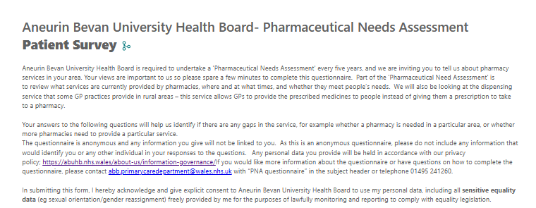
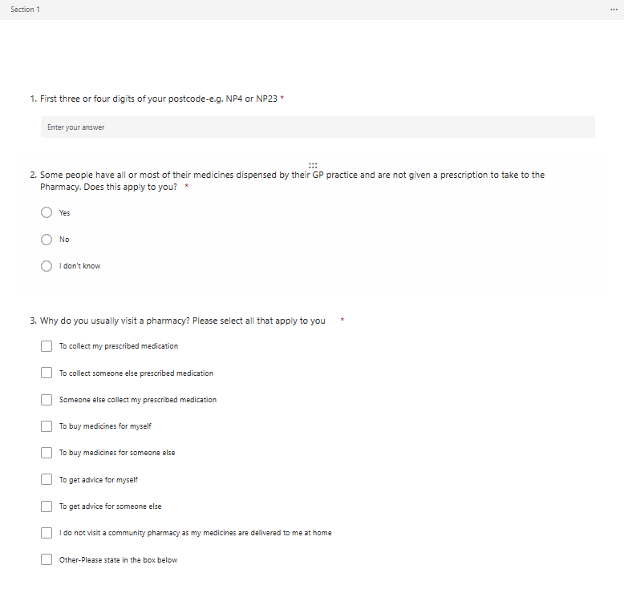
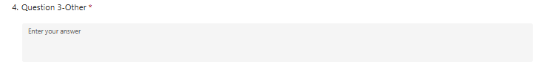
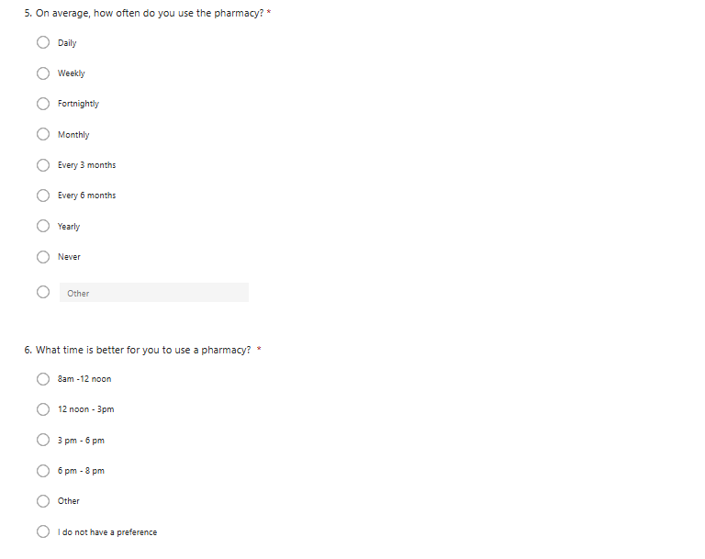
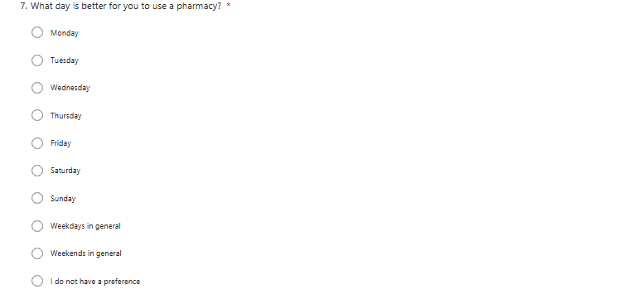
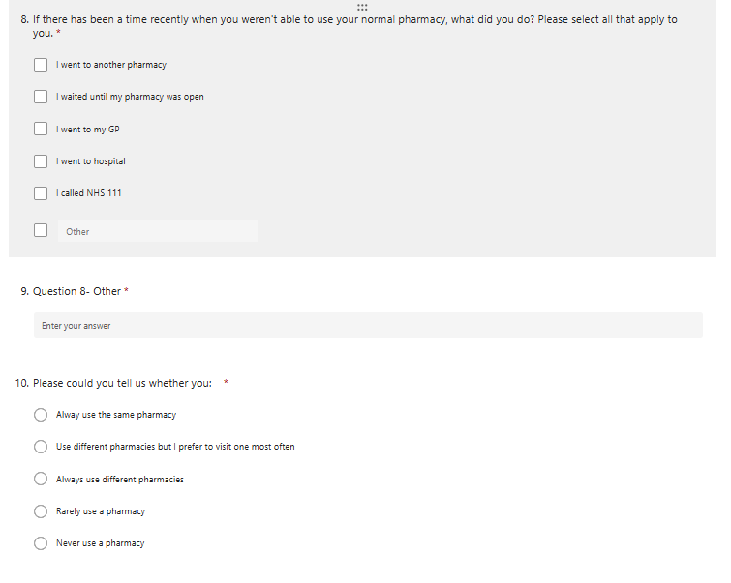
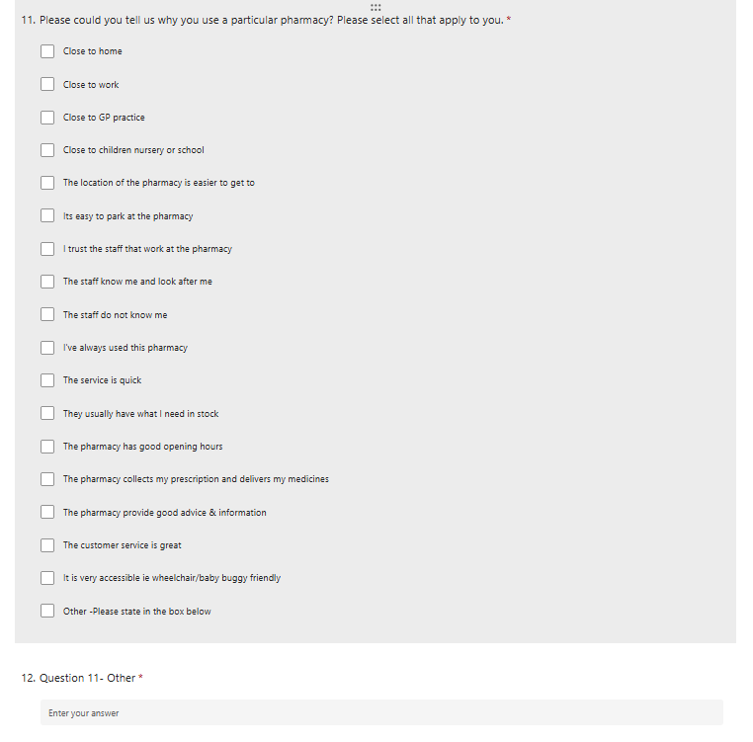
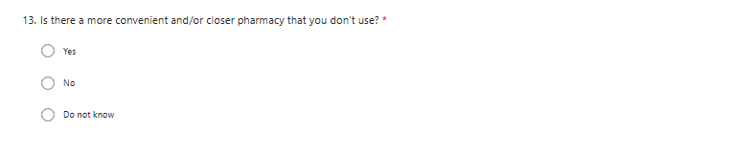
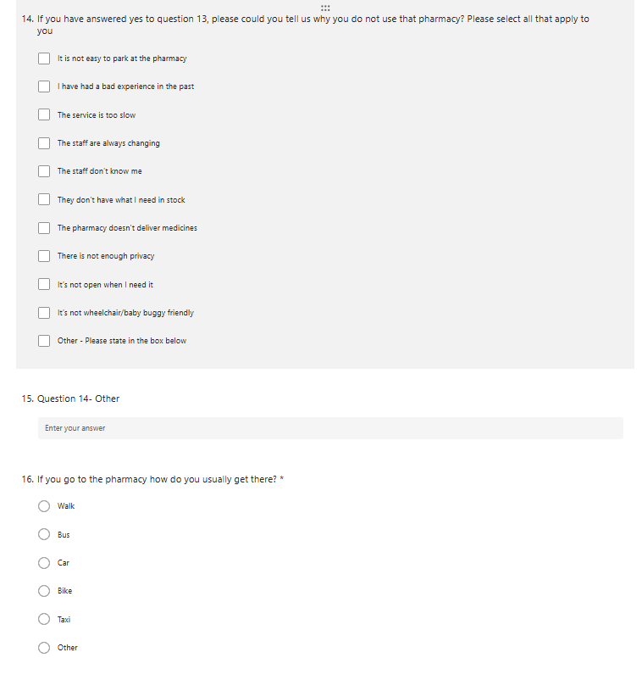
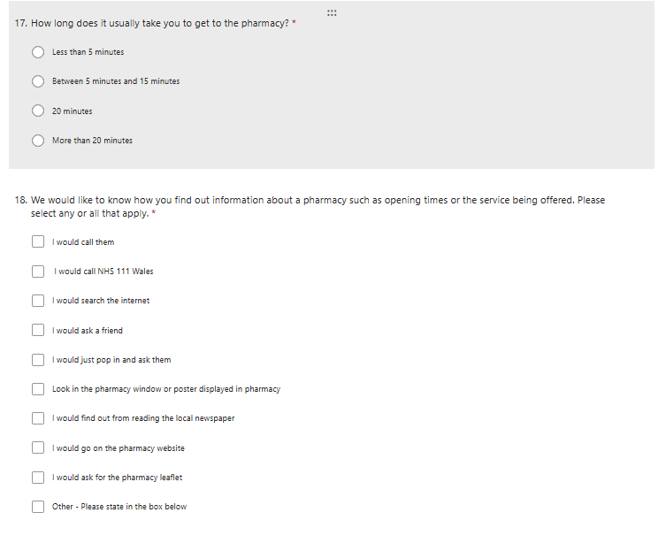
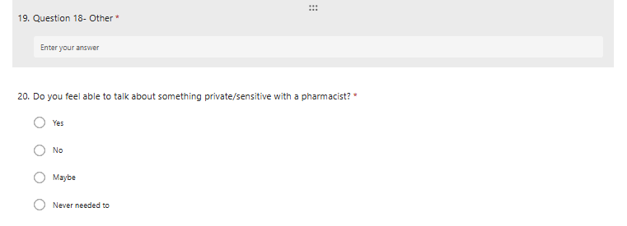
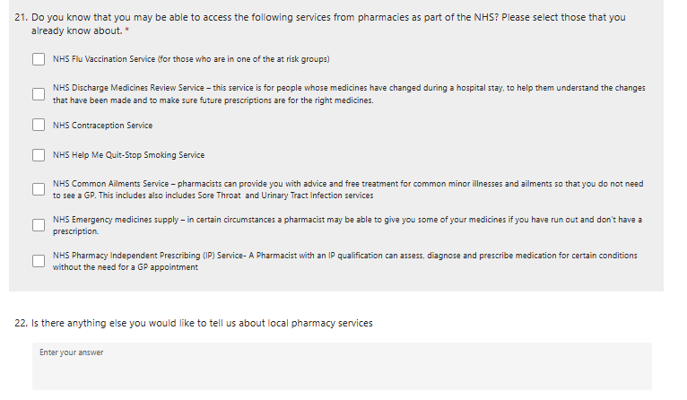
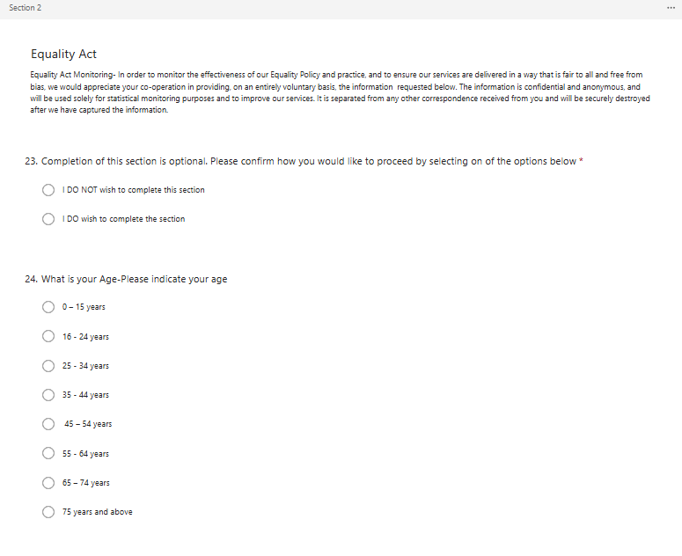
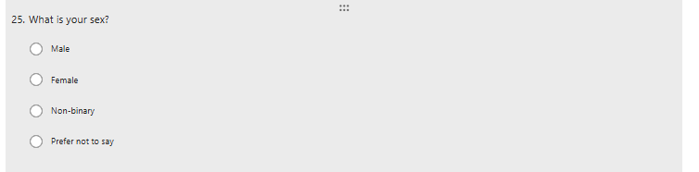
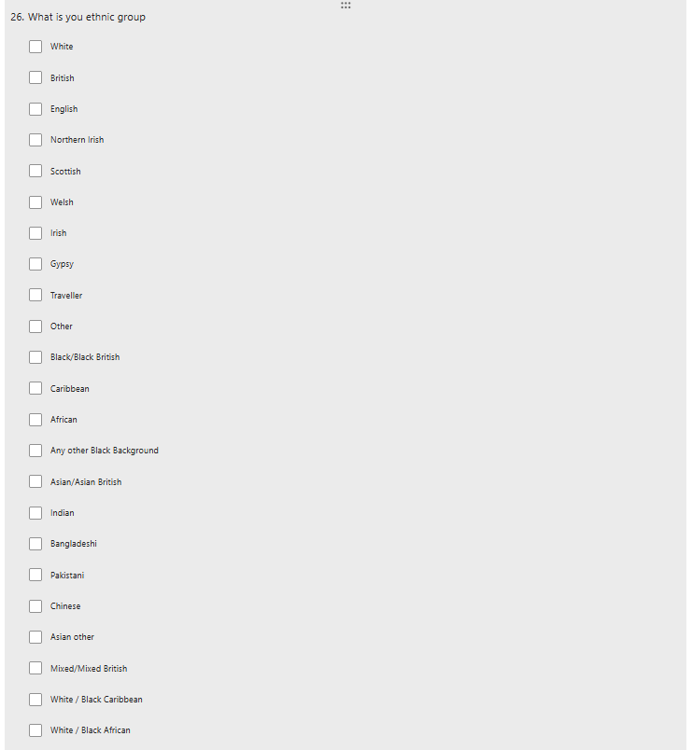
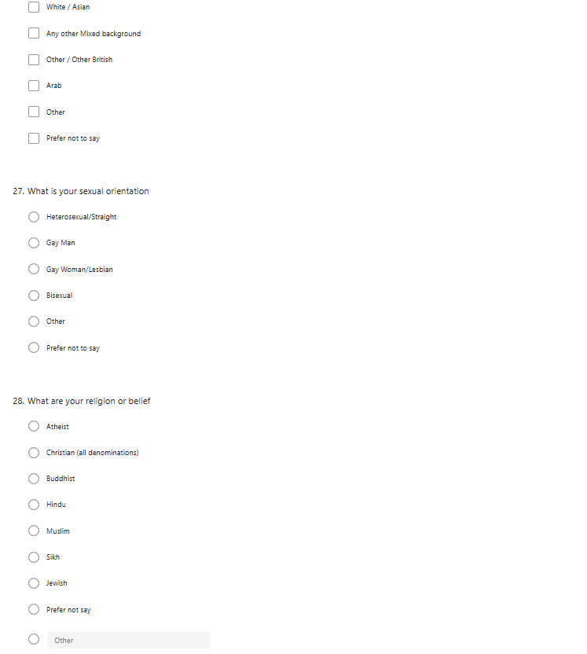
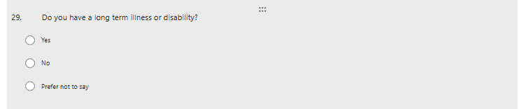
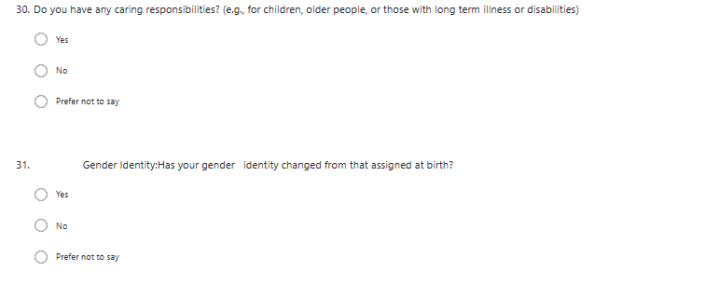

Appendix H – Full Results - Patient and public engagement Questionnaire
1. First three or four digits of your postcode- e.g. NP4 or NP23
First part of postcode | Number of respondents | First part of postcode | Number of respondents | First part of postcode | Number of respondents
NP26 | 322 | NP22 | 36 | NP24 | 3
NP16 | 130 | NP7 | 35 | CF46 | 2
NP11 | 85 | NP12 | 32 | CF3 | 1
NP4 | 70 | NP13 | 19 | GL14 | 1
NP44 | 56 | NP18 | 17 | GL15 | 1
NP19 | 54 | CF82 | 14 | NP48 | 1
NP20 | 48 | NP25 | 13 | NP6 | 1
NP23 | 46 | NP15 | 11 | NP8 | 1
CF83 | 39 | CF81 | 4 | Invalid Format | 18
NP10 | 39 | CF8 | 3 | Invalid Format | 18

2. Some people have all or most of their medicines dispensed by their GP practice and are not given a prescription to take to the Pharmacy. Does this apply to you?
Yes | 355
No | 708
I don't know | 39

3. Why do you usually visit a pharmacy? Please select all that apply to you
To collect my prescribed medication | 982
To collect someone else prescribed medication | 588
Someone else collect my prescribed medication | 96
To buy medicines for myself | 437
To buy medicines for someone else | 242
To get advice for myself | 396
To get advice for someone else | 151
I do not visit a community pharmacy as my medicines are delivered to me at home | 15
Other | 30

Question 3-Other
‘My medications are dispensed into a dosset box for me monthly and delivered to my home address'
‘To enquire why my meds\are late. as its impossible to get through on the phone.'
‘I email Pharmacy when required, just for current medication, who then deliver and collect from my GP surgery.'
‘Someone else will usually collect my medication for me.'
‘If my GP doesn't have my prescribed medicine in stock or it's for something they don't dispense.'
‘To collect my medication that I pay for to be delivered as they never deliver in time.'
‘Our pharmacy has a robox for 24 hour pick up'
‘Errors on issue of prescription'
‘Vaccination'
‘Pharmacy as they always space you don’t get your medications till three days later'
‘My GP is a £5 taxi ride away'
‘And collect husbands'
‘To buy multi-vitamin tablets and first aid equipment such as plasters and antiseptic cream.'
‘Different stuff'
‘My husband collects my script to give to Pharmacy. Then Pharmacy delivers when ready'
‘To go to work [Name removed] pharmacy Newport'
‘The GP sends the prescription to pharmacy'
‘Minor ailments service'
‘Flu jab'
‘I wish there were pharmacies in one or more of the local supermarkets'
‘I buy my haircare stuff, nails, and non-prescription medicines from our local chemist'
‘I have also used the service for emergency contraception once.'
‘My Kidney Transplant immuno suppressants are only issues by UHW'
‘Common ailment scheme'
‘To purchase first aid and other supplies.'
‘To drop off additional hospital-prescribed prescriptions'
‘[Name removed] pharmacy staff are very rude and unhelpful.'
‘Mine and husband'
‘To get vaccinated. '
‘Get a flu jab'
‘To have an appointment with the Pharmacist (Prescriber), for the Minor ailments scheme and for Vaccinations.'
‘To purchase sunglasses'
‘Flu jabs'
‘Have available vaccinations there
Take family member for vaccinations there (good access, pleasant and efficient'
‘Have had vaccinations at the Pharmacy and medicine reviews with the Pharmacist.'
‘Used the common ailments service and stop smoking service'
‘Advice'
‘To confirm diagnoses of common ailments.'
‘Medication'
‘Sometimes to buy med'
‘Flu jab'
‘We have an awesome Pharmacist [Name removed] and he is second to none. We are so lucky to have a knowledgeable Pharmacist in our area who takes the time. You need to clone him so everyone can share. thank you [Name removed] Pharmacy'
‘Visit on behalf of a residential home as they dispense the medication for the homes residents'

4. On average, how often do you use the pharmacy?
Daily | 5
Weekly | 78
Fortnightly | 132
Monthly | 724
Every 3 months | 68
Every 6 months | 24
Yearly | 14
Never | 1
Other | 54

5. What time is better for you to use a pharmacy
12 noon - 3pm | 121
3 pm - 6 pm | 220
6 pm - 8 pm | 175
8am -12 noon | 198
I do not have a preference | 376
Other | 12

6. What day is better for you to use a pharmacy?
Monday | 15
Tuesday | 13
Wednesday | 18
Thursday | 14
Friday | 26
Saturday | 95
Sunday | 3
Weekdays in general | 243
Weekends in general | 200
I do not have a preference | 475

7. If there has been a time recently when you weren't able to use your normal pharmacy, what did you do? Please select all that apply to you.
I went to another pharmacy | 590
I waited until my pharmacy was open | 455
I went to my GP | 38
I went to hospital | 11
I called NHS 111 | 23
Other | 86

Question 7 - Other
The majority of the response in this question were, ‘not applicable’ or ‘this hasn’t happened to me’, other responses are detailed below;
‘They have a break and no one covers’
‘Had to go without medication’
‘Have to ring around to find one and then try and get there! Extremely inconvenient’
‘Went without medication as GP send direct at times to chemist’
‘Went without’
‘Tried the supermarket’
‘Went without treatment’
‘Planned what I needed and went at an appropriate time’
‘I recently had to do a tour of about 3/4 pharmacies to get the Prescription I needed. And still didn’t get it for another 2 days after it was prescribed as there seemed to be a lot of confusion / knowledge around what I was prescribed and whether it as supplied. (Ear infection)’
‘Didn't collect my prescription as it wasn't ready when it should have been and I couldn't make time during work hours to collect.’
‘Had to arrange time off work to collect during work time’
‘I am considering another pharmacy’
‘Had to get time off work’
‘I had to get my elderly parents to collect their prescription’
‘I have no choice due to electronic prescriptions’
‘Used private healthcare’
‘Use Google to find any pharmacy within in 10-mile radius that was open on a Sunday’
Didn’t have meds in stock, huge queue and could not wait
‘Went to GP to see where else to take my prescription’
‘Told by my pharmacy that I needed to go to a prescribing pharmacy for Beconase’
‘I had to get another prescription as NHS Wales app did not show my medication’
‘I was given a new prescription but the dosage was different and was suggested I seen my GP to amend. Surgery suggested I contact all surgeries. Had confidence in my pharmacy but receptionist reluctantly rang another pharmacy. Tried pharmacy on route, agreed’
I use the Robot collection at [Name removed]
‘Went without my medication over the weekend’
[Name removed] refused to order a new insulin for me. Had to go back forwards between the doctors and chemist in the end they ordered it for me. They were very unhelpful to my wife as I was home ill in bed’
‘I was told by [Name removed] pharmacies that they were unable to provide my prescribed medication (Omacor). Nor were they likely to do so in future. I had to arrange for the GP to provide a paper prescription to take to a pharmacy in Chepstow 6 miles away. This normally required 2 trips due to the large quantities needed to be made up’
‘Depends on the situation-urgent/non-urgent’
‘Twice recently I have seen a doctor on a Friday and have had to go back on a Saturday morning to pick up medication as wasn’t available on the Friday. Including antibiotics’
‘I had to telephone a number of Pharmacies (some did not answer) to find someone who stocked a medicine that had been recommended by Velindre. Ended up driving to Newport’
‘Travelled to Bristol to be able to get the medication needed as not one pharmacy up to Cardiff had what I needed and paid for my script’
‘Pharmacy always had queues, for an hour sometimes so swapped to another’
‘Used the medicines helpline on 111 and got my forgotten meds (was on holiday in North Wales - excellent service.’
‘I would like to wait until a Saturday because of the hours i work through the week. By the time i head home the Pharmacy is usually closed.’
‘I am considering a different pharmacy’
‘Changed my pharmacy due to poor service’
‘I wanted something for a sore throat so went to the supermarket’
‘Phoned pharmacies to find which had the prescribed items’

8. Please could you tell us whether you:
Always use the same pharmacy | 748
Always use different pharmacies | 15
Rarely use a pharmacy | 19
Use different pharmacies but I prefer to visit one most often | 320

9. Please could you tell us why you use a particular pharmacy? Please select all that apply to you
Close to home | 744
Close to GP practice | 426
The location of the pharmacy is easier to get to | 364
The customer service is great | 354
I trust the staff that work at the pharmacy | 345
I've always used this pharmacy | 329
They usually have what I need in stock | 323
It’s easy to park at the pharmacy | 257
The pharmacy provides good advice & information | 257
The staff know me and look after me | 254
The service is quick | 223
The pharmacy has good opening hours | 222
Other | 98
Close to work | 92
The pharmacy collects my prescription and delivers my medicines | 55
It is very accessible ie wheelchair/baby buggy friendly | 50
Close to children nursery or school | 35
The staff do not know me | 18

Question 9 - Other
"They deliver "
"[Name removed] Pharmacy collects my prescription from my GP surgery and then delivers it to my home address."
"Only pharmacy that could deliver when I had an accident and was housebound for 4 months, I have carried on using them "
"Friendly staff that go out of their way to help."
"I collect my meds from the GP dispensary"
"I can go in with a prescription and the medicine is dispensed while you wait. My local pharmacists does not offer this service."
"GP send it there whether I want that or not"
"The pharmacy answers the phone when I request a repeat prescription "
"Dr Surgery send electronic batches to this pharmacy "
"I work away a lot so it's easier for my mother to pick up my prescription from there. She picks hers up from there too."
"My prescription is sent electronically from my GP surgery to this pharmacy"
"GP sends them there. "
"They collect my prescription but I get from pharmacy "
"In the GP surgery"
"I can collect my prescription from the [Name removed] robot"
"Service is good"
"The pharmacy collects my prescription and I pick the medicines from the pharmacy."
"Dispensing GP practice"
"The pharmacy advice is fab"
"Very helpful & obliging."
"The customer service is excellent and they provide a vending machine collection service which sends a text when collection is due. This means prescription can be collected out of hours. This service is leading practice."
"Online scheduled ordering via app"
"The pharmacy is in my surgery and my prescriptions go there automatically"
"Excellent "
"They treat you with respect and not as a commodity "
"Free px in Wales"
"Don’t have a particular pharmacy, where ever I am and in need just find one"
"The pharmacy collects my prescription and I pick it up from them"
"The pharmacy collects my prescription from the surgery."
"There is a problem with this tick box section q12 you need to pick other before you can progress to the next page"
"Go sends prescription direct to pharmacy for me to collect. "
"Force of habit."
"They send me a text to say my prescription is ready to collect - no wasted journeys!"
"N/A this question need to be completed to move on"
"The one my prescriptions are sent to."
"Ad-hoc basis - depends if I need something and where I am when I need it "
"Only one pharmacy open 7 days a week in Cwmbran "
"Repeat prescriptions from my GP go here."
"They have a 24/7 dispensing machine "
"It's the location where my GP sends the prescriptions"
"It is the pharmacy used by my GP practice to send prescriptions to."
"That’s where my prescription is sent"
"My pharmacy collect my prescription from my GP surgery and notify me when it is ready for collection."
"They collect prescriptions from GP"
"No particular reason"
"My GP prescriptions are sent there automatically "
"Easier to get too"
"They collect prescription from GP, but don’t deliver"
"Our previous pharmacy closed down with little warning."
"Not many of the pharmacies in Newport who are on the palliative list always have essential and routine palliative meds in stock. You quickly become reliant on the same pharmacy but then so is everyone else for the same reason"
"I use the local pharmacy to collect prescriptions, but for advice or anything else I will go anywhere else while I am in Bristol or Newport as I have experienced long queues, horrible customer service and terrible lack of choice at both pharmacies in [town]"
"I use the NHS app and it doesn’t allow you to change the pharmacy any more when you request a repeat prescription."
"Weekend opening hours"
"They have the prescription items I require. Other pharmacies no longer stock much."
"I like to support local, independent businesses "
"Other things I need also available "
"It’s where I’ve always been registered"
"My GP only deals with [name removed] in [town] "
"The doctor sends my prescriptions to one pharmacy for me to collect"
"Very professional"
"I can walk to it and avoid using car"
"I have always used [name removed] Pharmacy in [town], [name removed] is absolutely excellent and a really helpful person. I feel like he would go out of his way to help people, and for this reason I support his pharmacy. During the first covid lockdown, he personally stood outside his pharmacy, waiting to help people and I will not forget that."
"I like all the other bits they sell there also. "
"Surgeries nominated pharmacy "
"They have an automated robot dispenser, which is amazing for being able to collect my prescribed items outside of opening hours and without having to queue."
"My GP sends my prescriptions there; I have no choice"
"Keeps informed of supply difficulties with certain medications"
"Text me when prescription is ready to collect"
"I usually use the pharmacy at my doctor’s surgery as I live 7 miles from the town, but if not I go to another pharmacy in the town "
"My pharmacy has a robotic collection device to pick up my meds when the pharmacy is closed "
"I can never get the brand of medication I need so need to take a couple of hours off work every 2 months to ring round until I find a pharmacy that has my medication"
"They are able to get medications made up that other ‘chain’ pharmacies can’t and they can try multiple suppliers when items are out of stock because they are independent and not tied to limited suppliers."
"It has an outside dispensing service that can be accessed day or night "
"It’s the only chemist in my town"
"They allow my well-behaved dog in. "
"Opening hours are currently reasonable I can easily collect my prescriptions at weekends without too much disruption "
"In same building as drs "
"My pharmacy has a 24hr vending machine to collect prescriptions which I use when given a code via text. This means I am able to sometimes collect prescriptions out of hours "
"The doctor sends it there I don't have much choice "
"My pharmacy is open on Saturday morning"
"Common ailment scheme"
"The one closest to surgery was awful but changed to much better organised and friendly "
"An agreement with this pharmacy to provide a specific brand of medication with the GP (Teva 100mg Levothyroxine) if I wasn’t bound to [name removed] I would change as despite doing this for 5 years, they get it wrong every month, despite teva on their screens and script. Service is slow, and queues are a nightmare "
"The pharmacy delivers meds if needed and is remarkably more efficient, respectful and customer friendly than the one we used before [name removed]. Parking at [town] square is a nightmare"
"I have to catch a bus to the pharmacy [name removed] as my GP Practice can't /won't send my prescription to one that is just a few hundred yards (2 mins walk) from my front door in [town]. This is utterly ridiculous...that I can't nominate my local village pharmacy. And worse, [name removed] is only open on weekdays whilst [name removed] is also open on Saturdays "
"I get great advice"
"They have a robot collection so I can use this when the pharmacy is shut to collect a prescription "
"Collection for person who has their prescription sent here "
"Recently changed Chemists, because the staff in our usual place were rude!"
"They support our care home well so are our allocated pharmacy "
"I have experienced poor quality of service on multiple occasions in the pharmacy closest to my home, so have opted to use this pharmacy instead, whose customer service and knowledge is impeccable!"
"Prescriptions on repeat for all my family members sent to this pharmacy (occasionally use different one if not for picking up prescriptions or if I've been back to surgery to get physical paper prescription because they can't get item(s)."
"The pharmacy collects my prescription from the GP and I collect from the pharmacy"
"Good advice and very helpful if issues with medication / side effects"

10. Is there a more convenient and/or closer pharmacy that you don’t use?
Yes | 316
No | 752
I don't know | 34

11. If you have answered yes to question 10, please could you tell us why you do not use that pharmacy? Please select all that apply to you
The service is too slow | 133
They don’t have what I need in stock | 102
It is not easy to park at the pharmacy | 95
I have had a bad experience in the past | 94
Other - Please state in the box below | 94
It’s not open when I need it | 66
There is not enough privacy | 44
The staff are always changing | 43
The staff don’t know me | 41
The pharmacy doesn’t deliver medicines | 8
It’s not wheelchair/baby buggy friendly | 5

Question 11 - Other
"Stated they cannot get the repeat medication that I require every month."
"If you have a one-off prescription you have to hand it in and return hours later or the following day before you can collect your item. A regular prescription that they collect from the doctors on your behalf can have up to a 10-day waiting time to collect. If they are short staffed, they will just close for the day without notice"
"Queues to long and they do not answer the phone. "
"The pharmacist was rude, misogynistic, culturally paternalistic and didn’t give me the meds for my eye infection. Told me to go to the doctors for it. I know I don’t need to ask the doctors for that so just went to my normal pharmacy who saw me and helped me with no argument. The pharmacist at the other one closer is very grumpy "
"Always very, very busy"
"They don’t offer text collection from vending machine out of hours"
"I don't know if they have the app for online ordering"
"In England- would need to pay for px - and 1 assistant the oldest one is really miserable "
"Prefer the independent "
"It’s on the front line in [town] which makes me nervous "
"I like to walk into town to pick up medicine, and have a wander after "
"No other pharmacy close to home."
"My GP practice doesn’t deal with them!"
"Digital prescriptions are not sent there"
"My GP, decided where to send my prescriptions, no choice. "
"It’s closer but no parking (busy high st) "
"Staff were rude and not customer friendly"
"As above...my GP won't allow me to nominate my local pharmacy! "
"Robot collection out of hours available "
"The staff can be extremely rude, and despite being advised that they were ordering medication in for my little girl (as it was out of stock) on attempting to collect it 10 days later as advised, they hadn't even ordered it yet!"

12. If you go to the pharmacy, how do you usually get there?
Car | 761
Walk | 314
Bus | 16
Other | 6
Bike | 4
Taxi | 1

13. How long does it usually take you to get to the pharmacy?
20 minutes | 80
Between 5 minutes and 15 minutes | 647
Less than 5 minutes | 346
More than 20 minutes | 29

14. We would like to know how you find out information about a pharmacy such as opening times or the service being offered. Please select any or all that apply
I would search the internet | 816
Look in the pharmacy window or poster displayed in pharmacy | 344
I would go on the pharmacy website | 312
I would call them | 240
I would just pop in and ask them | 231
I would ask a friend | 62
Other - Please state in the box below | 54
I would call NHS 111 Wales | 14
I would ask for the pharmacy leaflet | 13
I would find out from reading the local newspaper | 6

Question 14 - Other
"GP told me"
"I would ask at my GP practice"
"I just know times"
"Facebook page"
"Use Google maps for opening times."
"It should be put in window"
"Google"
"Facebook "
"Google"
"I would ask the staff at the pharmacy"
"Through recommendation when I first moved to the area"
"i wouldn’t call them they ignore the phone seen it whilst waiting for meds"
"Google it"
"Drive by, if there is a que around the block, they are open, else they are shut"
"I only need what all pharmacies offer"
"My friend is a pharmacist and tells me about the services some pharmacies offer (the good ones) and where to find information. Not 111 though. Knowledge re anything there (based on experience) is poor"
"Ask a friend"
"Dr pharmacy is always open when I need a repeat"
"Facebook"
"Social media "
"Facebook "
"Facebook"
"Opening times - google maps. Extended opening, try and find the list that ABUHB publish not always in an obvious place online"
"Google "
"Community Facebook page "
"Listing info on Google Maps"
"Social media "
"I would go online but then find that there is are different hours each week (fortnightly hours) and then realise it doesn't tell you anywhere what week it currently is."
"Local knowledge "
"Hit and miss. We have 3 pharmacies close by and none of them are reliable."
"Opening times from Google Maps"
"I know as used same one decades"
"There is often conflicting information on the Internet about opening times."
"Normally have to check Facebook for times"
"Google maps info "
"Social media"
"Look on google maps "
"I’d ask on the community web page."
"Their Facebook page"
"Social media"
"Internet/Pharmacy"
"Facebook"
"Ask on social media "
"Social media "
"It’s boots it’s the same times as the shop"
"Partner also works for NHS so has informed me"
"Town Facebook page"
"Try to look online or social media as phoning our local pharmacies they tend not to answer phones"
"Aligned with Surgery"

15. Do you feel able to talk about something private/sensitive with a pharmacist?
Yes | 584
No | 137
Maybe | 235
Never needed to | 146

Do you know that you may be able to access the following services from pharmacies as part of the NHS? Please select those that you already know about.
16. Do you know that you may be able to access the following services from pharmacies as part of the NHS? Please select those that you already know about.
NHS Flu Vaccination Service (for those who are in one of the at-risk groups) | 899
NHS Common Ailments Service | 897
NHS Help Me Quit-Stop Smoking Service | 481
NHS Emergency medicines supply | 479
NHS Contraception Service | 413
NHS Pharmacy Independent Prescribing (IP) Service | 409
NHS Discharge Medicines Review Service | 226

Is there anything else you would like to tell us about local pharmacy services
17. Is there anything else you would like to tell us about local pharmacy services?
"Couldn’t be better"
"Always polite and respectful and I feel they offer an amazing service. When the phone lines are busy and I eventually get through to order meds, they are always polite and caring. [name removed]. Can’t speak highly enough. "
"Would like to get email/text when prescription has been received, then ready for collection or a delivery day."
"Employ someone to answer the phone, more staff needed"
"Excellent"
"The pharmacy that prepares My dosset for delivery, which has cost me £2 per delivery each month, has been taken over by a new firm who are going to now charge £25 per dosset per month from November!
Those couples where BOTH need dosset boxes are expected to pay £50 a month, and even though they are retired and on a low income are not exempt from this charge!"
"Excellent service from GP surgery script team to Pharmacy team.
I feel privileged to have this access and service."
"Our Pharmacy is excellent "
"There is a long wait, up to 5 days for our chemist to fill a script. If its a new medication"
"Excellent service"
"I complete my repeat prescriptions order through the NHS site and wait for 4 days to collect from the chemist. There was a recent mini-crisis when my GP decided not to authorise the order because I had missed a meds review. Some urgent messages went between GP/ chemist to get my meds approved."
"I recently made an appointment for my elderly parents to have NHS flu jab and myself a private one. It was written into the dairy at [name removed] about 3 weeks in advance. On a weekday morning I took time off work and took my immobile parents to the pharmacy. The pharmacist was incredibly rude refused to do my parents at all and told me I had to wait an hour. We all left without it. I’m public facing and still haven’t had time to book another. Really bad experience still cannot believe how rude the pharmacist was. I would never go there with an embarrassing problem. "
"They charge common ailment scheme"
"Yes, they are now charging for blister packs which is extortionate. While I appreciate it's time consuming, it's more time consuming when you have a disability or dementia to do it. You've robbed a valuable service from our community"
"My local pharmacy has a 'vending machine' that dispenses prescriptions therefore available 24/7 to collect."
"My pharmacist occasionally substitutes 'equivalent' products for those prescribed. I order online and have someone else collect the order (mobility issues) - it would be useful to have some way to provide feedback about the quality of the substitution..."
"None of my local pharmacies are user friendly, you have to queue for everything. They sport to be totally inefficient in their methods. I have to use a pharmacy three villages away. They are efficient, helpful and you tend to get served immediately."
"Excellent service at [name removed]"
"I have paid for treatment following chat with pharmacist when I later found out I could have gotten the treatment as part of the minor ailments scheme. The pharmacist did not advise me on this and charged me for the treatment after consultation."
"[name removed], offers deliveries, which makes my life much easier."
"My pharmacy is attached to my GP practice at [name removed]. Since the new centre opened, the pharmacy has been a joke. Because the pharmacist is busy seeing patients, there is always a build-up of prescriptions waiting to be checked by him, leading to long queues and unacceptable waits. This is not a one-off occasion, it is happening all the time, and in fact seems to be getting worse. There obviously needs to be another pharmacist available as well as the one seeing patients."
"The use of the robot for out of hours dispensing is amazing! friends and colleagues who don’t have this service are green with envy!"
"Often people confused about where their prescription is coming from. I don't think anyone ever gets told what being on repeat means, or what they have to do with it"
"There is a shocking lack of available pharmacies on a Sunday and especially out of hours. Not even a rota that is easily available with at least one pharmacy open at a time. It would save 111 so much time to just have a pharmacy with a prescribing pharmacist available. "
"Don't close at lunchtime
When there are some who would like to pick up, in their lunchtime "
"Rather things be done by a proper doctor"
"Queues and waiting time since COVID are ridiculous "
"I used to use [name removed], then it changed hands to [name removed], then it closed entirely - not happy"
"Yes. I used to put a repeat prescription in the GP surgery box and hey presto, the medicines were ready for pick up at the pharmacy after a few days. No further intervention from me. Now I don't get repeat prescriptions in my medicine bag. They go straight from GP to pharmacy BUT - I have to telephone the pharmacy to order them, phone so busy because everyone has to do this. Repeatedly phoning and pharmacy staff tied up with answering order calls. This is not an improvement for the patient. Why can't I order via the NHS Wales app, or better still, the order is done automatically every month and I get a notification on my phone via the NHS Wales app that my medicines are ready for collection. This is not progress. It is stressful."
"The main issue is opening times. last time I needed an emergency script at night (after an OOH GP visit) it involved driving to BRISTOL. Even with routine meds it is difficult sometimes to get to my pharmacy before it closes (it is only open weekdays not weekends)"
"[name removed] never got nothing in stock. Staff are rude as well. Something need to be considered. Thanks "
"I have a monthly script and its never ready on time, I'm always chasing on my last days of medication and most months have to have an emergency supply dispensed as I'm told that my prescription hasn't arrived on time. The chemist holds onto my repeat and they order each month. I've checked with the surgery and the repeat is printed well within the time so I've now asked to have a 2 monthly script as I have to visit my chemist at least 3 times each month to collect all the medication from one monthly script. "
"My GP surgery and chemist don’t always get my prescriptions ready on time it can take weeks, I’ve gone without my epilepsy meds. I can’t drive to go anywhere else"
"Sporadic provision of IP and common ailments service make them virtually pointless as you can’t rely on them being available even if the pharmacy is open. "
"Disappointed that it takes several hours to collect prescription in [name removed] (as you’re asked to call back hrs later or you have to call back the next day!). Plus there is no pharmacist between 2-3 daily"
"Please stay open at weekends "
"I work and not able to visit the pharmacy during office hours. Opening Saturdays is a huge plus as I can collect my batch medication during this time."
"The opening hours are completely and utterly useless to anyone with a full-time job.
The chaos is overwhelming with 30-minute queues and the staff mislaying prescriptions and medications on quite a regular basis "
"Contractually underfunded "
"We live approx. equal distance between two pharmacies. I tried one and have never had a problem with it so have had no need to try the other. They do seem to be becoming increasingly busy and waiting times are increasing but I believe the same applies at the other so haven't felt the need to change"
"They are meant to text when prescription is ready - never do. When call in, usually there but never been put up. End up having to wait. They see the same person twice rather than the once if it was ready. It's ridiculous, no wonder they are so busy. Appreciate that they dispense a lot of meds but there must be an easier method where repeat prescriptions can be ready in a timely manner."
"They are brilliant 🤩 "
"[name removed] is the best "
"I normally use the chemist on a Saturday as I work in the week. I understand that both of my local chemist plan to close on a Saturday. This may result in me going to Newport to collect my prescriptions in future."
"One in particular is VERY busy the shop is always full and you can be in the queue 20 mins then they say can you come back in an hour which I can’t... Nothing wrong with the service or people It is simply very oversubscribed."
"Having to remember to submit a repeat prescription request 7 days before you need it is difficult. Further we received no correspondence to let us know that this had changed from the normally 48 hours’ notice period"
"I like being acknowledged as a known customer"
"They do not open on weekends so I often have to ask someone to collect my prescription for me as I work full time and they close before I get back from work "
"The pharmacy across the road from [name removed] has closed, this is ridiculous considering the amount of new accommodation just built for the over 50s, again across the road. Up until its closure it was near impossible to get what you needed as they lacked the stock (or the ability to buy the stock). This needs to be addressed and not just ignored and expecting the local community to travel into [town] (do you know how much a return bus ticket is?).
"Reliable and always friendly "
"[name removed] is dreadful, never any staff and can't fill an emergency prescription for at least a week. Worst pharmacy I've ever known. "
"Never have my prescription in stock. Still got 121 tablets outstanding over a month after the prescription was issued "
"It is an advantage to be lucky enough to have a dispensing pharmacy at my GP practice. The only downside is if the prescribed medicine is not in stock then a journey to town needs to be made."
"Very helpful"
"Pharmacists shouldn't be doing GPs job"
"I wish they were better stocked as the medication is never there. Shelves are empty too. "
"I'd like to be able to have prescribed medication delivered by Royal Mail or similar as you can in England I believe.
I'd like to be able to specify the pharmacy when I order via the NHS app."
"Want to order earlier to do 2x weekly pill boxes in advance for elderly family. Can’t as can’t order until 3 days left. Pharmacy won’t do boxes. Struggle to get back from work in Bristol traffic to pick up day before run out"
"A lot of pharmacists can’t prescribe. Went to mine with an ear infection and they told me to book a GP appointment. Seems ridiculous when all I needed was antibiotic ear drops"
"The pharmacy I use is hopeless. I put the prescription into the GP a full week before it is due but the prescription is never ready when due. This month on the due day it was not completed they allegedly put it to priority and they said they would text me when it was ready. I had run out of my medication and it still wasn't ready and I had to hold my ground and ask them to fill it there and then which initially they were reluctant to do. It was only when I said I would go back to GP for emergency medication they agreed to fill it but I waited another forty minutes as the pharmacist was seeing patients via the common ailment scheme so could not sign off prescriptions.
"Absolute shambles"
"Not really"
"Always use [name removed] no other pharmacy can offer great service "
"They go above and beyond for anyone "
"Normally have shortages, even though prescription is with them a year in advance "
"There's always really long ques. I changed pharmacy as there was always medicine missing that they wouldn't tell me about, it's hard because I work full time and have to make time to collect my prescription. The pharmacy's shut to early and all my local ones shut at the same time for lunch. Then it's hard as you have to make time after waiting 20-30 minutes to go back to collect items that were out of stock. Parking spaces there aren’t enough. Every time I ask about the common ailments, they say they can't and you have to buy stuff "
"I am satisfied with the pharmacy I visit. "
"I feel that my local pharmacy does an amazing job but the doctors do not give the pharmacy enough time to dispense the medication before they tell the patients to collect it. "
"There is usually something not in stock. I try to order 2 weeks to combat this but NHS restrictions say no so I end up visiting the pharmacy 3 times in a week to try to get meds, the NHS app send messages to say prescription ready get to pharmacy get told it is not ready it is the doctors fault. I work long hours as a support worker so it wastes a lot of my time."
"They are generally fab. Especially given how crazily busy they are in our town pharmacy. [name removed] were terrible as they just can’t get the meds we need. (Not the same pharmacy as the grumpy one"
"[name removed] have very knowledgeable staff and are friendly & helpful"
"The pharmacists at [name removed] and the team of staff always offer excellent service and are at hand to offer and provide the full range of services provided."
"Staff are always nice. Bit of a pain if you’re going to multiple pharmacies and there’s a confusion or lack of knowledge about what it is you’ve been prescribed and you’re unable to get your antibiotics for days after being prescribed them "
"There should be two pharmacies in [town]. One is insufficient."
"I prefer to get my medicine/s while in hospital, the stress and thought of having to use [name removed] is enough to put me back in hospital, the wait times, the que times, the uncleanliness, understaffed, staff run off their feet, you may want to check their back room, as I believe I saw peeling paint, and black mould on their walls around their hand basin/washing facilities when the door was briefly opened"
"Our local on [name removed] has been closed for months saying no pharmacist "
"My local pharmacy is [name removed]. The staff are very friendly but the service is extremely slow! I went yesterday to an empty pharmacy only to wait 35 mins for my meds. This is a common occurrence. There are a lot of staff there but waiting times are terrible! There are at least 8 staff members there. This needs to change. "
"Ridiculous that both pharmacies in [town] are closed on Saturdays. Why can't they have a late night and Saturday rota? I'm sure this used to be the case."
"There should be at least one pharmacy in a town open in a Saturday. There should be a rota and they take turns. "
"I do not use the nearest pharmacy in [town] as they often do not have my medication in stock. It is very poorly managed with very limited non-prescription medication "
"Queues are too long. Lack of funding. "
"We had three in the area – [name removed] - poor service, supplies minimal - closed
[name removed] - poor service - waits always 30+ minutes
[name removed] - started to use - ok so far "
"Gaer pharmacy doesn't open at weekends."
"Services need to be consistent within all pharmacies. Opening need to accommodate those who work "
"Great service. Text me when prescription is ready to collect."
"My local pharmacy is great for just picking up a prescription but they don’t offer any other services. Thankfully I know other pharmacies in Cardiff and vale that do. Please make sure there are these exceptions pharmacies in Aneurin Bevan "
"Excellent friendly service"
"My local pharmacy [name removed] is so busy the staff are run off their feet. I feel sorry for them. I witnessed somebody being very rude to the staff there recently. I think they need more staff for the amount of people that go there. They don’t seem to be able to
keep up with the demand "
"Lots of stuff seems to be out of stock and ordered in, so have to make return journey "
"Sometimes medicines unavailable, as script batched 12 months unable to take to another pharmacy if part has been prepared, only option to trouble the surgery to get a script for items not received."
"Always a long wait, especially if you’re bringing in a prescription rather than just picking up medication that has already been dispensed. Always signs up saying they are short staffed. "
"It's perfect. Lovely, helpful people"
"My pharmacist and his staff go above and beyond with their service. I do feel they are stressed with the work load. But still do a good job"
"Currently chaotic. The pharmacy now requires 7 working days’ notice for repeat prescriptions. We were not notified about this change in advance and when my carer took me for blood tests and to collect my medication there were large queues of very unhappy people. I then submitted my next request 10 days prior to running out as I am on a lot of medication. I was told I would get a text when it was ready. The surgery will not send the prescription the few feet to the pharmacy until 48 hours before it is due. As a consequence, both myself and my husband were without medication over the weekend. My husband is on heart medication and I am on morphine, immunosuppressants, blood pressure medication, Thyroxine, aspirin to name but a few."
"Even though you have to apply for your prescription approx. 7 days before it’s due to be renewed it is never there and has to be made up and have to wait 1/2 an hour and most of the time the medication in not in stock and have to wait another few days and make another trip the pharmacy [name removed]"
"I was dispensed a larger bottle of gabapentin than my prescription allowed. My daughter booked online for a private flu vaccination and when she got there was told the woman doing them was sick. There is always a long queue or wait time for medication. If you want pharmacies to complement GP services they need to be up to scratch and professionalism greatly improved."
"[name removed] are outstanding service "
“[name removed] are great- really helpful. "
"My prescription is nearly always not ready and I have to wait or go away and return at a later time annoying "
"It is difficult to gain IP services when required - I had an ear infection over new year and rang numerous pharmacies to obtain treatment, all of which were open but none had an IP present to arrange prescription. During key times such as this, very little benefit to them being open when no IP or related services are available."
"Yes, there seems to be a great deal of problems getting certain brands of medication. They blame the supplier but I think it's far more to do with cost."
"Closer pharmacies will not order particular brands of medication that I am not allergic too. So, I have to go 20 mins away from my doctors to a pharmacy that will order it. "
"[name removed] is in need of more pharmacists, you wait over an hour for the prescription and most times I have medication missing which means I have to go through the process again."
"[name removed] recently changed hands. Phoned to check if prescription ready but had to hold on then got cut off. Tried this four times so gave up, visited Pharmacy and then had to wait for meds to be made up."
"We need an electronic prescription service. "
"As I work full time, I need to be able to access a pharmacy on a Saturday or evenings"
"The main issue that I have is that my prescription can often take more than a week to be dispensed. I have been told that they nearly always have to order my medication in but this has, in the past, left me without my meds. I have only recently been advised that I can have some dispensed as an emergency. "
"Sometimes it’s an issue when prescriptions are sent to other pharmacies to be filled then returned to your pharmacy. Sometimes this causes a delay"
"As a member of staff within the NHS the opening times are hard due to shift work so I cannot always collect my prescriptions "
"I’ve seen dispensing machines for prescriptions in North Wales. That has potential for less queues and more access."
"I believe that prescriptions should be every two months instead of monthly. In a previous practice this was the case and it worked brilliantly. Surely this would help the pharmacy too. Appreciate they may need more stock initially but overall, it would even out. I understand that you get the same amount of medication but putting up double batches would surely increase productivity in the pharmacy."
"Please don’t close on Saturdays I work long hours during the week and it’s the only time I can get my meds. I have nobody to go for me"
"Earlier opening"
"Yes - it is disgraceful that pharmacies now are charging for dosette boxes. Charging the elderly and most vulnerable an extortionate amount for this is a disgrace and a removal of their independence if they cannot afford it. The new owner of the pharmacy in [town] and [town] has failed businesses on companies’ house - and it now appears pensioners will be bearing the brunt of his commercial attempts to pay off his previous business debts. Where is the due diligence here? Shame on NHS ABUHB pharmacy services for allowing this and condoning this treatment of people who need support to live and medicate independently- not charging for illnesses that are part of getting older. "
"[town], [town] & [town] pharmacies just sold and ALL are closing on a Saturday. THIS IS A DISGRACE, especially for those that work Mon - Fri"
"I am grateful for the service at [name removed] pharmacy. They do a good job. "
"I am very concerned that our local pharmacy is charging £25 per month for dossette boxes. A huge financial burden on some people. "
"I think there always should be an OOH pharmacy available that remains open until late hours. This is something that is commonly practiced in other countries. Here in UK the only option is to go to the supermarket or in fact a hospital. People don’t only feel unwell from 9am-5pm and Saturday morning… I feel the service should be more adequate. I am aware that some pharmacies are open longer hours but this information isn’t widely available or advertised."
"Please keep Saturday opening as when you work weekdays it's often the only time I can collect "
"I like how my GP gives an 8 week repeat prescription - not monthly. Fewer visits to pharmacy!"
"At times the queues are very long and slow and they close for lunch which can be very annoying!"
"Would be helpful to be able to access common ailments service in out of hours. Unable recently to get antibiotics for a UTI on a weekend. Rang 111 twice was referred to OOH GP but nobody rang me"
"My usual local pharmacy is brilliant. On the rare occasion they haven't got something, they will order it for me. I prefer a local, pharmacy as they care about their customers."
"More should open at the weekend - the only one local that does is [name removed] and their service is vile. "
"Our pharmacy is terrible, never answer the phone, not helpful, and just recently they never have our medication and we have to travel to Newport 20 miles away. "
"The new pharmacies in [town] are no longer fit for purpose.
They are unable to provide prescribed medications and tell customers to go elsewhere.
Housebound registered disabled customers are being charged for services such as Dossette boxes"
"The time is takes for repeat prescriptions is ridiculous - so much so that a prescription that is needed 4 weekly, isn’t back in time."
"I think many pharmacies dispense unnecessary medications for patients - I work with patients who frequently complain they have surplus stock because the pharmacies dispensed it and won’t take it back. I have concerns over this in regard to the expense involved and stress caused to the patients. I am also aware that patients go to pharmacy for health advice and are required to pay for medications when the IP service is available but not offered. I appreciate patients get confused, but NOT all of them "
"I appreciate what they do for me and the community and they probably don't get told that enough. "
"They are not open late enough and I have to travel to [town] from [town] if out of office hours. There isn’t anything close to the Grange hospital for patients to collect prescriptions out of hours. I can’t get my medication on 111 website like I can in England if an emergency. Not enough prescribers "
"Opening times should be extended to weekends for people who work "
"I have had experience of waiting over an hour for a medicine - with nowhere to sit. I have also had experience of losing prescriptions, wrong medicines and not having medication in stock and it taken over a fortnight to be ready. The difference in pharmacies is very disappointing. The pharmacy that I now relay on is organised, friendly, sends out text messages when scripts are ready - this pharmacy is near to where I work and not in my home locality."
"Whenever I pick something up the service isn't always smooth, and there are a lot of people holding up the queue with issues or complaints. I wish they would have queues for people who are on their lunch break and have a prescription to collect or purchase some paracetamol, for example. Anyone who has all day to faff about can go in another queue! "
"The staff are amazing there was a time when I was on fort sips and was very weak physically and was unable to carry my prescription. the pharmacist helped me carry my prescription to the car and has been so supportive and kind"
"Shutting the chemists on a Saturday removes the ability to pick up medications that they keep low stocks of which are needed urgently. Currently they are always missing items from prescription orders due to no stock holding. This means multiple visits to just to fulfil one batch prescription. We live over 2 miles from the chemist which means multiple bus journeys. If we visit on a Friday and they are out of stock, if they are not open on a Saturday, we could be waiting 3 days or more to fulfil shortages."
"I have had issues where prescriptions have not been able to be filled due to low stock"
"Pharmacy do their best dealing with customers expecting instant turn around when the customer should have better time management. Pharmacy should keep a weekend opening even if that is at the expense of a weekday one day closure."
"It would help if more staff were registered professionals and their pay reflected this. It would help ensure their knowledge was up to date."
"Patients in this area sometimes called to see out of hours doctor at Nevill Hall but then can’t get prescription dispensed as no pharmacy around which they can get too (out of hours, overnight and at weekends) could hospital fulfil this need by establishing a community element!"
"The smaller pharmacies need better opening times, to accommodate now having a hospital in the town and to take the pressure off [name removed] in the town, which is the only pharmacy that’s open 7 full days a week in Torfaen "
"The local pharmacies in [town], have recently changed ownership / management. There are times when they cannot get the medication that has been prescribed causing you to seek another GP appointment for a new prescription, this is causing significant delays to getting the help required. "
"The staff at the pharmacy are very helpful."
"Both pharmacy close on Saturday afternoon. There has been talk of them closing all day on Saturday. Not acceptable especially for folk who have no transport to travel to another pharmacy"
"My pharmacy is [name removed] and they are always so helpful and I can get an appt when needed."
"I'm happy with [name removed] they work so hard and try to fix any issues that arise, it is very difficult to get owing medications sometimes however staff try to source it elsewhere, I've been told medication can't be ordered because it's out of stock and also hit quota which is highly frustrating because it means I have to attend several times but again not the staff's fault "
"Keep pharmacy open during lunch time and make sure a person is serving at all times"
"It is extremely difficult to get to a pharmacy that is open outside of my normal working hours. I have to plan my ordering from the GP to try and align with a day where I might be able to collect my script and take it to the nearest pharmacy. I have had to go without medication several times due to it not being in stock or not being able to drop it off in time"
"I needed sore throat test & treat over a bank holiday weekend, but it was hard to find who offered that service. The NHS website list of pharmacies isn't clear. The ones open those extended hours didn't offer that service. Making multiple phone calls when I could hardly talk already, was hard."
"My pharmacy now requires an appointment to discuss an issue with the pharmacist, which seems to contradict the NHS Wales advice to try the pharmacy first "
"I am fortunate that I have 3 local pharmacies within easy reach of my home"
"I would like [name removed] to broaden their opening times to meet the schedules of workers. One late night opening in the working week or a Saturday morning would be enough. "
"The number one problem with local pharmacies is complete lack of availability of pharmacy filled dossette boxes, which are so important for people experiencing memory issues who are often on many meds. Social care cannot put in carers for medication only so there is a real gap in the service. Existing patients are okay but any new requests they just don't have capacity for."
"It is an often occurrence that the prescription is not available or hasn’t been made up and I have to return sometimes more than once."
"Every single pharmacy in my area shuts at the same time for lunch making it impossible for me to collect medicines during my lunch breaks (which coincide with the 1-2pm lunch), and I finish after the pharmacy closes. I am often left with no meds for days until I can go on the weekends in the short time it’s open. Perhaps consider staggering opening times throughout the pharmacy’s to cater for more people. This would stop me having to use 111 to gain emergency prescriptions "
"The wait to get medicines, from requesting them at the Doctors, is taking longer. My last prescription took about 10 working days to be ready at the pharmacy. My prescription is requested online, via the NHS app and sent to the pharmacy."
"Yes. Please get [name removed] to stop closing for 1 hour lunch. It is a fabulous store and great staff. Surely in this day and age lunch can be staggered? "
"Search the internet "
"I have recently switched from paper requests and prescriptions to requests via the NHS Wales app and direct collections from the pharmacy. This has been a life-changing improvement for me, with far fewer journeys and delays and much less confusion than before. The pharmacy has also taken my phone number so that they can notify me when my medication is ready to collect - a wonderful service that enables me to live my life in a more organised and predictable way."
"Not enough staff and always long queues. Pharmacists are expected to do too much, some of what they do should go back to GP."
"Stopped opening on a Saturday which is very inconvenient. Not always able to get to the pharmacy during the week due to work commitments.
Very slow service. Needing to submit prescription request over a week in advance.
Service in the pharmacy is very slow. Always a long queue at the counter and generally only one person serving"
"Too slow......can't collect prescription until next day usually...if you're ill and wait to see GP don't need further delay to start treatment......should be able to get immediately but pharmacy so busy doing prescriptions that they make you wait ages or come back 24 hours
Also take 3/4 days to sort regular repeat prescription from GP. Much too long"
"Local services opening times are a bit restrictive. Sunday opening hours would be appreciated for those of us who work full-time."
"When I have spoken to the pharmacist, I felt that they were too busy to talk to me and that giving advice on a personal basis was an inconvenience "
"Not one pharmacy close to me and there are 3 of them open on a weekend, absolutely disgraceful "
"Always hard working and trustworthy"
"My local pharmacy is [name removed]. I wouldn’t go anywhere else. The staff are so warm and friendly and work so hard. If they don’t have what I need they will ask around other local pharmacies to try and source what I need. What service! "
"Our local pharmacy are brilliant....there's only one drawback you sometimes have to go back as the tablets you need are out of stock . There deliveries are not reliable. "
"I don’t think they can cope with the demands even with 3 locally. People that work Monday to Friday must find it hard ."
"Local pharmacy has limited parking.
Do not prescribe medication "
"All pharmacies should be open late one evening a week and on Saturdays, for the benefit of people who work full time."
"Having a local pharmacy opening once a fortnight on a Saturday would be very beneficial."
"Have now stopped opening on a Saturday morning, as the only pharmacy in [town] this is a poor decision on behalf of the pharmacy. Not everyone is able to get to a pharmacy during weekdays. Does not meet needs of the local community by closing on a Saturday morning.
Very slow service when in the pharmacy. Lots of staff around but only ever one person serving and queue out the door at times.
Very slow turnaround of prescription requests. Generally, takes over a week from submission of prescription request until medication is ready to collect"
"Saturday opening hours are not sufficient, my pharmacy closes at 1pm and due to medical issues, I'm not always able to get there before they close and have to wait for medication till the Monday. Waiting times from ordering prescription to it being ready to collect can be a week or more "
"You invariably have to queue for 20-30 minutes. Lots of staff but only one person serving & queues to the door & sometimes beyond."
"My husband & I have the same repeat medications every month. Invariably it takes 2 or 3 visits to the pharmacy to collect the items, every time having to queue and wait for items outstanding! It is really annoying, not the best place to have to wait in a crowded shop when you are immuno compromised!"
"The system is slow and always has been. Repeat prescriptions are never ready even when put in a week in advance. Always waiting around 20-30mins to pick up a prescription. Don't get given the Repeat paperwork so have to ask at the desk each month."
"I find common ailments service only works if pharmacist has time often it is a male pharmacist and do not fully understand any sensitive female issues, he can occasionally be rude and abrupt with you. Prefer the female workers in the local pharmacy who are kind and caring and always polite. Opening hours could be more user friendly ie Saturday Opening for people who work weekdays "
"I can only collect on a Saturday due to working in Bristol "
"Please don't shut [name removed] on Saturdays, how are employed people who work Mon - Fri supposed to get there medicines? "
"Very much against proposal to close on Saturday mornings. This will affect working people and people who depend on family and friends, who may be in work, to collect prescriptions for them. Will cause problems for people without transport. "
"Always a long wait, queue is usually to the door."
"Would be great if our pharmacy could message when medications were ready for collection"
"Due to working 9am-5pm and not getting home till nearly 6pm, it is much better for working people if the pharmacy is open later in the evening. This wouldn’t have to be everyday of the week but maybe a few days to allow us time to get there. "
"The system is terrible and not fit for purpose. Unable to order kids repeats online is ridiculous. The time for prescriptions to be ready for collections is far too long and always outside the advertised timescales. "
"Staff in local pharmacy are incredibly rude and are always so far behind that you can wait over a week for your prescription. Problematic when you can only your meds from GP 7 days before you run out"
"Opening times are not convenient as the local pharmacy is always closed on weekends and bank holidays "
"Little or no service at night or through weekends"
"The prescriptions are on automatic refill but I either get too many of one item & not the one I want. I have now taken control of ordering my medication so I have it when I need it. "
"With certain pharmacy branches it appears the opening times are not suitable for individuals working a usual 9 -5 Monday to Friday working week needing to collect regular medication whilst remaining in work "
"[name removed] on [town] deserve a medal. Hands down the most efficient and friendly pharmacy around. "
"Sometimes have a very long wait to pick up my prescription in the pharmacy I use. Happy that they sent me message when my prescription is ready for collection"
"[town] has no Bank Holiday Pharmacy provision. It is too far for many people to travel to [town] or [town]."
"I have had several issues between the GP surgery and pharmacist not communicating properly. They blame each other for the problems and make it my problem to go between them both to sort it out which is very frustrating. They both say that neither will answer the phone. "
"They’re desperately under staffed, I appreciate that staff are stressed, but their attitude could be better, people usually go there when unwell, they don’t need stroppy staff, a smile goes a long way."
"Difficult to find pharmacy after working hours, very frustrating as people work full time."
"Our area pharmacies are under huge pressure"
"Pharmacies should have longer opening hours and open more at weekends "
"All of the local pharmacies around [town], [town] and [town] are now owned by the same company. If one pharmacy is unable to get a certain medication in then all of them are unable to get it in.
I now have to travel from [town] to [town] to source one of my husbands heart medications because of the above."
"Pharmacies across [town] have to improve their stock of routine medications. I am a palliative nurse and my patients are frequently going without essential medications - oral, liquid and injectable due to stock issues. They are very good at blaming delays on GP surgery, where people are losing trust. Almost every time when I track a prescription for a patient, the prescription has been with the pharmacy for days.
Pharmacies who are the palliative list for stock never have the stock in. When someone is dying and we are trying to get medications as an emergency, we ALWAYS have to go to multiple pharmacies. It shouldn't be this way, it’s an additional stress. Especially when these are common medications as more people are dying in the community.
As a community nurse, one of the hardest parts about my job is my patients being able to get their medications. "
"The service is poor, mistakes are normal, supplies are difficult, staff are rude. This service would not be acceptable in any private field."
"[name removed] is a shambles with long waiting times, no staff at the counter, don’t put medication up until you go to collect despite them having the prescription weeks before, continual change of staff, having to make many visits as they say they haven’t everything and many times it is there but they fail to find it as it is so disorganised in the pharmacy part with boxes on the floor everywhere. Needs a good management system to oversee their working practices to make it good once again."
"There are not enough pharmacies open on a Saturday. Working 9-5 with a long commute can make it difficult to collect prescriptions on a weekday.
Pharmacies are not well stocked. I struggled recently to get common eye drops for my daughter, I had to visit 3 before I could finally get her prescription dispensed. It is becoming the norm to have to visit at least 2 pharmacies.
During my pregnancy it was very difficult to get my hospital blood pressure medication prescriptions dispensed. On the first occasion I rang over 10 pharmacies before finding one that stocked what I needed, it was incredibly stressful. It was a surprise to find out that not every pharmacy has the same list of medicines available so they could order in what was not in stock in a particular day. Some had no access to what I needed. There seems to be a complete lack of cohesion between what hospitals are prescribing and able to dispense themselves and what pharmacies are actually stocking or can order in. The hospital doctors couldn’t understand the difficulties I had and said the medication was common and widely available therefore I shouldn’t have any issues; the pharmacists and my experience suggested otherwise. There was no way of finding out where I could go to get the medicines either. A system like department stores use where you could check which pharmacy stocks what you need without having to call and waste time would be helpful."
"Lack of opening at weekend. Every pharmacy is run off its feet. Some days you will have to wait a while to be seen. Only retail business that actually closes for lunch. This is a time when people could leave their own work to pop in."
"Really appreciate the professional and approachable service provided by the majority of staff at [name removed]"
"My local pharmacy is about to stop opening on Saturdays. The one (of two) in the next town is also about to do the same. How are people who work full time meant to pick up their medication. My son has a significant repeat prescription list and often items require ordering and can take up to a week to arrive. I regularly have to pop back and fore to collect items as they come in. If this pharmacy were to close I would have to travel 7-8 miles to the next nearest with potentially the same issue. How would the frail and elderly manage when we don’t have a regular bus service either.
Also, what about emergency medication on a weekend? We had an occasion where my husband required antibiotics. The prescription was faxed to a pharmacy that had shut for the day at lunchtime. This resulted in several phone calls to 111 to sort and resulted driving 10 miles to get them medication and a few hours to sort all the while his infection was tracking up his leg!"
"Getting worse. Taking longer to sort prescription "
"Would like them to be open on Saturdays. Like they used to be. "
"With a growing trend of house building, my pharmacy is overcrowded and we often have a difficult time getting our months meds. The staff are brilliant but cannot cope with the fast-growing local population, Usual problem, increased population, no change in services."
"They go above and beyond to help"
"Each time I have visited my local pharmacy for a Common Ailment service I've been told to make an appointment with my GP!"
"Would like them to open on Saturdays. Always used to. Makes it even busier in the week. Difficult to stand in a long queue. Sometimes have to go home and go another time"
"They provide a great service "
"Not enough staff"
"[name removed] are brilliant, they know me and my family. Always friendly and supportive. I don’t go anywhere else. "
"I love my local pharmacy but they are clearly understaffed. I work 8am to 6pm m-f so I find it very difficult to get my medication. I have to arrange time out if work to go to collect"
"It's great that [name removed] had the machine for you to collect your prescription out of hours that would be ideal to add to all pharmacies in the area. "
"My local pharmacy attached to the health centre often has long waits for dispensing medication. Something I did not experience at my previous surgery."
"When trying to use common ailments scheme at [name removed], we were told we needed to make an appointment for the next day. Not helpful when you need medication straight away."
"Constantly out of stock. Long queues. Miserable and rude staff"
"Continuity is a must for me as I don’t cope with change well so my pharmacy now my needs and the staff are fantastic "
"I have really struggled to find a pharmacy that will dos dosset box for my parents, I have struggled with them being out of stock of items far more often than a few years ago. "
"Lovely staff always willing to help"
"Need a better way of requesting repeat prescriptions that are held in the chemist apart from joining the long queue"
"I have lived many places so can compare and confess myself appalled at the quality of our 2 local pharmacies: the inability to have repeat prescriptions automatically filled or to receive notifications when prescriptions are ready, the fact they are often unable to fully fill prescriptions even after a day or two after having being put in, and you never know if the service will be considerate and kind or indifferent and bordering on incompetent. We don't drive, so it is particularly infuriating to walk all the way there during a work lunch break only to find a prescription not ready or partially filled. "
"Our local pharmacy is brilliant and usually provides a first-class service. Sometimes they don’t have a particular medication in stock, or insufficient quantity but I don’t think this is their fault. "
"My pharmacy is excellent but I was disappointed to hear that since being taken over they are considering closing on Saturdays. Sometimes my GP doesn’t dispense prescription orders to be collected until Saturday so this would be very inconvenient. Also, my husband works all week and cannot collect for me if I am unable until the weekend. Rural pharmacy services are extremely important and need to be valued at all costs. "
"The pharmacies in [town] do not answer the phone so a special journey is required to order and then another to collect the prescription. I don’t have a car at my disposal every day and public transport is sparse"
"Our local pharmacy is due to close on a Saturday. It is always incredibly busy and I don’t understand how workers are supposed to collect their prescriptions now. We have hundreds of new homes being built in the area but the nearest GP surgery is closed in the afternoons, it’s incredibly difficult to actually see a GP in the surgery in [town] and our local pharmacy won’t be open on Saturdays so how can working people expect to ask for advice or help or even collect prescriptions? "
"[name removed] are great - best pharmacy around. Also, might be a good idea to sort out the branching on this form so respondents don’t see a large number of inapplicable questions"
"I am desperate for the electronic prescriptions service to be implemented throughout ABUHB. Speed up the roll out. When will it be finished? The benefits in efficiency and communication will be game changing. (Do you know how bad GP to pharmacy Comms are?)"
"They do not open on weekends and close for an hour at lunchtime which can cause difficulties due to work. The hospital changed arthritic drugs due to cost the pharmacy have trouble getting them which can be difficult when i have to inject every 2 weeks"
"We are very lucky within NP7 to have a range of pharmacies to access. For those who work full-time options of weekend opening are more limited and limit choice of which pharmacy to utilise. Needs to be more investment and advertising to support the additional roles that community pharmacy takes on, especially the IP services. Recently I was able to utilise this service for Sinusitis instead of requiring a GP appointment."
"After 630pm we have to drive to [town], [town] or further afield to get medication, support or advice which is ok for those that can drive! Both pharmacies are closed here on a Sunday which is absolutely ridiculous. Also I am prescribed a medication by an ABUHB specialist and often find that my medication is ordered from the wholesalers under my prescription yet another person can walk into the pharmacy ahead of me and be dispensed my medication just by the chance that they have gone to chemist before me, this is unacceptable! If it is ordered against my prescription it should be labelled and allocated to me only, not given to the person who collects just ahead of me! Not acceptable! The two chemists monopolise the chemist cover but they are rarely open out of hours or properly at weekends and more importantly they both close for lunch 1-2 pm every day, when others maybe on their lunch break!! We are very poorly addressed / covered as a large town! Please get this sorted!"
"The wait times for prescriptions to be made up (usually 20 mins +) seem excessive compared to a number of other pharmacies we have used that can dispense in less than 10 minutes. This is a regular occurrence even when there are no other patients waiting in the shop."
"Could use better opening hours (for people who work full time 9-5) also annoying to bring physical prescription from GP which combined with limited hours means sometimes I hold on to prescriptions for a long time before I get a chance to go (e.g. Asthma inhalers) "
"(See mini 'rant' above haha!)
With regards to opening times, it's unclear which pharmacy is open on the weekends (is there a rota?) and I work 12hr days, so I can sometimes only pick up prescriptions after 7pm, or otherwise wait until either someone else can pick them up for me or until my day off in the week (Wed). "
"Our most local Pharmacy owned by [name removed] was totally hopeless from day one and has now closed (no surprise to me). 9 times out of ten they could not give me my HRT or simple Iron tablets and couldn't even promise how long delivery was either. Not a pharmacy i could trust to provide me with meds i need to take daily without inconvenience It is the most local pharmacy located right next to a [name removed] (previously owned by [name removed]). It is highly needed to re-open asap with a reliable company that can source meds effectively, as a 45 bedroom later living apartment will be opening in the next month or 2 right next to this surgery and pharmacy, so the demand on the surrounding existing pharmacies (already taking up the extra demand that [name removed] can no longer provide) will impact ability to get the meds in the timeframe needed I'm sure."
"They work tirelessly to provide excellent support"
"Closed on Saturday, would be useful to have 1 chemist in the area open on the weekend "
"Grateful for accessible pharmacies, we need more to stay open later to accommodate those working 9-5! Disappointed when all [name removed] pulled out on Sainsburys supermarket, they were extremely useful!"
"It is essential to have a pharmacy open on a Saturday "
"[name removed] staff are great when it's your turn but except for two of them you feel invisible while you are waiting the that. Off-putting."
"1. The opening hours on the website or opening hours displayed on the pharmacy door are not always correct.
2. If your GP appt runs late (after 6pm) and you are provided a prescription for ABX to fight an infection nearly all pharmacies in ABUHB are closed. We had to travel to a different locality to seek a pharmacy which took an hour in the car and were informed upon arrival there was only one other pharmacy open in ABUHB which was also an hour away.
3. Most local pharmacies display opening hours until 6.30pm, however, as above example after travelling to at least 4 before this time they were all closed."
"Need more staff, more deliveries so we don't have "owing slips" nearly every time, and bigger stock holding"
"They’re slow and rude in [name removed]."
"Pharmacy services are excellent however some pharmacies do not offer all the services others do.
I feel sorry for community pharmacy staff as they seem really busy and provide an excellent service however, I know their wages are rubbish compared to working in a supermarket. (I have seen old pharmacy staff in supermarkets and when I ask them this is their reason).
The NHS would not survive without community pharmacies. "
"The service isn’t great. You often get ignored if they are chatting to each other. It sometimes seems like they don’t want to help. They lie about not receiving your prescription if it is sent from the GP. They close for a really long lunchtime; Staff breaks should be staggered so that it does not close for so long. There aren’t many businesses/shops that close at lunchtime as they can’t afford to, because they know you have no choice but to use them, they can close when they feel like it, and be as rude as they want to, it’s not run like a business would be. They don’t answer the phone either."
"The only issue I have is that there used to be a rota for weekends/eve that disappeared once the supermarkets started having pharmacies. A lot of the supermarkets no longer have pharmacies so if I did have a prescription from the out of hours doctor or the hospital, I am unsure I could get the medication until the next day, or possibly 2 days if it’s a weekend. If there is still an emergency pharmacy list it needs to be published on social media etc so people know as we used to "
"I’m concerned that this questionnaire implies you are planning to reduce an already struggling service. Please don’t. "
"Why does the pharmacy have to go to the GP to pick up paper copies of repeat prescriptions, surely, they could be sent over electronically, saving mileage, paper and pollution? It would also save money on employing people to get them!"
"Because of the increased use of the common ailments scheme, the waiting times for dispensing are becoming much bigger. The pharmacist is tied up advising people and this slows down authorising dispensing. Waiting times in general are quite big with there often being queues out of the door. You need to start having more than one pharmacist on site to alleviate these issues but also to resolve the 1hour closure at lunchtime which creates queues of people waiting for it to reopen. "
"I work full time so using my pharmacy on an evening weekday (if it was to open later) & having the option of a weekend is critical for me. "
"It’s always very busy and you often have to wait. This is because it has a great reputation locally and people would prefer to wait than go somewhere else. "
"There is not enough pharmacies that can prescribe a wide range of medications in the area. Not enough privacy. Staff can call out full name and ask address in public "
"Needs to stay open on Saturdays "
"Local pharmacy has recently been taken over by new owner. Since this, common named brand medications are not being stocked and I have had 2 occasions where I have been told this is because the medication is “out of stock” and told back to go to the pharmacy and ask for the generic rather than a particular brand or to ask them to change to a different medication. When asked if they can just order the medication and I can collect at a later date, this has been declined. It has since come to light that this is happening on multiple occasions. Pharmacy is also not stocking common over the counter medications and remedies now due to price"
"The pharmacy I use does not open on weekends which is an inconvenience but is the one that my GP sends medication to so feel no option but to visit. I try to catch them at end of work day to pick up my prescription as it is difficult to get there during work hours. It would be helpful of they opened late one evening or for a couple of hours on Saturday "
"Pharmacies should stay open over Lunchtime periods with a skeleton staff."
"The staff are amazing in [name removed] and the opening time work well as I work Mon to Friday 8-6"
"Local service with good opening times on Saturday so I can collect items as closed by time I get home on weekdays"
"[name removed] are superb, the staff are so friendly and always go above and beyond. "
"Not having your meds there and have to wait for them being ordered is not good "
"[name removed] provides a very good professional friendly service"
"Why are we not charging for prescriptions for most people so there is less waste and the money saved used to employ more doctors in Wales.
Why are prescriptions given out for medicines which only cost a few pounds or less and can be purchased.
Why is it so hard to get a GP appointment at [name removed]
Noticed in England some pharmacies now have like a vending machine which you can collect your prescription from anytime of the night or day.
The Pharmacy Team in [name removed] has vastly improved over the last 12 months - well done."
"My local pharmacy never has anything is stock, [name removed], it always multiple trips until they get what we need.
Also not open on weekends."
"Too many residents now living in the area after building so many new houses that our local pharmacy can't cope. Waiting times are always long and extended. The pressure is shown through some of the staffs attitude, they can sometimes be not very pleasant or helpful. "
"Need manners"
"The staff in all local pharmacies are under huge pressure; lack of staff, stock problems, too many customers, too many delays etc. This leads to customer concerns, slow service, mistakes, repeat visits to the counter. The whole system is broken. GPs continue to prescribe medications that cannot be procured causing multiple visits by patients who are poorly having to go back and fore. It's ridiculous."
"Not enough are open on weekends or bank holidays! I’ve had to drive across Gwent before on a bank holiday in order to find a pharmacy that was open to get a prescription issued by out of hours GP. When you have a sick toddler, this is really not ideal!!"
"[town] pharmacies are not fit for purpose. Overburdened pharmacist is rude when you complain it has taken 4 trips to get all items on your prescription. Shop too big, need to invest in a bigger section for the pharmacist. As a result, disorganised and won’t go back."
"Ridiculous that you can’t phone to order prescription anymore I have to go in person to order and then again to collect crazy process"
"Our 2 local pharmacies, both in [town] have decided to close on a Saturday because the service is apparently not used. It is always queued on a Saturday and I have even been turned away because they have been so busy. My GP will send the prescription to either of those 2 pharmacies but not ones further away so it will mean having to try to get to the GP to collect the prescription after work which will be very tight because they shut at 6 and then taking it to a pharmacy that is open on a Saturday somewhere else. Pharmacies also have a wait time at the moment so likely I would have to leave it there and go back to collect another Saturday. "
"My local pharmacy supplies all my needs "
"No other way."
"Yes I do but I think you put too much on pharmacists since the pandemic."
"Not that it affects me much but weekend opening would help a lot of people. I think even sacrificing a Monday in favour of a Saturday "
"As carer who also works, I would be lost without Saturday opening. The staff know me, sometimes they are the only people I talk to about how hard it is to keep working and caring. "
"I know because I was a pharmacist before I retired"
"Shutting pharmacies on Saturdays is another example of the NHS in Wales going down the pan, once again providing a poorer service to patients which let’s be honest is an ongoing trait in Wales."
"Always found them helpful and friendly"
"Not just my pharmacy, but also a lot of the others have stopped doing dossette boxes - this makes things more difficult for elderly relatives - although it doesn't apply specifically to my needs at the moment, it applies to family members. Would be great if pharmacies did these more readily."
"Always get good service."
"The local pharmacy at [name removed] is amazing. Great staff, very helpful and since the introduction of the robot dispenser system it is even better."
"Saturday opening is essential for people working full time. "
"Having the pharmacy’s closed on a Saturday would make it very difficult to pick up my elderly fathers’ prescriptions when I work full time Monday- Friday and need to travel down to him to pick up prescriptions on a Saturday"
"It would be helpful if they opened on a Saturday too. "
"[name removed] and [name removed] are great but understaffed. "
"I use [name removed] which has recently been taken over and no longer [name removed]. The service has hugely improved, and I am happy to go to speak to the amazing pharmacist for advice before contacting my GP, unless I feel it's an urgent matter. He goes above and beyond for all his customers. We're very lucky. "
"I use [name removed] in [town] and the staff there are wonderful. They work very hard and are always willing to help or work out a resolution for their clients. "
"The pharmacy I use are very friendly and helpful, nothing is to much trouble for them."
"We find that the staff at our local Pharmacy are very helpful and informative. They usually have the medicines we need in stock and have a private room you may need for consultations or vaccinations."
"It provides a valuable service in a place where the population is aging and is growing exponentially. It’s accessible, the staff are kind, considerate and professional. It has just gone through ownership change so this information is based on past experience. Long live local services"
"9/10 I use my pharmacy on the weekend "
"The pharmacy I use go above and beyond with their care and customer service. "
"It’s frustrating when both pharmacies are closed over lunchtimes because that’s often the only time, I can get a prescription "
"Currently the 2 [town] pharmacies have massive queues and often don’t have what people have been prescribed. They need to improve."
"It's essential that working people are catered too. I work from home a few days a week but inevitably its closed at lunch so I can't go then, which means I have to try and get there after work. 2 days I work in Chippenham and can't get to the pharmacy at all. Weekend (just one day!) opening is essential!"
"The pharmacist is the reason I stick with the pharmacy I do but they have ended up being unreliable due to being so busy it takes upwards of 5 days from ordering to collecting the prescription and they won’t open on a Saturday "
"[name removed] always first class service "
"Common ailments service is not offered. You have to know already and enquire. I think the pharmacy should promote this. I paid for items I could have been able to get on common ailments scheme and nobody told me. "
"They are extremely busy, always helpful. I do get annoyed I tell them I do not require medications the following month but they are in the bag. I was told even though not removed from pharmacy they go into the bin. Which I know is not true. Maybe easier than putting back on shelf because they are so busy "
I wish there was a better open time - 9/5 is not accessible: also getting prescriptions from GP sent down after 4pm there is a long wait usually to collect and quite often I’m given an IOU. I also have a child with a lot of medications and they’ve “lost” their prescription as it’s placed in a bag and put wherever there is space"
"Perhaps if there could be provided a tank with drinking water and access to toilet in case of emergency and in case of longer waiting time in a queue or to be seen by pharmacist."
"It’s great offering these services but they are inconsistent. Opening hours are poor, wait times are too long."
"No independent prescribers in all pharmacies causing the pharmacies that do to be overrun with people wanting to use the service."
"Health board website to check services available "
"All the ones I have contact with are friendly but it is so frustrating to keep losing pay so that I spend the afternoon looking for a pharmacy that has my meds. We should be able to order them in and they all say they can’t guarantee I will get my brand"
"I use [name removed] and they are amazing "
"Our local pharmacy [town] is stopping Saturday opening which is very difficult for the local people who work and cannot get their repeat prescriptions in the week "
"They are very busy and getting busier. The private appointment with the pharmacist is fab“
"In the summer I had an infected insect bite on the bank holiday weekend, and was in a lot of pain and starting to feel feverish. My usual pharmacy was closed, so I went to another one, but there was no one with the authority to provide me antibiotics (despite telling me that's what I needed) and they sent me to minor injuries. Please increase prescribing pharmacists in pharmacies to increase options of getting help quickly"
"We are concerned about medication availability. We have been unable to get the correct dosage for some of our medication due to shortages in supply."
"They are short staffed, I don’t feel I can ask for information when there is a queue of people behind me, no one wants to wait longer than they have to, usually in a pharmacy as you’re not feeling well, hanging around is the last thing you need. The staff are not very friendly, but they don’t have the time to be ."
"GP services need to work with pharmacists to ensure medication that is required gets to the pharmacy on time "
"My local Pharmacy is [name removed] and is absolutely amazing. They provide valuable service to the community and work alongside my GP"
"Sometimes we do not have a pharmacist with an IP qualification at the only local chemist "
"They have requested to close Saturdays realistically I work in Bristol Monday to Friday so this would make it difficult for me to get there. I also struggle to understand as they are already having issues keeping up with demand, filling prescriptions etc closing on Saturdays would have a knock-on effect into weekday service meaning longer waiting there’s many times I have to return multiple times due to prescriptions not being ready or items not ordered "
"It is fab, they all work very hard for us"
"If they are expanding their services to support GPs they need more support and adequate funding"
"It is imperative that small towns maintain a good pharmacy. Weekend opening hours should also be maintained due to working commitments "
"Excellent service at [name removed] with friendly, helpful staff who seem to know their patients (customers). Good communication skills added to a real understanding of patients' needs"
"Never had a problem with this pharmacy have been going there for 40+years...always have my meds waiting for me ..."
"Pharmacy is slow, why don't they use lockers like amazon for non-controlled drugs "
"I believe that my regular pharmacy has been taken over and they own all local pharmacies to [town]. They are proposing to shut on Saturdays. I work Monday-Friday, so therefore I'm unable to collect my prescription during the week. I rely on the pharmacies being open one day of the weekend so I can collect my medication. Also, because I work during the week I am unable to collect my prescription from my GP so I am worried as to how I, along with other people who work full-time are supposed to collect our repeat medication? "
"Staff are brilliant but sometimes very busy, another till near the door for items that are sold over the counter would be handy and save the sometimes-long queues."
"The communication between the GP & Pharmacy is not always great. Example is medications not being in the pharmacy when GP staff tells you that it is. Pharmacy would not dispense a new BP medication for my husband because the time I went to collect it wasn’t the time that they would normally dispense, despite me not being aware of these times. So my husband had to wait until the Monday to pick up & went without important BP medication over the weekend. I was not happy about that, as the doctor had changed his medication for him as he had high BP.
Lots of back & forth with GP surgery & pharmacy. Would be nice if either who was at fault accepted responsibility & communicated better. "
"Bit frustrating when you order online in advance but then still end up waiting 20+ mins at the pharmacy. Not directly the staff’s problem as you can see, they are very busy but you would think it would be ready on a shelf waiting days after."
"[name removed] have always been really helpful. The staff are always cheerful and will help you always. The pharmacies opposite in [town] village never go to. It never has that relaxed friendly feel like [name removed]. You feel as if they can’t be bothered. "
"As someone who works full time to know my pharmacy is closing on a Saturday means I won’t be able to access services. My dad has cancer so I am collecting his prescription at the moment and don’t know how we are going to do this going forward "
"Not happy that the local ones have been taken over and all the shop stock has been sold off leaving bare shelves. It was handy to have those items available in a little shop in the village instead of having to go into a supermarket. We have hardly any shops now. "
"I find when I ask to speak to the pharmacist i have never been asked to go into a room always over the counter. My pharmacy only has one counter open and other shut and often there are long queues when they are just talking. The other thing is when you have a GP appt at 5.30/6 and come out and they are shut and not able to get the medication to make you better. "
"I’ve been to numerous pharmacies but nowhere betters [name removed] for service. "
"The pharmacy that I use has helpful staff who try to solve any problems quickly."
"There is not enough pharmacies around that could help with ailments when you are unable to get a GP appointment and you may need antibiotics etc."
"Staff at my regular pharmacy have informed me of ‘struggle’ to stock a medication I have been recently been prescribed by dermatology, meaning I have to travel to different pharmacies to see if they have the medication in stock. Relatives have also struggled to collect their prescription of insulin due to the same issue."
"Sometimes they are so busy they don’t have time to answer the phone making a trip to the chemist necessary. they should really answer the phone"
"The stock of medicines, especially since Covid has been shocking. I regularly have to travel out of area or miss a dose whilst waiting for my prescription to arrive. Sometimes it is out of stock everywhere. Solo elleste. Also, my son’s duloxetine is difficult to source. I have had to travel up to Herefordshire before now to get my prescription. It isn’t good enough. This is a regular occurrence "
"It’s closed Saturdays which is unnecessary. It needs to be open Saturdays as it causes long queues during the week "
"Need to open at least one day over the weekend and additional staff required "
"Just that stock availability means I have to return there 2 or 3 times a month for our repeat medications"
"[name removed] at [town] offers excellent Customer Service"
"Collecting a prescription often takes close to one hour, there is a big queue, they can't find the medicine, they didn't order an item, they are unfriendly. "
"Need more efficient digital dispensing service for repeat prescriptions like an amazon locker system. Take the person out of this and waits. Crazy how they are so busy dispensing routine repeats but expected to support walk ins queries and support patients and no time to do this as the volume of patients accessing the service. It is the most inefficient pharmacy in [town]. "
"Pharmacies in the [town] area need to coordinate have one offering late night and weekend service"
"The opening times are too restricted. They close at lunchtime and close early. Patients would like flexibility to go during their lunch or when less traffic after work. "
"I am grateful that my pharmacy is open on the weekend. It would be nice if it was available all day on a Saturday. It’s hard to get there during work hours. The only issue we do have is that they never answer the phone. A system where you could check to see if your prescription is ready to save having to drive 10-15 mins only to arrive and it’s not going to be ready for another day or two is frustrating."
"They need to be open as much as possible to potentially reduce the burden on our GP surgeries and hospitals "
"It’s a shame they, and GP practices are not open 7 days per week. Surely they could introduce a shift pattern?"
"My pharmacy is extremely slow and you could be in there an hour just to hand in a prescription and that’s not even waiting for it. "
"My local independent community pharmacy provides an excellent service. Its popularity is such that there is often a long wait for dispensing. However, the wait is worth it. "
"Don't have Parkinson's meds have to wait. "
"I am carer and use a variety of pharmacies, depending on clients. They are all friendly and helpful and great we can access on weekend"
"Having more weekend availability would make a huge difference with the way today’s world is regarding working hours etc"
"Not applicable "
"It would be good if they opened on a weekend maybe 11am to 2pm?"
"They order and dispense my prescription. Text me when available for collection. "
"It seems to be under threat as landlords want to raise rents etc "
"The Pharmacy in [town] is EXCELLENT"
"My pharmacy are brilliant and always very helpful "
"Having pharmacies owned and run by private companies on NHS contracts is not good. They’re trying to make a profit. ABUHB should begin opening pharmacies that are run and staffed by ABUHB."
"No all ok thank you "
"Working full time means I am limited to getting to a pharmacy. As the one close to me is open Saturday mornings, this makes picking up my medication so much easier"
"Always receive excellent service from pharmacist and staff"
"Just that waits can be long because most of the town uses this pharmacy over the others available "
"[name removed] is excellent. [name removed] and his staff are so very helpful and friendly "
"I had needed to change pharmacy as the regular one constantly failed to complete my prescription every month so I had to keep chasing it up. "
"I use [name removed] in [town]. The staff are always extremely helpful, friendly and discreet when needed. They are always very busy but still keep smiling."
"The pharmacy l use now has limited opening. I think all pharmacy's should open earlier, later and lunchtime. Most of pharmacies are quite small units and crammed very little area to move as they fill up quickly at peak times. More needs to be done to avoid delays etc. I moved pharmacy because the nearest is so disorganised, changes pharmacists all the time, long delays and never enough stock held. Not a pleasant experience and frustrating.
Why do we waste money printing out prescriptions?! I have a prescription in my bag when l collect it why? "
"My local pharmacy has a robot that is accessible 24/7 to collect medication "
"Yes, firstly stop limiting prescriptions to monthly when they are lifelong conditions, especially to healthy working people, we don’t have time to spend hours going to the pharmacy on our only day off, to queue for ages every single month!! It’s a waste of our time, and health time and cost to do things multiple times, all the way through the system. "
"I would like to thank my pharmacy for everything they do."
"[name removed] gives exemplary service and with [name removed] has dispensed with paper prescriptions the online transfer of prescriptions is brilliant "
"They have been a breath of fresh air following our previous experience. Over the years they have been friendly, efficient and reliable. When my husband was terminally ill they have been extremely caring and helpful, and are a trusted source of information for treatment of common ailments and treat sensitive questions with respect and privacy. Excellent!"
"I use [name removed] based in [name removed]. The staff are cheerful, extremely hard working and deliver a high-quality service. Pharmacy staff rarely receive praise (usually it’s unnecessary abuse and complaints about things out of their control) I think the staff in my branch should be commended, they are fantastic!"
"Stop being backward about nominated pharmacies in this digital world...it should be simple to be able to use one that is closest to my home "
"Wait times after ordering prescriptions are longer than I’ve ever experienced anywhere else - I typically have to order two weeks in advance of whenever I need it (and even then, sometimes it hasn’t even been made up when I go to collect). But overall, friendly and helpful staff."
"Long waiting times regardless what time of day you go to either pharmacy, with the growing community there needs to be more public services to meet demand"
"A pharmacy needs to accommodate people who work full time and may only be able to go on a Saturday morning or at lunchtime."
"Just glad that it's here x top service and advice"
"These services are not readily advertised as available and when asked about have been sign posted back to the GP service "
"They all seem very short staffed"
"Vital service to the community "
"Often problems accessing repeat prescriptions seems to be issues between pharmacy and local surgery also most times pharmacy e mails to let us know prescriptions are ready to collect we visit the pharmacy to discover that the prescription isn’t ready or not all the medicines are available and we have to visit again to collect missing items. We have to reorder repeat prescriptions 10 days into a 28-day cycle to have any chance of getting the medicines on time."
"The pharmacy always seem overwhelmed and having to order medicines up to 2 weeks in advance and still not be ready, if frustrating."
"The current situation is that the current pharmacy I use is having difficulty getting medication. This is due to being unable to get one of the medications I require. I have to travel around the area to find a pharmacy who can get the medication, but a number of pharmacies are also unable to get hold of this particular medication. Also due to short staff at my local pharmacy - prescriptions need to be submitted at the beginning of the week and collected on a Friday. So forward planning is key to ensure I am able to obtain medication in a timely manner."
"I would like the pharmacy to be open on a weekend "
"Myself and the people around our local community are sometimes forced to go to other pharmacists as the workload on ours is overstretched. Due to lost prescriptions (once), long wait on inhalers, antibiotics and creams which are for my kids I do feel frustrated as they need these as soon as but there just isn't enough pharmacists in our area (one has been shut down leaving us with two). With a new system due to come in soon where they are not using paper prescriptions anymore, I see the situation getting worse as they cannot keep up with the workload they have now."
"I hate that many Pharmacies close for an hour at lunchtimes! This does seem like a very 'outdated' practice. ALSO - OVER-PRESCRIBING! Is this part of any review? I see and know of so many people who are on 20 - 40 tablets per day! Surely, they MUST contradict each other and be counter-active? Whenever I’ve been to collect ONE item for someone else - every time everyone else seems to be coming out with BAGS FULL! Would people 'request' so much medication if they had to pay for it? Does 'social prescribing' even exist? ? ? I'm a former non-executive director of two community NHS Trusts and I find it very WORRYING! "
"Recently changed from [name removed] because one member of staff was rude! Such a shame, but I have now gone to another where I can collect my medication(s) on the way home from work."
"The wait times are very long in my local pharmacy, probably due to the fact that they are based in the same building as the GP surgery. We have the electronic prescription service so the GP sends the repeat prescription directly to the pharmacy but it’s taking more than 24 hours after receiving the prescription from the GP for the medicines to be ready to collect, and it’s not due to the medicines being out of stock"
"Unhelpful to the point of being rude. "
"My local pharmacy doesn't open at the weekend which makes collecting medication very difficult. Changing to a pharmacy that does open is challenging because they are further away, parking is more difficult (and have to pay for parking)."
"If you have a UTI and go to a pharmacy they tell you to go to your GP as they cannot give you the antibiotics "
"Why is there a shortage of pharmacies that deal with dosset / nomad boxes. People can struggle so much they miss their medicines "
"The pharmacy we use- [name removed] is brilliant, the pharmacist Mr Merrick is extremely knowledgeable and approachable, but the wider staffing group are also excellent. It is a heavily used pharmacy, due to their strong reputation, so you anticipate a wait when you go in, but it is worth it for the service you receive!"
"Does everyone really need all these meds?! We must be a sick nation with the queues waiting for tablets building up. It’s difficult to get items in one go with lots of IOU slips issued. "
"They are good, but extremely, extremely busy."
"Mostly I collect all of my families repeat prescriptions (5 people), on weekdays, this is because they are often/always in work during the day. If my husband or daughter in particular have to use pharmacy to collect/or get advice they have to use at weekends or be off work for some reason."
"Customer service is great, helpful and understanding."
"They do not have a vending type machine to collect the prescription from which is good for out of hours collection "
"Sometimes queue for ages to be told only prescribing antibiotics late afternoon."
"My local pharmacy is a great place."
"The local pharmacy in the village is an important part of the community and should be available to all and on all days of the week."
"I feel it is important to continue the dispensing from my GP practice. This makes like much easier for me. "
"The pharmacy in [town] is awful. The staff are rude, they never have enough stock and you have to go back. The pharmacist won’t speak to you and you have to relay symptoms through staff and then told to visit doctor. "
"Sometimes the wait time is long"
"GP prescribes cheapest medication first but talking to Pharmacist gives a better product advice"
"With the common ailments scheme some local pharmacies don’t help with those conditions, twice I’ve been to my local pharmacy and one didn't help and the other sent me across the road for medication they sold.
The scheme itself is very helpful rather than see a doctor but local pharmacies should be on board more. [name removed] are brilliant best local pharmacy in my experience"

Equality Act
Completion of this section is optional. Please confirm how you would like to proceed by selecting on of the options below
1. Completion of this section is optional. Please confirm how you would like to proceed by selecting on of the options below/
I DO NOT wish to complete this section | 353
I DO wish to complete the section | 749

2. What is your Age? -Please indicate your age
0-15 years | 0
16-24 years | 6
25-34 years | 64
35-44 years | 122
45-54 years | 145
55-64 years | 212
65-74 years | 151
75 years and above | 46

3. What is your sex?
Male | 115
Female | 627
Non-binary | 1
Prefer not to say | 1

4. What is your ethnic group?
White | 607
British | 186
English | 37
Northern Irish | 3
Scottish | 6
Welsh | 228
Irish | 3
Gypsy | 1
Traveller | 1
Other | 3
Black/Black British | 0
Caribbean | 0
African | 0
Any other Black Background | 0
Asian/Asian British | 2
Indian | 2
Bangladeshi | 0
Pakistani | 0
Chinese | 0
Asian other | 0
Mixed/Mixed British | 0
White / Black Caribbean | 3
White / Black African | 0
White / Asian | 2
Any other Mixed background | 1
Other / Other British | 1
Arab | 1
Other | 3
Prefer not to say | 0

5. What is your sexual orientation?
Heterosexual/Straight | 659
Gay Man | 10
Gay woman/Lesbian | 5
Bisexual | 23
Other | 4
Prefer not to say | 24

6. What is your religion or belief?
Atheist | 183
Christian (all denominations) | 399
Buddhist | 1
Hindu | 2
Muslim | 1
Sikh | 2
Jewish | 1
Prefer not to say | 83
Other | 65

7. Do you have a long-term illness or disability?
Yes | 403
No | 317
Prefer not to say | 22

8. Do you have any caring responsibilities? (e.g., for children, older people, or those with long term illness or disabilities)
Yes | 320
No | 414
Prefer not to say | 10

9. Gender Identity: Has your gender identity changed from that assigned at birth?
Yes | 13
No | 724
Prefer not to say | 6

Appendix I- Community Pharmacy Engagement Questionnaire
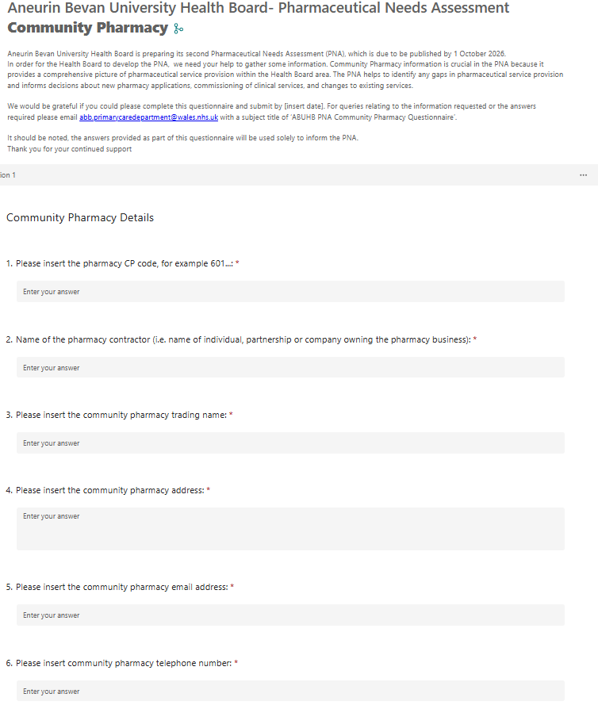
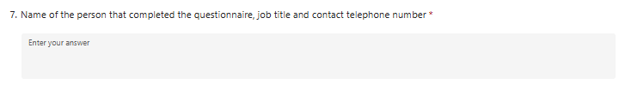
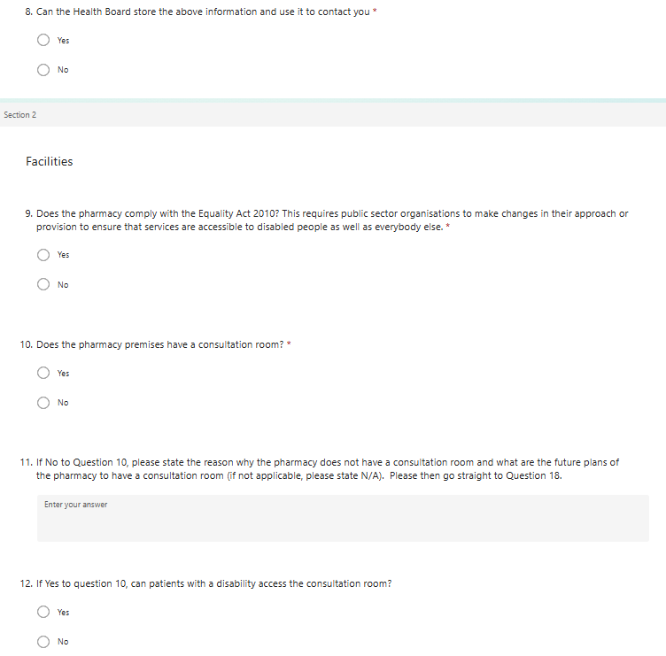
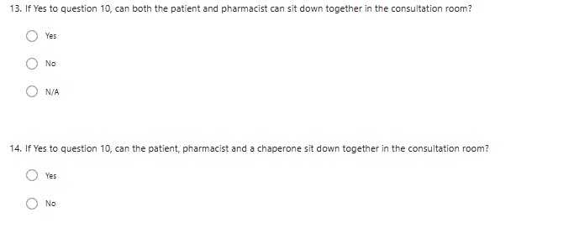
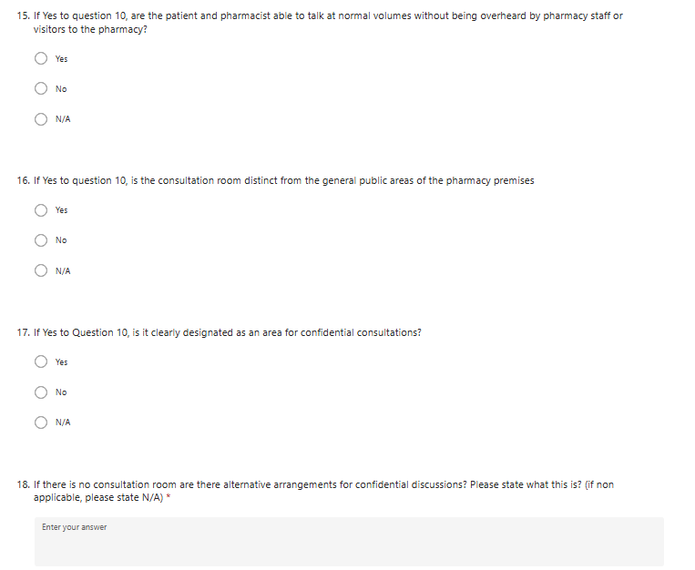
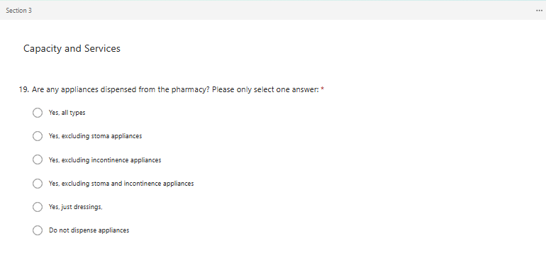
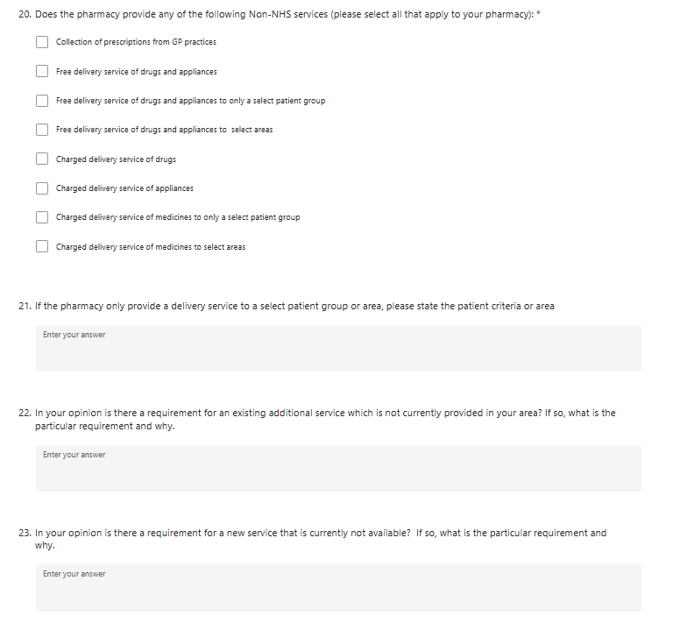
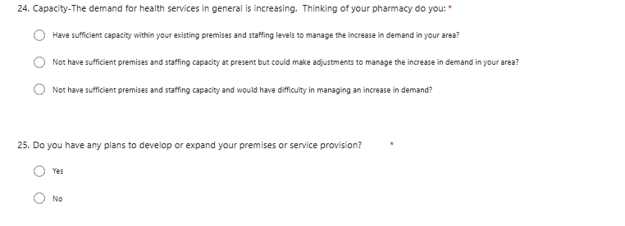
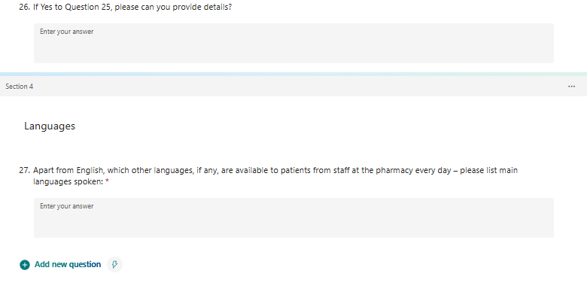

Appendix J – Dispensing Practice Questionnaire
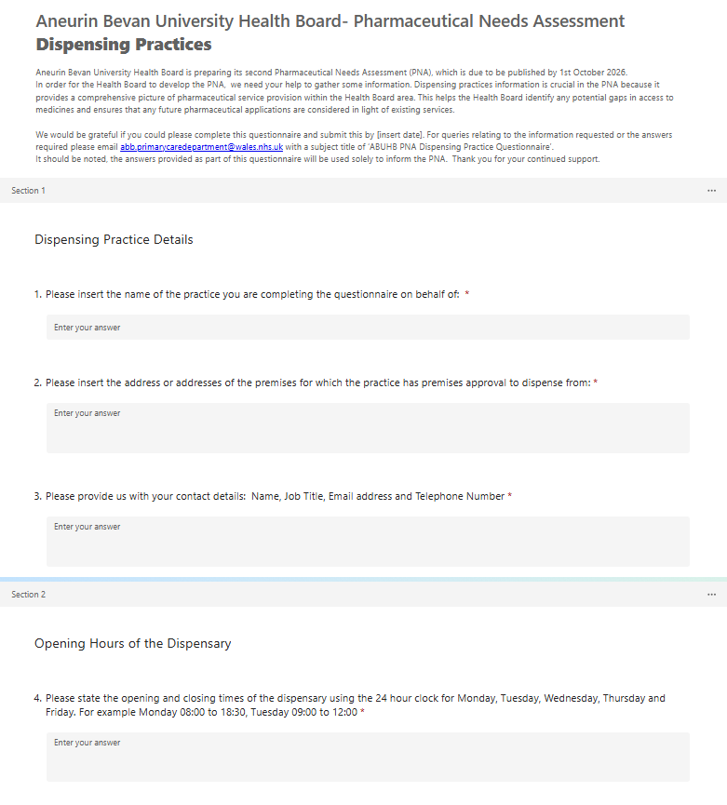
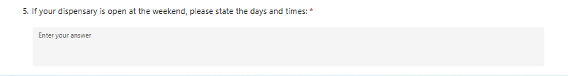
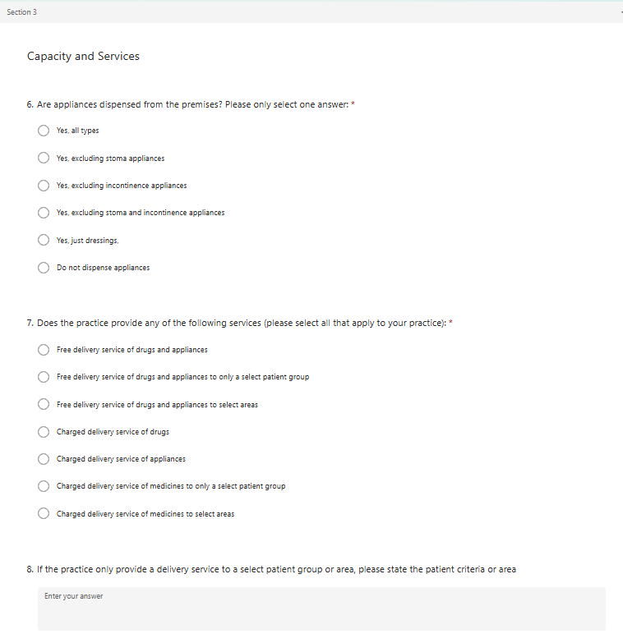
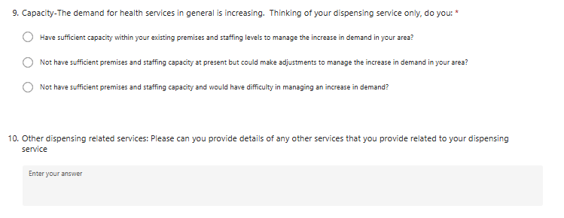
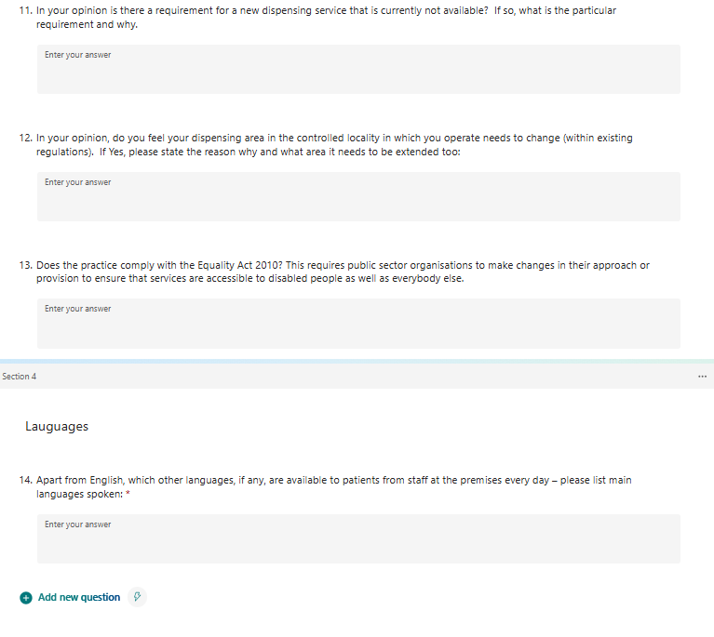

Appendix K – Consultation Changes

Introduction
As part of the Pharmaceutical Needs Assessment (PNA) process the Health Board is required to undertake a consultation of at least 60 days with certain organisations. The purpose of the consultation is to establish if the pharmaceutical providers and services supporting the population of the Health Board’s area are accurately reflected in the final PNA document. This report outlines the considerations and responses to the consultation and describes the overall process of how the consultation was undertaken.

Consultation process
In order to complete this process, the Health Board has consulted with those parties identified under regulation 7 of the NHS (Pharmaceutical Services) (Wales) Regulations 2020, to establish if the draft pharmaceutical needs assessment addresses issues that they considered relevant to the provision of pharmaceutical services;
- Community Pharmacy Wales
- Gwent Local Medical Committee
- Contractors included in its pharmaceutical list
- GPs included in the Aneurin Bevan University Health Board dispensing doctor list
- GP practices
- Llais
- Gwent Regional Partnership Board
- Blaenau Gwent County Borough Council
- Caerphilly County Borough Council
- Monmouthshire County Council
- Newport County Borough Council
- Torfaen County Borough Council
- Powys Teaching Health Board
- Cwm Taf Morgannwg University Health Board
- Cardiff and Vale University Health Board
- The integrated wellbeing networks
- Neighbourhood care networks
- The five public service boards
- Nye’s Community Champions
- Community groups
- Carers groups
- 50+ forums
- Gwent Association of Voluntary Organisations
- Torfaen Voluntary Alliance
- People First
- Gwent Citizens Panel
- BAME
The consultation version of the PNA was published on the Health Board’s website and the consultees were emailed and invited to respond to the online questionnaire. The link to the PNA and the questionnaire were included in the email. The consultation was also promoted on the Health Board’s website and social media pages.
As well as the PNA Consultation Draft, a Summary Document and Easy Read version were also produced to support the consultation.
Consultees were given the opportunity to respond by completing a set of questions. This was undertaken by completing the questions online or via the easy read version. Both the pharmaceutical needs assessment and the questions were available in Welsh and English.
The questions derived were to assess the current provision of pharmaceutical services, have regard to any specified future circumstance where the current position may materially change and identify any current and future gaps in pharmaceutical services.
The consultation ran from 2 July to 31 August 2026.
This report outlines the considerations and responses to the consultation. It should be noted that participants in the consultation were not required to complete every question.
Summary of questions, responses and the Health Board’s considerations
For the Aneurin Bevan University Health Board Draft Pharmaceutical Needs Assessment consultation, 14 responses were received through the online questionnaire. A separate detailed written response was received from Community Pharmacy Wales, bringing the overall number of consultation responses to 15. The responses comprised members of the public, pharmacy contractors, professional bodies and a GP practice:
Group | Response Rate- Count | Percentage of all consultation responses
Members of the Public | 8 | 53%
Pharmacy Contractors | 4 | 27%
Professional Bodies | 2 (Gwent LMC and CPW) | 13%
GP Practice | 1 | 7%
Total | 15 | 100%

Summary of online responses and Health Board considerations
The online consultation received 14 responses, which identified as follows. Relevant free-text comments from the online questionnaire are reproduced as submitted. Limited redactions have been made where necessary to reduce the risk of identifying an individual, organisation or location, and minor presentational corrections have been made where required for readability. The separate Community Pharmacy Wales submission is summarised in this report and appended in full.
Question 1.
1. Has the purpose of the Pharmaceutical Needs Assessment been sufficiently explained?
Yes | 12
No | 1
Don’t know | 1

Verbatim comments in relation to the question above;
“Enough information provided for the purpose of PNA”
“Easy to read document”
“I have read the Summary Document of the Pharmaceutical Needs Assessment and it explained things in detail which I understood.”
“all documented”
“I have checked the details of the Pharmaceutical Needs Assessment and I understand the document.”
“Don't understand”
“If the question is intended to attract ‘a meaningful response’ from members of the public then it should be made far easier for the public to access more, and meaningful information. about the pharmaceutical Needs Assessment, and its impact on the users, i.e. Member of the Public, as presumably, the purposes of this consultation depends usefulness in a PATIENT CENTERED FACILITY. ”
“I’ve read the supporting paperwork”
“I have read and understand the pharmaceutical Needs Assessment document.”
Health Board consideration and response
The Health Board notes the respondent's comment about attracting a meaningful response from members of the public. The purpose of the consultation was to seek views on the draft PNA and its assessment of pharmaceutical service provision across the Health Board area. To support public engagement, the consultation materials, including the draft PNA and accompanying information, were made publicly available throughout the consultation period.
Question 2
2. In your opinion, does the Pharmaceutical Needs Assessment reflect the current provision of pharmaceutical services within your area
Yes | 11
No | 2
Don’t know | 1

Verbatim comments in relation to the question above;
“It covers the need for pharmacy community services in local community especially IP pharmacists are improving their service provision and scopes.”
“I’m lucky to live in a town with two excellent independent pharmacy branches. I don’t understand why GPs are allowed to dispense. They do not have pharmacists in the dispensary or supervising GPs (risk), they provide no additional pharmacy services and patients have to travel to the practice to get their drugs, driving past community pharmacies. We all know it’s a money-making operation for the GPs, who I understand get paid more than community pharmacies per script. So poorer service costing more. Madness!”
“The results of the Assessment regarding my local area are accurate.”
“We have no pharmacies open on a Saturday.”
“More pharmacies need to be open on Saturdays at least and more on Rota on Sundays.”
“Covered all aspects”
“The number of pharmacies serving the area is accurate”
“Because it will depend on the supervision of the various pharmaceutical public services providers, by THE ABHB Pharmaceutical provision leaders. particularly to the extent that proper enforcement, of the regulations, of independent `CHEMIST SHOPS, of the eventual agreed policies, so that its eventual impact of the continued proper dispensing of patients necessary medication continues, and that there is no diluting of what should already be, but is not always the case, of the one important `job` they should be doing and that is the proficient dispensing of "prescribed` medications.”
“The current provision of services in my area is reflected in the Needs Assessment.”
Health Board consideration and response
The Health Board notes the comments regarding pharmacy opening hours and while the PNA considers whether pharmaceutical services are adequate to meet population need, minimum core opening hours for pharmacies are agreed nationally through regulation, and operational matters such as staffing arrangements and breaks are the responsibility of individual contractors and are outside the scope of the PNA or beyond the direct control of the Health Board.
Question 3
3. The Health Board has identified that the majority of prescriptions for appliances are dispensed by contractors outside of its area, either elsewhere in Wales or in England, and that those contractors provide the appliance use review and stoma appliance customisation services. It has therefore assumed that the need for these two services is being met by these out of area providers. Do you agree with this?
Yes | 7
No | 2
Don’t know | 3

Two of the respondents to the questionnaire did not answer this question. Those who answered ‘No’ were asked to provide comments;
“I am happy to provide appliance use review and stoma appliance customisation however I have never had opportunity to discuss what services and expertise we can provide in community.”
“I answered no because the ABHB undertake a regular ‘appliance use review’ each time BEFORE any repeat services are (or at least that appears to be the case because every time a patient requires to use these external services or equipment, `and currently these services are provided by contractors outside the area of the ABHB. HOWEVER, in order to access then in `repeat form because of a patients continued needs, each patient has to make contact with agents working in, and for, the ABHB, already and currently none of those regular continued, repeat services can be activated UNTILL they are REGULARLY sanctioned and I presume by the ABHB direct. Patients do not have direct access to the `providers` of stoma and bowel, equipment. ”
Health Board consideration and response
The Health Board notes the comments about willingness to provide Appliance Use Reviews and Stoma Appliance Customisation and about repeat appliance-authorisation pathways. The PNA assesses whether population need is met rather than determining individual referral or repeat-authorisation arrangements. Current dispensing evidence indicates that most appliance prescriptions are supplied by out-of-area contractors, many of whom provide associated review and customisation support. No evidence of unmet need, delay or inability to access these services was identified through consultation. The Health Board therefore retains its conclusion that current need is met through existing out-of-area provision, while access and utilisation will remain under review.
Question 4
4. In your view, are there any gaps in service provision that the Pharmaceutical Needs Assessment has not identified?
Yes | 5
No | 8
Don’t know | 1

Verbatim comments in relation to the question above;
“Scope of IP services provided by Pharmacist”
“Covid, pneumonia and RSV vaccination - why can’t pharmacists do these vaccines? They did during the pandemic when GP practices were more or less closed……. More cash for GPs? It’s like a cartel or monopoly”
“Need a pharmacy delivery service in [town removed] and a more helpful pharmacy,7 days wait for tablets is not acceptable.”
“Weekend opening times and availability of pharmacies which are open.”
“The introduction and best use of NHS IT to benefit patients was not mentioned (as far as I can see). The promotion of the use of the NHS App and take up of the EPS system should underpin future needs. EPS is well rolled out now, but it still has much more potential to reduce patient frustration and inefficiency - for example, alerts when medicines are ready, better planning to reduce medicines out of stock... This improvement should be front and centre of the strategy. (There must be benefits to surgeries and pharmacies too, but I am looking only at patient benefits). User-facing IT should seek to integrate diverse systems to the tangible benefit of patients - improving systems, not just digitizing them.”
Health Board consideration and response
The Health Board recognises the points raised above. In relation to Pharmacist Independent Prescribing (PIPS) any expansion of services would be dependent on changes to the National Directed Service specification and associated commissioning arrangements. As these matters are determined nationally, they are outside the scope of the PNA.
Consultation respondents identified COVID-19 booster, pneumococcal and respiratory syncytial virus vaccination as potential future community pharmacy services. Any expansion would be subject to national policy, assessed need, workforce capacity, clinical governance and sustainable commissioning. These services are not identified as current gaps in pharmaceutical provision.
Digital developments, including continued implementation of the Electronic Prescription Service and development of the NHS Wales App, may improve access to and experience of pharmaceutical services over the lifetime of the PNA. Potential benefits include improved communication between patients, prescribers and pharmacies, clearer prescription-status information, notification when medicines are ready for collection and fewer unsuccessful journeys. Digital systems are enabling infrastructure rather than pharmaceutical services in their own right and do not alter the statutory assessment of need. They should complement appropriate support for people who cannot or choose not to use digital services.
As detailed above, pharmacy core opening hours are determined through national contractual arrangements. A routine medicines home-delivery service is not identified as a nationally commissioned pharmaceutical service for the purposes of this PNA. Individual contractors may offer delivery arrangements outside the scope of their NHS pharmaceutical-service obligations. The availability of such arrangements does not, by itself, determine whether a statutory gap in pharmaceutical provision exists.
Question 5
5. Do you feel that the draft Pharmaceutical Needs Assessment reflects the needs of your area’s population?
Yes | 9
No | 3
Don’t know | 2

Verbatim comments in relation to the question above;
“Local community requires services fairly efficiently hence they are willing to see pharmacist and their team as doctor appointments are difficult to manage.”
“In [town removed] the pharmacy service is diabolical considering all the new houses built”
“I HOPE IT DOES, after all the pharmaceutical services have ONE job to do, and that it continue to provide access to those once prescribed by a fully qualified clinician after considerable consideration by the Doctor after a full and qualified interaction with a patient, PHARMACIST are, in my opinion demonstrating they do not ALL have the personal qualities to interact with patients, in fact some already demonstrate they do not, and will not, or find it impossible to follow current guidelines produced by the ABHB to protect the care and interests of patients.”
“Torfaen North and South.”
Health Board consideration and response
The Health Board acknowledges that some comments relate principally to individual service experience rather than evidence of a population-level gap in pharmaceutical provision. The consultation evidence did not demonstrate a current systemic or geographical gap or a specific future need for additional pharmaceutical premises in the areas referenced.
However, the comments concerning housing growth, access, prescription turnaround, medicine availability and provider capacity informed the additional monitoring provisions included in Chapter Six.
Individual service-quality concerns will continue to be considered through the appropriate contractual, governance or service-management route.
Question 6
6. In your view, has the draft Pharmaceutical Needs Assessment provided enough information to support decision making i.e. decisions on applications for new pharmacies and dispensing appliance contractor
Yes | 9
No | 2
Don’t know | 3

Verbatim comments in relation to the question above;
“Not enough detail about the application process and who makes the decision.”
“The public cannot easily access the draft Pharmaceutical Needs Assessment DRAFT. there has been no public centred publicity about this issue and proposed ABHB actions.”
“We don’t have any additional needs for pharmacist in our area as we are already have sufficient number in our community.”
Health Board consideration and response
The purpose of the PNA is to assess the current and future need for pharmaceutical services and identify any gaps in provision. Whilst the PNA informs decisions on applications for new pharmacy premises and relocations, the application process itself is governed by the NHS (Pharmaceutical Services) (Wales) Regulations 2020 and is therefore outside the scope of the PNA.
The draft PNA was made available on the Health Board's website, with information shared through a number of channels, including social media, Llais and community groups.
The Health Board notes that the detailed procedural requirements for submitting and determining an application are set out in the NHS (Pharmaceutical Services) (Wales) Regulations 2020 and are not replicated in full within the PNA. However, the Executive Summary, Chapter One, Chapter Seven and Appendix A have been amended to explain more clearly that the PNA provides an important evidential basis for market-entry decisions, that it does not itself approve a new pharmacy or determine an application, and that each application must be determined separately under the applicable regulatory provisions and the evidence prevailing at that time.
Question 7
7. In your view, has the draft Pharmaceutical Needs Assessment provided sufficient information to inform how pharmaceutical services in the Health Board’s area may be commissioned in the future?
Yes | 7
No | 1
Don’t know | 6

Verbatim comments in relation to the question above;
“Not much new information provided”
“With the development of North Torfaen in Mamilhad it is planned that there will be a pharmacy built? If so this would have implications on dispensing practices who have dispensing patients within 1.7km. This would likely destabilise local GP dispensaries”
Health Board consideration and response
The Health Board has considered the comments concerning Mamhilad Urban Village and the possible effect of future pharmacy provision on dispensing-doctor arrangements. The fixed requirements for new pharmacy premises previously proposed for Mamhilad have been removed. The detailed locality assessment describes Mamhilad Urban Village as a matter requiring monitoring. The area has not been defined as a current gap, and Chapter Seven concludes that no specific future need for additional pharmaceutical provision has been identified on the evidence presently available.
Monitoring will consider construction and occupation, population growth, access, service use, provider capacity and alternative pharmaceutical and other NHS services. Any future application would be determined separately under the applicable regulations and the evidence prevailing at that time, including relevant controlled-locality and distance provisions. The PNA does not itself determine any change to dispensing eligibility.
In response to Questions 7 and 8, the final PNA has been amended to distinguish current gaps, conditional future needs and matters requiring monitoring. The detailed locality assessment now describes Mamhilad Urban Village as a matter for monitoring. Chapter Seven now concludes that no specific future need for additional pharmaceutical provision has been identified on the evidence presently available. The final PNA also explains the action available under regulation 6 if a significant change in pharmaceutical need or service availability occurs.
Question 8
8. In your opinion, has the draft Pharmaceutical Needs Assessment provided enough information to inform future pharmaceutical services provision and plans for pharmacies, dispensing appliance contractors
Yes | 7
No | 1
Don’t know | 6

Verbatim comments in relation to the question above;
“With the development of North Torfaen in Mamilhad it is planned that there will be a pharmacy built? If so this would have implications on dispensing practices who have dispensing patients within 1.7km. This would likely destabilise local GP dispensaries”
“The population of Chepstow continues to increase and the pharmacies we currently have appear to be at capacity in that the repeat prescription turnaround time keeps increasing. This has been noticeable since the development of a housing estate near Tesco in Chepstow.”
Health Board consideration and response
The Health Board has considered the comments concerning Mamhilad Urban Village and the possible effect of future pharmacy provision on dispensing-doctor arrangements. The fixed requirements for new pharmacy premises previously proposed for Mamhilad and Glan Llyn have been removed.
The detailed locality assessment has been amended to describe Glan Llyn and Mamhilad Urban Village as matters requiring monitoring. Neither is identified as a current gap, and Chapter Seven concludes that no specific future need for additional pharmaceutical provision has been identified on the evidence presently available.
Regarding increasing populations. Ongoing monitoring will consider construction and occupation, population growth, access, service use, provider capacity and alternative pharmaceutical and other NHS services. Any future application would be determined separately under the applicable regulations and the evidence prevailing at that time, including relevant controlled-locality and distance provisions. The final PNA also explains the action available under regulation 6 if a significant change in pharmaceutical need or service availability occurs
Question 9
9. In your opinion, are there any pharmaceutical services that could be provided in the pharmacy setting in the future that have not been highlighted within the draft Pharmaceutical Needs Assessment?
Yes | 4
No | 6
Don’t know | 4

Verbatim comments in relation to the question above;
“Covid, pneumonia and RSV vaccination”
“Friendly staffed pharmacy needed in [town removed].”
“A proper and meaningful ENFORCMENT of a pharmacists’ activities in respects to ensure members of the public continue to have proper access to Necessary medication, and to prevent pharmacist from taking an independent position and ignoring ABHB patient safety provisions, and this would only be the case if the ABHB ensured a proper inspection and audit of a pharmacist `ACTIVITIES and prevented ANY local sweetheart deals in respect to public concerns at anytime.”
“Vaccinations for Covid boosters, RSV vaccinations.”
Health Board consideration and response
Consultation respondents identified COVID-19 booster, pneumococcal and respiratory syncytial virus vaccination as potential future community pharmacy services. Any expansion would be subject to national policy, assessed need, workforce capacity, clinical governance and sustainable commissioning. These services are not identified as current gaps in pharmaceutical provision.
The Health Board acknowledges the other comments, including those concerning staff approach, oversight and enforcement. These matters do not demonstrate a population-level gap in pharmaceutical provision and therefore do not alter the Schedule 1 assessment. Service-quality, professional-regulation and individual-contractor concerns will continue to be considered through the appropriate complaints, contractual, governance and regulatory routes
Question 10
10. Are you aware of any developments that will arise within the lifetime of the Pharmaceutical Needs Assessments that have not been identified? For example, housing developments, regeneration projects?
Yes | 4
No | 8
Don’t know | 2

Verbatim comments in relation to the question above;
“There are number of new developments approved by council in the area however we don’t have any plans for new services for community reflect that.”
“LDPs and pharmacy’s going bust due to the contract and rising cost of drugs and staff costs”
“I refer you to my response in the previous question, and refers to the basic `control` of a pharmacist to ensure the BASIC quality of the service is properly SECURED for all current and future USERS of the patient lead service.”
“See answer to question 8” (regarding the population of Chepstow)
Health Board consideration and response
Local Development Plans and other relevant population developments across the Health Board area were reviewed during preparation of the PNA. This included identified strategic developments in Newport and Torfaen. The consultation evidence did not establish an additional current gap or a specific future need for new pharmaceutical premises arising from the further developments mentioned by respondents.
However, Chapter Six has been amended to record explicitly the concerns relating to housing growth, weekend access, prescription turnaround, medicine availability and perceived provider-capacity pressures, including comments concerning Magor and Chepstow.
These matters will be monitored through dwelling completions and occupation, registered-population change, prescription and service activity, contractor capacity, opening hours, weekend and bank-holiday access, travel considerations, turnaround times and the availability of alternative pharmaceutical and other NHS services.
Question 11
11. Do you agree with the conclusions of the draft Pharmaceutical Needs Assessment?
Yes | 9
No | 0
Don’t know | 5
No additional comments were received in respect of this question
Question 12
12. Do you have any other comments in respect of the draft Pharmaceutical Needs Assessment?
Yes | 2
No | 12
Don’t know | 0

Verbatim comments in relation to the question above;
“The ABHB HAVE to ensure that the proper enforcement and inspection regulatory function of pharmacy’s and individual pharmacist takes place, and that any observations or formal submissions by PATIENTS have a proper role within the process to ensure the high quality of pharmaceutical services in GWENT is maintained. I do not know if such a provision is considered AT ANY TIME" by the AGHB even currently.?”
“Far greater need for old age pensioner services as there is nothing apart from voluntary organisations and charities. Far more provision for patients with serious long term health conditions especially at weekends.”
Health Board consideration and response
In response the comments above, the Health Board recognises the importance of ensuring that pharmaceutical services are delivered in a safe, effective and high-quality manner and that patients have opportunities to provide feedback on the services they receive. However, the inspection, regulation and enforcement of pharmacy services and individual pharmacists are the responsibility of national regulatory and professional bodies and are not matters that are considered as part of the PNA.
A comprehensive population needs assessment was undertaken as part of the development of the PNA. This included consideration of current and projected population changes, demographic characteristics, health needs, life expectancy, deprivation, disability and other factors that may influence the future need for pharmaceutical services across the Health Board area.
The findings of this assessment have informed the conclusions within the PNA. Following consideration of this evidence, no additional pharmaceutical service needs were identified beyond those set out in the document.

Summary of Written Response and Health Board Considerations
A detailed written response was received from Community Pharmacy Wales (CPW). CPW acknowledged the work undertaken in preparing the draft PNA and broadly supported its description of current community pharmacy provision. However, CPW raised concerns about the evidential basis for some draft conclusions concerning future pharmaceutical need, hypothetical changes in service availability, controlled localities and the sustainability of provider capacity. The response is summarised below.
Question 1
1. Has the purpose of the pharmaceutical needs assessment been explained?
Community Pharmacy Wales response | Yes, with qualifications

Summary of comments
CPW considered that the draft correctly described the PNA as a statutory assessment of current and future pharmaceutical need.
CPW recommended that the Executive Summary and Introduction give greater prominence to the PNA's role as an important evidential basis for decisions under the pharmaceutical market-entry framework, because the evidence, methodology and conclusions may affect subsequent regulatory decisions.
Health Board consideration and response
The Health Board accepted this recommendation. The Executive Summary, Chapter One, Chapter Seven and Appendix A have been amended to give greater prominence to the PNA's role as an important evidential basis for market-entry decisions, while clarifying that the PNA does not itself approve a new pharmacy or determine an application.
Question 2
2. Does the pharmaceutical needs assessment reflect the current provision of pharmaceutical services within the area?
Community Pharmacy Wales response | Yes, with qualifications

Summary of comments
CPW considered that the draft broadly reflected current community pharmacy provision and drew on an appropriate range of contractual, dispensing, service-activity and local intelligence data.
CPW advised that contractor questionnaire findings on capacity should be treated as a point-in-time assessment rather than evidence of future resilience. It stated that continued capacity and service delivery depend on contractual funding and workforce sustainability.
Health Board consideration and response
The Health Board accepted the qualification. Contractor questionnaire findings are treated as point-in-time evidence and considered alongside premises, workforce, activity, accessibility and local intelligence. The final PNA does not treat reported capacity as a guarantee of future resilience and recognises its dependence on workforce availability, contractual arrangements, clinical governance and sustainable resources.
Question 3
3. Is the need for Appliance Use Reviews and Stoma Appliance Customisation being met through providers outside the Health Board area?
Community Pharmacy Wales response | Yes

Summary of comments
CPW considered it reasonable, in the absence of evidence to the contrary, to assume that the need for Appliance Use Reviews and Stoma Appliance Customisation is being met through existing out-of-area provision.
Health Board consideration and response
The Health Board agreed that available evidence supports the conclusion that current need is met through out-of-area provision. A local contractor's willingness to provide a service does not itself establish an unmet need. Appliance-service access and utilisation will remain under review.
Question 4
4. Are there gaps in service provision that have not been identified in the pharmaceutical needs assessment?
Community Pharmacy Wales response | Unable to confirm

Summary of comments
CPW considered that the PNA included much of the relevant information about the location, opening hours and range of pharmaceutical services.
CPW was not in a position independently to verify the completeness or accuracy of that information and therefore could not confirm whether additional gaps existed.
Health Board consideration and response
The Health Board reviewed provision data, opening hours, locations, activity, contractor feedback and consultation evidence. No additional current systemic or geographical gap was identified. Any material change in availability, access or capacity identified during the lifetime of the PNA will be considered under regulation 6.
Question 5
5. Does the draft pharmaceutical needs assessment reflect the needs of the area's population?
Community Pharmacy Wales response | No

Summary of comments
CPW considered that the draft did not sufficiently evidence proposed future pharmacy requirements in Newport East and Torfaen North, or the consequences attributed to pharmacy closure, reductions in Saturday opening and cessation of dispensing-doctor services.
For Glan Llyn and Mamhilad Urban Village, CPW questioned whether the development thresholds would be reached during the PNA period and highlighted the accessibility of existing pharmacies. It recommended monitoring unless evidence showed that relevant development and population changes would occur and existing provision could not meet demand.
CPW opposed assumptions that loss of a pharmacy, supplementary Saturday hours or dispensing-doctor provision would automatically create a like-for-like replacement need. It considered that any change should prompt a fresh assessment of access, alternative provision, service use, population need, controlled-locality requirements and network capacity.
CPW also cautioned that inadequately evidenced market-entry needs could create over-provision and adversely affect the sustainability of existing pharmacies.
Health Board consideration and response
The Health Board accepted the concern in part. The fixed requirements for new pharmacy premises previously proposed for Glan Llyn and Mamhilad Urban Village have been removed. The detailed locality assessment describes Glan Llyn and Mamhilad Urban Village as matters requiring monitoring. Neither is identified as a current gap, and Chapter Seven identifies no specific future need for additional pharmaceutical provision on the evidence presently available.
Statements implying that pharmacy withdrawal, loss of supplementary Saturday hours or cessation of dispensing-doctor services would automatically create replacement need have been removed.
Statements that any future change will be managed in line with the conditions set out in regulation 6 of the NHS (Pharmaceutical Services) (Wales) Regulations 2020 have been incorporated at relevant points.
Question 6
6. Has the pharmaceutical needs assessment provided sufficient information to inform market-entry decisions?
Community Pharmacy Wales response | No

Summary of comments
CPW considered that the concerns raised under question 5 should be resolved before the PNA was relied upon for market-entry decisions.
CPW also raised concerns about controlled-locality determinations, dispensing-doctor outline-consent areas and mapping. It requested prioritised clarification around Abergavenny and clarification of the position relevant to Mamhilad Urban Village before any future application was considered.
Health Board consideration and response
The final PNA strengthens the explanation of its market-entry function and clarifies that applications are determined separately under the applicable regulatory tests and current evidence.
Chapter One now explains that eligibility for doctor dispensing is governed by the statutory controlled-locality framework and cannot be extended through the PNA. The Schedule 1 map identifies pharmaceutical and dispensing premises but does not determine or reproduce controlled-locality boundaries. The consultation concerns relating to controlled-locality information, including those concerning Abergavenny and the status relevant to Mamhilad Urban Village, have been recorded.
The underlying controlled-locality and mapping position is not resolved by publication of the PNA and will require consideration through the appropriate statutory, regulatory and Health Board governance process. Before determining any affected application, the Health Board will need to establish and consider the applicable controlled-locality, distance, outline-consent and other regulatory evidence prevailing at that time.
Question 7
7. Has the pharmaceutical needs assessment provided information to inform how pharmaceutical services may be commissioned in the future?
Community Pharmacy Wales response | Qualified response

Summary of comments
CPW recognised that the PNA provides a five-year planning framework but referred back to its concerns about the evidence supporting the current and future needs identified in the draft.
Health Board consideration and response
The PNA remains a five-year assessment of pharmaceutical need but is distinguished from subsequent commissioning decisions. Future commissioning must be considered alongside national policy, assessed need, workforce capacity, clinical governance, contractual arrangements and sustainable funding. Monitoring provisions have been included accordingly.
Question 8
8. Has the pharmaceutical needs assessment provided enough information to inform future service provision and plans for pharmacies, appliance contractors and dispensing doctors?
Community Pharmacy Wales response | No

Summary of comments
CPW considered that the draft did not demonstrate that a need for new pharmacy provision in Newport East or Torfaen North would arise during the PNA period, given uncertainty about development timing, occupation, population growth, access, demand, existing capacity and future general medical services.
CPW recommended continued review using clearer evidence on development progress, occupancy, access and network capacity. It also stated that capacity conclusions should recognise financial and workforce pressures and the need for recurrent funding and contractual support.
Health Board consideration and response
The detailed locality assessment has been amended to describe Glan Llyn and Mamhilad Urban Village as matters for monitoring. Neither location is identified as a current gap, and Chapter Seven now concludes that no specific future need for additional pharmaceutical provision has been identified on the evidence presently available. Statements have been included to describe that monitoring will include dwelling completions and occupation, population growth, access, service use, opening hours, provider capacity and alternative pharmaceutical and NHS services. If evidence shows that existing provision can no longer meet need, the Health Board will consider action under regulation 6.
Question 9
9. Are there pharmaceutical services that could be provided in the pharmacy setting in future that have not been highlighted?
Community Pharmacy Wales response | Yes

Summary of comments
CPW suggested that pharmacy-based weight-management services could contribute to addressing the prevalence of overweight and obesity identified in Chapter Two.
CPW stated that such services would require investment beyond the existing Community Pharmacy Contractual Framework and recommended development in line with Community Pharmacy by Design principles and sustainable recurrent funding.
Health Board consideration and response
Chapter Two now records weight-management support as a potential future community pharmacy service. Any development would be subject to national policy, a separate assessment of need, workforce capacity, clinical governance, Community Pharmacy by Design principles and sustainable commissioning. No current Schedule 1 gap has been identified.
Question 10
10. Are there developments likely to arise during the lifetime of the pharmaceutical needs assessment that have not been identified?
Community Pharmacy Wales response | No

Summary of comments
CPW was not aware of additional developments but noted that contractors, members of the public and other stakeholders with local knowledge might identify further developments through consultation.
Health Board consideration and response
No additional developments were identified by CPW. The final PNA continues to consider material population or service changes, through ongoing monitoring. Any future change will be managed in line with the conditions set out in regulation 6 of the NHS (Pharmaceutical Services) (Wales) Regulations 2020.
Question 11
11. Do you agree with the conclusions of the pharmaceutical needs assessment?
Community Pharmacy Wales response | No

Summary of comments
CPW did not agree with the draft conclusions because it considered that the identified unmet and future needs had not been sufficiently demonstrated, principally for the reasons set out in its response to question 5.
Health Board consideration and response
Following consultation, the conclusions have been substantially revised. The final PNA identifies no current systemic or geographical gap and no specific future need for additional pharmaceutical provision on the evidence presently available. Strategic developments and changes in service availability are treated as matters for monitoring, with significant changes considered under regulation 6. The Health Board retains responsibility for its final statutory assessment.
Question 12
12. Do you have any other comments?
Community Pharmacy Wales response | No

Summary of comments
CPW made no additional comments.
Health Board consideration and response
No additional comments were made under this question. The response as a whole nevertheless informed revisions to the Executive Summary, Chapter One, Chapters Two, Six and Seven, Appendix A and this amendment record.
Summary of principal points raised by Community Pharmacy Wales
- CPW broadly supported the description of current community pharmacy provision and agreed with the assessment of appliance-related services obtained from out-of-area providers.
- CPW did not agree with the draft's overall conclusions because it considered that several identified future needs and hypothetical replacement requirements were insufficiently evidenced.
- CPW recommended clearer recognition of the PNA's market-entry role; evidence-led monitoring of strategic developments; removal or revision of speculative future-need statements; clarification of controlled-locality information; recognition of funding and workforce dependencies; and consideration of pharmacy-based weight-management services subject to assessed need and sustainable commissioning.
Health Board consideration and response to summary points
The Health Board accepted that hypothetical changes arising during the lifetime of the PNA should not automatically be treated as established future needs.
The Executive Summary, Chapter One, Chapter Seven and Appendix A have been amended to clarify and explain the Health Board's duties under regulation 6, including consideration of a revised assessment under regulation 6(2) and, where the statutory conditions are met, publication of a supplementary statement under regulation 6(3).

Summary conclusions
Consultation responses broadly supported the description of current pharmaceutical provision but raised concerns about the evidence supporting some proposed future needs and hypothetical replacement requirements. The Health Board accepted those concerns in part.
The final PNA identifies no current systemic or geographical gap and no specific future need for additional provision on the evidence presently available. Strategic housing growth, weekend access, service availability, prescription turnaround, medicine availability and provider capacity will be monitored, with significant changes considered under regulation 6 of the NHS (Pharmaceutical Services) (Wales) Regulations 2020.
The final PNA removes speculative statements that provider withdrawal, reduction in supplementary Saturday hours or cessation of dispensing-doctor services would automatically create replacement need. The detailed locality assessment describes Glan Llyn and Mamhilad Urban Village as matters for monitoring; neither is identified as a current gap, and Chapter Seven identifies no specific future need on the evidence presently available.
Potential vaccination and weight-management services are future commissioning considerations, subject to policy, assessed need, workforce capacity, clinical governance and sustainable funding, and are not current gaps.
The Health Board will continue to make proportionate use of the existing pharmaceutical network and place-based models of care, while recognising that reported capacity is point-in-time evidence and may depend on workforce availability and sustainable contractual support.

Equalities monitoring
Eleven of the 14 online respondents completed the equality monitoring section and provided demographic information, Of these:
- Eleven respondents stated that their preferred language is English.
- One respondent is aged 35 to 44 years, two are aged 45 to 54 years, two are aged 55 to 64 years, four are aged 65 to 74 years and two are aged 75 years or older.
- Three respondents are male and eight are female.
- Five respondents described their ethnic group as White, three as Welsh, two as British and one as Indian.
- Nine respondents stated that they are heterosexual or straight and two preferred not to say.
- Eight respondents are Christian, one is Atheist, one is Hindu and one preferred not to say.
- Six respondents stated that they did not have a long-term illness or disability and five stated that they did.
- Eleven respondents stated that their gender identity has not changed from that assigned at birth.
- Five respondents confirmed that they have caring responsibilities, five stated that they did not and one preferred not to say.

Amendments to the PNA following consultation
- The Executive Summary, Chapter One, Chapter Seven and Appendix A were amended to emphasise the PNA's role as an important evidential basis for market-entry decisions while clarifying that applications are determined separately.
- Chapter One and Appendix A were expanded to explain regulation 6 of the NHS (Pharmaceutical Services) (Wales) Regulations 2020 including revised assessments under regulation 6(2) and supplementary statements under regulation 6(3).
- The dispensing-doctor sections were corrected and expanded to explain controlled localities, the 1.6 kilometre test, the distinction between controlled-locality mapping and the Schedule 1 premises map, and the need to establish relevant status before determining an affected application.
- Vaccination text was amended to record COVID-19 booster, pneumococcal and respiratory syncytial virus vaccination as potential future services subject to policy, assessed need, workforce capacity, clinical governance and sustainable commissioning, not as current gaps.
- Weight-management support was recorded as a potential future community pharmacy service, subject to national policy, assessed need, workforce capacity, clinical governance and sustainable commissioning, and not as a current gap. This terminology should be read consistently with the corresponding PNA reference to weight-loss support.
- Contractor capacity evidence was qualified as point-in-time information rather than a guarantee of future resilience.
- Chapter Six was amended to record consultation concerns about weekend access, prescription turnaround, medicine availability, housing growth and perceived capacity pressures, including Magor and Chepstow, and to establish the related monitoring framework.
- The fixed future pharmacy requirements previously proposed for Glan Llyn and Mamhilad Urban Village were removed. The detailed locality assessment describes Glan Llyn and Mamhilad Urban Village as matters for monitoring; Chapter Seven concludes that no specific future need for additional pharmaceutical provision has been identified on the evidence presently available.
- Statements implying automatic replacement need following pharmacy withdrawal, reduced supplementary Saturday hours or cessation of dispensing-doctor services were removed. Material changes will be managed in according to regulation 6 of the NHS (Pharmaceutical Services) (Wales) Regulations 2020.
- The conclusions within individual NCN assessments in Chapter Six were revised to state that existing pharmaceutical services, including provision accessed in neighbouring localities, are currently sufficient to meet identified need. This replaces more absolute statements that no current or future need exists.
- Chapter Seven was amended to distinguish current gaps, conditional future needs and matters requiring monitoring, and to conclude that no specific future need for additional provision is identified on the evidence presently available.
- Appendix K was updated to provide a Health Board consideration and response to each principal consultation issue and a traceable record of the resulting amendments.

Appendix L - Protected Characteristics and Vulnerable and inclusion groups Data
Ethnic groups by percentage by local authority and Wales
Local authority | White | Asian/ Asian British | Mixed/ Multiple ethnic groups | Black/ African Caribbean /Black British | Other ethnic group
Blaenau Gwent | 97.7 | 1.0 | 0.8 | 0.1 | 0.3
Caerphilly | 97.6 | 1.0 | 0.9 | 0.2 | 0.2
Monmouthshire | 96.9 | 1.3 | 1.2 | 0.2 | 0.4
Newport | 85.6 | 7.6 | 2.8 | 2.3 | 1.7
Torfaen | 97.0 | 1.3 | 1.1 | 0.2 | 0.2
Wales | 93.8 | 2.9 | 1.6 | 0.9 | 0.9

Welsh language skills by local authority
% | Blaenau Gwent | Caerphilly | Monmouthshire | Newport | Torfaen
No skills in Welsh | 90.2 | 84.8 | 87.3 | 88.6 | 88.2
Can speak, read and write Welsh | 4.7 | 8.5 | 6.8 | 5.7 | 6.5
Can understand spoken Welsh only | 2.3 | 3.1 | 2.5 | 2.5 | 2.3
Can speak and other combinations of skills in Welsh | 0.1 | 0.2 | 0.1 | 0.2 | 0.1
Can speak but cannot read or write Welsh | 0.9 | 1.2 | 1.2 | 1.2 | 1.1
Can speak and read but cannot write Welsh | 0.5 | 0.6 | 0.5 | 0.5 | 0.6

Religion at local authority and Wales level
Religion | Blaenau Gwent | Caerphilly | Monmouthshire | Newport | Torfaen
No religion | 56.4 | 56.7 | 43.4 | 43.0 | 50.8
Christian | 36.5 | 36.4 | 48.7 | 42.8 | 41.5
Buddhist | 0.2 | 0.2 | 0.4 | 0.3 | 0.3
Hindu | 0.1 | 0.1 | 0.2 | 0.5 | 0.3
Jewish | 0.0 | 0.0 | 0.1 | 0.1 | 0.0
Muslim | 0.4 | 0.3 | 0.5 | 7.1 | 0.4
Sikh | 0.2 | 0.1 | 0.1 | 0.3 | 0.1
Other religion | 0.5 | 0.4 | 0.6 | 0.5 | 0.5
Not answered | 5.8 | 5.7 | 6.2 | 5.6 | 6.1

Percentage of Gypsy or Irish Traveller ethnic groups who lived in each lower tier local authority in England and Wales, Census 2021
Blaenau Gwent - 0.0% of the population
Caerphilly - 0.1% of the population
Monmouthshire - 0.0% of the population
Newport - 0.4% of the population
Torfaen – 0.0% of the population

Appendix M - Dispensing Practice Opening Hours
The most recent copy of this appendix is available from Dispensing Doctors Opening Hours.xlsx



Appendix N - Community Pharmacy Opening Hours
The most recent copy of this appendix is available from Appendix Nv1 Oct 26.xlsx



Appendix O – Maps for the purposes of Schedule 1 of the NHS Pharmaceutical Services Regulations
Overall map of Aneurin Bevan University Health Board showing pharmacy and dispensing doctor locations
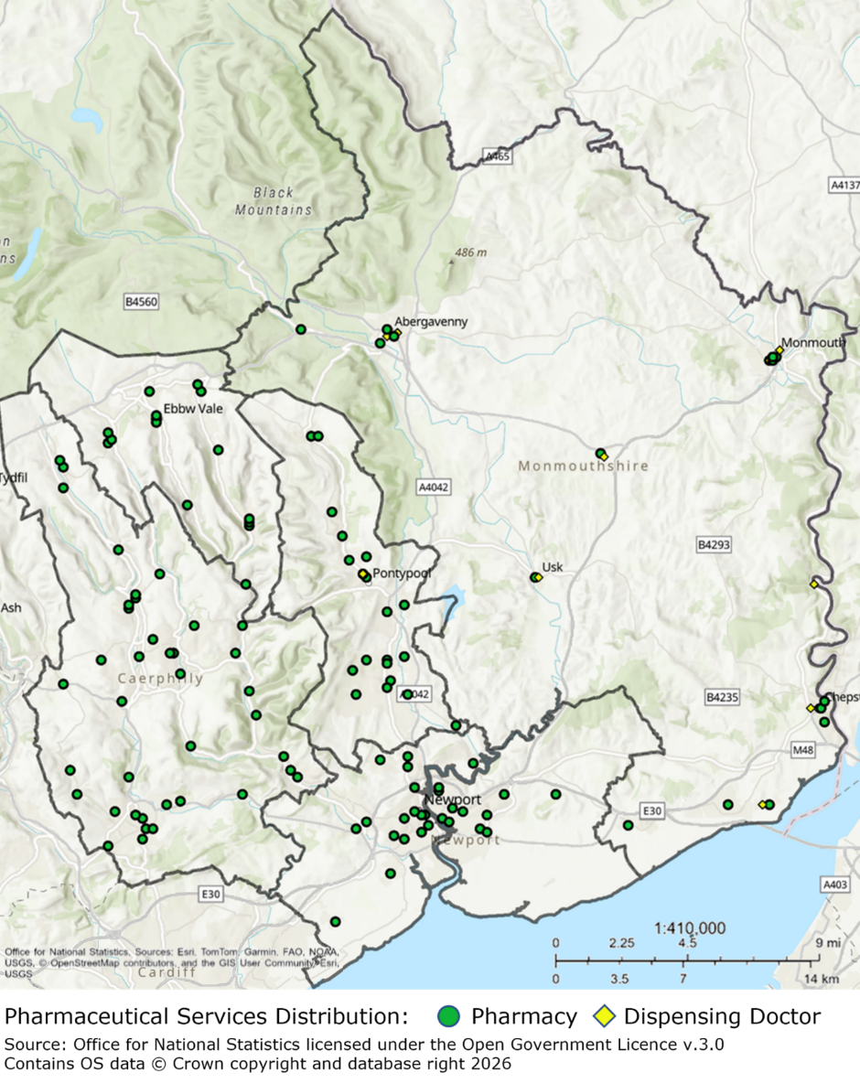
Map of Blaenau Gwent - Showing Pharmacy Locations in Blaenau Gwent East and Blaenau Gwent West NCNs
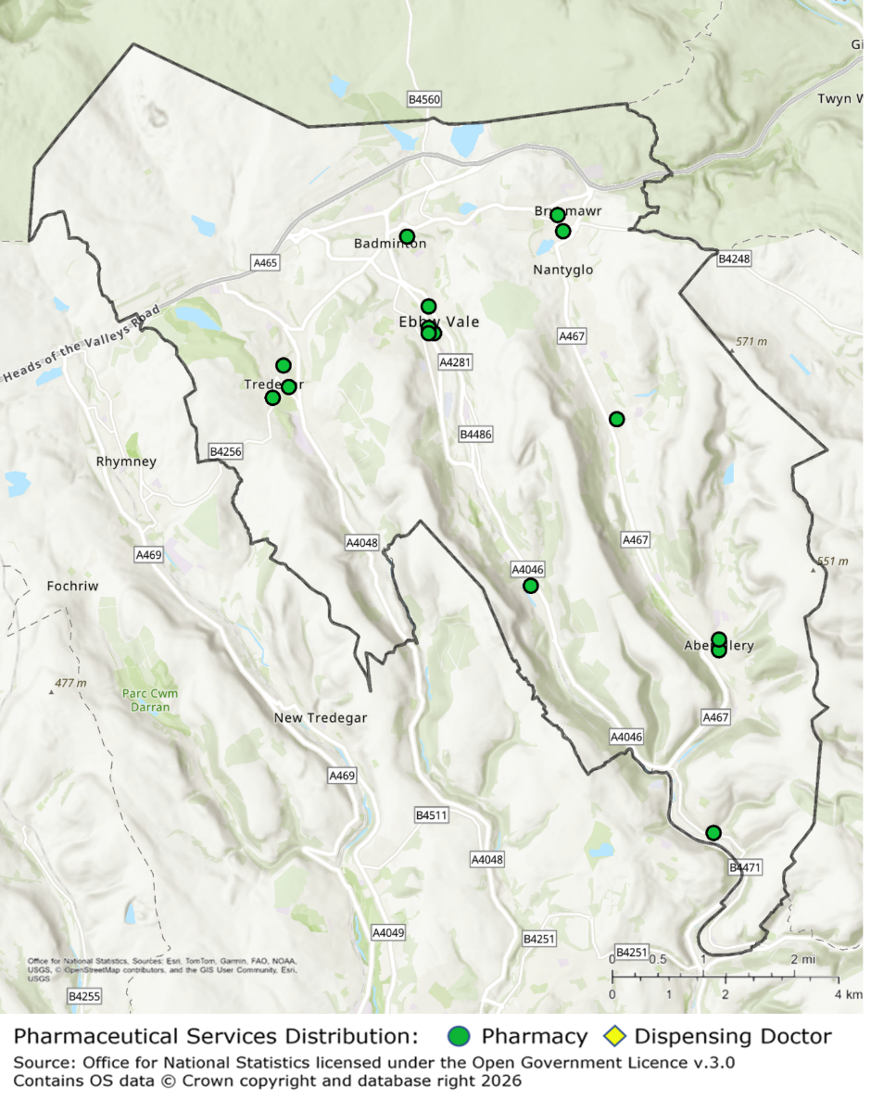

Map of Caerphilly - Showing Pharmacy Locations in Caerphilly East, Caerphilly North and Caerphilly South NCNs
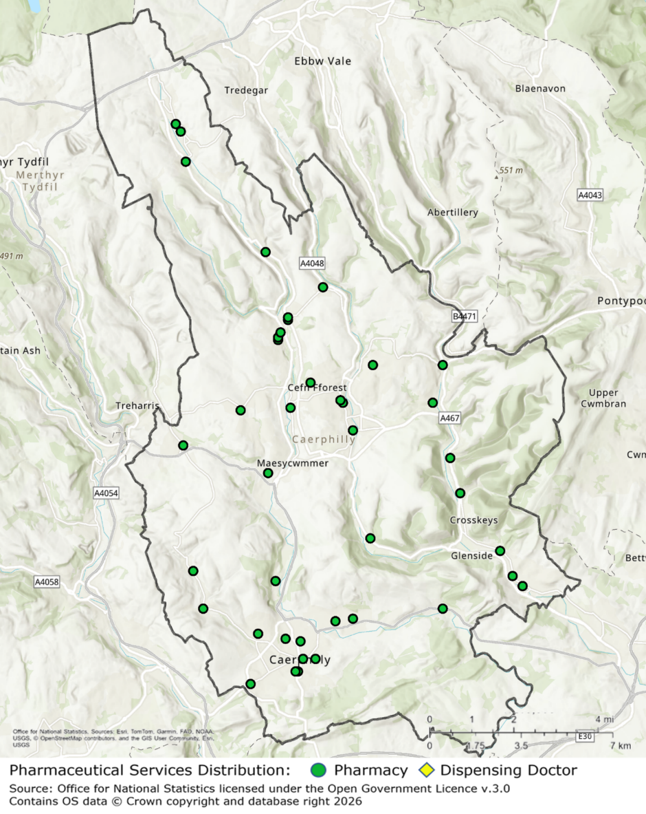

Map of Monmouthshire - Showing Pharmacy and Dispensing Doctor Locations in Monmouthshire North and Monmouthshire South NCNs
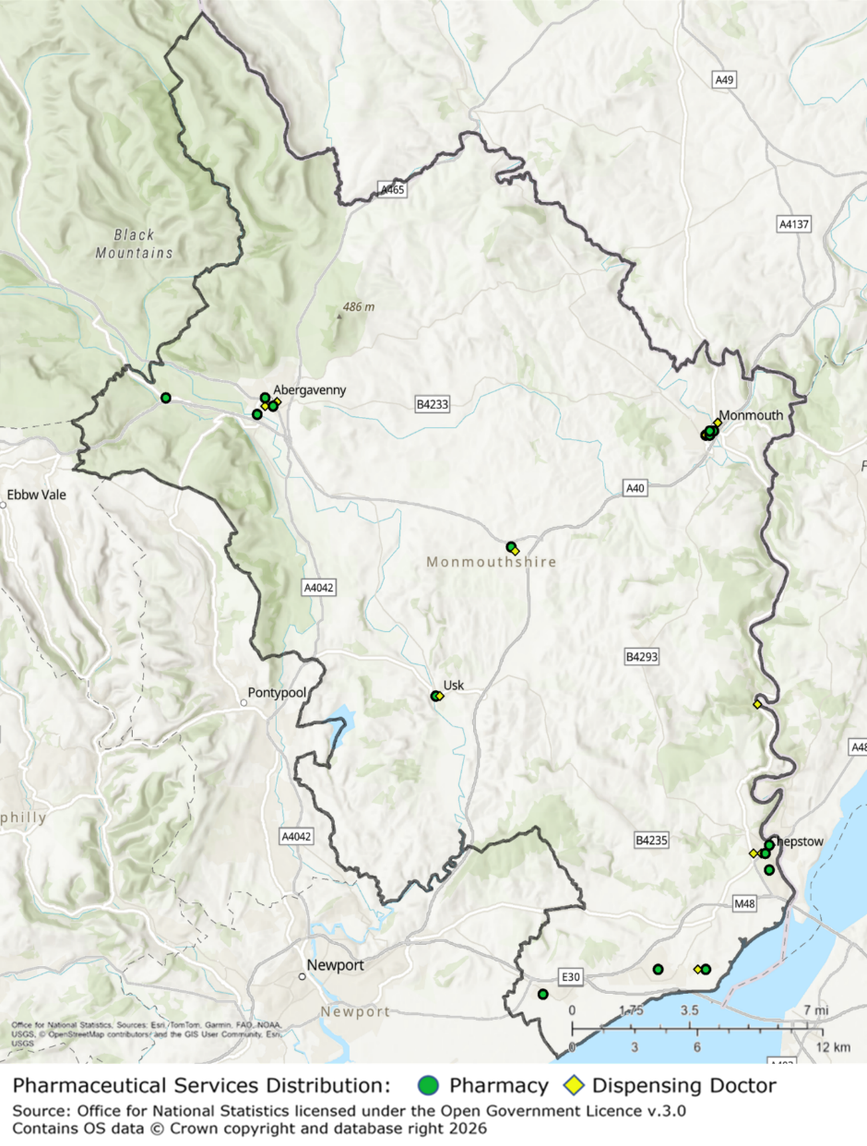

Map of Newport - Showing Pharmacy Locations in Newport East and Newport West NCNs
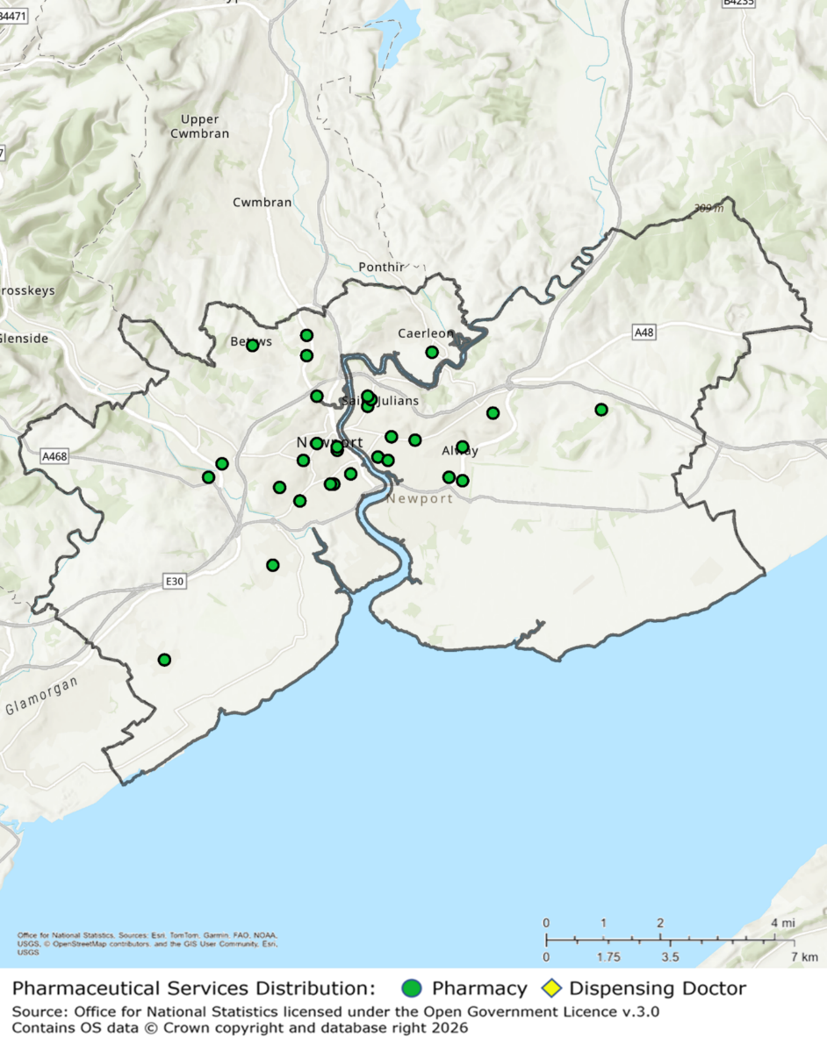

Map of Torfaen – Showing Pharmacy and Dispensing Doctor Locations in Torfaen North and Torfaen South NCNs
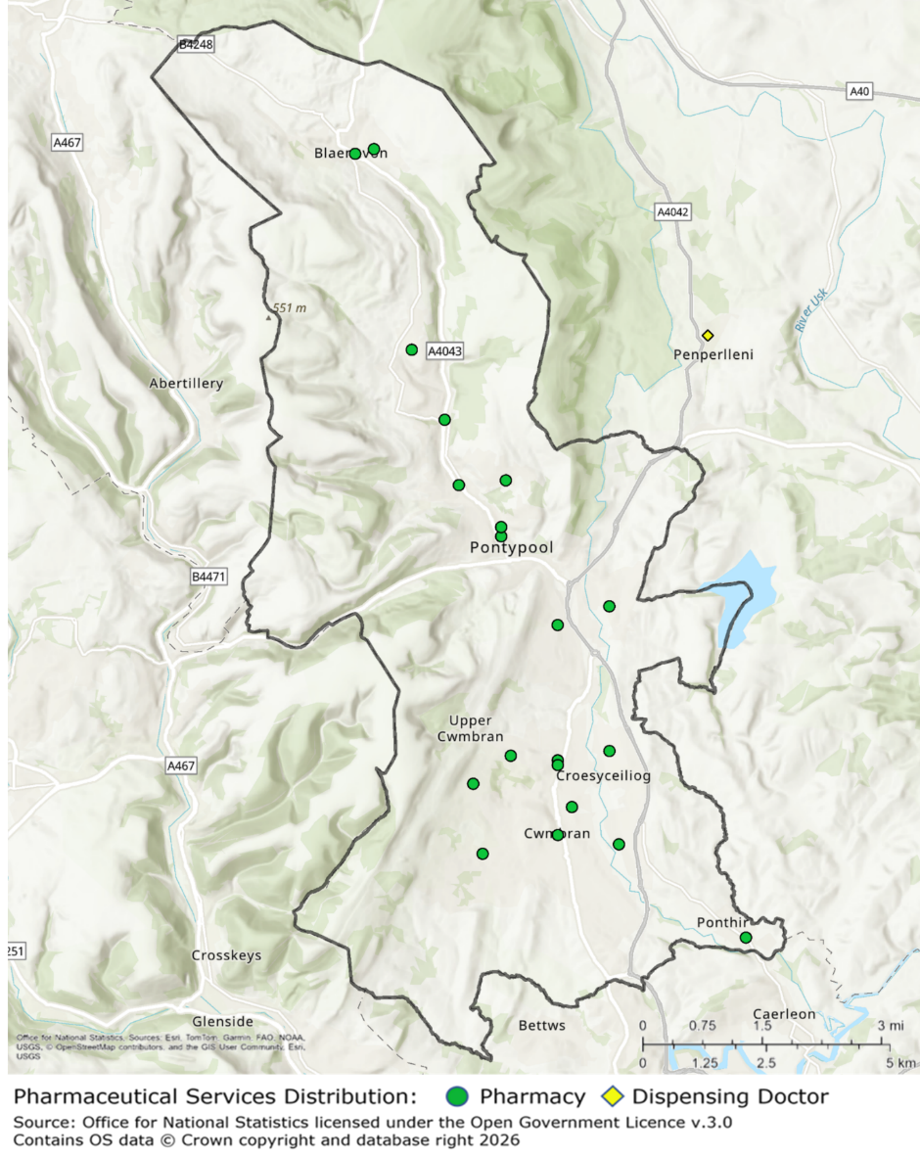

The Gwent Joint Strategic Assessment 2024/25 Edition - Aneurin Bevan University Health Board
Gwent Well-being Plan - Gwent Public Services Board Gwent Public Services Board
Welsh Government, A healthier Wales: long term plan for health and social care, 2018
Welsh Pharmaceutical Committee, Pharmacy: Delivering a Healthier Wales, April 2019
Gwent 35: Our Ten Year Strategy - Aneurin Bevan University Health Board
Integrated Medium Term Plan 2025-2028 - Aneurin Bevan University Health Board
MECC // Public Health Network :: Home
Pharmaceutical Needs Assessment - Aneurin Bevan University Health Board
The National Health Service (Pharmaceutical Services) (Wales) Regulations 2020
National Health Service (Wales) Act 2006
Medicines Act 1968
The National Health Service (General Medical Services Contracts) (Wales) Regulations 2023
The National Health Service (Pharmaceutical Services) (Wales) Regulations 2020
The Pharmaceutical Services (Clinical Services) (Wales) Directions 2022 | GOV.WALES
The Pharmaceutical Services (Advanced Services) (Appliances) (Wales) Directions 2010 (2010 No.13) | GOV.WALES
The Primary Care (Contracted Services: Immunisations) (Influenza) Directions 2025 | GOV.WALES
The National Health Service (Pharmaceutical Services) (Wales) Regulations 2020
The Pharmaceutical Services (Clinical Services) (Wales) Directions 2022 | GOV.WALES
The Pharmaceutical Services (Advanced Services) (Appliances) (Wales) Directions 2010 (2010 No.13) | GOV.WALES
The Primary Care (Contracted Services: Immunisations) (Influenza) Directions 2025 | GOV.WALES
The Pharmaceutical Services (Advanced Services) (Appliances) (Wales) Directions 2010 (2010 No.13) | GOV.WALES
The Gwent Joint Strategic Assessment 2024/25 Edition - Aneurin Bevan University Health Board
Gwent Well-being Assessment - Gwent Public Services Board Gwent Public Services Board
Gwent-WBP-Final-digital-version-2023-2.pdf
Nomis - Official Census and Labour Market Statistics
Catalogue
Public Health Wales Observatory
Welsh Index of Multiple Deprivation (WIMD) 2025 results report: overall index [HTML] | GOV.WALES
Home | DataMapWales
StatsWales population estimates
Health Maps Wales, NHS Wales Informatics Service
GWBA-Economic-Section-V10-FINAL.pdf
Economic activity status, England and Wales - Office for National Statistics
General health, England and Wales - Office for National Statistics
Tackling Poverty - Monmouthshire
How life has changed in Newport: Census 2021
Household deprivation - Census Maps, ONS
StatsWales population estimates
2022-based population projections by local authority, age, sex, year and variant | StatsWales
JSA 2024/25
Source: Gwent JSA 24/25 (Life expectancy for local areas of Great Britain - Office for National Statistics + Health state life expectancy, all ages, UK - Office for National Statistics)
Source - Gwent JSA 24/25 (Estimates of the population for England and Wales - Office for National Statistics).
Source – Gwent JSA 24/25 (Estimates of the population for England and Wales - Office for National Statistics).
Stats Wales - 2022-based population projections by local authority and age
Nomis DC1109EW - Household composition by age by sex
ONS - Deaths registered in England and Wales
Blaenau Gwent Well-being Assessment 2022-23
Public Health Outcomes Framework (PHOF 2025)
Births in England and Wales: birth registrations - Office for National Statistics
Welsh Index of Multiple Deprivation 2025 | GOV.WALES
(Welsh Index of Multiple Deprivation (WIMD) 2025 local authority deprivation profiles | StatsWales)
Source – Gwent JSA 24/25 (PHOF Reporting Tool)
Source – Gwent JSA 24/25 (Annual Population Survey/Labour Force Survey - Data Sources - home - Nomis - Official Census and Labour Market Statistics)
StatsWales density
2021 Census - Census of Population - Data Sources - home - Nomis - Official Census and Labour Market Statistics
Equality Act 2010
Population Needs Assessment 2022-2023
Source – Gwent Indicator Framework 24/25 (Adult general health and illness by local authority and health board, 2020-21 onwards)
Nomis - 2021 Ethnic groups
Source - Gwent JSA (Ethnic group - Office for National Statistics)
Nomis 2021 language proficiency (English)
Women's Health Plan for Wales.pdf
Inclusion Health Evidence Summaries and Infographics - Primary Care One
Census 2021 - Unpaid care by age, sex and deprivation, Wales
caring-in-wales-census-2021-briefing.pdf
(Roma community to be recognised in the 2021 Census - Friends, Families and Travellers)
(Gypsy or Irish Traveller populations, England and Wales - Office for National Statistics)
Roma populations, England and Wales - Office for National Statistics
Content Navigation - Inclusion Health 2025-26 - Power BI
(2023.06-Making-sense-of-the-Census-2021-for-the-outcomes-and-experiences-of-Gypsy-Roma-and-Traveller-people.pdf).
primarycareone.nhs.wales/topics/teg-i-bawb-fair-for-all/wales-health-inequalities-programme-for-primary-care/phw-onlinedocs-summary-gypsy-d-pdf/
Content Navigation - Inclusion Health 2025-26 - Power BI
primarycareone.nhs.wales/topics/teg-i-bawb-fair-for-all/wales-health-inequalities-programme-for-primary-care/phw-onlinedocs-summary-justicesystem-f-pdf/
Content Navigation - Inclusion Health 2025-26 - Power BI
primarycareone.nhs.wales/topics/teg-i-bawb-fair-for-all/wales-health-inequalities-programme-for-primary-care/phw-onlinedocs-summary-homeless-d-pdf/
About - University of South Wales
Great Britain Tourism Survey: Day Visit 2023, background quality report) revised post methodological review
Cancer mortality - Public Health Wales
Wide inequalities in cancer death rates in Wales remain - with no recent improvement - Public Health Wales
Source – Gwent Indicator Framework (https://phw.nhs.wales/services-and-teams/welsh-cancer-intelligence-and-surveillance-unit-wcisu/cancer-reporting-tool-official-statistics/cancer-mortality/)
Source: Disease registers by local health board, cluster and GP practice
https://statswales.gov.wales/Catalogue/National-Survey-for-Wales/Population-Health/Adult-general-health-and-illness/generalhealthillness-by-healthboard
Source: Gwent indicator Framework 24/25 https://statswales.gov.wales/Catalogue/National-Survey-for-Wales/Population-Health/Adult-general-health-and-illness/generalhealthillness-by-healthboard)
Source: Gwent indicator Framework 24/25 (Adult general health and illness by local authority and health board, 2020-21 onwards)
Source Gwent JSA 24/25 - Smoking habits in the UK and its constituent countries - Office for National Statistics
https://publichealthwales.shinyapps.io/PHOF_Dashboard_Eng/_w_7d77dfd1/
Healthy Weight: Healthy Wales delivery plan 2025 to 2027 [HTML] | GOV.WALES
Table | Lifestyle, 2020-21 onwards (National Survey for Wales) | General health | Health and social care | Data | Home - InfoBaseCymru
Overview | Contraceptive services for under 25s | Guidance | NICE
phw.nhs.wales/publications/publications1/sexual-health-trends-in-wales-annual-report-2025/
https://www.gov.wales/community-pharmacy-services-april-2023-march-2024-html#159863
Public Health Outcomes Framework - Public Health Wales
Table | Lifestyle, 2020-21 onwards (National Survey for Wales) | General health | Health and social care | Data | Home - InfoBaseCymru
The-Big-Gwent-Vaccination-Conversation-DPH-Annual-Report-2025.pdf
Schedule 7 of The NHS (Pharmaceutical Services) (Wales) Regulations 2020
NHS Wales Shared Services Partnership
NHS Wales Shared Services Partnership
The Human Medicines Regulations 2012
https://www.legislation.gov.uk/ukpga/2006/42
NWSSP Dispensing Data -https://nwssp.nhs.wales/ourservices/primary-care-services/general-information/data-and-publications/pharmacy-practice-dispensing-data/
NWSSP Dispensing Data
NWSSP Dispensing Data
NWSSP Dispensing Data
The National Health Service (Pharmaceutical Services) (Wales) Regulations 2020
Adopted LDP | Blaenau Gwent CBC
Caerphilly - Caerphilly County Borough
Adopted Local Development Plan 2011-2021 - Monmouthshire
Local Development Plan adoption | Newport City Council
Local Development Plan | Torfaen County Borough Council
Ethnic group, England and Wales - Office for National Statistics
2021 Census
Nomis 2021 - Religion
Gypsy or Irish Traveller populations, England and Wales - Office for National Statistics

