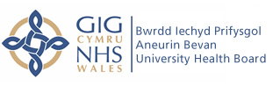
Physiotherapy Department

Work Experience Application Form

Name:

Address:

Telephone Number:

E-mail Address:

Age:

The hospitals we offer the placements in are Nevill Hall, Royal Gwent and Ysbyty Ystrad Fawr. Specific dates will be arranged following successful short-listing and clearance by Occupational Health.

Please state the hospital you would like to be based for the duration:

_____________________________________________________________

Please explain the reason why you are applying for this physiotherapy work placement opportunity. Please provide as much detail as possible to help in short-listing:

Please turn over
What are you currently studying and where?:

Which Physiotherapy course are you looking to complete in the future?:

Please provide any additional information you feel will help in your application:

