

Wales Eye Health Needs Assessment

31 March 2025

Approved by Eye Care Wales Committee 28 April 2025

Contents
Executive Summary 3
1.0 Introduction 4
1.1 Our population 4
1.2 Eye Health 5
1.3 NHS Wales 6
1.4 WGOS 8
1.5 Welsh Index Multiple Deprivation 8
2.0 Health Boards 10
2.1 Aneurin Bevan University Health Board 10
2.1.1 Overview of Gwent 11
2.1.2 Commissioned Services 26
2.1.3 Clinical conditions including prevalence 31
2.1.4 Risk factors 41
2.1.5 Contractors and activity 46
2.1.6 Neighbourhood Care Network provision 53
2.1.6 Summary and recommendations 90

Executive Summary
To support the eye care needs of communities, in 2023 Welsh Government imposed a duty on Local Health Boards to conduct an Eye Health Needs Assessment every three years to ascertain the needs of the public in terms of eye care provision in both primary and secondary care.
Higher levels of clinical services identified by the local eye care needs assessments will be delivered on a Neighbourhood Care Network (NCN) level to bolster this provision. Taken together, the needs assessment combined with delivery on a Neighbourhood Care Network footprint will ensure that local population needs will be fully considered and delivered against.
This Eye Health Needs Assessment is prepared in accordance with Legislative Direction and relates to the provision of Wales general ophthalmic Services (WGOS) levels 1–5 provided under arrangements made by Local Health Boards and includes:
(a) an assessment and summary of the provision of WGOS 1–5;
(b) an assessment and summary of the demand for WGOS 1–5;
(c) proposals for further ophthalmic services that may be needed to meet demand for those services;
(d) an outline of the prevalence and impact of sight loss in each Local Health Board’s area, including the aetiology, risk factors, demographics and public health and other consequences of sight loss;
(e) an analysis of the information provided by all data sources;
(f) a map that identifies the premises at which any or all of WGOS 1–5 are provided in each Local Health Board’s area.
In preparing this Eye Health Needs Assessment, each Local Health Board
(a) has regarded, in so far as it is practicable to do so, the following matters—
(i) the demography of its area,
(ii) any different needs of different localities within its area,
(iii) the ophthalmic services provided under arrangements with any neighbouring Local Health Board which affect the need for ophthalmic services in its area,
(iv) any other NHS services provided in or outside its area (which are not covered by sub-paragraph (iii)) which affect the need for ophthalmic services in its area,
(v) any relevant information provided to the Local Health Board either under the Legislative Directions or the 2023 Regulations, and
(b) has taken into account the likely future needs having regard to changes to the number of people in its area who will require any or all of WGOS 1–5.

1.0 Introduction

1.1 Our population
Wales, covering an area of 20,779 km² with a population of approximately 2.98 million2, has seven diverse Local Health Boards (LHB). LHB boundaries describe areas whose geographical size ranges from under 500 km2 in Cardiff & Vale University LHB, to over 6,000 km2 in Betsi Cadwaladr University LHB. LHB resident populations range from 132,000 in Powys Teaching LHB to 678,500 in Betsi Cadwaladr University LHB. The more urban and post-industrial southern and eastern areas of Aneurin Bevan, Cardiff and Vale, Cwm Taf Morgannwg and Swansea Bay University Health Boards make up 60% of the population of Wales but just 17% of the land mass area of Wales. In contrast, Powys, Betsi Cadwaladr and Hywel Dda University Health Boards are dominated by more rural areas.
The Royal National Institute of Blind People (RNIB) estimates that nearly one in five people will experience permanent sight loss in their lifetime, with one in three experiencing any sight loss in their lifetime. In 2016-2017, 90% of the incidence of sight loss occurred in people aged 65 and over. However, in the same year, 25 people aged between 15-64 were affected by sight loss every day. It is estimated that two million people in the UK are living with sight loss that impacts their lives daily. (RNIB 2016)
In Wales, an estimated 3.5% of the population are living with sight loss that impacts their daily lives. An estimated 111,000 in Wales are identified as having sight loss and this is expected to increase by 35% to 146,000 by 2030 (RNIB 2021, Pezzullo et al 2018). Sight loss has profound effects on the wellbeing of an individual. The relationship between sight loss and general health are closely linked and it is important to address this relationship and seek ways to improve it.
Age is a risk factor for eye disease. Of the people aged 65-74, there are 23,400 people living with sight loss in Wales. This increases to 34,800 in those over 85 (RNIB 2021, Pezzullo et al 2018 and Access Economics Pty Limited for RNIB 2009). The number of older people in the UK and therefore in Wales is also projected to increase (ONS 2019 ONS 2020 and Stats Wales 2020). An older population places more demand on healthcare, particularly eye care as eye disease becomes more prevalent with age (RNIB 2021, Pezzullo et al 2018 and Access Economics Pty Limited for RNIB 2009).
In the UK, the main causes of sight loss are: (RNIB 2021, Pezullo, L 2018 and Access Economics Pty Limited for RNIB 2009).
- Uncorrected refracted error – 39%
- Age Related Macular Degeneration (AMD) – 23%
- Cataract – 19%
- Glaucoma – 7%
- Diabetic eye disease – 5%
According to RNIB (2018), half of sight loss is avoidable. Corrective prescription lenses can improve visual impairment because of a refractive error. People living with cataracts can receive cataract surgery and there have been advances in treatment for conditions such as Wet AMD with research constantly being conducted about prevention of all ocular diseases. Improved access to eye care is key to preventing sight loss. In Wales, the numbers of people registered sight impaired is reducing, and this is likely to be due to improved treatments and improved access to eye care, however there is still much to do (Bourne RRA et al 2018 and Stats Wales 2021).
A projected increase in the number of people with eye disease is compounded by issues with capacity within ophthalmology units. Additionally, improvement in treatment for eye conditions such as Wet Age Macular Degeneration (Wet AMD) and improved guidelines has caused a greater demand for ophthalmology appointments. The waiting lists have unfortunately been extended further due to the COVID-19 pandemic. This can unfortunately result in irreversible harm to patients because of worsening eye conditions, which impact every part of their life. Improved ways of working are required to increase capacity and improve patient care (Boyce, 2014, Foot & MacEwen 2017, Ting et al 2020, Ting et al 2021). Optometry contract reform seeks to implement improved collaboration and improved delivery of eye care. Optometrists are upskilling, and contract reform seeks to make use of these vital skills to benefit the people of Wales. New care pathways have been introduced in some areas of Wales with a view to reducing referral to hospitals and freeing up capacity in secondary care and these will be rolled out across Wales (Welsh Government 2021, Wales eye care services and Pyott 2021). This Eye Health Needs Assessment aims to provide information required to plan for these services and expand them across Wales. This will build on previous work regarding the Optometric Workforce (Schumm, S 2021) and the Patient Management Plan (Morgan, Tim 2021).

1.2 Eye Health
Many risk factors for systemic disease are shared with eye disease. Modifiable risk factors can be addressed to help prevent onset or reduce progression of sight loss. Non-modifiable risk factors can be targeted for screening in the interests of early identification and access to treatment.
Sight loss has many negative implications. General health and eye health are closely linked and efforts to improve eye health will have a positive impact on wellbeing as whole.
There are an estimated 111,000 people living with sight loss and 12,137 registered blind or partially sighted in Wales. Cataract, glaucoma, AMD, diabetic retinopathy and refractive error, are the greatest causes of vision impairment in the UK. 1 in 3 people over 75 have visually impairing cataracts.
An estimated 36,100 people in Wales are living with glaucoma. Around 73% of over 75s have some form of AMD. Of an estimated 210,000 diabetic adults in Wales, 62,800 have any diabetic retinopathy and 5,780 have severe diabetic retinopathy. Around a third of children and adults under 20 have refractive error. With early intervention and appropriate management, sight loss caused by these conditions can be reduced or even prevented.
The prevalence of cataract, AMD, glaucoma, any diabetic retinopathy and sight loss are predicted to increase by the year 2040. Refractive error in children under 16 looks to remain stable until 2040, however these calculations do not include increasing prevalence of myopia. Provision of services and workforce will need to increase to meet the demand for eye care in the future. If no attempt is made to address the predicted increasing level of sight loss, many people will suffer from visual impairment which cause an increased strain on Health and Social Care systems.
The population of Wales is projected to increase by 120,726 by 2040. An increasing population will place a greater demand on eye care services and needs to be considered when planning for future services.
The data in this section shows evidence of an ageing population which will result in a greater burden of eye disease. This is most notable in Powys Teaching Health Board, Hywel Dda University Health Board and Betsi Cadwaladr University Health. Cwm Taf Morgannwg University Health Board, Cardiff and Vale University Health Board and Aneurin Bevan University Health Board have a younger demographic which may be relevant given that increasing prevalence of myopia is expected in younger age groups.
The second largest ethnic group in Wales in 2019 was Asian, with the greatest percentage in Cardiff and Vale University Health Board. As a risk factor for some eye conditions, as well as general health conditions, collating information regarding ethnicity is vital for planning of eye care provision and ensuring uptake of eye care services amongst at risk groups, particularly at a local level.
Cardiff and Vale University Health Board, Aneurin Bevan University Health Board, Cwm Taf Morgannwg University Health Board and Swansea Bay University Health Board have the greatest proportion of 20% most deprived Lower Layer Super Output Areas (LSOAs). Socioeconomic backgrounds can influence the prevalence of eye disease and access to eye care services.
Clinical risk factors may be a predictor of increased likelihood of eye disease. Capturing information regarding clinical risk factors opens up the discussion regarding behavioural advice and will help to determine appropriate patient management. Smoking is a significant risk factor for eye disease as well as other conditions. Advice regarding smoking cessation should be given by all health care professionals including optometric staff to support a reduction in sight loss.
Vulnerable groups, including those living with disability are at increased risk of visual impairment: Powys Teaching Health Board, Betsi Cadwaladr University Health Board and Hywel Dda University Health Board had the highest percentage of people registered as living with a disability in 2019.

1.3 NHS Wales
NHS Wales is the public funded National Health Service of Wales providing healthcare to some three million people who live in the country. The Welsh Government sets the Health Care strategy and NHS in Wales delivers that strategy and services via the seven Local Health Boards, three NHS Trusts and two Special Health Authorities. The NHS has a key principle which is that - good healthcare should be available to all.
Key strategic drivers for NHS Wales include:
- The Well-Being of Future Generations Act (2015)
The Well-Being of Future Generations Act (2015) invites collaboration across services and sectors and with the individual to improve wellbeing and reduce demand on services (Future Generations Commissioner for Wales 2021).
Optometry contract reform embedded collaboration of services and sectors. Optometrists and Dispensing Opticians work closely with patients and other health care professionals to improve eye health and general health, ensuring preventative advice is given to improve wellbeing and reduce demand on secondary care.
- A Healthier Wales
This policy encourages a more holistic approach to health and social care and supports the use of community-based services rather than secondary care where appropriate. The quadruple aim outlines the use of a motivated workforce, the higher value of care being provided, the improved population health and wellbeing, and the improved quality and increased access to care to achieve the ‘A Healthier Wales’ goals (Public Health Network 2021 and Welsh Government 2016, Welsh Government 2021).
Optometrists are at the very centre of the community and are well placed to deliver a holistic approach to patient health. By upskilling the work force, Optometrists and Dispensing Opticians can utilise their skills to keep care closer to home and signpost to other health care professionals where required. Making Every Contact Count (MECC) ensures each interaction is of high value and will help to improve the wellbeing of the individual and provide preventative advice.
- Optometry: Delivering A Healthier Wales (Welsh Optometric Committee 2021)
This paper outlines how optometry should effect the change required to achieve the goals set out in A Healthier Wales - by upskilling the workforce, working in clusters and providing care greater to home. An Eye Health needs Assessment is therefore appropriate and necessary to achieve the goals for eye care, to ensure areas are prioritised and to help us plan for the future, ensuring quality based services are delivered throughout.
- Accelerated Cluster Development
Accelerated Cluster Development will enhance integrated planning between clusters, health boards and local authorities. Accelerated Cluster Development ensures that a wider range of services is available locally and that plans can be made based on the needs assessment of the local population by health care professional in the cluster through working collaboratively. Optometrists form part of cluster working through engaging in professional collaboratives, ensuring that the needs of the local population are being met. Local Population needs assessments are vital to delivering changes that really benefit the local community (Primary and Community Care Development and Innovation Hub. 2022).

1.4 Wales General Ophthalmic Services
Wales General Ophthalmic Services (WGOS) were introduced on 20 October 2023, with unification of the service architecture, governance and evaluation across Wales to provide care closer to home and ensure that people only attend hospital eye services when required. WGOS is a tiered Service comprising of the following:
- WGOS 1: eye examinations and patient management plan.
- WGOS 2: made up of three bands:
  - Band 1 – Acute eye care and referrals for examination from another healthcare professional.
  - Band 2 - Further examinations following WGOS 1 to inform or prevent a referral.
  - Band 3 - Follow up examinations to WGOS 2 Band 1 and Cataract Post-operative Assessments.
- WGOS 3:
  - Assessments for those with low vision and providing low vision aids where appropriate, as well as holistically supporting the patient and providing rehabilitative support.
  - Certification of vision impairment for patients whose leading cause of vision loss is Dry Age-Related Macular Degeneration
- WGOS 4: examinations for patients who would previously have been referred to/or managed in the Hospital Eye Service instead remain in primary care for further enhanced assessment as part of an agreed referral refinement or monitoring pathway for patients:
  - with or with suspected medical retina conditions
  - with or with suspected glaucoma or ocular hypertension; and
  - who are at risk of retinopathy due to taking hydroxychloroquine or chloroquine
- WGOS 5: examinations in primary care for acute eye conditions that require management by an independent prescriber optometrist to reduce the need for onward referrals to Hospital Eye Services.
- NHS Optical vouchers: financial support for the provision of spectacles or contact lenses to patients in eligible categories determined by Welsh Government.

1.5 Welsh Index Multiple Deprivation
The Welsh Index of Multiple Deprivation (WIMD) is the Welsh Government’s official measure of relative deprivation for small areas in Wales. It identifies areas with the highest concentrations of several different types of deprivation. Deprivation is the lack of access to opportunities and resources, which we might expect in our society. WIMD ranks all small areas in Wales from 1 (most deprived) to 1,909 (least deprived). It is a National Statistic produced by statisticians at the Welsh Government. Small areas are Census geographies called Lower-layer Super Output Areas (LSOAs). ¹
The full index is updated every four to five years. The most recent index was published in 2019. There are numerous indicators that feed into WIMD. Some of these are updated annually (when possible), some periodically, some only for the overall WIMD update and some only when census data becomes available.

The Welsh Index of Multiple Deprivation statistics look at:
- Income Deprivation
- Employment
- Health
- Education
- Access to Services
- Housing
- Community Safety
- Physical Environment

The health domain measures a lack of good health. The indicators are:
- People with a GP-recorded diagnosis of a Chronic condition (indirectly age-sex standardised)
- People with a GP-recorded diagnosis of a Mental health condition (indirectly age-sex standardised)
- Cancer Incidence (indirectly age-sex standardised)
- Limiting Long-Term Illness (indirectly age-sex standardised)
- Premature Death Rate (death of those under the age of 75)
- Children aged 4-5 who are obese
- Low Birth Weight, single births (live births less than 2.5kg)

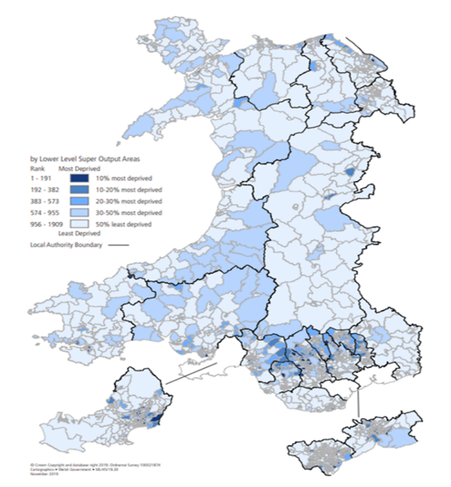

The indicators above are age-sex standardised to adjust for the expected prevalence of disease within the underlying population. This allows the index to identify areas where health deprivations exists beyond the effect of age and sex.

The association between deprivation and health is clearly apparent across Wales especially in the post-industrial valley communities in South Wales. Here poorer health outcomes are significantly worse than Wales as a whole.

2.0 Health Boards

2.1 Aneurin Bevan University Health Board
This Eye Health Needs Assessment describes the need of the population living within the Aneurin Bevan University Health Board area. Need is established by looking at prevalence and incidences of eye health problems, including risk factors. The Eye Health Needs Assessment reviews the current level of services available whilst considering future need. The information is presented at a Gwent, local authority and neighbourhood care network footprint.
Data has been collated from nationally produced data including Welsh Government, Census, Royal National Institute for the Blind and National Eye Health Epidemiological Model. Local contracting information including activity levels is used along with and academic papers.
For this Eye Health Needs Assessment patients and providers were not involved but will be considered for future iterations of this Eye Health Needs Assessment.

2.1.1 Overview of Gwent

2.1.1.1 Introduction

The footprint of Aneurin Bevan University Health Board is coterminous with Greater ‘Gwent’, a term used to reflect the five local authority areas of:

- Blaenau Gwent County Borough
- Caerphilly County Borough,
- Monmouthshire County,
- Newport City and
- Torfaen County Borough.

Gwent will be used throughout this Eye Health Needs Assessment to reflect the area covered by Aneurin Bevan University Health Board.

Gwent covers an area of 1,533 square kilometres (km²), which is 7.2% of Wales (21,225 km²) and has a population of 594,412, which equates to 18.8% of the whole of the Welsh population (3,164,404).

The Health Board area is varied with both urban centres and rural countryside, along with the most easterly of the South Wales valleys. The map below shows the rural urban classification for the Lower Super Output Areas in the area of the Health Board and shows the general split of rurality in the East against the urban areas in the West.
Gwent is a Marmot Region which means there is a network of local stakeholders committed to tackling inequity through action on the social determinants of health – the social and economic conditions which shape our health. Becoming a Marmot Region signifies a collective intent to work together to improve equity across Gwent, and improve the lives of all our communities as a result, in line with Marmot principles
Map 2.1.1 Gwent local authorities

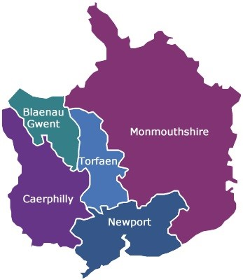

Map 2.1.2 – rural urban classification (2011) Aneurin Bevan University Health Board

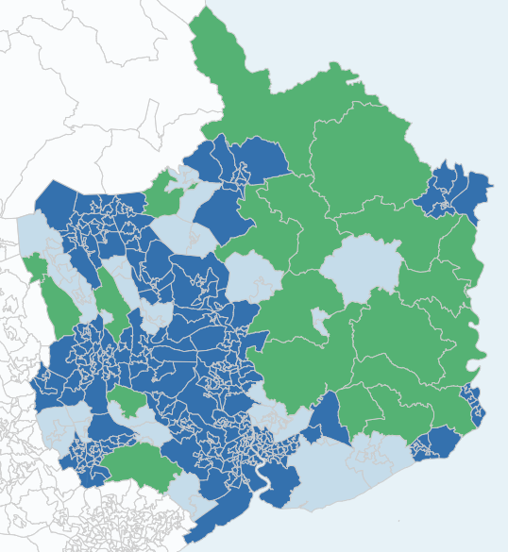

Crown copyright and database rights 2013 Ordnance Survey 100050829

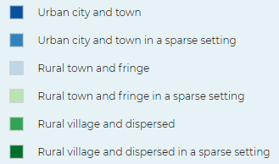

Local authorities

Blaenau Gwent is a relatively small area approximately 109 km², with a population of 67,356. Blaenau Gwent is defined physically by high hillsides dividing the three main valleys.

Blaenau Gwent, despite its busy, urban atmosphere given to it by its towns, it is primarily a rural area. It faces high unemployment, and a significant portion of the population relies on benefits.

Map 2.1.3 – Blaenau Gwent County Borough

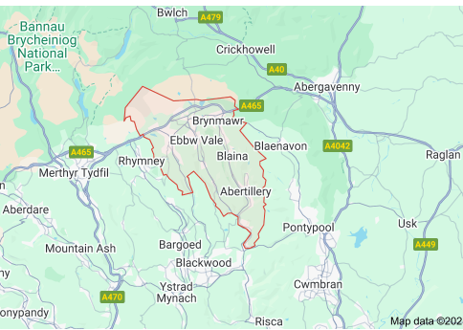

Caerphilly County Borough covers some 280 km² of the Valleys area of South East Wales and has a population of 176,437. The county borough is a mixture of urban and rural communities. Three quarters of the county borough is used for agriculture and forestry.

Caerphilly town has an expanding economy and benefits through good transport links to Cardiff but there are significant levels of unemployment and poor health, particularly in the north of the county borough.

Map 2.1.4 – Caerphilly County Borough

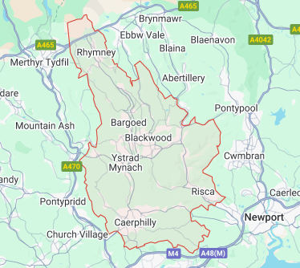

Located in South East Wales, Monmouthshire County has a strategic position between the major centres in South Wales, the South West of England and the Midlands. The county covers an area of approximately 880 km² with an estimated population of 94,572.

Monmouthshire is generally a prosperous area offering a high quality of life for its residents, but this does mask some areas of deprivation.

Map 2.1.5 – Monmouth County

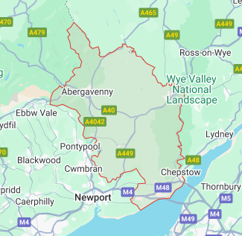

Newport City is a multi-cultural city and is the third largest urban centre in Wales with a population of 163,628 and covers an area of 217.7 km². It has the second largest number of people from minority ethnic communities of all the Welsh counties (after Cardiff) and has continued to increase since 2009 when the figure was estimated at 6.6% of the population.

Map 2.1.6 – Newport City

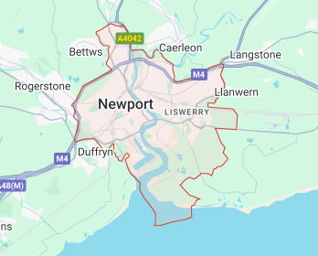

The county borough of Torfaen has an area of 126km² and is the third smallest borough in Wales; it has a population of around 93,419. Torfaen is the most easterly of the industrial valleys of South Wales.

Map 2.1.7 – Torfaen County Borough

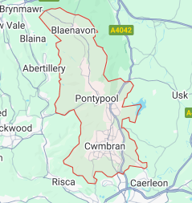

Table 2.1.1 – Population of Gwent by local authority

 | Population | % of Gwent
Gwent | 594,412
Blaenau Gwent | 67,356 | 11.31
Caerphilly | 176,437 | 29.63
Monmouthshire | 94,572 | 15.88
Newport | 163,628 | 27.48
Torfaen | 93,419 | 15.69

2.1.1.2 Population

Based on StatsWales population estimates for mid-year 2023, the total population of the Health Board’s area was 594,412, of which 49.06% were male and 50.94% were female.

The population is projected to increase by 6.02% by 2043, from the population estimate of 594,412 in 2023 to 617,305 in 2034 (3.71% increase) and to 630,230 in 2043, a further increase of 2.31%. The greatest increases will be seen in Newport with an estimated 7.95% increase (163,628 to 176,631), Monmouthshire has a projected increase of 7.04%, Torfaen 5.09% and Caerphilly 4.82%. Between 2018 and 2023 Blaenau Gwent had a population decrease of -3.39% but the population is projected to increase by 2.80% by 2043.

Figure 2.1.1 - population projection by locality

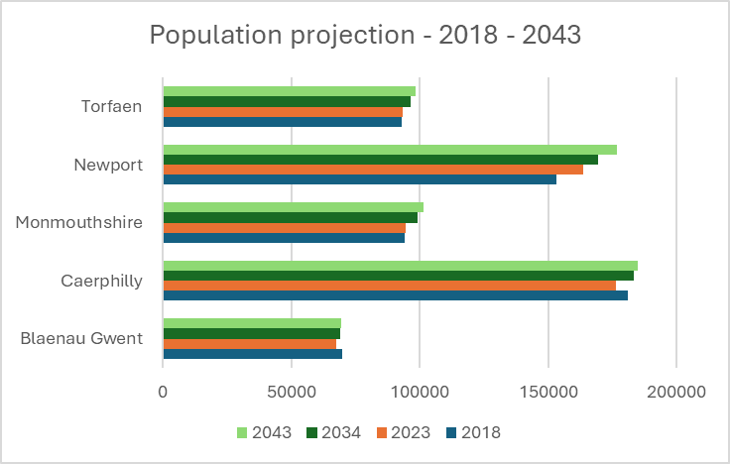

In 2023, 21% of the population were aged over 65 years old and almost six in every ten (61%) were of working age (16 to 64 years) and nearly one in five (18%) were aged under 16.

Between 2013 and 2023 the population aged between 16 to 24 has decreased by 12,078 (22.72%), from 65,233 to 53,155. Which is significantly higher than the figure for Wales which sits at 8.6%.

The figure below shows how the age of the population has changed in the ten years 2013 to 2023, with a reduction in those aged 0-4, 16 to 24 and those aged 45 to 64.

Figure 2.1.2 – change in the age of the population based on mid-year population estimates, 2013 and 2023

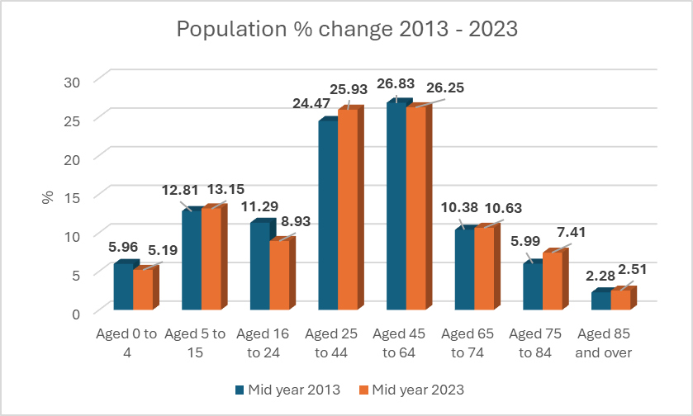

The population over 65 years has a projected increase of 16.7% when in 2034 an estimated one in four people (25%) will be aged 65 or older - which is slightly higher than the projection for Wales (15.5%).

By 2034, it is projected that the number of people aged 85 and over will increase by 42.7% (from around 15,311 in 2023 to 21,842). This is higher than the overall projected Wales increase which sits at 31.3%.

The mid-year estimates in 2023 show that 303,328 members of the population are female and 292,084 are male.

Mortality
Since 2013 each local authority has seen a decrease in the mortality rates (aged standardised) for those aged over 80, with Monmouthshire showing a 10.53% decrease in those aged between 80-84. But there have been significant changes in Blaenau Gwent and Monmouthshire in the age 85-89 with decreases of 21.57% and 13.38%. There are also changes within the other age brackets with decreased mortality rate in Blaenau Gwent in the 35-39 and 55-59 and in Torfaen in most age groups, with the exception of 40-49 year olds.

Density
With the exception of Monmouthshire, the health board region has a greater population density than the average for Wales, with the most densely populated area being Newport.

Table 2.1.2 - population density (persons per square kilometre), 2023

Wales | 152.60
Blaenau Gwent | 619.49
Caerphilly | 636.07
Monmouthshire | 111.37
Newport | 859.25
Torfaen | 743.20

2.1.1.3 Ethnicity

According to Census 2021 data, 94.2% of the Health Board’s population fell within the White ethnic group. The remaining 5.8% are residents who describe themselves as:

- Asian/Asian British – 2.9%
- Mixed/multiple ethnic groups – 1.5%
- Black/African/Caribbean/Black British – 0.8%
- Other ethnic group – 0.7%.

Figure 2.1.3 - % ethnicity of Gwent

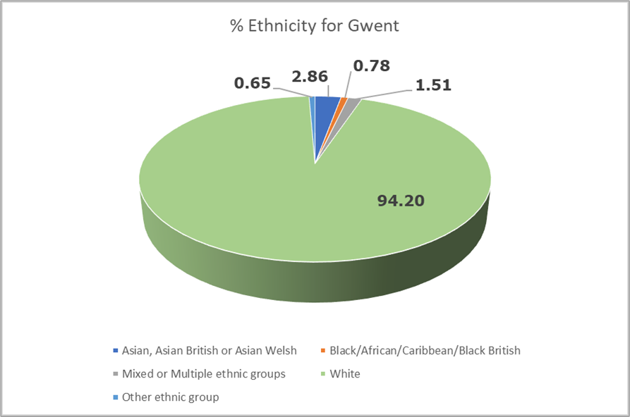

Newport has a more ethnically diverse population than the other local authority areas and other than Newport the local authorities have a higher % of the White ethnic group than the Wales %.

Table 2.1.3 – Ethnic groups by percentage by local authority and Wales

Local authority | White | Asian/ Asian British | Mixed/ Multiple ethnic groups | Black/ African Caribbean /Black British | Other ethnic group
Blaenau Gwent | 97.8 | 0.9 | 0.8 | 0.2 | 0.2
Caerphilly | 97.7 | 0.9 | 1 | 0.2 | 0.2
Monmouthshire | 96.9 | 1.3 | 1.2 | 0.2 | 0.3
Newport | 85.5 | 7.6 | 2.8 | 2.4 | 1.7
Torfaen | 97.1 | 1.3 | 1.1 | 0.2 | 0.3
Wales | 93.8 | 2.9 | 1.6 | 0.9 | 0.9

2.1.1.4 Household language

The 2021 Census tells us that 97% of the population (569,430) in Gwent state English or Welsh is their main language with 3,441 say they are not able to speak English well.. As can be seen from the figure below the ability to speak English is greatest in the middle adult ages.

Figure 2.1.4 – Proficiency in English by age

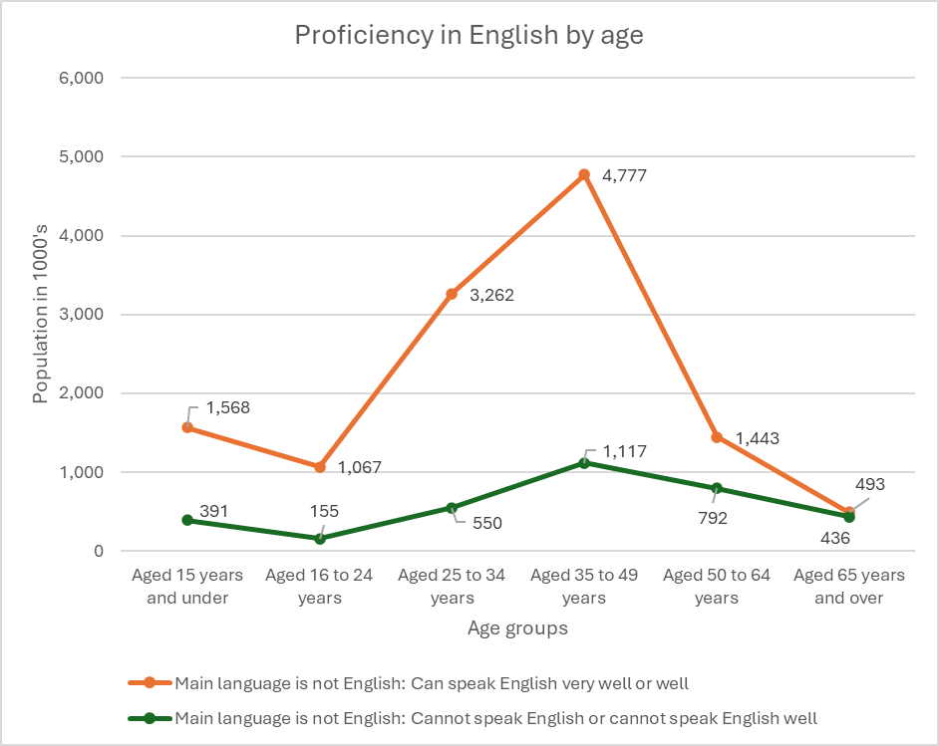

The next six most commonly spoken languages were:

- Polish – 2.7%
- Romanian – 0.9%
- Bengali (with Sylheti and Chatgaya) – 0.2%, Arabic, Hungarian and Panjabi 0.5% each

There is some variation at local authority level with fewer people who have English as their main language in Newport (95%) compared to the other local authority areas (all at 99%).

2.1.1.5 Welsh language skills

Caerphilly’s Welsh language skills are generally better than in the other local authority areas, with those in Blaenau Gwent the least likely to have any skills. But the majority of the residents in the Health Board’s area reported no skills in Welsh in the Census 2021 (87%).

Table 2.1.4 – Welsh language skills by local authority

% | Blaenau Gwent | Caerphilly | Monmouthshire | Newport | Torfaen
No skills in Welsh | 90.2 | 84.8 | 87.3 | 88.6 | 88.2
Can speak, read and write Welsh | 4.7 | 8.5 | 6.8 | 5.7 | 6.5
Can understand spoken Welsh only | 2.3 | 3.1 | 2.5 | 2.5 | 2.2
Can speak and other combinations of skills in Welsh | 0.1 | 0.2 | 0.1 | 0.2 | 0.1
Can speak but cannot read or write Welsh | 0.9 | 1.2 | 1.2 | 1.2 | 1.1
Can speak and read but cannot write Welsh | 0.4 | 0.6 | 0.5 | 0.5 | 0.5
Can read but cannot speak or write Welsh | 0.7 | 1.1 | 1.0 | 0.8 | 0.7
Can read and write but cannot speak Welsh | 0.4 | 0.4 | 0.5 | 0.5 | 0.4
Can write but cannot speak or read Welsh | 0.1 | 0.1 | 0.1 | 0.1 | 0.2

2.1.1.6 Religion

In 2021, 44.2% of the population stated they followed one of the six main religions, this is down from 57.1% in the 2021 census. 49.9% stated they did not follow any religion, up from 35.3%. With 5.82% not providing any response.

The table below shows the variation in religions. Christianity remains the most popular religion but is slightly lower than the Welsh total. Those who do not follow a religion is slightly higher than the Welsh position. Newport is second only to Cardiff in relation to those identifying Muslim as their main religion.

Table 2.1.5 – religion at local authority and Wales level

Religion | Blaenau Gwent | Caerphilly | Monmouthshire | Newport | Torfaen
No religion | 56.4 | 56.7 | 43.4 | 43.0 | 50.8
Christian | 36.5 | 36.4 | 48.7 | 42.8 | 41.5
Buddhist | 0.2 | 0.2 | 0.4 | 0.3 | 0.3
Hindu | 0.1 | 0.1 | 0.2 | 0.5 | 0.3
Jewish | 0.0 | 0.0 | 0.1 | 0.1 | 0.0
Muslim | 0.4 | 0.3 | 0.5 | 7.1 | 0.4
Sikh | 0.2 | 0.1 | 0.1 | 0.3 | 0.1
Other religion | 0.5 | 0.4 | 0.6 | 0.5 | 0.5
Not answered | 5.8 | 5.7 | 6.2 | 5.6 | 6.1

2.1.1.7 Welsh Index of Multiple Deprivation

Deprivation is measured using The Welsh Index of Multiple Deprivation 2019, this is calculated for small geographical areas called Lower Super Output Areas, from 1 (most deprived) to 1,909 (least deprived).

There are eight domains which make up the index, each of which have different indicators within them. These are weighted and then combined to give the overall index of multiple deprivation. The figure below shows each domain and their weighting.

Figure 2.1.5 – the eight domains of the Welsh Index of Multiple Deprivation and their respective weighting

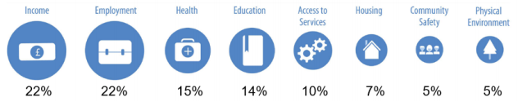

Whilst an area may be classed as one of low deprivation it does not necessarily follow that everyone living in a deprived area is deprived and that not all deprived people live in deprived areas. It is the circumstances of people who are living there that affect its deprivation ranks, not the area itself.

The map below shows each Lower Super Output Area within the Health Board area and where it sits in the index.

Map 2.1.8 – Map of the Welsh Index of Multiple Deprivation by lower super output area

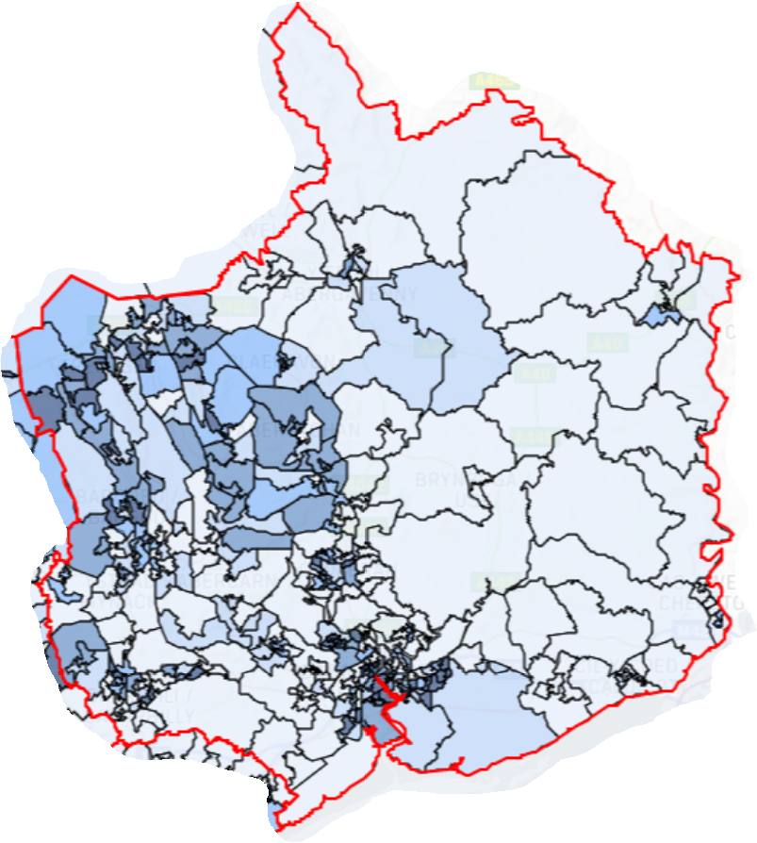
Crown Copyright and database right 2019. Ordnance Survey 100017916

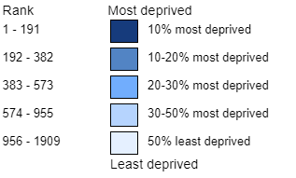

The table below shows the number of the most deprived lower super output areas by local authority area.

Table 2.1.6 – most deprived lower super output areas by local authority

 | Total lower super output areas (LSOAs) | Most deprived 10% LSOAs in Wales (ranks 1 - 191) | Most deprived 20% LSOAs in Wales (ranks 1 - 382) | Most deprived 30% LSOAs in Wales (ranks 1 - 573) | Most deprived 50% LSOAs in Wales (ranks 1 - 955)
Blaenau Gwent | 47 | 6 | 21 | 30 | 40
Caerphilly | 110 | 11 | 26 | 42 | 69
Monmouthshire | 56 | 0 | 1 | 3 | 11
Newport | 95 | 23 | 33 | 38 | 57
Torfaen | 60 | 3 | 19 | 25 | 34

Within the health board region, Blaenau Gwent is the local authority with the highest percentage of deprived areas, and Monmouthshire has the lowest percentage.

2.1.1.8 Life expectancy and healthy life expectancy

The latest data for life expectancy (2018-2020) shows that the life expectancy for males is 78.12, which is a decrease from the 2017-2019 figure of 78.35. The life expectancy for females is higher, although we have seen the same fall in life expectancy from 82.07 to 81.70. The Gwent average is lower than the life expectancy for males and females across Wales (78.3 and 82.1 years respectively).

When looking at a local authority level, Monmouthshire is the local authority with the highest life expectancy for both male and female, 81.63 years and 84.6 years respectively. This contrasts with Blaenau Gwent where life expectancy is the lowest 76.3 years for males and 79.96 years for females.

The tables below show how life expectancies have changed for males and females at local authority level. In 2018 – 2020 females born in Monmouthshire are expected to live almost 5 years longer than females born in Blaenau Gwent, and for males the difference is over 5 years.

Table 2.1.7 Life expectancy for males 2001 – 2020

 | 2001-2003 | 2006-2008 | 2011-2013 | 2017-2019 | 2018-2020
Blaenau Gwent | 73.63 | 75.26 | 75.51 | 76.54 | 76.3
Caerphilly | 74.57 | 75.58 | 77.64 | 77.76 | 77.4
Monmouthshire | 77.03 | 78.74 | 79.81 | 81.49 | 81.63
Newport | 74.66 | 76.93 | 77.85 | 77.87 | 77.54
Torfaen | 75.45 | 76.78 | 77.59 | 78.23 | 78.12

Table 2.1.8 Life expectancy for females 2001 – 2020

 | 2001-2003 | 2006-2008 | 2011-2013 | 2017-2019 | 2018-2020
Blaenau Gwent | 78.44 | 78.6 | 80.06 | 80.42 | 79.96
Caerphilly | 79.37 | 80.73 | 81.46 | 81.39 | 81.12
Monmouthshire | 81.31 | 83.21 | 83.98 | 84.45 | 84.6
Newport | 80.43 | 80.92 | 82.2 | 82.25 | 81.63
Torfaen | 79.97 | 80.7 | 81.74 | 81.85 | 81.34

Healthy life expectancy is the number of years that people live in good health. The difference in healthy life expectancy between most and least deprived areas is 12.8 years for men and 20.5 years for women.

Monmouthshire has the highest healthy life expectancy for both males and females and Blaenau Gwent has the lowest.

The table below shows the variation at local authority as well as their ranking against all the other local authorities in Wales (one represents the local authority with the greatest number of healthy lives and 22 is the least). From this table we can see that Blaenau Gwent is the lowest ranked local authority for the whole of Wales.

Table 2.10.9 Premature deaths from key non communicable diseases, 2016-2018 by local authority

 | Rate | Rank
Blaenau Gwent | 391.4 | 1
Caerphilly | 344.7 | 7
Monmouthshire | 244.7 | 22
Newport | 347.3 | 5
Torfaen | 342.2 | 8

2.1.1.9 Deaths

Unhealthy behaviours such as poor diet, lack of physical activity, and smoking contribute significantly to circulatory diseases and certain cancers. Early detection and diagnosis often lead to better outcomes for all non-communicable diseases, including many types of cancer. This relies not only on healthcare services but also on individuals being aware of cancer and other disease symptoms and seeking treatment promptly.

2.1.1.10 Economic activity

The 2021 Census shows that 57.8% of Gwent were economically active (those employed, self-employed either unemployed but looking for work and able to start within two weeks, and also a full-time student), with the remainder (42.2%) economically inactive (unemployed, retired, a student, looking after home or family, long-term sick or disabled).

In relation to the population as a whole:

- Newport has the highest level of those economically active at 58.6% and lowest in Blaenau Gwent at 54%. Of those economically active:
  - 39.5% work full-time,
  - 15.2% work part-time, and
  - 6.9% are self-employed.
- For Gwent 3.35% of full-time students reported also being economically active whilst 4% were full time students but not economically active, in both cases Newport had the highest %. In both groups, with Monmouthshire the lowest of students economically active and both Blaenau Gwent and Monmouthshire the lowest for students who are not economically active.
- For those not economically active 23.87% were retired with the highest in Monmouthshire at 15.7% and lowest in Newport at 11.5%.
- 4.6% were looking after home or family (highest in Newport at 2.83% and lowest in Monmouthshire at 1.9%).
- 6.8% were long-term sick or disabled and economically inactive (highest in Caerphilly at 10.43% and lowest in Monmouthshire at 2.94%).

2.1.2 Commissioned Services
2.1.2.1 Primary ophthalmic services

The National Health Service (Wales) Act 2006 places the responsibility for the commissioning of primary ophthalmic services on Local Health Boards. This responsibility includes sight tests and eye examination services for their patient population.
Changes to legislation in 2023 amended the requirements of what Local Health Boards had to Commission in relation to primary ophthalmic services and these services are now referred to as WGOS.
Detailed arrangements for the provision of these services are provided for by the National Health Service (Ophthalmic Services) (Wales) Regulations 2023 and The National Health Service (Wales Eye Care Services) (Wales) Directions 2023.
Sight Test

The main care a patient receives in relation to their eye health is a sight test. This can be provided on the NHS for those patients who are eligible or as a private service. NHS Sight tests are referred to as a General Ophthalmic Services (GOS). Where the term sight test is used in this Eye Health Needs Assessment it refers to a sight test.
Sight tests are performed by appropriately qualified and registered persons known as Optometrists or Ophthalmic Medical Practitioners (OMPs).
The requirements of the sight test are set out in The Opticians Act 1989
Patients should have a sight test based on the minimum intervals as set out in a memorandum of understanding.
Sight tests are undertaken either at a registered premise or where the patient is eligible at their normal place of residence or at a recognised day centre.
On provision of a sight test further care may be identified and the contractor may refer the patient on for other WGOS or to a secondary care provider as appropriate to their clinical need.
Following a sight test a patient may need optical appliances and where eligible may receive a financial contribution to the cost of the appliances (NHS Vouchers).
Eye examination services
An eye examination is defined in the General Ophthalmic Services (Wales) Regulations 2023, as being “an examination of the eye for the purpose of diagnosing or determining treatment for an eye condition, or reviewing an existing condition, which includes such tests, procedures and advice as appropriate to the presenting signs, symptoms and needs of the patient”.
The services provided for under the NHS Health (Wales) Act now comprise of:
WGOS 1 – an eye examination comprising of a sight test with embedded prevention and well-being provision to create a patient management plan specific to the patient.
WGOS 2 – three distinct eye care services to be completed in primary care:
- Band 1: Acute eye care and to accept referrals from another healthcare professional;
- Band 2: Further examination to inform or prevent a referral; and
- Band 3: Follow up to Band 1 and Post Cataract Assessment.
These services were previously known as Eye Health Examination Wales (EHEW)
WGOS 3 – enables patients who would benefit from optical and non-optical aids as well as holistic rehabilitation support (including sight impairment registration) and advice to access a low vision service in / close to their place of residence. WGOS 3 also includes Certification of Vision Impairment (CVIW).
This service was previously known as the Low Vision Service.
WGOS 4 – a service where patients who would previously have been referred to/or managed in the Hospital Eye Service instead remain in primary care for further enhanced assessment as part of an agreed referral refinement or monitoring pathway.
Conditions managed under WGOS 4 (service agreements available) are:
- Medical retina
- Hydroxychloroquine (HCQ)
- Glaucoma referral filtering
- Glaucoma monitoring
For some services these may have been previously commissioned as a local service, but these will now come under WGOS4.
WGOS 5 – provision of eye care services in primary care that require an independent prescriber Optometrist/OMP to manage, treat and monitor patients to prevent onward referral.
For some services these may have been previously commissioned as a local service, but these will now come under WGOS 5.
Contractors who are on the local health boards ophthalmic list are expected to provide WGOS1 and WGOS2 routinely. WGOS3-5 are provided by contractors where specifically commissioned by the local health board.
Detailed information on each of these services can be found at https://www.nhs.wales/wgos services
Additional services
Alongside the WGOS services, Local Health Boards can commission other local services as they see fit to meet the eye health needs of the population. These are not set nationally but are for local consideration and negotiation. Services that have been commissioned by Local Health Boards include:
- Wet AMD referral refinement
- Independent Prescribing Optometrist (IPOS)
- Glaucoma shared care
- Retinal review
- Diabetic retinopathy referral scheme
Some of these previously commissioned services are now included in the WGOS services.
The health board have commissioned a Glaucoma Ophthalmic Diagnostic and Treatment Centre, where an ophthalmology consultant triages and decides which patients can be seen under this service. Patients are then seen by an optometrist to undergo relevant tests and information gathering for virtual review by the consultant ophthalmologist. This will now become a WGOS4 – Glaucoma service.
The health board have also commissioned a Wet AMD referral refinement scheme. Patients are seen by an appropriate optometrist within two days of a referral. Images and visual acuity are recorded and then review by a consultant ophthalmologist. If Wet AMD is suspected, they are then seen in a rapid access clinic for confirmation of diagnosis and treatment. This will now sit under the WGOS4- Medical Retina Service.
Diabetic Eye Screening Wales
A commissioned service to monitor patients with diabetes (with exceptions) in relation to diabetic retinopathy. Patients with no or limited retinopathy have an annual review. Where it is found the patient is referred onwards to an ophthalmology department.
Hospital Eye Services
Whilst many eye conditions can be managed appropriately in the community there are conditions that do require more specialist care which is access at ophthalmology services, usually in a secondary care setting. This is care where the patient has been referred on via an optometrist or GP. Care may also follow an emergency attendance at A&E / eye casualty clinic. Care is provided as both inpatient and outpatient care.
2.1.2.2 Patient eligibility
WOGS 1 – eye examination
Eligibility to receive a free NHS sight test are set in the National Health Service (Ophthalmic Services) (Wales) Regulations 2023 (2008) as amended.
Patients who are eligible for a sight test are those who:
- are under 16
- are under the age of 19 years and receiving qualifying full-time education
- are 60 or over
- are required to wear a complex appliance (your optician can advise you about your entitlement)
- are registered sight impaired or severely sight impaired in a register kept by a local authority
- have been diagnosed with diabetes or glaucoma or have been advised by an ophthalmologist to be predisposed to the development of glaucoma
- are 40 or over and are the parent, brother, sister or child of a person who has been diagnosed with glaucoma
- are under 18-years-old and in the care of a local authority (to whose maintenance a responsible local authority is contributing)
- are a prisoner
- are uniocular (have sight in one eye only)
- have a hearing impairment
- have been diagnosed with retinitis pigmentosa
- have been clinically assessed as being at risk of developing eye disease
You are also entitled if:
- you or your partner (including civil partner) receive certain benefits
- you are under the age of 20 and the dependant of someone receiving certain benefits
- you have a low income
A WGOS 1 service is available regardless of where a patient resides, including being outside of Wales.
WGOS 2
Band 1 – Acute eye care
Patients are eligible who have an acute eye problem requiring clinical examination, those who have been referred by another health care professional for further investigation or via another agreed pathway.
Band 2 – inform or prevent onward referral
Patients are eligibleif during a WGOS 1 eye examination/private sight test, it is determined further investigation is required to inform or prevent onward referral,
and that by providing a Band 2 will prevent or provide additional valuable information.
Band 3 – Band 1 or cataract post operative assessment
Patients are eligible where a follow up to a Band 1 examination is required, or where patient has been discharged to optometry for a cataract postoperative assessment or as part of ana agreed pathway.
There is no patient charge associated with WGOS 2 services.
WGOS 3 – Low vision and CVIW
A patient is eligible for the service when they have had a WGOS 1 Eye Examination or Private Sight Test within the last year (this may be completed immediately preceding the Low Vision Assessment or Follow-Up) and the patient has at least one of:
- Binocular distance vision acuity of 6/12 or worse
- Near acuity of N6 or worse with a +4.00 reading addition
- Impairment of visual function and/or significant visual field defector
- Certification of Sight Impaired or Severely Sight Impaired (CVIW)
There is no patient charge for an eligible WGOS 3 patient.
WGOS 4 – Medical retina, Hydroxychloroquine (HCQ) and Glaucoma
Medical retina referral refinement– a patient is referred from an optometrist of after triage in the Hospital Eye Service.
Medical retina monitoring – a patient is eligible where their condition has been identified as being capable of being managed within this remit or on discharge from a Hospital Eye Service.
Hydroxychloroquine – a patient is eligible following a referral where there is a risk of HCQ retinal toxicity.
Glaucoma referral filtering - a patient is referred from an optometrist of after triage in the Hospital Eye Service.
Glaucoma monitoring – patients referred from other clinicians following consultation or after triage in the Hospital Eye Service, or where on discharge they cannot be managed by a non-glaucoma optometrist.
There is no patient charge for an eligible WGOS 4 patient.
WGOS 5 IPOS
A patient is eligible following a referral after a WGOS examination for a condition that cannot be managed by a non-IP optometrist or contact lens optician, this can also include patient choice for a WGOS 5 rather than WGOS 2 service. A patient may also be eligible where they have been triaged by ophthalmology and deemed then suitable for WGOS 5 and cannot be managed by a WGOS 2 service.
Domiciliary services
If a person requires a domiciliary service, then they must be eligible.
They must meet the eligibility requirement for each service but then must also meet the requirements that:
“the patient’s circumstances related to their physical or mental illness or disability make it impossible or unreasonable for them to receive primary ophthalmic services at a registered premises”
Patient choice
A patient has the choice to seek their sight test from any provider of NHS services. This may be a provider close to where they live but could be any provider and may not necessarily be in the local health board where they live.
The local health board where the sight test takes places is responsible for paying the contractor for the provision of the service.
Where a patient is eligible for a domiciliary sight test, they are also able to seek this service from any contractor who is on the ophthalmic list for the provision of Sight test. They would not be able to receive a sight test from a contractor who is not on this list.
A domiciliary contractor for WGOS 1 and 2 will cover the whole of Gwent. For services provided under WGOS 3 and 5 services can be provided where commissioned and may cover an agreed area which is smaller than the whole Gwent boundary.

2.1.3 Clinical conditions including prevalence
In the UK over two million people are living with sight loss. Of those over one million are due to a long-term condition that cannot be reversed. It is estimated that this figure will double to over four million by 2050.
The main causes of sight loss are attributed to five clinical conditions.
Fig 2.1.5 – Percentage sight loss by condition
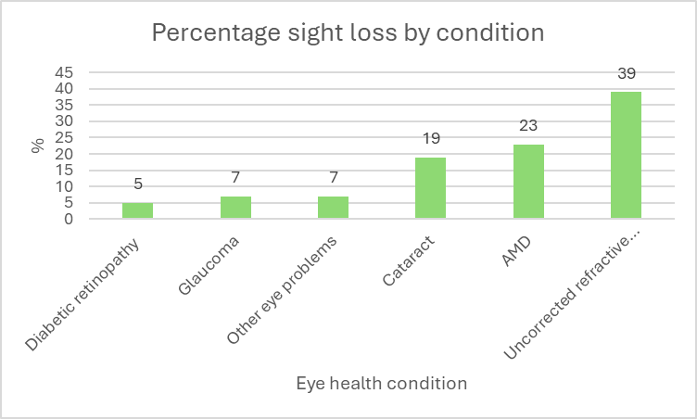
The prevalence of each eye health condition in this chapter are calculated using the Royal National Institute for the Blind People (RNIB) tool (2021) which uses the prevalence model taken from the National Eye Health Epidemiological Model (NEHEM). The base prevalence rates are then applied to the most recent estimates and projections available from the relevant national statistics agency.
2.1.3.1 Cataracts
A cataract is the development of irregularities in the structure of the crystalline lens that leads to a reduction of transparency and the lens becoming misty or cloudy. Cataracts may be classified as nuclear which affect the inner core of the lens or cortical cataracts which affect the outer layers, and subcapsular cataracts which occur on the lens surface.
Cataracts are a common condition in older people, which get worse over time but the impact on vision can be difficult to notice. It is usually treated by replacing the lens with an artificial one.
In 2022 there were an estimated 6,790 people living in Gwent with cataracts that may require surgical intervention (where it is deemed an extraction will be beneficial). This is predicted to increase to 8,200 in 2032, an increase of 17%, but which is below the predicted Welsh rise of 22%.
Monmouthshire is predicted to see the largest increase (27%) whilst Blaenau Gwent has the lowest predicted rise with a 16% increase.
Figure 2.1.6 - Estimated number of people living with cataracts 2022 and 2032 and % increase
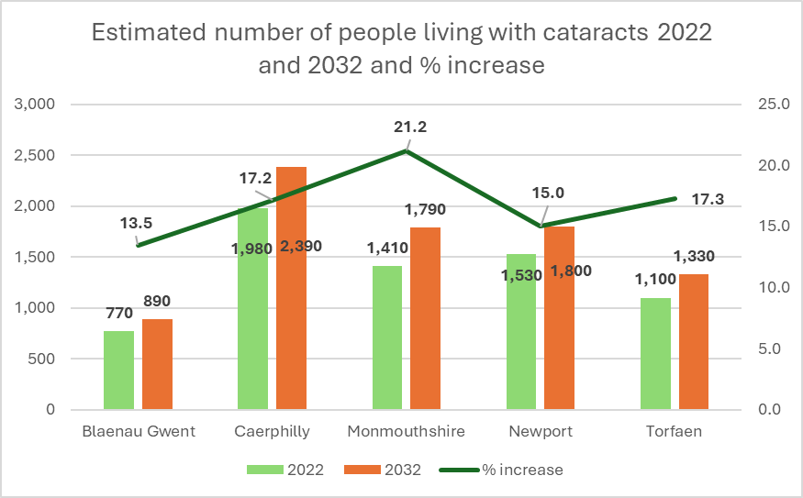

2.1.3.2 Glaucoma
Glaucoma is a chronic, progressive eye disease caused by damage to the optic nerve, which leads to peripheral vision loss and can lead to blindness. The onset is gradual, and the condition worsens. It is not reversible, but it can be treated with medication, laser or filtration surgery.
One of the major risk factors is ocular hypertension (eye pressure) where an abnormality in the eye's drainage system can cause fluid to build up, leading to excessive pressure that causes damage to the optic nerve. A patient diagnosed with ocular hypertension will require ongoing monitoring. Other factors include age, family history and ethnicity. Recent systemic reviews have identified that hypertension can increase the risk of glaucoma, but that a low diastolic blood pressure is also a risk factor for the potential development of glaucoma .
There are an estimated 6,700 people living with Glaucoma in Gwent in 2022 and this is predicted to increase to 7,670 in 2032, an increase of 13%, which is below the Welsh increase of 16%. The smallest increase is in Blaenau Gwent at 10% with Monmouthshire at 19%, with the others all predicting a 14% increase.
Figure 2.1.7 - Estimated number of people living with glaucoma 2022 and 2032 and % increase
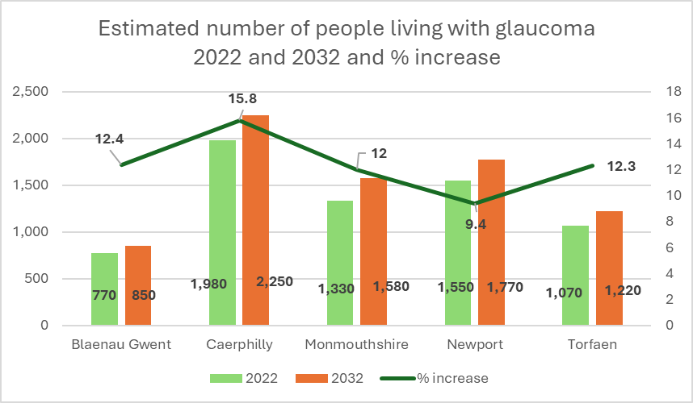

2.1.3.3 Diabetic eye disease
Patients with diabetes mellitus can suffer certain eye conditions due to their disease. For patients with diabetes, diabetic retinopathy is the most common cause for vision loss. Diabetic retinopathy is caused by high blood sugar levels damaging the back of the eye (retina). It may by asymptomatic at first, but it is important that it is diagnosed early, and a patient should have regular screening. Risk factors for diabetes include family history, age and being overweight.
Patients can also suffer from diabetic macular oedema (accumulation of fluid in the retina) and also cataracts and glaucoma.
In Gwent there are an estimated 39,790 people living with diabetes which is expected to rise by 7% (42,850) in 2032. Of those patients 30% (11,820) have diabetic retinopathy, this is predicted to rise by 4% to 12,300 in 2032. Both these increases are below the predicted figures for Wales.
Figure 2.1.8 - Estimated patients living with Diabetes and Diabetic Retinopathy 2022 - 2032

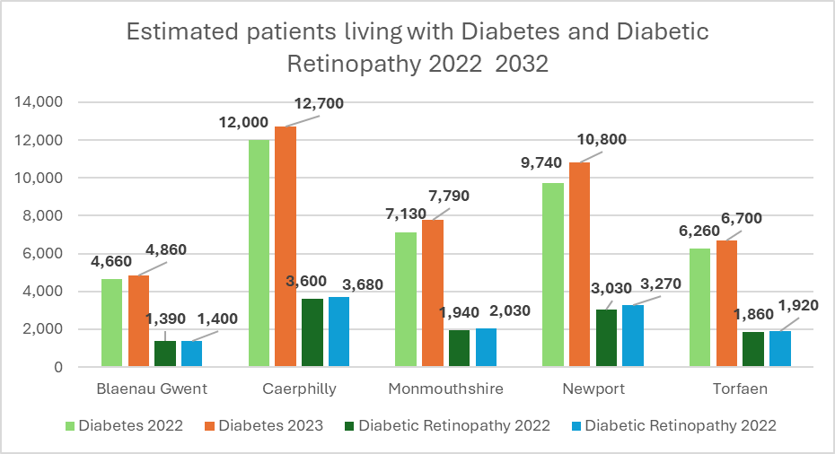

Each local authority will see an increase in patients living with these diseases ranging from 4–9% (Diabetes) and 1.7–4% (Diabetic Retinopathy).
To ensure that patients with diabetes are regularly monitored the diabetic eye screening programme has been established for all patients aged 12 or over with a diagnosis of type 1 or type 2 diabetes. This will be every one or two years.
In 2019/20 64.1% of patients who were eligible and invited to a screening attended, this was down from 69% in 2018/19.
Figure 2.1.9 - % coverage for eye health screening
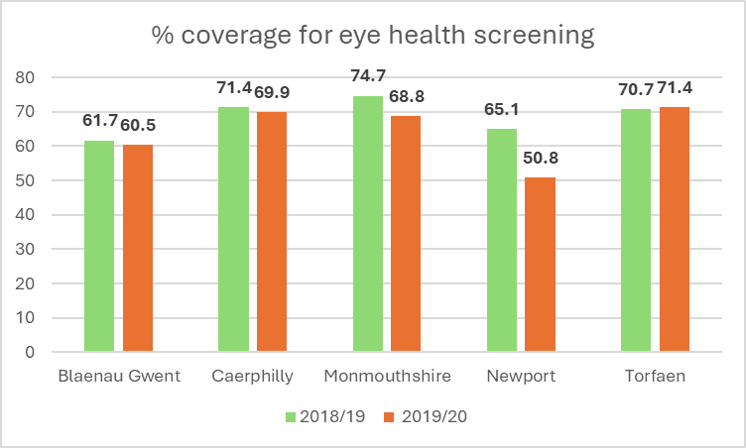
Torfaen was the only local authority that improved their coverage in 2019/20, whereas Newport saw a significant drop of 14.3%.

2.1.3.4 Age related macular degeneration (AMD)
AMD is a condition which affects the middle part of your vision and whilst it does not cause total blindness it makes everyday tasks difficult. There are two types of AMD – dry AMD, where the condition worsens over several years or wet AMD, where the onset is rapid, usually over a few weeks or months. An early indication of AMD can be Drusen, yellow deposits under the retina.
Whilst the cause is unknown it has been linked to high blood pressure, smoking, obesity and family history.
AMD is the leading cause of blindness in the UK.
All areas are expected to see an increase in the number of patients living with both dry and wet AMD. With 1,663 currently having dry AMD which will increase to 2,500, with local authority raises between 13 and 26% and with wet AMD increasing by 18% (4,300 to 5,220) With Monmouthshire seeing the largest increases and Blaenau Gwent the lowest.
Figure 2.1.10 - Estimated number of people living with Dry and Wet AMD 2022 and 2032
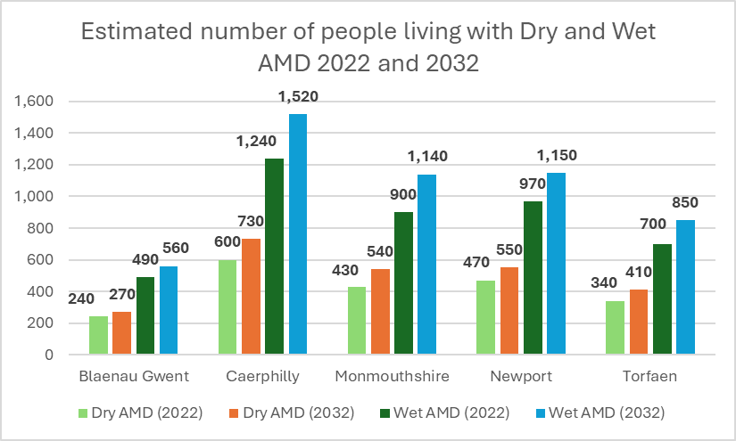

2.1.3.5 Uncorrected refractive error
Refractive error refers to a condition where the eye is unable to focus light properly, leading to blurred or impaired vision. This occurs due to irregularities in the shape of the eye, which affects how light is focused onto the retina.
Due to the potential impact on educational attainment or the development of amblyopia (lazy eye) it is important that refractive errors are corrected in children.
Refractive errors are correctable through glasses, contact lenses, or refractive surgery. Despite these available treatments, refractive errors still contribute to a significant degree of visual impairment, both in the UK and globally. Many individuals remain undiagnosed or unable to access corrective measures, particularly in areas with limited healthcare resources.
There is an association with age and evolve at different rates as people age. Astigmatism is not preventable and tends to increase progressively with age but can start in childhood.
Myopia often starts between first and second decades of life and can progress every few to several months until the late teens with progression being fastest in the age range 7-10 years but can also develop in their second and third decades. Early intervention is important in young children, especially those under 12 to reduce the likelihood of a child ending up with high myopia, which can lead to glaucoma, retinal detachment or myopic macular degeneration. Progress has been made in spectacle and contact lens allowing for ‘myopia control’ which slows the progression of myopia. At the time or publication this treatment is currently only available privately, but can have a significant impact on reducing the risk of irreversible sight loss.
Although many children are born with hyperopia the condition often improves as their eyes grow. Hyperopia can progress in children with a high degree of hyperopia and those over 50.
There is little robust data on the prevalence of uncorrected refractive errors for the UK and Welsh populations
A systematic review of studies into of myopia trend and projections shows a range of prevalence between 24.32 to 3.5.81% and a predicted increase in the prevalence of myopia to 36.59% by 2040 and 39.80% in 2050, with females, adolescents and those in urban areas seeing a higher proportion of myopia.
Studies have been undertaken these have generally been on non-UK based populations and so caution must be given to the figures due to the differences in the populations studied.
A 2017 paper by Hashemi stated that the prevalence of refractive errors in those under 20 are:
- Myopia (shortsightedness) – 14.3%
- Hyperopia (far sightedness) – 9%
- Astigmatism (irregularly shaped cornea or lens)– 12.9%
- Giving an overall a prevalence of 36.2%.
Based on the population 0-14 in 2023 the prevalence of refractive errors is:
Table 2.1.10 – Prevalence of refractive errors in 0-14 year olds
 | Population | General prevalence | Myopia | Hyperopia | Astigmatism
 | 0-14 | 36.2% | 14.3% | 9% | 12.9%
Gwent | 111,993 | 40,541 | 16,015 | 10,079 | 14,447
Blaenau Gwent | 12,158 | 4,401 | 1,739 | 1,094 | 1,568
Caerphilly | 33,554 | 12,147 | 4,798 | 3,020 | 4,328
Monmouthshire | 15,358 | 5,560 | 2,196 | 1,382 | 1,981
Newport | 33,451 | 12,109 | 4,783 | 3,011 | 4,315
Torfaen | 17,472 | 6,325 | 2,499 | 1,572 | 2,254

Studies in adults show that around 57%of those over 40 will have some form of refractive errors and that generally in adults the prevalence is:
- Myopia 25.3%
- Hyperopia 33.8%
- Astigmatism 59.7%
Looking at the 45+ population over 158,000 adults will have some form of refractive error, although this does not show the rate of uncorrected errors.
Table 2.1.11 – Prevalence of refractive errors in 45+ year olds
 | Population | General prevalence | Myopia | Hyperopia | Astigmatism
 | 45+ | 57% | 25.3% | 33.8% | 59.7%
Gwent | 278,643 | 158,827 | 70,497 | 94,181 | 166,350
Blaenau Gwent | 32,136 | 18,318 | 8,130 | 10,862 | 19,185
Caerphilly | 82,968 | 47,292 | 20,991 | 28,043 | 49,532
Monmouthshire | 52,083 | 29,687 | 13,177 | 17,604 | 31,094
Newport | 67,779 | 38,634 | 17,148 | 22,909 | 40,464
Torfaen | 43,677 | 24,896 | 11,050 | 14,763 | 26,075

2.1.3.6 Sight impaired and severely sight impaired
The best source of the prevalence of sight impairment and (severe sight impairment is through the Certifications of Visual Impairment Wales (CVI), these can be provided either by a Consultant Ophthalmologist or an optometrist who are accredited.
The issuing of a certificate is voluntary and not all patients who are deemed partially sighted or blind will hold a CVI.
Where the cause has been captured in 2022-23, 129 were due to age related macular degeneration, 34 from Glaucoma and 5 due to diabetic eye disease.
Data is also captured from the low vision service and the data captured shows that Cataracts are the most common diagnosis followed by Dry AMD and other and then Wet AMD. It should be noted that a patient may have more than one diagnosis and both are captured, therefore the overall numbers per diagnosis may be lower than reported below.
We see the expected decrease during Covid with those accessing the service increasing, 2023/24 did see a decrease across all areas.
Figure 2.1.11 - Rate of people living with sight loss per 1,000

In 2022 the estimated number of patients living with some form of sight loss in Gwent was 20,480 with a prediction that this will increase to 24,080 in 2032 (14.95% increase). This range of increase for the local authority ranges from 11.11% to 18.52%.
The national rate for those living with sight loss per 1,000 is 36. All local authorities other than Monmouthshire are below the national average.
Figure 2.1.12 - Rate of people living with sight loss per 1,000 (2022)

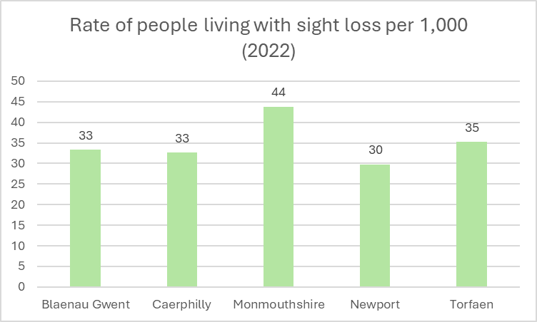
When looking at the rate of those registered as blind or partially sighted per 100,000, Blaenau Gwent is significantly below the national figure of 417 (at 186) with Monmouthshire being higher at 574.
In 2023/24 there were 3,719 new referrals into the low vision service and 72.8% were from Optometrists.
2.1.3.7 Summary
All clinical conditions are expected to see an increase in the % prevalence in the next 20 years. These conditions are managed partly in the community and in secondary care. Consideration will need to be made to ensure that there is enough capacity in the system, workforce and robust services are put in place to manage this increase and minimise the impact on patients.
Planning can include clinical pathways where patients are seen and managed appropriately in the community, freeing up resources in secondary care for patients who require the specialised support. This includes commissioning more contractors to provide WGOS 3, 4 and 5 services.

2.1.4 Risk factors
When looking at risk factors for sight loss there are those that are both non-modifiable and modifiable risk factors. The prevalence of each eye health condition in this chapter are calculated using the Royal National Institute for the Blind People (RNIB) tool (2021) which uses the prevalence model taken from the National Eye Health Epidemiological Model (NEHEM). The base prevalence rates are then applied to the most recent estimates and projections available from the relevant national statistics agency.
2.1.4.1 Non-modifiable risk factors
Age is a significant factor with 79% of those affected with sight loss being over 65 and 32% of those over 85 being affected. Estimates for 2023 show that 107,699 (18%) people in Gwent were over 65. Which puts an estimated 85,000 patients affected with some form of eye health issues.
Figure 2.1.13 - Population by age band (mid 2023)
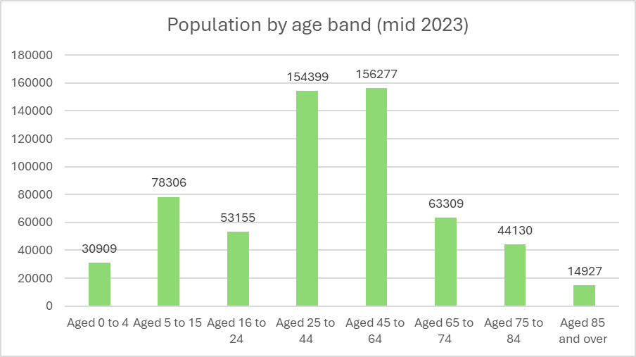
Gender - Females are generally more likely to be affected by sight loss (61%) than males (39%), with a higher frequency of cataracts although diabetic retinopathy is more prevalent in males. In Gwent 303,328 of the population are female and 292,084 are male.
Ethnicity - South-East Asian populations are more likely to suffer from diabetes and to go on and develop diabetic eye diseases compared with those living with diabetes from other ethnic groups. Those from the African and African-Caribbean populations are at a greater risk of developing glaucoma. 3.7% of Gwent’s population fall into these two ethnic groups.
Learning disabilities - It is estimated that 5.6% of children and young people with learning disabilities are blind or partially sighted. This equates to one in 18 children. For adults the estimated prevalence increases to 9.3%, meaning they are 10 times more likely to be blind or partially sighted than the general population. Adults with learning disabilities are unlikely to seek treatment more frequently or in a timelier fashion.
Figure 2.1.14 – Estimated number of adults with learning disabilities and sight loss

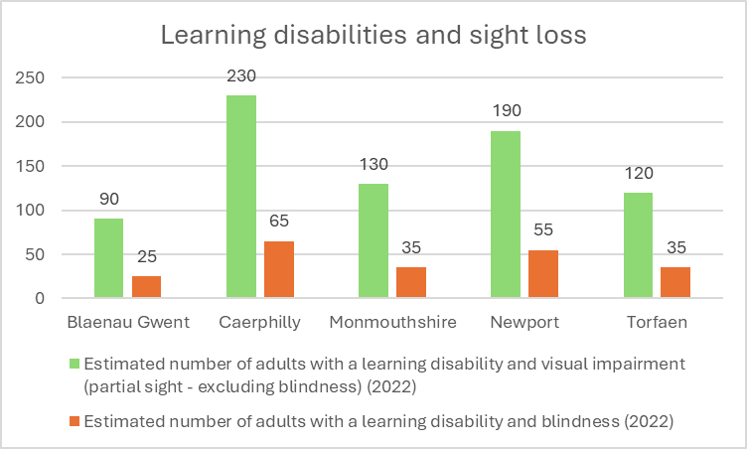

2.1.4.2 Modifiable factors and co-morbidities

Smoking - The link between smoking and the development of AMD is as strong as the link between smoking and lung cancer. With a smoker doubling their risk of developing AMD and earlier than a non-smoker. Smoking can also impact the severity of diabetes related eye health conditions as well as the development of cataracts. The prevalence of current smokers has seen a steady decrease over the last five years.
Rates of smoking are higher in the areas of greatest deprivation.
Figure 2.1.15 – Percentage of current smokers
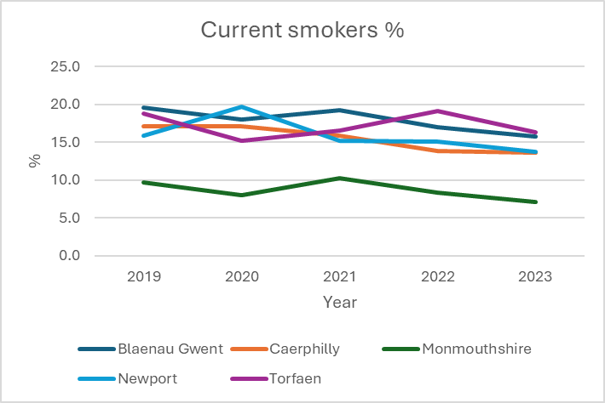

Obesity – there is a strong link to the development of and management of diabetes including a deterioration of diabetic retinopathy. There is also a link to development of AMD and cataracts. The prevalence in the local authorities of those overweight or obese, with the exception of Monmouthshire are above the Welsh average (60%).

Table 2.1.11 – Percentage of overweight or obese population

 | % overweight or obese
Blaenau Gwent | 70
Caerphilly | 67
Monmouthshire | 56
Newport | 67
Torfaen | 65

There are 42,278 patients with a recorded diagnosis of type 2 diabetes in Aneurin Bevan University Health Board. There are an additional 1,368 with a HBA1c at a diagnostic level, but no recorded diagnosis, and a further 18,123 in a prediabetes range (QAIF 2021-2022)
Hypertension – this is a significant cause of sight loss. It affects the development of diabetic retinopathy. High Blood pressure also increases risk of strokes, vein and artery occlusion all of which can cause a sudden loss of vision in one eye. For those patients who survive a stroke 60% of them will have some eye health issues Hypertension has a number of risk factors including age, ethnicity, family history, overweight or obesity, lack of physical activity, tobacco use and high salt intake.
It is estimated that just over 100,819 adults in Gwent are on their GP hypertension register and that as many as 40,000 could be undiagnosed.
Table 2.1.12 – Estimated number of people that have a long-standing health condition due to a stroke

 | Estimated number of people that have a long-standing health condition due to a stroke (2022)
Blaenau Gwent | 370
Caerphilly | 960
Monmouthshire | 660
Newport | 720
Torfaen | 520

Socioeconomic factors - a link has been shown between people on low income and living in deprivation on eye health, with three out of four blind or partially sighted people living in poverty or it’s margins. Evidence shows an increase in Cataract rates. There are also links associated with deprivation and glaucoma, including the late presentation, the aggressiveness of the disease and outcome of blindness.

Dementia - It is estimated that 3,540 people live with dementia and significant sight loss in Gwent (35% of all patients with dementia), which with an aging population will only increase. Gwent has a projected 16.7% increase in the population over 65 by 2034. Sight loss can worsen the symptoms of dementia as well as impacting on a person’s quality of life and also increases the care needs of this group. Patients with dementia may be less likely to access eye care either for a sight test or for exploring symptoms.
Falls - Falls and sight loss are closely linked. In 2022 3.7% of falls that required hospital treatment were directly attributable to a patient with sight loss and is estimated to cost 10% of the total costs of treatment for accidental falls.
2.1.4.3 Summary

Whilst there are a number of non-modifiable factors associated with sight loss, support to ensure that appropriate services are in place to help manage eye care conditions to minimise the impact sight loss. Where there are modifiable factors, it is important that eye health services are part of a wider health system and are included in care pathway design and planning, including preventative measures such as addressing unhealthy lifestyle behaviours, not just managed in isolation.

2.1.5 Contractors and activity
2.1.5.1 Provision of services
The following chapter provides information on the activity provided in Gwent as a whole and then at Neighbourhood Care Network level. Data includes the number of contractors, the range and delivery of services available and the total hours of availability of services during the week across all contractors.
Recognising that patients have a choice of where they receive their care under WGOS1 and 2, activity for each Neighbourhood Care Network is also provided although we are unable to show if the patient is attending a contractor in the same Neighbourhood Care Network in which they live.
2.1.5.2 Contractors
Gwent has 60 contractors of eye health services across their 11 Neighbourhood Care Network. Of this 54 provide services from registered premises, five are domiciliary only contractors and one domiciliary low vision service contractor.
Table 2.1.13 – Number of contractors
Local authority | Neighbourhood Care Network | Population | Practices
Blaenau Gwent | Blaenau Gwent East | 67,356 | 2
 | Blaenau Gwent West |  | 4
 |  |  | 6
Caerphilly | Caerphilly East | 176,437 | 9
 | Caerphilly North |  | 3
 | Caerphilly South |  | 5
 |  |  | 17
Monmouthshire | Monmouth North | 94,572 | 8
 | Monmouth South |  | 3
 |  |  | 11
Newport City | Newport East | 163,628 | 4
 | Newport West |  | 8
 |  |  | 12
Torfaen | Torfaen North | 93,419 | 3
 | Torfaen South |  | 4
 |  |  | 7
Domiciliary contractors | Domiciliary only contractor |  | 5
 | Contractors who have a fixed premise and a domiciliary services agreement. |  | 6
 | Domiciliary low vision service |  | 1
 |  |  | 12

In the last five years 8 contracts were terminated by the contractor and two contractors merged their two contracts and relocated. One new contract has been placed. Five of the contractors provided a low vision service.
Map 2.1.9 - all contractors (excluding domiciliary only contractors) against population density
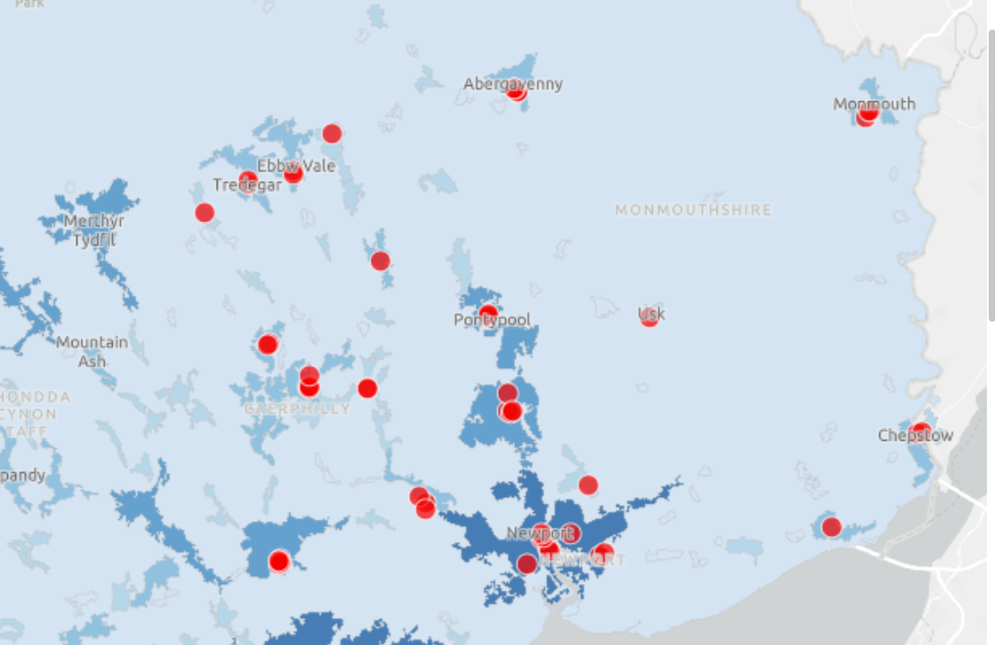

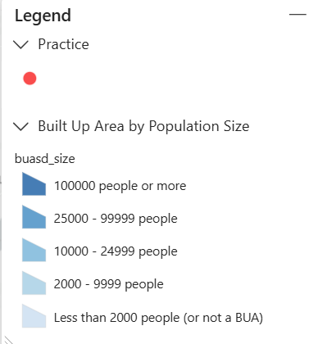
Map 2.1.10 all contractors (excluding domiciliary only contractors) against deprivation
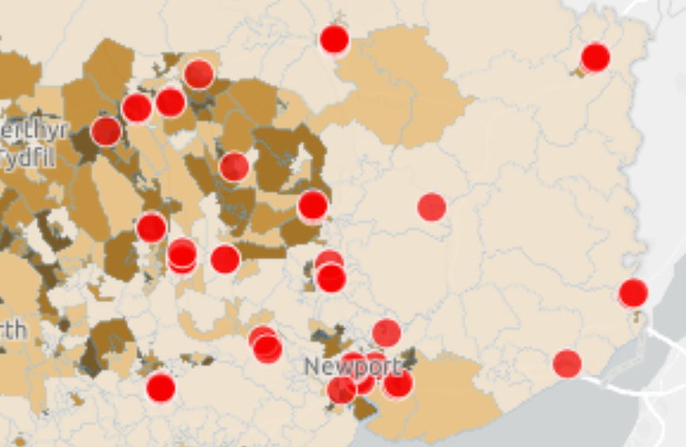
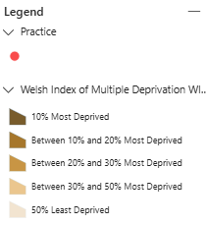
WGOS 3-5 are based on a referral basis, this could be from another clinician or self-referred. An Neighbourhood Care Network may not have a contractor of one or more of these services. A breakdown of these figures is included in each of the Neighbourhood Care Network sections.
Across Gwent there are 35 contractors of WGOS3 services, 11 contractors of WGOS4 - Glaucoma (previously the Ophthalmic Diagnostic and Treatment Centre (ODTC)), 25 who provide WGOS4 Medical Retina. There are 2 contractors doing WGOS4 HCQ and 22 who provide WGOS5 services. Gwent has 1 contractor of the Wet AMD referral refinement scheme which is based in Newport, as part of the changes to the services under the new regulations this service will not be continued.
2.1.5.3 Activity

In 2023/24 over 162,000 sight tests to all eligible persons were provided in Gwent, of these just under 5,800 (3.54% of all sight tests) were provided for as a domiciliary sight test. This equates to 27.37% of the Gwent population accessing a sight test. This is slightly lower than the overall position for Wales at 29.29%.
It is not known how many of the population are eligible for a sight test but chose either not to access a sight test or seek a private sight test instead.
Activity has recovered well since 2020/21 where service was impacted due to Covid-19 and more patients received a sight test either at a registered premises (an increase of 3.34%) or domiciliary (an increase of 9.54%) in 2023/24 than they did in 2019/20. This is against a population increase of 1.87% between 2019 and 2023.
Table 2.1.14 Sight tests, fixed and domiciliary premises
 | 201920 | 202021 | 202122 | 202223 | 202324
Sight test from registered premises | 152,026 | 67,561 | 146,693 | 150,067 | 156,907
Domiciliary sight test | 5,215 | 1,579 | 4,070 | 4,252 | 5,765
Total | 157,241 | 69,140 | 150,763 | 154,319 | 162,672

An assumption has been made that a patient has their sight test in the same local authority where they live therefore the percentage of the population by local authority who had a sight test are:
Table 2.1.15 % population who receive and NHS sight test
 | Population | % who received NHS sight test
Blaenau Gwent | 67,356 | 21.5
Caerphilly | 176,437 | 27.1
Monmouthshire | 94,572 | 27.5
Newport | 163,628 | 23.9
Torfaen | 93,419 | 28.5

WGOS1

Figure 2.1.16 – Total sight tests 2019/20 – 2023/24

Figure 2.1.17 – Sight tests from registered premises 2019/20 – 2023/24
Figure 2.1.18 – Domiciliary sight tests 2019/20 – 2023/24

Sight tests provided by eligibility grouping
The change in claiming by eligibility shows small % increases in those under 18 and a small % decrease in those over 60. Larger % changes are seen in other groups, especially those eligible due to financial support reasons, which has seen an overall decrease of 51.12%.
Table 2.1.16 – Sight tests by eligibility
 | 2019/20 | 2023/24 | % change
Total eligible patients | 157,241 | 162,672 | 3.34
Persons aged 60 and over | 82,722 | 82,261 | -0.56
Children aged 15 or under | 37,960 | 39,005 | 2.68
Students aged 16 - 18 | 4,551 | 4,601 | 1.09
Adults receiving Income Support | 8,602 | 3,400 | -153
Adults receiving Tax Credit | 6,302 | 4,501 | -40.01
Adults receiving Job Seekers Allowance | 1,900 | 3,000 | 36.67
Adults holding a low-income certificate | 350 | 450 | 22.22
Registered blind/partially sighted* | 250 | 100 | -150
Diabetics/glaucoma sufferers | 4,751 | 4,751 | 0.00
Persons requiring complex lenses | 300 | 550 | 45.45
Close relatives aged 40 and over of glaucoma sufferers | 6,252 | 7,301 | 14.37

 | 2019/20 | 2023/24 | % change
Adults receiving Income Support | 8,602 | 3,400 | -153
Adults receiving Tax Credit | 6,302 | 4,501 | -40
Adults receiving Job Seekers Allowance | 1,900 | 3,000 | 36.67
Adults holding a low-income certificate | 350 | 450 | 22.22
Total | 17,154 | 11,351 | -51.12

WGOS 2 – Bands 1, 2 and 3

The provision of WGOS 2 (previously EHEW bands 1-3) has seen a significant increase during the previous three years across all bands, where the % change for each band is 28%, 28.7% and 26.7% respectively.
Figure 2.1.19 – WGOS2 activity

WGOS3
1,466 patients accessed the low vision service in 2023/24 which saw a small decrease from those accessing in 2022/23 (1,572) but was similar to those in 2021/22 (1,456).
WGOS4
The WGOS 4 Referral Filtering service was launched within Gwent in November 2024. 493 claims have been made to date. Data reported for Glaucoma below is based on the ODTC Glaucoma service.
Table 2.1.17 – ODTC Glaucoma
 | 2021/22 | 2022/23 | 2023/24
Blaenau Gwent | 603 | 559 | 517
Caerphilly | 793 | 1,322 | 1,905
Monmouthshire | 591 | 606 | 627
Newport | 1,281 | 1,181 | 1,083
Torfaen | 377 | 756 | 1,255
Total | 3,645 | 4,424 | 5,387

Table 2.1.18 WGOS 4 claims
Total WGOS 4 Claims - Dec 2024- Feb 2025
Cluster | Med Ret Monitoring | Med Ret Filtering | Glaucoma Monitoring Claims | Glaucoma filtering Claims | Total Claims
Blaenau Gwent | 0 | 14 | 0 | 6 | 20
Caerphilly | 2 | 83 | 0 | 64 | 149
Monmouthshire | 0 | 42 | 0 | 27 | 69
Newport | 1 | 86 | 0 | 143 | 230
Torfaen | 0 | 13 | 0 | 12 | 25

Torfaen and Caerphilly have seen a significant increase in patients seen in the ODTC service in the last three years, whereas Blaenau Gwent and Newport have seen small decreases.
WGOS5
Provision of care which can be provided for by an independent prescriber (IPOS) was introduced in 2023 and for the year 2023/24 a total of 988 IPOS claims were made. Up until February 2025, a total of 5390 claims have been made in 2024/25.

2.1.6 Neighbourhood Care Network provision

Data used in this section is based on locally reported data and as such there are small discrepancies to the totals reported on StatsWales.
No information is available on where patients live versus where they attended a premises for a sight test or other eye-health care.
2.1.6.1 Blaenau Gwent East Neighbourhood Care Network

There are two contractors of WGOS services from registered premises based in Blaenau Gwent East with one contractor also providing domiciliary services. Both contractors are situated in the main towns of Abertillery and Brynmawr. According to the 2021 census, Abertillery has a population of 10,252 and Brynmawr 5,250. Both the towns are within the 20-30% most deprived areas in Wales. It is recognised though that some patients will live in the local authority area but not in the towns or cities.
Blaenau Gwent East had one contract terminated by the contractor in December 2023.
Map 2.1.11 - Blaenau Gwent East contractors by rurality
Map 2.1.12 - Blaenau Gwent East contractors by deprivation
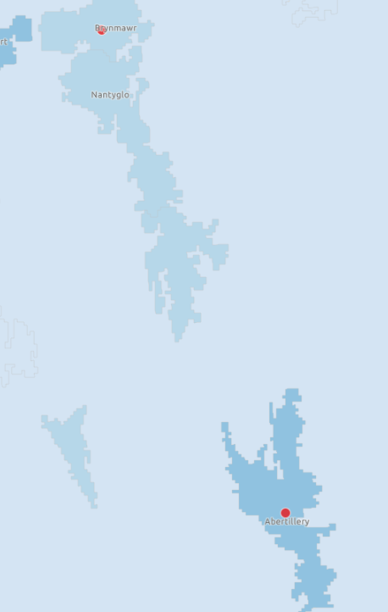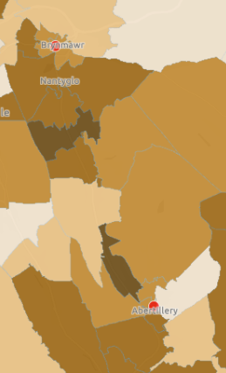

Table 2.1.19 – Blaenau Gwent East contractors and number of claims
Service | Number of Practices | Number of claims 2023/24
WGOS 1 | 2 | 4684
WGOS 2  Band 1  Band 2  Band 3 | 2 | 2,121  425  397
WGOS 3 | 2 | 79
WGOS 4 - Glaucoma (previously ODTC) | 0 | 0
WGOS 4 – Medical Retina | 2
WGOS 4 – HCQ | 2
WGOS 5 | 2 | 114
Domiciliary | 1 | 41

Please note that the number of domiciliary sight tests could have been provided by any of the 13 domiciliary contractors in Gwent.
Table 2.1.20 – Blaenau Gwent East sight test claims
 | Sight Test | Domiciliary Sight Test
2021/22 | 5,557 | 67
2022/23 | 3,206 | 83
2023/24 | 4,684 | 41

Blaenau Gwent East saw a 32% (1,478) increase in the number of sight tests performed from 2022/23 (registered premises) and a 50% decrease in the number of domiciliary sight tests.
Primary eye health services are available:
Table 2.1.21 – Blaenau Gwent East hours of services
 | Hours available
Monday | 15
Tuesday | 15
Wednesday | 15
Thursday | 15
Friday | 15
Saturday | 7
Sunday | 0
Total | 92

The earliest start time on a weekday is 09.00 and latest finish us 17.30. On Saturday it is 09.00 and 12.30. No service is available on a Sunday.
2.6.2 Blaenau Gwent West Neighbourhood Care Network

There are four contractors of WGOS services from registered premises in Blaenau Gwent West, with one contractor also providing domiciliary services. The practices are located in the towns of Ebbw Vale and Tredegar. Ebbw Vale has a population of 19,633 and is between the 20-30% most deprived whilst Tredegar is in the 10-20% most deprived areas of Wales and has a population of 14,529. It is recognised though that some patients will live in the local authority area but not in the towns or cities.
Map 2.1.13 - Blaenau Gwent West contractors by rurality
Map 2.1.14 - Blaenau Gwent West contractors by deprivation
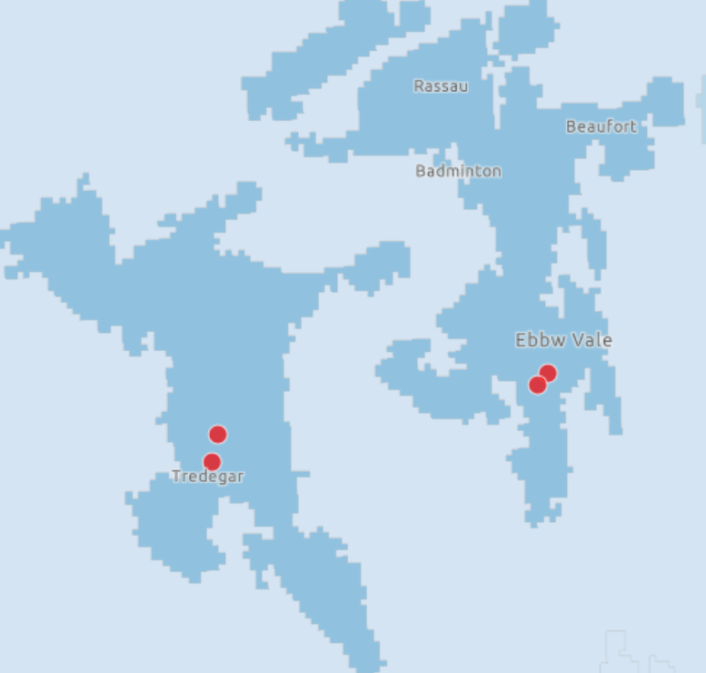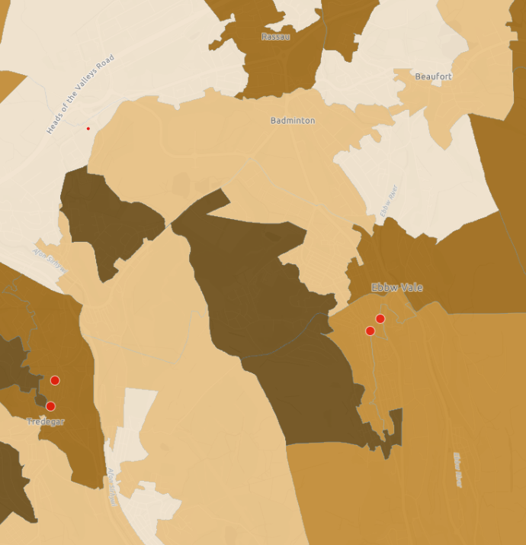

Table 2.1.22 – Blaenau Gwent West contractors and number of claims
Service | Number of contractors | Number of claims 2023/24
WGOS 1 | 4 | 9,790
WGOS 2  Band 1  Band 2  Band 3 | 4 | 1,558  665  388
WGOS 3 | 3 | 85
WGOS 4 - Glaucoma (previously ODTC) | 1 | 517
WGOS 4 – Medical Retina | 1
WGOS 4 – HCQ | 0
WGOS 5 | 2 | 258
Domiciliary | 1 | 48

Table 2.1.23 – Blaenau Gwent West sight test claims
 | Sight Test | Domiciliary Sight Test
2021/22 | 8,866 | 29
2022/23 | 8,452 | 18
2023/24 | 9,790 | 48

Blaenau Gwent West saw a 14% (1338) increase in the number of sight tests performed from 2022/23 (registered premises) and a 62% increase in the number of domiciliary sight tests (+30).
Primary eye health services are available:
Table 2.1.24 – Blaenau Gwent West hours of services
 | Hours available
Monday | 22
Tuesday | 24
Wednesday | 24
Thursday | 29
Friday | 22
Saturday | 18
Sunday | 0
Total | 139

The earliest start time on a weekday is 09.00 and latest finish us 18.00. On Saturday it is 09.00 and 16.30. No service is available on a Sunday.
2.6.3 Caerphilly East Neighbourhood Care Netwrok

There are nine contractors of WGOS services from registered premises in Caerphilly East and no domiciliary contractors who are based in Caerphilly East. The practices are located in the towns of Blackwood (population 12,615), Newbridge (7,586) and Risca (15,197). The towns are in the 30-50% most deprived areas in Wales. It is recognised though that some patients will live in the local authority area but not in the towns or cities.
Caerphilly East had one contract terminated by the contractor in April 2022.
Map 2.1.15 - Caerphilly East contractors by rurality
Map 2.1.16 - Caerphilly East contractors by deprivation

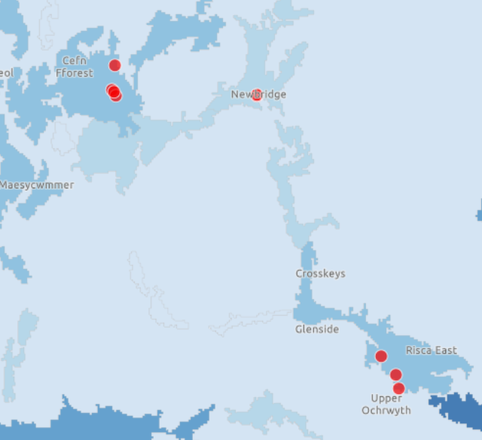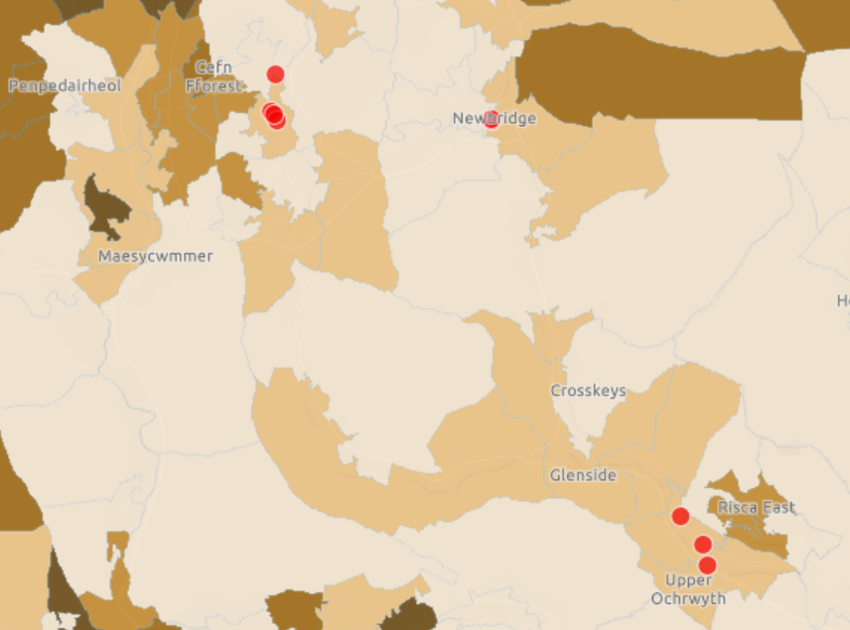
Table 2.1.25 – Caerphilly East contractors and number of claims
Service | Number of contractors | Number of claims 2023/24
WGOS 1 | 9 | 22,865
WGOS 2  Band 1  Band 2  Band 3 | 9 | 3,975  1,586  1,081
WGOS 3 | 7 | 165
WGOS 4 - Glaucoma (previously ODTC) | 1 | 1,162
WGOS 4 – Medical Retina | 2
WGOS 4 – HCQ | 0
WGOS 5 | 2 | 49
Domiciliary | 0 | 1

Table 2.1.26 – Caerphilly East sight test claims
 | Sight Test | Domiciliary Sight Test
2021/22 | 20,252 | 2
2022/23 | 21,350 | 1
2023/24 | 22,865 | 1

Caerphilly East saw a 7% (1515) increase in the number of sight tests performed from 2022/23 (registered premises) but the number of domiciliary sight tests remained the same.
Primary eye health services are available:
Table 2.1.27 – Caerphilly East hours of services
 | Hours available
Monday | 70.6
Tuesday | 6
Wednesday | 65
Thursday | 72.1
Friday | 50
Saturday | 35.5
Sunday | 6
Total | 363.2

The earliest start time on a weekday is 08.30 and latest finish us 17.30. On Saturday it is 09.00 and 17.30, for Sunday it is 10.00 and 16.00.
2.6.4 Caerphilly North Neighbourhood Care Network

There are three contractors of WGOS services from registered premises in Caerphilly North and one domiciliary contractor based in Caerphilly North. One practice is located in Rhymney and two in Bargoed. Rhumney with a population of 4,989 is in the 10% most deprived areas in Wales, whilst Bargoed (8,030) is between 30-50% most deprived. It is recognised though that some patients will live in the local authority area but not in the towns or cities.
Caerphilly North had one contract terminated by the contractor in April 2024.
Map 2.1.17 - Caerphilly North contractors by rurality
Map 2.1.18 - Caerphilly North contractors by deprivation

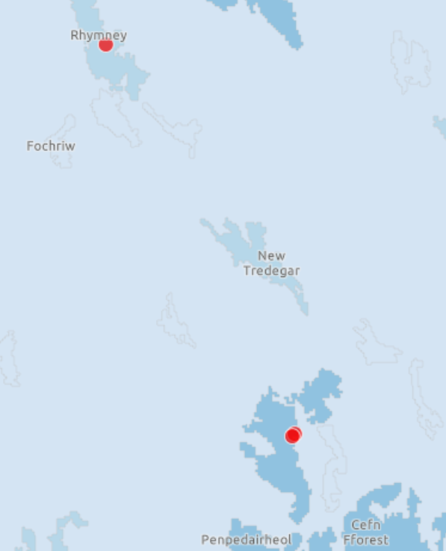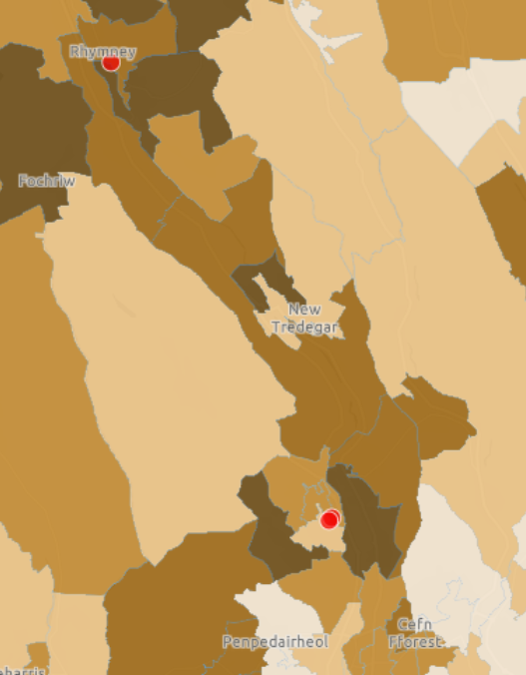

Table 2.1.28 – Caerphilly North contractors and number of claims

Service | Number of contractors | Number of claims 2023/24
WGOS 1 | 3 | 4,832
WGOS 2  Band 1  Band 2  Band 3 | 3 | 769  489  343
WGOS 3 | 3 | 54
WGOS 4 - Glaucoma (previously ODTC) | 1 | 0
WGOS 4 – Medical Retina | 3
WGOS 4 – HCQ | 0
WGOS 5 | 1 | 0
Domiciliary | 1 | 27

Table 2.1.29 Caerphilly North sight test claims
 | Sight Test | Domiciliary Sight Test
2021/22 | 5,148 | 20
2022/23 | 4,633 | 27
2023/24 | 4,832 | 27

Caerphilly North saw a 4% (199) increase in the number of sight tests performed from 2022/23 (registered premises) but the number of domiciliary sight tests remained the same.
Primary eye health services are available:
Table 2.1.30 – Caerphilly North hours of services
 | Hours available
Monday | 23.5
Tuesday | 23.5
Wednesday | 23.5
Thursday | 23.5
Friday | 23.5
Saturday | 6.5
Sunday | 0
Total | 124

The earliest start time on a weekday is 09.00 and latest finish us 17.30. On Saturday it is 09.30 and 13.00. No service is available on a Sunday.
2.6.5 Caerphilly South North Neighbourhood Care Network

There are five contractors of WGOS services from registered premises in Caerphilly South and no domiciliary contractors who are based in Caerphilly South. All five contractors are in the town of Caerphilly, what has a population of 175,952 and is between 30-50% most deprived areas in Wales. It is recognised though that some patients will live in the local authority area but not in the towns or cities.
Map 2.1.19 - Caerphilly South contractors by rurality
Map 2.1.20 - Caerphilly South contractors by deprivation
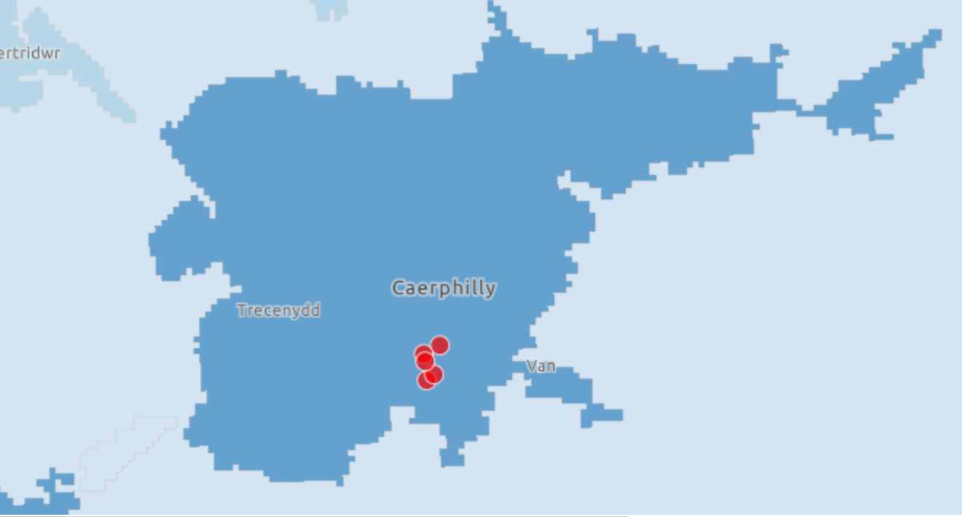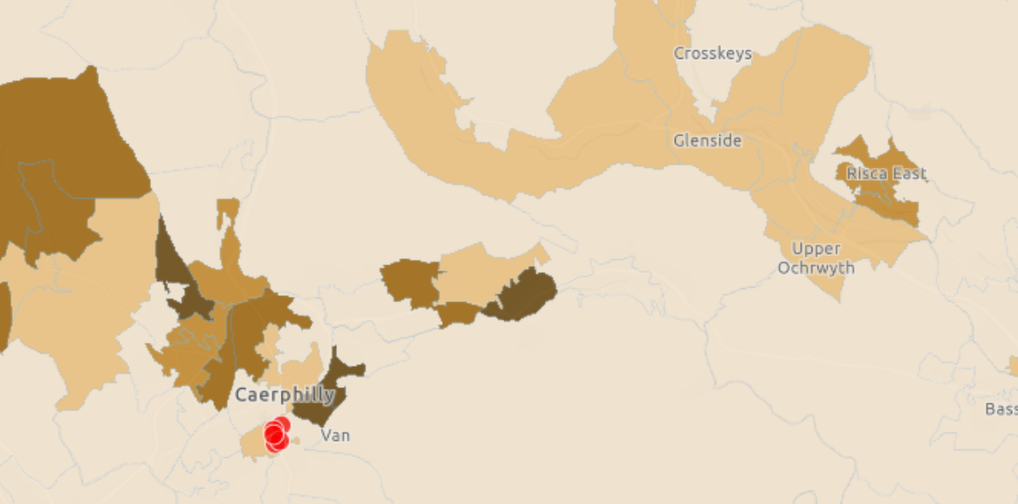

Table 2.1.31 – Caerphilly South contractors and number of claims
Service | Number of contractors | Number of claims 2023/24
WGOS 1 | 5 | 20,074
WGOS 2  Band 1  Band 2  Band 3 | 5 | 4,603  1,546  1,505
WGOS 3 | 4 | 132
WGOS 4 - Glaucoma (previously ODTC) | 1 | 743
WGOS 4 – Medical Retina | 2
WGOS 4 – HCQ | 0
WGOS 5 | 2 | 135
Domiciliary | 0 | 0

Table 2.1.32 - Caerphilly South sight test claims
 | Sight Test | Domiciliary Sight Test
2021/22 | 15,453 | 14
2022/23 | 18,970 | 6
2023/24 | 20,074 | 0

Caerphilly South saw a 5% (1104) increase in the number of sight tests performed from 2022/23 (registered premises) but the number of domiciliary reduced to 0.
Primary eye health services are available:
Table 2.1.33 - Caerphilly South hours of services
 | Hours available
Monday | 22.75
Tuesday | 35.75
Wednesday | 35.75
Thursday | 22.75
Friday | 29.75
Saturday | 22.25
Sunday | 8.25
Total | 177.25

The earliest start time on a weekday is 09.00 and latest finish us 17.30. On Saturday it is 09.00 and 17.15, for Sunday it is 09.00 and 17.15.
2.6.6 Monmouthshire North Neighbourhood Care Network

There are eight contractors of WGOS services from registered premises in Monmouthshire North and no domiciliary contractors who are based in Monmouthshire North. There are four contractors in the town of Abergavenny (population 13,691) three in Monmouth (10,317) and one located in Usk (2,629). Whilst Abergavenny has areas which are both in the least 50% of deprived areas but also in the 30-50% most deprived, the contractors are set in the former area. Monmouth and Usk contractors are located in areas which sit in the least 50% deprived areas in Wales. It is recognised though that some patients will live in the local authority area but not in the towns or cities.
Monmouthshire North had three contracts terminated by the contractor in November 2019, March 2022 and March 2023. One contractor merged with another contractor in March 2024 and moved their premises to Newport.
Map 2.1.21 - Monmouthshire North contractors by rurality
Map 2.1.22 - Monmouthshire North contractors by deprivation
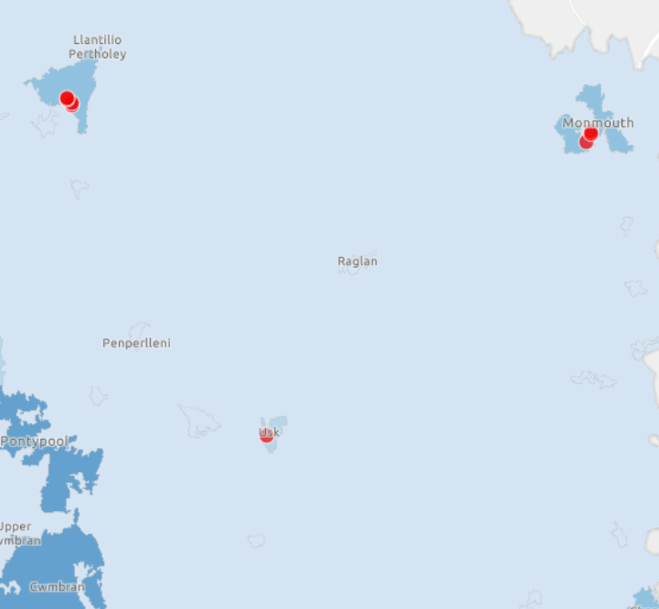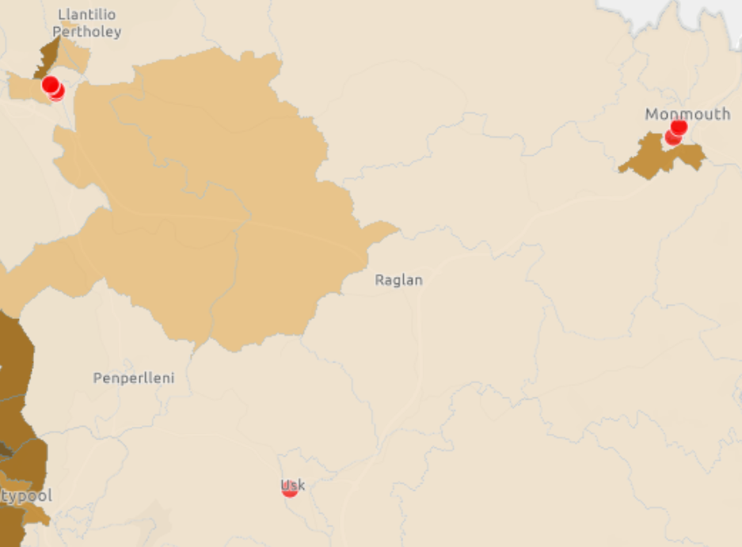

Table 2.1.34 – Monmouthshire North contractors and number of claims
Service | Number of contractors | Number of claims 2023/24
WGOS 1 | 8 | 18,852
WGOS 2  Band 1  Band 2  Band 3 | 8 | 2,843  979  713
WGOS 3 | 4 | 161
WGOS 4 - Glaucoma (previously ODTC) | 1 | 627
WGOS 4 – Medical Retina | 2
WGOS 4 – HCQ | 1
WGOS 5 | 2 | 38
Domiciliary | 0 | 4

Table 2.1.35 - Monmouthshire North sight test claims
 | Sight Test | Domiciliary Sight Test
2021/22 | 21,406 | 13
2022/23 | 19,896 | 11
2023/24 | 18,852 | 4

Monmouthshire North saw a 5% (1044) decrease in the number of sight tests performed from 2022/23 (registered premises) and the number of domiciliary sight tests decreased by 175%
Primary eye health services are available:
Table 2.1.36 - Monmouthshire North hours of services
 | Hours available
Monday | 49.5
Tuesday | 53
Wednesday | 49.5
Thursday | 57.5
Friday | 53.5
Saturday | 36.5
Sunday | 13
Total | 312.5

The earliest start time on a weekday is 09.00 and latest finish us 17.30. On Saturday it is 08.30 and 17.30, for Sunday it is 09.00 and 16.00.
2.6.7 Monmouthshire South Neighbourhood Care Network

There are three contractors of WGOS services from registered premises in Monmouthshire South and one domiciliary contractor based in Monmouthshire South.
Two contractors are located in the town of Chepstow and one in Caldicot. The contractors in Chepstow serve a population of 11,934 and are within the areas in the 30-50% most deprived, whilst Caldicot (9,813) is in the 20-30% bracket. It is recognised though that some patients will live in the local authority area but not in the towns or cities.
Map 2.1.23 - Monmouthshire South contractors by rurality
Map 2.1.24 - Monmouthshire South contractors by deprivation

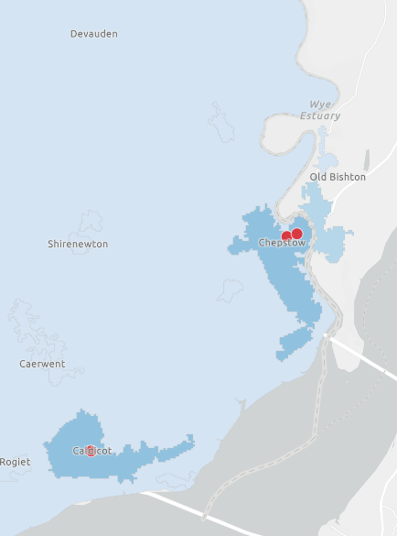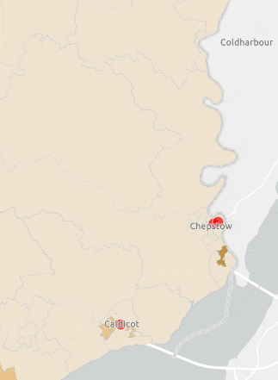

Table 2.1.37 – Monmouthshire South contractors and number of claims
Service | Number of contractors | Number of claims 2023/24
WGOS 1 | 3 | 7,126
WGOS 2  Band 1  Band 2  Band 3 | 3 | 1,374  522  346
WGOS 3 | 1 | 20
WGOS 4 - Glaucoma (previously ODTC) | 0 | 0
WGOS 4 – Medical Retina | 1
WGOS 4 – HCQ | 1
WGOS 5 | 1 | 40
Domiciliary | 1 | 20

Table 2.1.38 - Monmouthshire South sight test claims
 | Sight Test | Domiciliary Sight Test
2021/22 | 8,108 | 8
2022/23 | 7,659 | 16
2023/24 | 7,126 | 20

Monmouthshire South saw a 7% (533) decrease in the number of sight tests performed from 2022/23 (registered premises) but the number of domiciliary sight tests increased by 20%.
Primary eye health services are available:
Table 2.1.39 - Monmouthshire South hours of services
 | Hours available
Monday | 23
Tuesday | 23
Wednesday | 23
Thursday | 25
Friday | 23
Saturday | 14.5
Sunday | 0
Total | 131.5

The earliest start time on a weekday is 09.00 and latest finish us 17.30. On Saturday it is 09.00 and 17.30. No service is available on a Sunday

2.6.8 Newport East Neighbourhood Care Network

There are five contractors of WGOS services from registered premises in Newport East and no domiciliary contractors who are based in Newport East.
One contractor is located in Caerleon with the other contractors in Newport city itself. Caerleon has a population of 7,967 and is in the 50% least deprived but the locations of the practices in Newport East sit within the 10% most deprived areas and serve a population of 11,644. It is recognised though that some patients will live in the local authority area but not in the towns or cities.
.
Map 2.1.25 - Newport East contractors by rurality
Map 2.1.26 - Newport East contractors by deprivation
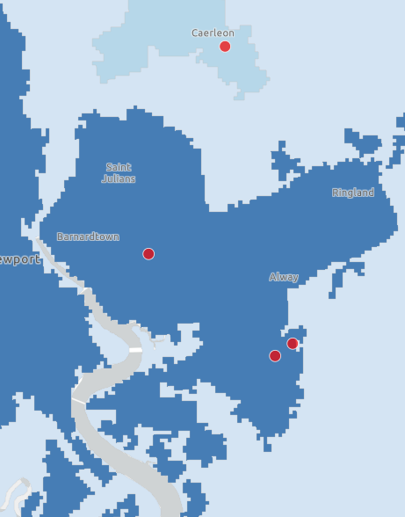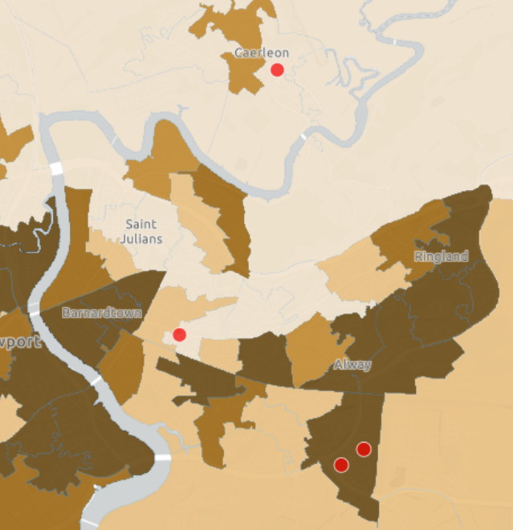

Table 2.1.40 – Newport East contractors and number of claims
Service | Number of contractors | Number of claims 2023/24
WGOS 1 | 4 | 17,251
WGOS 2  Band 1  Band 2  Band 3 | 4 | 4,255  1,789  898
WGOS 3 | 2 | 83
WGOS 4 - Glaucoma (previously ODTC) | 0 | 0
WGOS 4 – Medical Retina | 2
WGOS 4 – HCQ | 0
WGOS 5 | 2 | 220
Domiciliary | 0 | 1

Table 2.1.41 - Newport East sight test claims
 | Sight Test | Domiciliary Sight Test
2021/22 | 13,950 | 0
2022/23 | 14,608 | 1
2023/24 | 17,251 | 1

Newport East saw a 15% (2643) increase in the number of sight tests performed from 2022/23 (registered premises) but the number of domiciliary sight tests stayed the same.
Primary eye health services are available:
Table 2.1.42 - Newport East hours of services
 | Hours available
Monday | 33
Tuesday | 25.5
Wednesday | 33
Thursday | 33
Friday | 25.5
Saturday | 20
Sunday | 6
Total | 176

The earliest start time on a weekday is 09.00 and latest finish us 18.00. On Saturday it is 09.00 and 17.00, for Sunday it is 09.30 and 15.30.
2.6.9 Newport West Neighbourhood Care Network

There are eight contractors of WGOS services from registered premises in Newport West and one domiciliary contractor who is based in Newport West.
One contractor is based on the outskirts of the city with the remaining seven all in the city itself. Newport West has a population of 159,600. One contractor is between the 10 and 20% most deprived but all remaining contractors sit within a10% most deprived area. It is recognised though that some patients will live in the local authority area but not in the towns or cities.
Newport West had one contract terminated by the contractor in February 2023.
Map 2.1.27 - Newport West contractors by rurality
Map 2.1.28 - Newport West contractors by deprivation
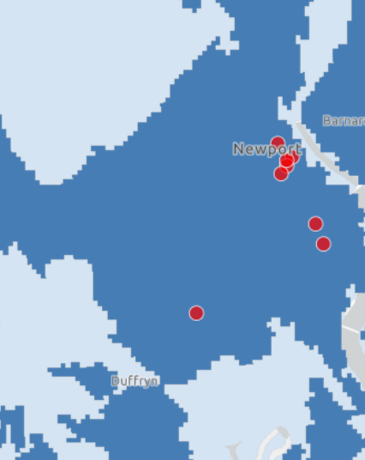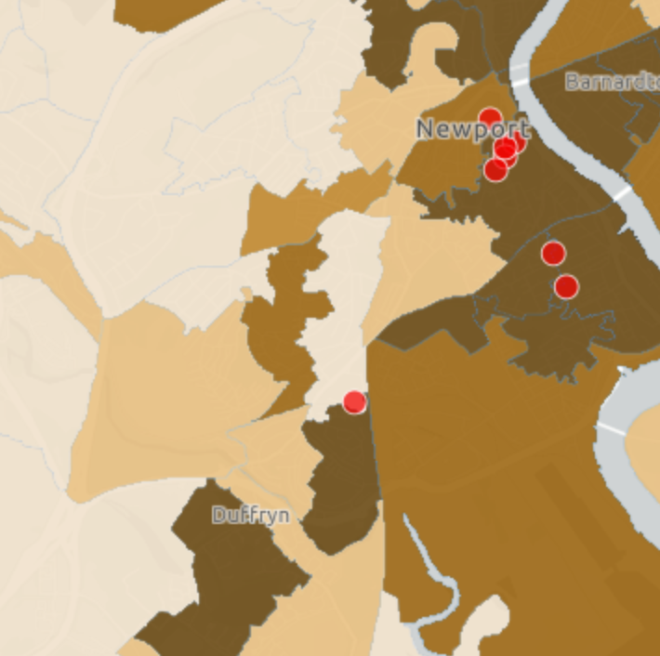

Table 2.1.43 – Newport West contractors and number of claims
Service | Number of contractors | Number of claims 2023/24
WGOS 1 | 8 | 21,783
WGOS 2  Band 1  Band 2  Band 3 | 8 | 4,582  1,676  1,156
WGOS 3 | 4 | 317
WGOS 4 - Glaucoma (previously ODTC) | 2 | 1083
WGOS 4 – Medical Retina | 5
WGOS 4 – HCQ | 4
WGOS 5 | 4 | 144
Domiciliary |  | 363

Table 2.1.44 - Newport West sight test claims
 | Sight Test | Domiciliary Sight Test
2021/22 | 20,822 | 354
2022/23 | 20,990 | 382
2023/24 | 21,783 | 363

Newport West saw a 4% (793) increase in the number of sight tests performed from 2022/23 (registered premises) but the number of domiciliary sight tests decreased by 5% (19).
Newport West provides the Wet AMD referral refinement scheme which in 2021/22 provided 1529 referrals and 1371 in 2023/24 (data is not available for 2022/23).
Primary eye health services are available:
Table 2.1.45 - Newport West hours of services
 | Hours available
Monday | 49.5
Tuesday | 62
Wednesday | 58
Thursday | 41.5
Friday | 54
Saturday | 31.75
Sunday | 0
Total | 296.75

The earliest start time on a weekday is 09.00 and latest finish us 17.30. On Saturday it is 09.00 and 17.00. No service is available on a Sunday.
2.6.10 Torfaen North Neighbourhood Care Network

There are three contractors of WGOS services from registered premises in Torfaen North and no domiciliary contractors who are based in Torfaen North. All three contractors are located in the town of Pontypool, serving a population of 29,062, all practices sit in the 20 – 30% most deprived. It is recognised though that some patients will live in the local authority area but not in the towns or cities.
Torfaen North had one contract terminated in January 2022.
Map 2.1.29 - Torfaen North contractors by rurality
Map 2.1.30 - Torfaen North contractors by deprivation

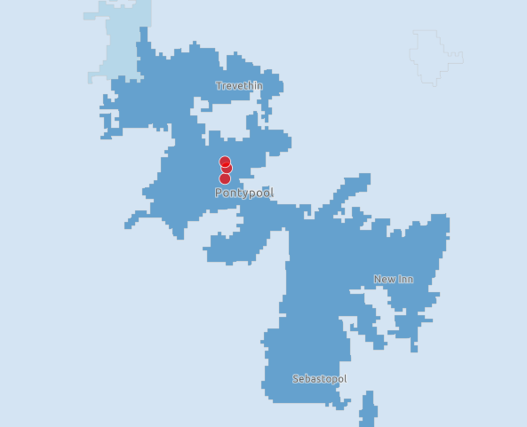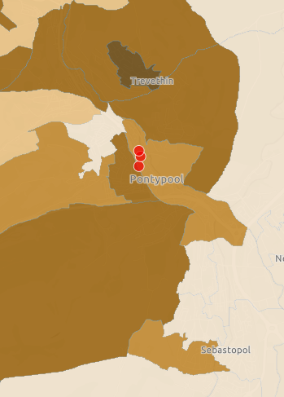

Table 2.1.46 – Torfaen North contractors and number of claims
Service | Number of contractors | Number of claims 2023/24
WGOS 1 | 3 | 6,640
WGOS 2  Band 1  Band 2  Band 3 | 3 | 1,146  660  256
WGOS 3 | 2 | 55
WGOS 4 - Glaucoma (previously ODTC) | 0 | 1255
WGOS 4 – Medical Retina | 2
WGOS 4 – HCQ | 0
WGOS 5 | 1 | 0
Domiciliary | 0 | 0

Table 2.1.47 - Torfaen North sight test claims
 | Sight Test | Domiciliary Sight Test
2021/22 | 8,003 | 0
2022/23 | 6,077 | 0
2023/24 | 6,640 | 0

Torfaen North saw an 8% (563) increase in the number of sight tests performed from 2022/23 (registered premises) no domiciliary sight tests were undertaken, but this is standard for this Neighbourhood Care Network.
Primary eye health services are available:
Table 2.1.48 - Torfaen North hours of services
 | Hours available
Monday | 24
Tuesday | 24
Wednesday | 24
Thursday | 19.5
Friday | 16.5
Saturday | 8.5
Sunday | 0
Total | 116.5

The earliest start time on a weekday is 09.00 and latest finish us 17.30. On Saturday it is 09.00 and 17.30. No service is available on a Sunday.
2.6.11 Torfaen South Neighbourhood Care Network

There are four contractors of WGOS services from registered premises in Torfaen South and one domiciliary contractor who is based in Torfaen South. One contractor is located in Pontnewydd which has a population of 7,136 and is in the least 50% deprived area. The remaining three are all located in the town of Cwmbran which sits in a 10-20% most deprived area and services a population of 46,915. It is recognised though that some patients will live in the local authority area but not in the towns or cities.
Torfaen South had one contract terminated in June 2022

Map 2.1.31 - Torfaen South contractors by rurality
Map 2.1.32 - Torfaen South contractors by deprivation
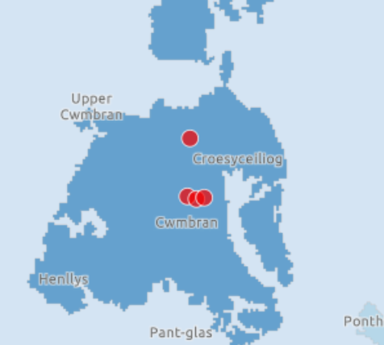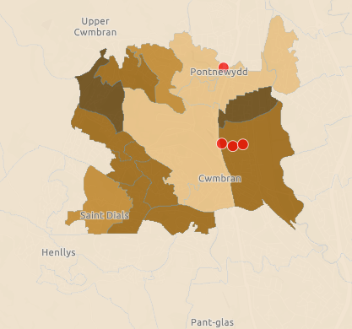

Table 2.1.49 – Torfaen South contractors and number of claims
Service | Number of contractors | Number of claims 2023/24
WGOS 1 | 4 | 19,953
WGOS 2  Band 1  Band 2  Band 3 | 4 | 2,871  897  739
WGOS 3 | 1 | 68
WGOS 4 – Glaucoma (previously ODTC) | 0 | 0
WGOS 4 – Medical Retina | 0
WGOS 4 – HCQ | 0
WGOS 5 | 0 | 0
Domiciliary | 1 | 103

Table 2.1.50 - Torfaen South sight test claims
 | Sight Test | Domiciliary Sight Test
2021/22 | 19,121 | 111
2022/23 | 18,771 | 117
2023/24 | 19,953 | 103

Torfaen South saw a 6% (1182) increase in the number of sight tests performed from 2022/23 (registered premises) but a 14% decrease in domiciliary sight tests.
Primary eye health services are available:
Table 2.1.51 - Torfaen South hours of services
 | Hours available
Monday | 32.5
Tuesday | 32.5
Wednesday | 29
Thursday | 33.5
Friday | 33.5
Saturday | 29
Sunday | 8.5
Total | 198.5

The earliest start time on a weekday is 09.00 and latest finish us 17.30. On Saturday it is 08.30 and 17.30, for Sunday it is 08.30 and 17.00
2.6.12 Domiciliary contractors

There are 12 domiciliary contractors providing services for the population of Gwent. A patient in Gwent can request a domiciliary sight test from any domiciliary contractor regardless of where they live or where the domiciliary contractor is located.
Six of these are national organisations are organisations whose head offices are located outside of the Gwent boundary.
Six are located within individual Neighbourhood Care Networks:
- Blaenau Gwent East
- Blaenau Gwent West
- Caerphilly North
- Monmouth South
- Newport West
- Torfaen South
One domiciliary contractor is a low vision service only.
Map 2.1.33 – Domiciliary providers based on home office
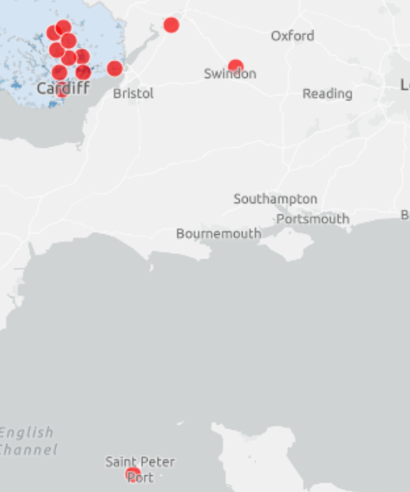
Gwent based domiciliary contractors.
Map 2.1.34 – Gwent based domiciliary providers by rurality
Map 2.1.35 – Gwent based domiciliary providers by deprivation
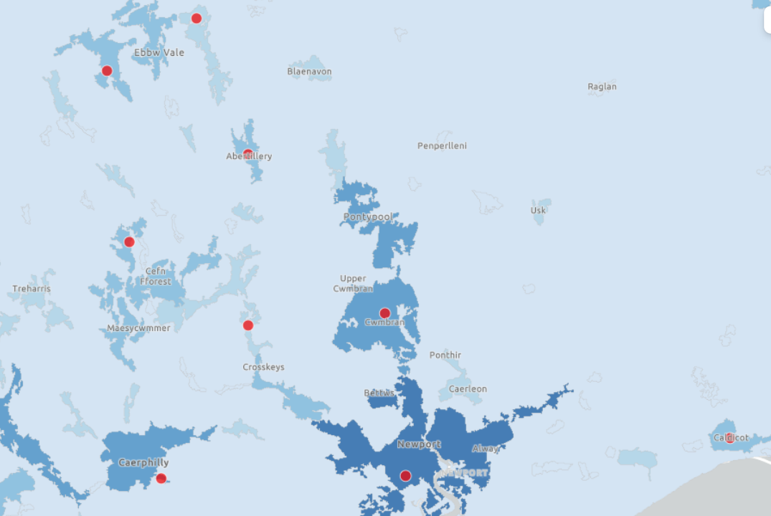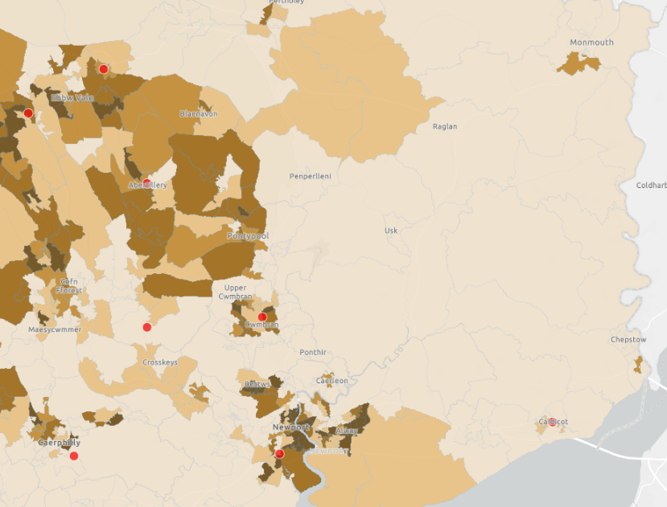

Table 2.1.52 – Torfaen South contractors and number of claims
Service | Number of contractors | Number of claims 2023/24
WGOS 1 | 12 | 4,692
WGOS 2  Band 1  Band 2  Band 3 | 12 | 7  28  4
WGOS 3 | 6 | 268
WGOS 4 – Glaucoma (previously ODTC) | 0 | 0
WGOS 4 – Medical Retina | 0 | 0
WGOS 4 – HCQ | 0 | 0
WGOS 5 | 0 | 0

Table 2.1.53 – Domiciliary contractor (only) sight test claims
 | Domiciliary Sight Test
2021/22 | 3,452
2022/23 | 3,583
2023/24 | 4,692

There was an 23% increase in the number of domiciliary sight tests performed from 2022/23.
2.6.13 Work force

Following four years of the numbers of ophthalmic practitioners (both optometrists and OMPs) increasing there was a small decline in 2024.
Table 2.1.54 – Workforce
As at | Number of Optometrists and OMPs
31 March 2020 | 157
31 March 2021 | 167
31 March 2022 | 181
31 March 2023 | 195
31 March 2024 | 192

2.6.14 Welsh language

Data from the quality in optometry responses show that Welsh language is available from half the practices in Blaenau Gwent West, Monmouthshire North (one practice out of eight), Newport West (one practice out of eight) and Torfaen South (one practice out of four). It is partly available in one practice in Blaenau Gwent East (out of two) and partly from one domiciliary only contractor.
2.6.15. Growth

Sight tests

Based on population projections for 2034 and 2043 and with the current % population of those who receive a sight test and if there is no change in the overall eligibility of patients, a further 1,493 sight tests will be required by 2034 and a further 2,244 by 2043, giving a total 3,737 required in the next 20 years. Of these 91 would be domiciliary sight tests, 77 from domiciliary only contractors.
Table 2.1.55 – Extra sight tests by 2034 and 2043
Sight tests –  all | 2023 | 2034 | 2034 Extra | 2043 | 2043 Extra | Total extra
Blaenau Gwent | 14,539 | 14,617 | 78 | 14,624 | 86 | 164
Caerphilly | 47,799 | 48,287 | 488 | 48,395 | 596 | 1,084
Monmouthshire | 26,002 | 26,321 | 319 | 26,472 | 470 | 789
Newport | 39,398 | 39,724 | 326 | 40,091 | 693 | 1,019
Torfaen | 26,696 | 26,932 | 236 | 27,065 | 369 | 605
Domiciliary only | 4,692 | 4,739 | 47 | 4,769 | 30 | 77
 |  |  | 1,493 |  | 2,245 | 3,738

However, as we know that the population is ageing and those over 65 increasing by 16.7% by 2034 and with 50% of sight tests given to those over 60 then we can predict that this figure could increase by a further 312 sight tests by 2043.
Alongside the projected increase in population there is a projected increase in patients with co-morbidities who may not currently sit within any of the eligibility groups but may do so in the future. Therefore, the expected growth in the requirement of sight tests is likely to be higher than that stated in this section.
Table 2.1.56 – Predicted growth in population and the corresponding eligibility for sight tests
 | % Population growth |  | % who have sight test is | % increase in population accessing NHS Sight test
 | 2034 | 2043 |  | 2034 | 2043
Blaenau Gwent | 2.48 | 2.73 | 21.5 | 0.53 | 0.59
Caerphilly | 3.76 | 4.60 | 27.1 | 1.02 | 1.25
Monmouthshire | 4.46 | 6.58 | 27.5 | 1.23 | 1.81
Newport | 3.46 | 7.36 | 23.9 | 0.83 | 1.76
Torfaen | 3.10 | 4.85 | 28.5 | 0.88 | 1.38
Domiciliary (whole Gwent growth) | 3.71 | 6.02 | 27.27 | 1.01 | 1.64

WGOS 2 - 5

Based on population growth and those who are eligible for a sight test an additional 2,078 WGOS2 band 1 appointments will be required, 787 band 2 and 535 band 3 by 2043. There is likely to be a minimum of 17 WGOS3 appointments. and 12 for WGOS5.
Along with the increase based on population and sight test increases, the predicted average 18% increase in prevalence of patients with Wet AMD means a minimum of 26 appointments will need to be available, and with the 13% increase in prevalence of Glaucoma 321 more appointments.
However, as care pathways become more sophisticated and imbedded in both eye-health providers but also the wider healthcare and with more patients becoming eligible due to increasing prevalence of the clinical conditions and co-morbidities, these figures are likely to increase. Whilst there may be a corresponding decrease in the need for secondary care, future services should be commissioned appropriately and across the whole footprint of Gwent.

2.6.16 Local authority planning

Consideration also needs to be given to planned developments within each local authority. Each authority must produce local development plans (LDP). Most had been in place looking at plans up to 2021, these are now being reviewed and replaced (RLDP) with plans covering 2022 up to 2041 depending on the county borough. Many of these plans have yet to be published in full.
Highlights of planned development plans based on their plans include:
Blaenau Gwent
The RLDP aimed to deliver between 1,755 and 2,155 new homes by 2033, with 478 being affordable housing.
Caerphilly
The LDP plans for 218 new houses being built, including affordable homes, later living scheme and a sheltered housing scheme.
Monmouthshire
The RLDP plan aims to build around 2,100 new homes, with half of them being affordable. With developments being based in Abergavenny, Caldicot, and Bayfield Chepstow.
The plan has also identified further settlements that could deliver a further 619 homes.
Newport
The RDLP proposes up to 10,530 new properties. 5,851 homes are already in the pipeline, either currently under construction or expected to be completed by the end of 2036.
Torfaen
The original LDP set a 4,700 dwellings housebuilding target over the 2006 to 2021 plan period, by 1 April 2021 3,480 dwellings (74%) had been built, with a further 619 being built by end of 2024. 1,316 of these are affordable houses.

2.6.17 Hospital eye services
Gwent has four hospitals and 11 community hospitals/facilities.
Ophthalmology services are available at the four hospitals (outpatients only at Ysbyty Ystrad Fawr)
Map 2.1.33 – Gwent hospitals

Depending on the clinical condition the appropriate treatment may require surgical intervention or treatment that is only available by secondary care physicians.
Outpatient appointments relating to Ophthalmology are the second highest reasons for a patient to attend a secondary care outpatient appointment. Aneurin Bevan UHB Hospital Services data shows provides information on outpatient appointments split by new, follow up and pre-operative appointments.
Table 2.1.57 – Outpatient appointments by type
 | New appointments | Follow up appointments | Pre-Operative Assessment Attendance | Total
2020 | 8,395 | 26,984 | 1,635 | 37,014
2021 | 13,267 | 33,575 | 2,139 | 48,981
2022 | 15,405 | 36,264 | 1,923 | 53,592
2023 | 12,622 | 32,141 | 2,075 | 46,838
2024 | 13,682 | 39,592 | 1,354 | 54,628

Gwent saw the expected decrease in outpatient appointments during Covid 19 and then saw a 24% increase the following year, this was followed by a smaller increase of 8% in 2022. In 2023 we saw a 14% decrease in the total number of appointments, this was reversed in 2024 where we are back to 2022 rates.
Figure 2.1.20 – Outpatient appointment by type and local authority

When looking at the new attendances by the main clinical categories, Cataracts and Glaucoma are the largest reasons for new attendances.
Figure 2.1.21 – New attendances by clinical category

However, when analysing follow up attendances whilst Glaucoma remains one of the highest reasons for follow up attendances, the second highest is those without specific categorisation.
Figure 2.1.22 – Follow up appointments by clinical category

Table 2.1.58 – Outpatient appointments clinical category
The full table of appointment type by clinical categorisation and year is below.
Clinical category | New Attendance |  |  |  |  | Total | Follow Up Attendance |  |  |  |  | Total | Pre-Op Assessment |  |  |  |  | Total | Grand total
Year | 2020 | 2021 | 2022 | 2023 | 2024 |  | 2020 | 2021 | 2022 | 2023 | 2024 |  | 2020 | 2021 | 2022 | 2023 | 2024
Ophthalmology - Cataract | 1073 | 1805 | 1230 | 1607 | 1483 | 7198 | 66 | 233 | 692 | 161 | 128 | 1280 | 1 | 12 | 12 | 3 | 2 | 30 | 8508
Ophthalmology - Diabetic Retinopathy | 107 | 175 | 358 | 232 | 340 | 1212 | 326 | 396 | 715 | 467 | 786 | 2690 |  |  |  |  |  |  | 3902
Ophthalmology - General | 818 | 1690 | 2037 | 1327 | 665 | 6537 | 4214 | 3606 | 2720 | 1567 | 1177 | 13284 | 1 | 6 | 15 |  | 3 | 25 | 19846
Ophthalmology - Glaucoma | 468 | 803 | 947 | 1245 | 1612 | 5075 | 4135 | 8842 | 9379 | 7924 | 11635 | 41915 |  |  | 0 | 3 | 1 | 4 | 46994
Ophthalmology - Wet AMD | 406 | 564 | 477 | 560 | 707 | 2714 | 8236 | 10572 | 11256 | 12077 | 12533 | 54674 |  | 2 | 9 | 2 |  | 13 | 57401
Uncategorised | 254 | 420 | 415 | 403 | 496 | 1988 | 734 | 979 | 1055 | 921 | 1108 | 4797 | 35 | 50 | 53 | 53 | 38 | 229 | 7014
Ophthalmology | 466 | 1423 | 2777 | 277 | 204 | 5147 | 2279 | 1800 | 1864 | 753 | 1112 | 7808 | 1597 | 2063 | 1811 | 2006 | 1303 | 8780 | 21735
Ophthalmology - Cornea | 68 | 220 | 101 | 152 | 255 | 796 | 771 | 686 | 577 | 645 | 1084 | 3763 |  | 2 | 1 |  | 1 | 4 | 4563
Ophthalmology - Laser | 67 | 515 | 872 | 719 | 836 | 3009 | 218 | 750 | 840 | 720 | 690 | 3218 |  |  | 3 |  | 1 | 4 | 6231
Ophthalmology - Minor Ops |  |  | 13 | 94 | 97 | 204 |  |  | 24 | 82 | 134 | 240 |  |  |  | 1 |  | 1 | 445
Ophthalmology - Oculoplastic | 287 | 473 | 423 | 689 | 849 | 2721 | 1062 | 898 | 1186 | 1111 | 1101 | 5358 |  |  | 1 |  | 1 | 2 | 8081
Ophthalmology - Paeds | 262 | 327 | 567 | 566 | 281 | 2003 | 701 | 544 | 616 | 633 | 457 | 2951 |  |  | 2 | 6 | 3 | 11 | 4965
Ophthalmology - Retina | 797 | 954 | 1198 | 1047 | 1241 | 5237 | 2815 | 2496 | 3661 | 2914 | 3510 | 15396 | 1 | 2 | 15 | 1 |  | 19 | 20652
Ophthalmology Advice only |  |  |  |  | 49 | 49 |  |  |  |  |  |  |  |  |  |  |  |  | 49
Ophthalmology Casualty | 3322 | 3898 | 3990 | 3664 | 3603 | 18477 | 1427 | 1773 | 1679 | 1667 | 1801 | 8347 |  | 2 | 1 |  | 1 | 4 | 26828
Ophthalmology Imaging |  |  |  |  | 376 | 376 |  |  |  |  | 363 | 363 |  |  |  |  |  |  | 739
Ophthalmology Reg Cataract |  |  |  |  | 551 | 551 |  |  |  |  | 20 | 20 |  |  |  |  |  |  | 571
Optometry |  |  |  | 40 | 37 | 77 |  |  |  | 499 | 1953 | 2452 |  |  |  |  |  |  | 2529
Totals | 8395 | 13267 | 15405 | 12622 | 13682 | 63371 | 26984 | 33575 | 36264 | 32141 | 39592 | 168556 | 1635 | 2139 | 1923 | 2075 | 1354 | 9126 | 241053

2.16.18 Hospital Eye Service Growth
With the predicted increase in the prevalence of patients with the main clinical conditions, the minimum number of appointments for new attendances is:
Table 2.1.59 – Outpatient appointments clinical category
Condition | % prevalence increases by 2032 | Number of additional new attendances
Cataract | 22% | 326
Glaucoma | 13% | 210
Diabetic retinopathy | 7% | 14
Wet AMD | 4% | 120
Total |  | 670

In 2024 there were a total of 54,628 outpatient appointments which equates to 9.17% of the population. Looking at the predicted population growth in 2034 and 2044 there would need to be an additional 1,978 appointments by 2034 and a further 1185 by 2043.
2.16.19 Outpatient waiting times and attendance
As of January 2025, there are 24,074 patients in the referral to treat pathway for Ophthalmology services. The breakdown is shown in the table below.
Table 2.1.60 – Patients on referral to treat list
Patient count on the referral to treat list | Out-patient WL | Diagnostic | Therapy | Follow Up | Day case WL | Inpatient WL | Total
Ophthalmology cataract | 7,230 | 3 | 1 | 41 | 1,416 | 3 | 8,694
Ophthalmology regional cat | 2,227 |  |  | 3 | 138 |  | 2,368
Ophthalmology general | 1,847 | 7 | 6 | 66 | 143 | 5 | 2,074
Ophthalmology retina | 1,669 | 36 | 48 | 146 | 77 |  | 1,976
Ophthalmology glaucoma | 1,161 | 10 | 34 | 141 | 112 |  | 1,458
Ophthalmology oculoplastic | 1,145 | 3 | 1 | 155 | 127 | 8 | 1,439
Ophthalmology laser | 1,176 | 1 | 31 | 110 |  |  | 1,318
Ophthalmology | 1,174 | 21 |  | 70 | 10 | 1 | 1,276
Ophthalmology paeds | 965 | 38 |  | 47 | 53 | 1 | 1,104
Ophthalmology diabetic retinopathy | 1,028 | 3 | 23 | 25 | 1 |  | 1,080
Ophthalmology cornea | 926 | 2 | 13 | 35 | 69 | 2 | 1,047
Ophthalmology minor op | 118 |  |  | 8 | 5 |  | 131
Ophthalmology wet AMD | 59 |  | 2 | 15 | 7 | 1 | 84
Ophthalmology USC | 11 |  |  | 6 | 8 |  | 25
Grand total | 20,736 | 124 | 159 | 868 | 2,166 | 21 | 24,074

The average wait time for (booked) patients on these pathways are:
Table 2.1.61 – Wait time for booked patients
Average wait for booked patients–(weeks) | Outpatient WL | Diagnostic | Therapy | Follow Up | Day case WL | Inpatient WL
Ophthalmology cataract | 99 |  |  | 1 | 61
Ophthalmology regional cat | 82 |  |  |  | 37
Ophthalmology general | 42 |  |  | 13 | 38 | 98
Ophthalmology retina | 23 | 12 | 30 | 20 | 39
Ophthalmology glaucoma | 42 |  |  | 13 | 6
Ophthalmology oculoplastic | 61 | 15 |  | 13 | 35 | 14
Ophthalmology laser | 18 | 17 | 19 | 11
Ophthalmology | 6 | 10 |  | 15 |  | 2
Ophthalmology paeds | 36 | 10 |  | 20 | 59
Ophthalmology diabetic retinopathy | 24 | 8 | 30 | 47
Ophthalmology cornea | 48 |  | 34 | 27 | 28
Ophthalmology minor ops | 43 |  |  | 7
Ophthalmology wet AMD | 4 |  |  | 19
Ophthalmology USC | 7 |  |  |  | 31

Surgery for cataracts is one of the most common procedures.
Table 2.1.62 – Cataract admissions
 | Cataract admissions
2019/20 | 3,967
2020/21 | 990
2021/22 | 3,027
2022/23 | 2,040

2.6.20 Summary
To reduce the demand on secondary services appropriate community services should be identified and commissioned to allow for care to be provided closer to home, by appropriately trained clinicians. This will include a continuous review of patients being seen under the new WGOS to identify improvements in referral patterns and numbers, but also to identify where gaps remain.

2.1.6 Summary and recommendations
Sight loss and visual impairment can have a significant impact on all aspects of a person’s health, including an increased risk of falls, management of or increased risk of developing other chronic conditions and overall impact on quality of life. Those with sight loss may require more support in adaptations to their environment community or require residential support.
There are both modifiable and non-modifiable risk factors for sight loss.
It is clear that eye health services should be sat within a whole system approach to the planning of health and care services and not sit in isolation. This should include addressing the modifiable risk factors, the local Neighbourhood Care Networks are well placed to drive this position forward.
Vision loss
With an estimated 20,480 individuals living with sight loss and a predicted 14% increase in the next 10 years it is important that all appropriate services are made available to patients. This figure is likely an underestimation due to the reporting methodology of using the certificate of visual impairment.
Early intervention can significantly reduce the risk of permanent vision impairment. Ensuring that all eligible patients receive an eye health check when due and available when any concerns arise will help identify issues before they worsen and put patients on appropriate care pathways to manage their conditions.
We know that there are certain demographics who do not always access eye health services in as a timely manner as they should, if at all.
Communication and outreach programmes supporting the increase in patient knowledge of the importance of having their sight checked should be encouraged. This can be across the whole health care system, joining up messaging alongside general health care messages, such as health checks and vaccination reminders.
Identification of potential new treatments should be monitored and considered for NHS commissioning where appropriate.
Aging population
With a projected population increase, with a significant increase in the 65+ (16.7%) and 85+ (42.7%) population in the next 20 years and therefore more individuals becoming eligible for a sight test it is important that appropriate services are available, not just for the NHS sight test but also the wider eye care services and Commissioners should consider the needs of these patients against commissioned services, including WGOS 3-5 and other community services.
Eligibility
As well as an aging population we are seeing changes in other eligibility groups and gaining further understanding of these changes should be included in any future Eye Health Needs Assessment to look at any impact on inequalities within the population.
Co-morbidities
The predicted increase in patients with co-morbidities such as hypertension, diabetes mellitus and obesity, will have an impact on wider primary care as well as secondary care services and capacity in secondary care services should be taken into consideration but identifying where care can be provided closer to home, on a more preventative basis, utilising workforce or commissioned differently will be important ways of meetings needs of patients. Many of these comorbidities can be prevented with appropriate early advice on healthy lifestyles and should be factored into care pathways.
Outpatient activity
Ophthalmic outpatient attendances are the second highest outpatient appointments in Gwent.
Capacity in terms of both appointments and workforce need to be reviewed to ensure any increase can be managed, however, enabling care in the community either by optometrists or other appropriate clinicians through relevant pathways can help alleviate some of the demand for these services and make a service that could be more convenient for patients to access.
Clinical pathways
As part of a clinical pathway many elements can be manage appropriately in the community, such as referral refinement, pre and post operative follow ups for cataracts, glaucoma filtering. Commissioners should review care pathways to ensure that the whole system is being used appropriately and maximising where care is best given.
Workforce
Identifying and utilising the skill sets of optometrists and other healthcare professionals with advanced qualifications and experience in community and hospital eye services will be crucial for managing care requirements going forward. Targeted training should be provided to maximise their potential, ensuring that their skills are effectively deployed, especially in community settings. This approach will enable better use of the available workforce and improve overall service delivery.
Footfall
At time of publication information on where a patient lives versus where they attend for their eye-health care, both primary and secondary care is not available. This should be sought for future Eye Health Needs Assessments to ensure that information can be correlated to travel to providers.

1. WG. Welsh Index Multiple Deprivation. WG. Accessed 25/11/24, 2024. https://statswales.gov.wales/Catalogue/Community-Safety-and-Social-Inclusion/Welsh-Index-of-Multiple-Deprivation

StatsWales population estimates
ABUHB Map of Gwent
Health Maps Wales, NHS Wales Informatics Service
StatsWales population estimates
StatsWales population estimates
StatsWales population estimates
StatsWales population estimates
StatsWales population estimates
StatsWales population estimates
StatsWales density
Nomis - 2021 Ethnic groups
Nomis 2021 language proficiency (English)
Nomis 2021 language proficiency (Welsh)
Nomis 2021 - Religion
Welsh Government, Welsh Index of Multiple Deprivation 2019http://www.publichealthwalesobservatory.wales.nhs.uk/wimd-2014
ABUHB Life Expectancy And Causes Of Death
Blaenau Gwent Well-being Assessment 2022-23
Public Health Wales Observatory, Public Health Outcomes Framework reporting tool
Blaenau Gwent Well-being Assessment 2022-23
GDS (Wales) Regulations
Pezzullo (2018)
RNIB sight loss data tool
RNIB sight loss data tool
NEHEM
Nislawti et al (2021)
Eijgen et al (2023)
Diabetic Eye Screening Wales
National Eye Institute Astigmatism.
Hou et al (2018)
Tricard et al (2020)
Brennan et al (2021)
Majmunder S and Tripathy K (2023)
Liang et al (2023)
Hashemi et al (2017)
Pateras E (2012)
Ferraz et al (2014)
StatsWales low vision service
StatsWales low vision service
RNIB sight loss data tool
NEHEM
RNIB sight loss data tool
Ang and Afshari (2021)
Holman et al (2011)
RNIB learning disabilities
McCulloch et al (1996)
Thornton et al (2005)
Solberg, Rosner and Belkin (1998)
ons.gov.uk/smoking
Heidari (2015)
Awareness of AMD and associated risk factors
Do et al (2015)
Rowe et al (2013)
RNIB sight loss data tool
RNIB.org.uk/report
Ang and Asfhari (2021)
Fraser et al (2001)
RNIB sight loss data tool
RNIB falls
StatsWales sight tests
StatsWales Admissions for cataract procedures

