

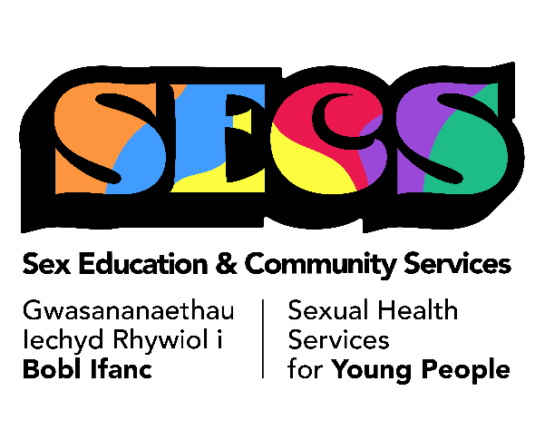
'SECS’ aims to provide specific support to individuals aged 13-25 to promote positive sexual health and wellbeing.
To discuss referring someone outside of this age range, sharing information, group work or sending a referral, please email abb.secs@wales.nhs.uk

Date of referral:
Consent given for referral:  If no, give reasons why: | YES ☐  NO ☐

YOUNG PERSONS DETAILS
Surname: |  | Forename: |  | Gender: | Male  Female ☐  Transgender ☐  Non-binary ☐  None of the above:  Prefer not to comment ☐
D.O.B |  | Age: |  | Social Services involved? | YES ☐  NO ☐
Address: |  | YP telephone number: |  | Parent/  Guardian telephone number:
Referral Source:

Email address:

Tel no.

GP details: | Name:  Email:  Telephone number: | Social Worker: | Name:  Email:  Telephone number:
Education: | Name: Newport Youth Academy  Email:  Telephone number: | Any other services: | Name:  Email:  Telephone number:

Presenting sexual health needs:

Brief description of concerns:

Referral needs:  Outreach Worker ☐  Outreach Nurse ☐  Support after sexual assault (SA) ☐  Please be aware we are not able to undertake work directly linked to the SA as this can impact police investigations. | - CSE – grooming, sexting and internet safety ☐  - Sexual health choices - Safe relationships, boundaries ☐  - Contraception ☐  - STI testing options ☐  - Support with an Unplanned pregnancy ☐

Are there any risks we need to be aware of?  Is a joint appointment needed or do we need to speak to referrer before appointment? | YES ☐  NO  Yes  No

Parent/Guardian aware of referral?  Add details if relevant: | YES  NO ☐
For office use only  Referral Accepted  If no, reasons why: | YES ☐  NO ☐

All completed referral forms to be sent to – abb.secs@wales.nhs.uk

